INDEX

Particulars
Organization Structure:
Support
Warehouse
Segment Management:
Customer Segment Identification
Customer Mapping
Potential Mapping

Target Setting
Basket Sales
Annual Rate Contract
Managing LYBTYNB Customer
New Customer Acquisition
Business Development
Segment Marketing
Enterprise Portal
Customers Connect
Customer Welcome
Collection Forecast
Collection Against Projection
Critical Outstanding Management
Business Understanding for Critical Customers
Sales and Order Booking Forecast
Sales Policy Adherence
Customer Category Bases on BFM Analysis
Brand Management:

Principal Relationship Management

Principal Target Management

Special Price Approval Process

Sales Policy

Sales Policy Adherence

Enquiry Management

Sales Quotation

Quotation Conversion Management

Brand Development

Brand Sales Target Management
Inventory management
Brand visit planning
Brand marketing
After sales management
Understanding of purchase planning
Purchase planning report
Market purchase
Procurement
Stock transfer
Non moving stock liquidation
KPI confirmation date process
Open purchase order
Service centre
Job card process for service centre
New price list update
Brand on boarding process

Support & SOV Management
Operation Management :
Email and case management
Sales order booking
Fastrack billing (Cash Counter Sales)
Sales order approval
Delivery note process
Auto delivery note
Back order review
Unapproved back order
Approved back order
Material supply for sample purpose
Dispatch of material purchased in Urgency
Roles and responsibilities for order processing on same day
Order amendment
Customer service ratio
Email communication templates
Export billing process
Operations faq's
Commercial management:
Credit Management and review
Customer code opening
Credit calculator process
Commercial sales order approval
Collection forecast
Cheque bounce
Invoice booking process
RC adjustment
Sales credit note
Sales debit note .
ledger reconciliation (customer)
LC billing and discounting process
PDC customer billing and approval process
Digital signature through SAP
Adjustment of TDS in invoice deducted by customer
Adjustment of TCS collected in invoice
Commercial faq's
Customer refund process
Talent management:
Band and level
Sourcing: Business plan- attraction - acquisition
Induction
HR policy
KPI culture
Value, ethics, and compliance policy
Non disclosure and confidentiality policy
Whistle blower policy
Updation is the must
Office timings
Entertainment expense
other claim submission through zing
Corporate ola facility
Healthy working environment
First aid box
Employee journey in zing hr
Health and safety
Employee engagement
Learning and development
Growth review
Rewards and recognition
Compensation
Compensatory offers:
Festival bonus
Statutory complaince:
Retention
KPI governance process
Program for process certification test
Technology management:
It management
It asset procurement
It asset maintenance calendar
IT asset maintenance
It network upgradation management
It security
SAP backup
It backup
SAP management
SAP document numbering - fiscal year
SAP document numbering - new location
Business partner master management
Item master management
User master management
Software development
Salesforce app
Location management
System enhancement
Server maintenance and checklist
Accounts management:
Bank guarantee
Letter of credit
Incoming payment
Bank reconciliation
Vendor invoice booking
Bill to ship to AP booking
AP checking
Expense AP booking and checking
Outgoing payment
Outgoing payment approval
Petty cash payment
Vendor payment checklist
Auto og
Book of accounts filing
Ledger reconciliation (vendors)
GST payment process
Direct dispatch
Statutory compliances:
Overview of compliance
Statutory calendar
Preparation of financial statement
Invoice billing to merchant exporter
Gstr 2a reconciliation
Gstr 2a reconciliation in clear tax
Gstr 2B reconciliation
GST 1 return filing and checking
Gstr1 return filing
Gstr 3b return filing and checking
Export and sez documents update in SAP
e-Invoicing
Blocking of generation of e-way Bill
TCS and tDS provision on sales and collection
Reconciliation of gstr1 with E way bill
Understanding of eway bill
System and Audit process:
Daily audit checklist
Audit procedure step by step
Audit compliance
Balance score card
Marketing management:
Marketing calendar
Print media
Design development and branding
Digital advertising
Website maintenance
Social media
Exhibitions, customer meet and seminars
Database generation file
Admission management:
Canteen management
Housekeeping management
Fixed asset non IT
Outstation travel management(with accommodation)
Consummables management
Safety and security
Guest relation management
Insurance
Meeting protocol
Warehouse management :
Good inwards management
Material inward process
Delivery challan process
Good storage management
Goods outward management
Perpetual inventory counting process
Goods transport management
Inward management
Outward management
Test certificate from SAP
Bulk green copy/ LR upload in invoice
Single click invoicing of multi dNS
Auto AP of St and batch creation process
Invoice transport details update
E invoicing
Bulk invoice printing process
E way bill
DN return
Repair warehouse inventory
Interview Questions: 1. What is the colour of the wall behind you?

Organisational Structure:

Segments:
Purchase Department:

- Pawan Goyal
- Karan Goyal
Sales Department:

- Pawan Goyal
- Karan Goyal
- Mohan Sharma
Machines Department:

- Padam Sharma
Welding Department:
- Rohit Welder
- Tiku Welder
- Raju Chetri Workforce
- Dileep Thakur Staff

Gas Cutting Department:
- Padam Sharma
- Dileep Thakur

Threading Department:
- Padam Sharma
- Raju Chetri
- William Workforce
- Ram Bhattarai
- Shyam
Hole Department:
- Padam Sharma
- Dileep Thakur
- Manoj Sharma
- Shyam
- Raju Chetri
Accounts Department:
- Mohan Sharma
- Karan Goyal
- Pawan Goyal
Brands available with KPI for different products:

Product | Brand
Square Pipe | Duragpur
Round Pipe | Nezone, I-Form, Bansal
TMT
HR Sheets | Tata, SAIL
Round Rods | Durgapur
Channel / Angle / Joist | Durgapur

Support:

Warehouse:
KPI warehouses are available at:
Warehouse Number | Location | Items kept

Segment Management:
Customer Segment Identification:
Customer must be classified in the following categories:

Customer Mapping:
Objective: The objective of this SOP is to systematically analyze and map the customer journey to gain insights into customer behavior, preferences, and pain points to enhance the overall customer experience.
Scope: This SOP applies to all personnel involved in analyzing and improving the customer journey within the organization.
Responsibilities:
- Customer Insights/Research Team: Responsible for gathering and analyzing customer data.
- Marketing/UX/CRM Team: Involved in creating and implementing strategies based on customer insights.
- Management/Leadership: Oversight and support for the implementation of customer mapping strategies.
Procedure:
1. Data Collection:
a. Gather customer data from various sources, including CRM systems, surveys, feedback, website analytics, sales records, and customer service interactions.
2. Define Customer Journey Stages:
a. Identify and define the stages a customer typically goes through from initial contact to post-purchase.
b. Typical stages might include awareness, consideration, purchase, post-purchase, and loyalty/advocacy.
3. Map Customer Touchpoints:
a. Identify all touchpoints where customers interact with the business across each defined stage (e.g., website, social media, emails, customer service, physical stores).
4. Gather Customer Insights:
a. Analyze customer behaviors, needs, emotions, and pain points at each touchpoint and stage using the collected data.
b. Use qualitative and quantitative data to understand customer motivations and actions.
5. Create Customer Journey Map:
a. Develop a visual representation of the customer journey, illustrating the identified stages, touchpoints, and customer insights.
b. Incorporate personas or segments if applicable, to represent different customer types.
6. Identify Pain Points and Opportunities:
a. Analyze the customer journey map to identify pain points, challenges, and areas for improvement.
b. Simultaneously, look for opportunities to enhance the customer experience or provide additional value.
7. Develop Strategies for Improvement:
a. Based on the identified pain points and opportunities, devise strategies to address them and enhance the overall customer experience.
8. Implement Changes:
a. Execute the improvements identified, aligning them with the customer mapping insights and objectives.
b. Test and iterate changes as necessary to ensure effectiveness.
9. Monitor and Measure:
a. Continuously monitor and measure the impact of implemented changes.
b. Collect feedback, analyze data, and refine strategies to optimize the customer experience further.
10. Review and Update:
a. Periodically review and update the customer journey map and strategies based on evolving customer behaviors and business objectives.
Revision and Approval:
This SOP should be periodically reviewed, updated, and approved by relevant department heads and management to ensure it remains effective and aligned with business goals.

Training:
Ensure all personnel involved in analyzing and improving the customer journey are trained on this SOP and any relevant tools or methodologies.

Potential Mapping:
Objective: The objective of this SOP is to systematically identify, evaluate, and categorize potential customers or leads to streamline the sales and marketing process.
Scope: This SOP applies to all personnel involved in identifying and categorizing potential customers within the organization.
Responsibilities:
- Sales/Marketing Team: Responsible for identifying, evaluating, and categorizing potential leads.
- CRM/Data Analysis Team: Involved in analyzing and organizing potential customer data.
- Management/Leadership: Oversight and support for the implementation of potential mapping strategies.
Procedure:
1. Define Ideal Customer Profile:
a. Collaborate with sales, marketing, and other relevant departments to define the characteristics and attributes of an ideal customer or target audience.
2. Identify Data Sources:
a. Determine sources of potential customer data, which may include CRM systems, marketing campaigns, website traffic, social media, industry events, referrals, etc.
3. Gather Potential Customer Data:
a. Collect relevant data points that align with the identified ideal customer profile, including demographics, firmographics, behavior patterns, interests, and engagement metrics.
4. Analyze and Segment Data:
a. Analyze collected data to segment potential customers based on shared characteristics, behaviors, needs, or other relevant criteria.
b. Create distinct categories or segments that reflect different levels of potential or readiness to engage.
5. Score or Rank Leads:
a. Develop a scoring system or ranking criteria to prioritize potential leads within each segment based on their likelihood of conversion or engagement.
6. Implement Lead Qualification Process:
a. Establish a lead qualification process that involves validating and verifying potential leads through further interactions, surveys, or direct contact.
7. Document Potential Customer Profiles:
a. Create detailed profiles or records for each potential customer segment, including relevant data, scoring, and qualification notes.
8. Nurture and Engage Potential Leads:
a. Develop tailored marketing or engagement strategies for each segment to nurture potential leads and move them through the sales funnel.
9. Monitor and Track Progress:
a. Continuously monitor and track the progress of potential leads within each segment, recording interactions, responses, and changes in status.
10. Review and Adjust:
a. Periodically review and adjust potential customer segments, criteria, or strategies based on feedback, changing market dynamics, or business objectives.
Revision and Approval:
Regularly review, update, and seek approval from relevant department heads and management to ensure the SOP remains aligned with business goals and market trends.
Training:
Ensure all personnel involved in identifying and categorizing potential customers are trained on this SOP and any relevant tools or methodologies.

Target Setting:
Objective: The objective of this SOP is to establish a systematic process for setting realistic and achievable targets that align with the organization's goals.
Scope: This SOP applies to all departments and personnel involved in setting and achieving targets within the organization.
Responsibilities:
- Management/Leadership Team: Responsible for defining overarching organizational goals and targets.
- Department Heads/Managers: Responsible for setting departmental targets aligned with organizational goals.
- Team Leaders/Supervisors: Involved in cascading and communicating targets to team members.
Procedure:
1. Establish Organizational Goals:
a. Review the organization's mission, vision, and strategic plans to determine overarching goals.
b. Collaborate with relevant departments to define key performance indicators (KPIs) that align with these goals.
2. Cascade Goals to Departments/Teams:
a. Communicate the overarching organizational goals and KPIs to department heads or managers.
b. Discuss how these goals can be translated into specific targets for each department or team.
3. Analyze Past Performance and Trends:
a. Review historical data and performance trends to understand past achievements and areas for improvement.
b. Consider market trends, industry benchmarks, and internal capabilities when setting new targets.
4. Define SMART Targets:
a. Ensure that targets are Specific, Measurable, Achievable, Relevant, and Time-bound (SMART).
b. Each target should be clearly defined, quantifiable, realistic, and have a specific deadline.
5. Allocate Resources and Support:
a. Assess the resources, tools, and support needed to achieve the set targets.
b. Allocate necessary resources and provide support to departments or teams to meet their targets.
6. Communicate Targets Clearly:
a. Clearly communicate the set targets to all relevant stakeholders within the organization.
b. Ensure that team members understand their individual roles in achieving departmental or team targets.
7. Monitor Progress and Performance:
a. Establish a system to regularly monitor progress towards the set targets.
b. Use KPIs and metrics to track performance and identify areas needing attention or improvement.
8. Review and Adjust Targets as Needed:
a. Conduct periodic reviews to assess the progress towards targets.
b. Adjust targets if necessary based on changing circumstances, unforeseen challenges, or shifts in organizational priorities.
9. Celebrate Achievements and Provide Feedback:
a. Recognize and celebrate milestones or achievements towards meeting targets.
b. Provide constructive feedback to teams on their performance and progress.
10. Documentation and Reporting:
a. Maintain records of target setting processes, including initial targets, revisions, progress reports, and final outcomes.
Revision and Approval:
Regularly review and update this SOP as needed, ensuring it remains aligned with the organization's objectives and current market conditions. Seek approval from relevant department heads and management for any revisions.
Training:
Ensure all personnel involved in target setting and execution are trained on this SOP and understand their roles in achieving the set targets.

Basket Sales:
Objective: The objective of this SOP is to establish a systematic process for creating, promoting, and selling bundled or basket offerings to customers.
Scope: This SOP applies to all personnel involved in creating, marketing, and executing basket sales within the organization.
Responsibilities:
- Product/Service Managers: Responsible for selecting products/services for bundle offerings.
- Marketing Team: Involved in creating promotional materials for basket sales.
- Sales Team: Responsible for promoting and selling basket offerings to customers.
Procedure:
1. Identify Target Customer Segments:
a. Analyze customer data and behavior to identify target segments interested in bundled offerings.
b. Determine which products/services are commonly purchased together or would complement each other.

2. Select Products/Services for Bundles:
a. Collaborate with product/service managers to select a mix of products/services suitable for bundled offerings.
b. Consider pricing, compatibility, customer demand, and profitability when selecting items.
3. Design Bundled Offerings:
a. Create different bundle options with varying combinations or tiers, catering to different customer preferences and needs.
b. Ensure clear and appealing packaging or presentation of the bundle.
4. Pricing Strategy:
a. Establish pricing strategies for the bundled offerings, considering discounts or incentives to encourage purchases.
b. Ensure that the bundled price offers value compared to individual purchases.
5. Marketing and Promotion:
a. Develop marketing materials and campaigns to promote the bundled offerings through various channels (online, in-store, email, social media, etc.).
b. Highlight the benefits and savings of purchasing the bundle, emphasizing the value proposition.
6. Train Sales Team:
a. Train the sales team on the features, benefits, and pricing of the bundled offerings.
b. Equip them with persuasive selling techniques to effectively communicate the value to customers.
7. Customer Engagement and Upselling:
a. Engage with customers, highlighting the bundled offerings based on their needs or preferences.
b. Utilize upselling techniques to encourage customers to opt for bundled options during sales interactions.

8. Process Sales and Transactions:
a. Ensure smooth and efficient processing of bundled sales transactions through the POS system or relevant software.
b. Provide necessary guidance and support to customers during the purchase process.
9. Customer Feedback and Evaluation:
a. Gather feedback from customers who purchased bundled offerings to assess satisfaction and identify areas for improvement.
b. Evaluate the performance of different bundle options based on sales data and customer feedback.
10. Adjust and Improve Offerings:
a. Based on the evaluation, make necessary adjustments to bundled offerings, pricing, or promotion strategies to optimize performance.
Revision and Approval:
Regularly review and update this SOP to incorporate feedback, changes in market trends, and sales performance data. Seek approval from relevant department heads and management for any revisions.
Training:
Ensure all personnel involved in creating, marketing, and executing basket sales are trained on this SOP and understand their roles in promoting and selling bundled offerings effectively.

Annual Rate Contract
Objective: The objective of this SOP is to establish a standardized process for creating, negotiating, and managing Annual Rate Contracts (ARCs) for procurement or services.
Scope: This SOP applies to all personnel involved in the procurement or service contract management within the organization.
Responsibilities:
- Procurement Department/Contract Managers: Responsible for negotiating and managing ARCs.
- Finance Department: Involved in financial evaluations and budgetary considerations.
- Legal Department: Ensuring contracts comply with legal requirements and protect the organization's interests.
Procedure:
1. Needs Assessment and Requirement Identification:
a. Identify recurring procurement/service needs that can benefit from an Annual Rate Contract.
b. Define the specifications, quantities, and duration of the contract.
2. Vendor Identification and Prequalification:
a. Identify potential vendors capable of fulfilling the specified requirements.
b. Prequalify vendors based on criteria such as quality, capability, reliability, past performance, and financial stability.
3. Request for Proposal (RFP) or Tender:
a. Issue an RFP or tender document outlining the requirements, terms, and conditions for the ARC.
b. Communicate the evaluation criteria, timelines, and submission guidelines to interested vendors.
4. Evaluation and Selection:
a. Evaluate received proposals based on predetermined criteria.
b. Shortlist vendors based on their compliance with requirements and pricing competitiveness.
5. Negotiation and Contract Finalization:
a. Initiate negotiations with shortlisted vendors to finalize terms, pricing, and scope of the ARC.
b. Draft the Annual Rate Contract including all agreed-upon terms and conditions.
6. Legal Review and Approval:
a. Submit the drafted contract to the legal department for review to ensure compliance with legal and regulatory requirements.
b. Make necessary revisions based on legal recommendations.
7. Approval and Sign-off:
a. Obtain approval from relevant stakeholders, department heads, or management.
b. Ensure signatures from authorized personnel on the finalized contract.
8. Implementation and Communication:
a. Communicate the finalized ARC to all relevant stakeholders, including procurement, finance, and operational teams.
b. Ensure understanding of roles and responsibilities outlined in the contract.
9. Performance Monitoring and Management:
a. Monitor vendor performance against agreed-upon terms and Key Performance Indicators (KPIs).
b. Address any issues or discrepancies promptly and efficiently.
10. Contract Renewal or Termination:
a. Evaluate the performance of the ARC before its expiry.
b. Decide on renewal, renegotiation, or termination based on performance assessment and organizational needs.
11. Documentation and Record Keeping:
a. Maintain accurate records of the ARC, amendments, performance evaluations, and any correspondence related to the contract.
Revision and Approval:
Regularly review and update this SOP as needed to adapt to changing business requirements and industry standards. Seek approval from relevant department heads and management for any revisions.
Training:
Ensure all personnel involved in managing ARCs are trained on this SOP and understand their roles in the ARC lifecycle.

Managing LYBTYNB Customer
Objective: The objective of this SOP is to establish a structured approach for managing LYBTYNB customers, emphasizing relationship-building and fostering repeat business opportunities.
Scope: This SOP applies to all personnel involved in customer relationship management and post-sales activities within the organization.
Responsibilities:
- Customer Relationship Managers: Responsible for overseeing LYBTYNB customer relationships.
- Sales/Account Managers: Involved in maintaining contact and nurturing relationships with LYBTYNB customers.
- Marketing Team: Collaborating on retention strategies and communication with LYBTYNB customers.
Procedure:
1. Identify LYBTYNB Customers:
a. Identify customers who have shown interest in future business collaborations or have the potential for continued engagement.
b. Consider factors such as previous interactions, expressed interest, or future project discussions.
2. Gather Customer Insights:
a. Collect and analyze customer data, including past interactions, preferences, feedback, and buying patterns.
b. Use this data to understand the specific needs and expectations of LYBTYNB customers.
3. Develop Relationship-Building Strategies:
a. Create personalized strategies to engage and nurture LYBTYNB customers, focusing on building long-term relationships.
b. Customize communication and engagement methods based on individual customer preferences.
4. Maintain Regular Communication:
a. Initiate regular communication with LYBTYNB customers through personalized emails, calls, newsletters, or targeted marketing campaigns.
b. Provide valuable insights, updates, or offerings that align with their interests or business needs.
5. Offer Value and Support:
a. Provide ongoing support and assistance to LYBTYNB customers, offering value-added services, advice, or resources that benefit their business.
b. Proactively address their concerns or challenges, demonstrating commitment and reliability.
6. Seek Feedback and Engagement:
a. Request feedback and input from LYBTYNB customers about their experience with your products/services and areas for improvement.
b. Encourage their participation in surveys, webinars, or events to maintain engagement.
7. Recognize and Appreciate:
a. Recognize the loyalty and partnership of LYBTYNB customers through personalized gestures, thank-you notes, or exclusive offers.
b. Show appreciation for their ongoing support and collaboration with your business.
8. Monitor and Measure Engagement:
a. Track the engagement levels of LYBTYNB customers, including response rates, participation, and feedback received.
b. Use metrics to evaluate the effectiveness of relationship-building strategies.
9. Review and Adapt Strategies:
a. Periodically review the effectiveness of LYBTYNB customer engagement strategies.
b. Adapt and adjust approaches based on feedback and changing customer needs.
10. Documentation and Record Keeping:
a. Maintain detailed records of interactions, feedback, preferences, and engagement history with LYBTYNB customers.
Revision and Approval:
Regularly review and update this SOP to incorporate feedback, changes in customer expectations, or emerging best practices in customer relationship management. Seek approval from relevant department heads and management for any revisions.
Training:
Ensure all personnel involved in managing LYBTYNB customers are trained on this SOP and understand the importance of nurturing long-term relationships for future business opportunities.

New Customer Acquisition
Objective: The objective of this SOP is to establish a structured approach for acquiring new customers, from initial prospect identification to conversion.
Scope: This SOP applies to all personnel involved in sales, marketing, and customer acquisition activities within the organization.
Responsibilities:
- Marketing Team: Responsible for lead generation and initial engagement with potential prospects.
- Sales Team: Involved in converting qualified leads into new customers.
- Customer Acquisition Managers: Overseeing the acquisition process and strategies.
Procedure:
1. Define Target Audience:
a. Identify and define the ideal customer profile or target audience based on demographics, behavior, interests, and needs.
b. Create buyer personas to understand the motivations and pain points of potential customers.
2. Lead Generation:
a. Utilize various lead generation methods such as content marketing, social media, SEO, paid advertising, events, etc., to attract potential prospects.
b. Capture leads through website forms, landing pages, or opt-in mechanisms.
3. Qualify Leads:
a. Evaluate and qualify generated leads based on predefined criteria, ensuring they match the ideal customer profile.
b. Prioritize leads based on their level of interest, engagement, and potential conversion.
4. Initial Engagement:
a. Initiate initial contact with qualified leads through personalized emails, calls, or targeted content.
b. Provide valuable information or resources addressing their specific needs or pain points.
5. Nurture Leads:
a. Implement lead nurturing campaigns using drip emails, newsletters, webinars, or other relevant content to build trust and engagement.
b. Gradually guide prospects through the sales funnel, addressing objections and providing solutions.
6. Qualification and Sales Pitch:
a. Further qualify interested prospects to determine their readiness to make a purchase.
b. Deliver a tailored sales pitch or presentation focusing on the unique value proposition and benefits of your products/services.
7. Handling Objections and Closing:
a. Address objections or concerns raised by prospects and provide relevant information or reassurance.
b. Guide them through the purchasing process and close the sale, ensuring a smooth transition to becoming a customer.
8. Onboarding and Follow-Up:
a. Ensure a seamless onboarding process for new customers, providing necessary resources or assistance to get started.
b. Follow up with new customers to gather feedback, ensure satisfaction, and address any immediate concerns.
9. Documentation and Reporting:
a. Maintain accurate records of acquired customers, their journey, and conversion metrics.
b. Generate reports to analyze the effectiveness of acquisition strategies and identify areas for improvement.
Revision and Approval:
Regularly review and update this SOP to adapt to changing market conditions, new acquisition techniques, or feedback from sales and marketing teams. Seek approval from relevant department heads and management for any revisions.
Training:
Ensure all personnel involved in customer acquisition activities are trained on this SOP and understand their roles in acquiring new customers effectively.

Business Development
Segment Marketing
Objective: The objective of this SOP is to establish a structured approach for targeting, engaging, and converting specific market segments to drive business growth.
Scope: This SOP applies to all personnel involved in segment-focused business development and marketing activities within the organization.
Responsibilities:
- Segment Marketing Managers/Team: Responsible for strategizing and executing segment-focused marketing plans.
- Sales and Business Development Team: Collaborating on segment-specific engagement and conversion strategies.
- Leadership/Management: Overseeing and supporting the segment marketing process.

Procedure:
1. Segment Identification and Analysis:
a. Identify and define specific market segments based on demographics, behavior, needs, or industry verticals.
b. Conduct in-depth analysis of each segment's characteristics, pain points, buying behavior, and potential value to the organization.
2. Define Segment-Specific Goals:
a. Align segment-focused marketing goals with the organization's overall business development objectives.
b. Define specific targets, such as revenue growth, market share, or client acquisition within each identified segment.
3. Tailored Value Proposition Creation:
a. Develop a tailored value proposition for each identified segment, emphasizing how the organization's offerings address their unique needs or challenges.
b. Customize messaging and positioning to resonate with the specific pain points or goals of each segment.
4. Segment-Specific Content Creation:
a. Create targeted content (articles, whitepapers, case studies, etc.) catering to the interests and needs of each segment.
b. Utilize various content formats and distribution channels aligned with the preferences of each segment (webinars, blogs, social media, industry events, etc.).
5. Segment Outreach and Engagement:
a. Initiate targeted outreach campaigns aimed at engaging each segment through personalized emails, direct mail, calls, or webinars.
b. Use segmentation tools or CRM systems to manage and track interactions with each segment.
6. Relationship Building and Nurturing:
a. Focus on building relationships through ongoing engagement and follow-ups, providing value-added insights or resources relevant to each segment.
b. Offer specialized support or guidance to address specific challenges faced by each segment.
7. Customized Sales and Conversion Strategies:
a. Tailor sales strategies and pitches for each segment, aligning them with the unique needs and preferences identified.
b. Customize pricing, proposals, and negotiations based on the segment's characteristics and priorities.
8. Performance Tracking and Optimization:
a. Monitor and analyze segment-specific campaign performance metrics, such as engagement rates, conversion rates, and revenue generated.
b. Use insights to optimize strategies and campaigns, adapting approaches based on the effectiveness of each segment's response.
9. Documentation and Reporting:
a. Maintain records of segment-specific marketing campaigns, content, interactions, and outcomes for future reference and analysis.
Revision and Approval:
Regularly review and update this SOP to adapt to changing market conditions, emerging segment needs, and feedback from marketing and sales teams. Seek approval from relevant department heads and management for any revisions.
Training:
Ensure all personnel involved in segment-focused marketing and business development activities are trained on this SOP and understand their roles in targeting and engaging specific market segments effectively.

Enterprise Portal
Objective: The objective of this SOP is to establish a structured approach for the management, maintenance, and utilization of the enterprise portal to streamline internal processes and improve organizational efficiency.
Scope: This SOP applies to the IT department, portal administrators, and all personnel using the enterprise portal within the organization.
Responsibilities:
- IT Department/Portal Administrators: Responsible for portal setup, maintenance, security, and technical support.
- Departmental Managers/Team Leaders: Overseeing and managing content, access permissions, and user roles within their respective departments.
- End Users: Utilizing the portal for various organizational purposes.
Procedure:
1. Portal Setup and Configuration:
a. Identify the specific needs and functionalities required for the enterprise portal in collaboration with different department heads.
b. Select an appropriate portal platform based on organizational requirements and implement necessary customizations.
2. User Access and Permissions:
a. Establish user roles and access permissions based on job roles, responsibilities, and departments.
b. Assign access rights to ensure appropriate levels of access for different users while maintaining data security.
3. Content Management:
a. Create a standardized structure for organizing and managing content within the portal, ensuring intuitive navigation.
b. Assign content management responsibilities to designated departmental managers for their respective sections.
4. Training and Support:
a. Provide comprehensive training sessions to all users on portal navigation, features, and functionalities.
b. Offer ongoing technical support and assistance to address user queries or issues related to portal usage.
5. Security Measures:
a. Implement robust security measures, including firewalls, encryption, and regular security updates to protect sensitive data.
b. Conduct regular security audits to identify vulnerabilities and ensure compliance with data protection regulations.
6. Regular Maintenance and Updates:
a. Schedule regular maintenance activities to optimize portal performance and address any technical issues promptly.
b. Implement updates and patches for the portal platform and related applications to ensure smooth operations.
7. Monitoring and Analytics:
a. Utilize analytics tools to monitor portal usage, track user behavior, and identify areas for improvement.
b. Generate reports and analytics to assess the effectiveness of the portal in meeting organizational objectives.
8. Continuous Improvement:
a. Collect feedback from users regarding their experience and suggestions for enhancements.
b. Incorporate user feedback into future updates and improvements to enhance portal functionality.
9. Disaster Recovery and Backup:
a. Establish a comprehensive backup and disaster recovery plan to safeguard portal data in case of system failures or emergencies.
b. Test backup systems regularly to ensure data recovery readiness.
10. Documentation and Guidelines:
a. Maintain comprehensive documentation, including user guides, FAQs, and troubleshooting manuals for easy reference.
b. Update documentation as the portal evolves or new features are introduced.
Revision and Approval:
Regularly review and update this SOP to incorporate technological advancements, changing user needs, or security requirements. Seek approval from relevant department heads and management for any revisions.
Training:
Ensure all portal administrators and users are trained on this SOP and understand their roles and responsibilities in utilizing and maintaining the enterprise portal.

Customers Connect
Objective: The objective of this SOP is to establish a structured approach for engaging with customers, fostering relationships, and ensuring satisfaction to drive loyalty and retention.
Scope: This SOP applies to all personnel involved in customer-facing roles, including sales, customer service, and marketing teams.
Responsibilities:
- Customer Service Representatives: Responsible for direct customer interactions and issue resolution.
- Sales and Marketing Teams: Involved in customer outreach, communication, and relationship building.
- Management/Leadership: Overseeing and supporting customer engagement strategies.
Procedure:
1. Customer Segmentation:
a. Identify and segment customers based on factors such as purchase history, preferences, engagement levels, and feedback.
b. Categorize customers into groups to tailor communication and engagement strategies.
2. Communication Channels:
a. Determine appropriate communication channels (emails, phone calls, social media, etc.) based on customer preferences and nature of interactions.
b. Establish guidelines for effective communication, ensuring consistency in tone, language, and branding.
3. Personalized Engagement:
a. Initiate personalized interactions based on the identified segmentation, addressing specific needs or interests of each customer group.
b. Provide personalized offers, content, or solutions that cater to their individual preferences or pain points.
4. Proactive Outreach:
a. Implement strategies for proactive outreach, such as follow-up calls after purchases, service reminders, or special occasion greetings.
b. Anticipate customer needs and provide proactive solutions or assistance before they are requested.
5. Customer Feedback Collection:
a. Set up mechanisms to collect feedback from customers, including surveys, feedback forms, or post-interaction follow-ups.
b. Analyze and evaluate feedback to identify areas for improvement and address any issues promptly.
6. Issue Resolution and Support:
a. Establish protocols for addressing customer issues or complaints promptly and efficiently.
b. Provide timely and effective solutions to ensure customer satisfaction and retention.
7. Relationship Building:
a. Focus on building long-term relationships by engaging in meaningful conversations and providing ongoing support.
b. Engage customers beyond transactions, aiming for loyalty and advocacy.
8. Customer Appreciation and Recognition:
a. Show appreciation to customers through loyalty programs, exclusive offers, or personalized rewards based on their engagement levels.
b. Acknowledge and recognize loyal customers publicly to reinforce their importance to the organization.
9. Performance Monitoring:
a. Monitor key performance indicators (KPIs) related to customer satisfaction, retention rates, and engagement metrics.
b. Track the effectiveness of customer engagement strategies and adjust approaches based on performance data.
10. Documentation and Reporting:
a. Maintain records of customer interactions, feedback, issues resolved, and any communication for reference and analysis.
Revision and Approval:
Regularly review and update this SOP to incorporate changing customer needs, feedback, or emerging best practices in customer engagement. Seek approval from relevant department heads and management for any revisions.
Training:
Ensure all personnel involved in customer-facing roles are trained on this SOP and understand their roles in fostering strong customer relationships and satisfaction.

Customer Welcome
Objective: The objective of this SOP is to establish a standardized process for warmly welcoming and onboarding new customers, ensuring a positive initial experience and fostering engagement.
Scope: This SOP applies to all personnel involved in customer-facing roles, including customer service, sales, and onboarding teams.
Responsibilities:
- Customer Service Representatives: Responsible for guiding customers through the welcome process and addressing initial queries.
- Onboarding Specialists: Involved in facilitating the onboarding process and providing necessary assistance to new customers.
- Management/Leadership: Overseeing and supporting the implementation of the customer welcome process.
Procedure:
1. Pre-Welcome Preparation:
a. Gather necessary resources, welcome kits, or information packets tailored for new customers.
b. Ensure all relevant departments are briefed and prepared to assist new customers seamlessly.
2. Welcome Communication:
a. Initiate contact immediately after a customer’s acquisition or registration, acknowledging their entry into the system.
b. Send a personalized welcome email, message, or package introducing the organization and its offerings.
3. Introduction to Products/Services:
a. Provide comprehensive documentation or guides explaining how to use products/services effectively.
b. Offer video tutorials, walkthroughs, or webinars showcasing the key features and benefits of using your offerings.
4. Onboarding Assistance:
a. Assign dedicated onboarding specialists or customer success managers to guide new customers through the onboarding process.
b. Schedule one-on-one calls or meetings to assist with account setup, configuration, or any initial challenges.
5. Personalized Support:
a. Offer personalized assistance based on the customer’s needs and level of familiarity with your products/services.
b. Address any queries or concerns promptly and ensure accessibility for further assistance.
6. Welcome Package or Kit:
a. Provide a welcome package containing branded merchandise, instructions, discount codes, or resources relevant to their onboarding journey.
b. Tailor the package to align with their preferences or the specific products/services they’ve signed up for.
7. Follow-Up and Feedback:
a. Follow up with customers shortly after the welcome process to ensure they have successfully navigated through the initial steps.
b. Collect feedback on their onboarding experience to identify areas for improvement or additional support.
8. Introduction to Support Channels:
a. Familiarize new customers with the various support channels available (phone, email, live chat, knowledge base, etc.) for assistance.
b. Provide guidelines on when and how to reach out for help.
9. Documentation and Reporting:
a. Maintain records of the welcome process, including communication, resources provided, and feedback received.
Revision and Approval:
Regularly review and update this SOP to incorporate changing customer needs, feedback, or emerging best practices in customer onboarding. Seek approval from relevant department heads and management for any revisions.
Training:
Ensure all personnel involved in customer welcome procedures are trained on this SOP and understand their roles in creating a positive and engaging onboarding experience for new customers.

Collection Forecast
Objective: The objective of this SOP is to establish a structured approach for predicting and planning collections from customers or clients to ensure accurate cash flow management.
Scope: This SOP applies to finance departments, accounts receivable teams, and personnel responsible for managing collections within the organization.
Responsibilities:
- Accounts Receivable Manager/Team: Responsible for overseeing the collection forecast process.
- Sales and Customer Service Teams: Providing input and information regarding customer payment behavior.
- Financial Analysts/Controllers: Assisting in data analysis and forecasting.
Procedure:
1. Data Collection and Analysis:
a. Gather historical payment data, including payment patterns, trends, and customer payment behavior.
b. Analyze customer payment histories, aging reports, and any outstanding invoices or receivables.
2. Customer Segmentation:
a. Segment customers based on payment behavior, credit history, and payment terms.
b. Categorize customers into groups for forecasting purposes (e.g., high-risk, regular payers, late payers).
3. Forecasting Methods:
a. Utilize forecasting models (such as time-series analysis, weighted averages, or regression analysis) to predict future collections.
b. Factor in seasonal trends, economic conditions, and any specific industry or customer-related influences.
4. Review of Invoices and Payment Terms:
a. Review existing invoices and payment terms to ensure accuracy and consistency.
b. Verify that payment terms are clear and in line with customer agreements or contracts.
5. Collaboration with Sales and Customer Service:
a. Collaborate with the sales team to gather insights on upcoming orders, potential delays, or changes in customer commitments.
b. Engage with customer service to understand any customer issues that might impact payments.
6. Forecasting Documentation:
a. Document the collection forecast, detailing the predicted amounts, timelines, and the basis of the forecast methods used.
b. Maintain clear and accessible records of the forecast for reference and comparison.
7. Monitoring and Adjustment:
a. Monitor actual collections against forecasted amounts regularly.
b. Adjust forecasts based on actual collections, identifying deviations and updating forecasts accordingly.
8. Reporting:
a. Generate reports summarizing forecasted versus actual collections.
b. Provide reports to relevant stakeholders, such as finance teams, management, and sales, for visibility and decision-making.
9. Continuous Improvement:
a. Regularly review the accuracy of forecasts and identify areas for improvement.
b. Incorporate feedback and make adjustments to forecasting methods or data sources as needed.
10. Revision and Approval:
Regularly review and update this SOP to incorporate changes in payment patterns, customer behavior, or improvements in forecasting techniques. Seek approval from relevant department heads and management for any revisions.
Training:
Ensure all personnel involved in the collection forecast process are trained on this SOP and understand their roles in accurate and effective forecasting.

Collection Against Projection
Objective: The objective of this SOP is to establish a structured approach for managing collections in comparison to the projected amounts, ensuring alignment between forecasts and actual collections.
Scope: This SOP applies to finance departments, accounts receivable teams, and personnel responsible for monitoring and managing collections within the organization.
Responsibilities:
- Accounts Receivable Manager/Team: Responsible for overseeing and tracking collections against projections.
- Financial Analysts/Controllers: Assisting in data analysis and comparisons between projections and actual collections.
- Sales and Customer Service Teams: Providing input and information regarding customer payments and collections.
Procedure:
1. Collection Projection Reference:
a. Obtain the collection projections or forecasts generated from the collection forecast SOP.
b. Ensure clarity on the projected amounts, timelines, and the basis of the forecast methods used.
2. Tracking Actual Collections:
a. Record and track actual collections received from customers or clients regularly.
b. Maintain a detailed record of each payment received, the date, and the associated customer account.
3. Comparison and Analysis:
a. Compare actual collections against projected amounts on a regular basis (weekly, monthly, etc.).
b. Analyze variances between projections and actual collections to identify any deviations.
4. Investigate Deviations:
a. Investigate the reasons for discrepancies between projected and actual collections.
b. Determine if the deviations are due to delayed payments, changes in customer behavior, economic factors, or other issues.
5. Engagement with Sales and Customer Service:
a. Collaborate with the sales team to gather insights on customer commitments, delays, or potential changes affecting payments.
b. Engage with customer service to address any customer issues impacting payments or collections.
6. Reporting and Documentation:
a. Generate reports summarizing the comparisons between projected and actual collections.
b. Document the findings and reasons for deviations, detailing any corrective actions taken or required.
7. Adjustment and Re-Forecasting:
a. Adjust future projections or forecasts based on insights gained from comparing actual collections.
b. Update forecasting models or methods to enhance accuracy based on actual collection data.
8. Continuous Improvement:
a. Regularly review the effectiveness of the collection process against projections.
b. Incorporate feedback and implement process improvements to align forecasts more closely with actual collections.

9. Revision and Approval:
Regularly review and update this SOP to incorporate changes in collection patterns, customer behavior, or improvements in forecasting techniques. Seek approval from relevant department heads and management for any revisions.
Training:
Ensure all personnel involved in managing collections against projections are trained on this SOP and understand their roles in aligning projections with actual collections.

Critical Outstanding Management
Objective: The objective of this SOP is to establish a structured approach for identifying, prioritizing, and resolving critical outstanding accounts to minimize financial risk and ensure timely collections.
Scope: This SOP applies to finance departments, accounts receivable teams, and personnel responsible for managing critical outstanding accounts within the organization.
Responsibilities:
- Accounts Receivable Manager/Team: Responsible for overseeing critical outstanding account management.
- Financial Analysts/Controllers: Assisting in data analysis and identifying critical accounts.
- Sales and Customer Service Teams: Providing input and information regarding critical accounts and payment statuses.
Procedure:
1. Identification of Critical Outstanding Accounts:
a. Identify accounts with outstanding balances that are critical to the organization’s financial health.
b. Define criteria for determining criticality (e.g., high-value accounts, aging of outstanding amounts, contractual importance).
2. Prioritization and Categorization:
a. Categorize critical outstanding accounts based on severity, urgency, and potential impact on the organization.
b. Prioritize accounts based on the level of risk and importance to the organization’s financial stability.
3. Collection Strategy Formulation:
a. Develop specific collection strategies tailored for each category of critical outstanding accounts.
b. Determine appropriate collection approaches, such as direct contact, negotiation, or escalated communication.
4. Engagement with Internal Teams:
a. Collaborate with sales and customer service teams to gain insights into customer issues, disputes, or potential payment delays.
b. Engage in cross-departmental discussions to resolve outstanding issues affecting critical accounts.
5. Communication and Escalation:
a. Initiate direct communication with account holders to address outstanding amounts, clarify payment terms, and resolve disputes.
b. Escalate communications to higher management or legal teams if necessary, following established protocols.
6. Negotiation and Resolution:
a. Negotiate payment plans, settlements, or alternative arrangements with account holders to facilitate timely collections.
b. Document all negotiations and agreements made to ensure clarity and compliance.
7. Monitoring and Follow-Up:
a. Monitor progress and actions taken to resolve critical outstanding accounts regularly.
b. Follow up persistently to ensure agreed-upon payment schedules or resolutions are adhered to.
8. Documentation and Reporting:
a. Maintain detailed records of all communications, negotiations, and actions taken regarding critical outstanding accounts.
b. Generate reports summarizing the status, progress, and resolution of critical accounts for review and decision-making.
9. Continuous Improvement:
a. Regularly review the effectiveness of strategies in managing critical outstanding accounts.
b. Incorporate feedback and implement process improvements to enhance the resolution of critical accounts.
10. Revision and Approval:
Regularly review and update this SOP to incorporate changes in collection strategies, account statuses, or improvements in resolution techniques. Seek approval from relevant department heads and management for any revisions.
Training:
Ensure all personnel involved in managing critical outstanding accounts are trained on this SOP and understand their roles in resolving critical financial issues effectively.

Business Understanding for Critical Customers
Objective: The objective of this SOP is to establish a structured approach for gaining deep insights into critical customers, understanding their needs, challenges, and expectations to foster strong relationships and drive mutual growth.
Scope: This SOP applies to sales, customer service, and account management teams responsible for engaging and managing relationships with critical customers.
Responsibilities:
- Account Managers/Relationship Managers: Responsible for maintaining and understanding critical customer relationships.
- Sales and Customer Service Teams: Involved in day-to-day interactions and gathering customer feedback.
- Management/Leadership: Overseeing critical customer relationships and strategies.

Procedure:
1. Identification of Critical Customers:
a. Define criteria for identifying critical customers (e.g., high-value clients, strategic partners, long-term relationships).
b. Create a list of critical customers based on revenue contribution, strategic importance, or influence within the industry.
2. Customer Profiling and Segmentation:
a. Gather and analyze customer data including purchase history, interactions, feedback, and preferences.
b. Segment critical customers based on their industry, needs, challenges, and growth potential.
3. Relationship Mapping:
a. Identify key decision-makers and influencers within critical customer organizations.
b. Map out internal and external relationships within the customer's organization to understand decision-making processes.
4. Needs Assessment and Analysis:
a. Conduct regular assessments to understand critical customers' evolving needs, challenges, and pain points.
b. Analyze data collected from assessments and interactions to identify opportunities for alignment and support.
5. Customized Engagement Strategies:
a. Develop tailored engagement strategies for each critical customer segment based on their specific needs and expectations.
b. Implement communication plans and engagement tactics personalized to each customer's preferences.
6. Continuous Communication and Feedback:
a. Maintain open lines of communication with critical customers through regular check-ins, meetings, and feedback sessions.
b. Gather feedback proactively to understand satisfaction levels, concerns, and areas for improvement.
7. Cross-Functional Collaboration:
a. Foster collaboration between departments to address critical customer needs effectively.
b. Coordinate efforts across teams to ensure a unified approach in serving critical customers.
8. Customer Success Planning:
a. Develop customer success plans outlining mutual goals, milestones, and strategies for achieving success together.
b. Review and update these plans periodically based on evolving customer needs and organizational objectives.
9. Documentation and Reporting:
a. Maintain detailed records of interactions, feedback, and strategies employed for each critical customer.
b. Generate reports summarizing the status, progress, and future plans for each critical customer relationship.
10. Revision and Approval:
Regularly review and update this SOP to incorporate changes in customer needs, feedback, or improvements in relationship management techniques. Seek approval from relevant department heads and management for any revisions.
Training:
Ensure all personnel involved in managing critical customer relationships are trained on this SOP and understand their roles in nurturing and understanding these key relationships effectively.

Sales and Order Booking Forecast
Objective: The objective of this SOP is to establish a structured approach for predicting and planning sales and order bookings to facilitate efficient production, resource allocation, and financial planning.
Scope: This SOP applies to sales departments, sales operations teams, and personnel responsible for sales forecasting and order booking.
Responsibilities:
- Sales Managers/Team: Responsible for providing sales forecasts and order booking information.
- Sales Operations Analysts: Involved in data analysis and forecasting methodologies.
- Production/Inventory Teams: Utilizing forecasted data for resource planning and inventory management.
Procedure:
1. Data Collection and Analysis:
a. Gather historical sales data, order bookings, and relevant market trends.
b. Analyze past performance, seasonal trends, market demand, and any external factors influencing sales.
2. Sales Forecasting Methods:
a. Utilize forecasting models (such as time-series analysis, trend analysis, or predictive analytics) to predict future sales and order bookings.
b. Consider multiple factors including historical data, market trends, customer behavior, and product lifecycle.
3. Collaboration with Sales Teams:
a. Collaborate with sales teams to gather insights into potential future orders, new leads, or market developments.
b. Regularly update forecasts based on input from sales representatives regarding customer interactions and future opportunities.
4. Review of Sales Pipeline:
a. Review the sales pipeline, identifying pending deals, prospects, and their likelihood of conversion.
b. Assess the probability of closing deals and their potential impact on future sales and order bookings.
5. Sales Forecast Documentation:
a. Document the sales forecast, detailing predicted sales volumes, expected timelines, and underlying assumptions.
b. Maintain clear and accessible records of the forecast for reference and comparison.
6. Alignment with Production and Inventory Planning:
a. Share forecasted sales and order booking information with production and inventory teams for resource planning.
b. Align production schedules and inventory levels based on the forecasted demand.
7. Monitoring and Adjustments:
a. Monitor actual sales against forecasted figures regularly.
b. Analyze variances and make adjustments to forecasts based on actual sales data and market changes.
8. Reporting and Communication:
a. Generate reports summarizing forecasted versus actual sales and order bookings.
b. Communicate forecast updates and changes to relevant departments for coordinated planning.
9. Continuous Improvement:
a. Regularly review the accuracy of forecasts and identify areas for improvement.
b. Incorporate feedback and make adjustments to forecasting methods or data sources as needed.
10. Revision and Approval:
Regularly review and update this SOP to incorporate technological advancements, changing market conditions, or improvements in forecasting techniques. Seek approval from relevant department heads and management for any revisions.
Training:
Ensure all personnel involved in sales forecasting and order booking procedures are trained on this SOP and understand their roles in predicting and planning future sales accurately.

Sales Policy Adherence
Objective: The objective of this SOP is to establish a structured approach to ensure that all sales activities and practices comply with company policies, legal regulations, and ethical standards.
Scope: This SOP applies to the sales department, sales managers, representatives, and all personnel involved in sales-related activities.
Responsibilities:
- Sales Managers/Supervisors: Responsible for enforcing and overseeing adherence to sales policies.
- Sales Representatives/Team: Responsible for implementing and adhering to sales policies in their activities.
- Legal/Compliance Team: Assisting in the creation and revision of sales policies to ensure legal compliance.
Procedure:
1. Policy Awareness and Training:
a. Ensure all sales personnel are familiar with the company's sales policies, including legal and ethical guidelines.
b. Conduct regular training sessions or orientations on updated policies and changes.
2. Clear Policy Documentation:
a. Maintain a centralized repository of sales policies, accessible to all sales team members.
b. Ensure policies are well-documented, clearly written, and easily understandable.
3. Policy Implementation in Sales Processes:
a. Integrate sales policies into daily workflows, emphasizing their importance in sales strategies and customer interactions.
b. Monitor and ensure adherence to policies during various sales stages, including lead generation, prospecting, pitching, and closing deals.
4. Regular Audits and Compliance Checks:
a. Conduct periodic audits to assess compliance with sales policies.
b. Identify areas of non-compliance and take corrective actions promptly.
5. Reporting and Documentation:
a. Maintain detailed records of sales activities, ensuring documentation complies with established policies.
b. Generate reports highlighting compliance rates, exceptions, and corrective actions taken.
6. Addressing Policy Violations:
a. Establish a process for reporting policy violations or ethical concerns.
b. Implement disciplinary actions or corrective measures for individuals found violating policies.
7. Review and Revision of Policies:
a. Regularly review sales policies to ensure they align with changing industry standards, legal requirements, and company objectives.
b. Involve key stakeholders, legal, and compliance teams in policy revision discussions.
8. Communication and Awareness:
a. Communicate policy changes or updates promptly to the sales team.
b. Promote a culture of compliance by emphasizing the importance of adherence to policies.
9. Continuous Training and Improvement:
a. Provide ongoing training sessions to reinforce policy adherence and ethical sales practices.
b. Gather feedback from sales personnel for policy improvement and clarity.
10. Revision and Approval:
Regularly review and update this SOP in line with changes in regulations, company objectives, or industry standards. Seek approval from relevant department heads and management for any revisions.
Training:
Ensure all sales personnel are trained on this SOP and understand their responsibility to adhere to sales policies throughout their sales activities.

Customer Category Bases on BFM Analysis
Objective: The objective of this SOP is to establish a structured approach for segmenting customers using Behavioral, Financial, and Market analysis to better understand their needs, preferences, and potential value to the organization.
Scope: This SOP applies to the sales, marketing, and customer service departments responsible for customer segmentation and targeting strategies.
Responsibilities:
- Data Analysts/Researchers: Responsible for analyzing behavioral, financial, and market data.
- Sales and Marketing Teams: Utilizing customer segments for tailored strategies.
- Management/Decision-Makers: Overseeing the implementation and utilization of segmented customer data.
Procedure:
1. Data Collection and Integration:
a. Collect and consolidate data sources including customer transactions, interactions, demographics, financial data, and market insights.
b. Integrate data from various sources into a centralized system or database for analysis.
2. Behavioral Analysis:
a. Analyze customer behaviors such as purchase history, browsing patterns, engagement levels, and interaction frequency.
b. Identify behavioral clusters or patterns to understand preferences, buying habits, and brand interactions.
3. Financial Analysis:
a. Assess financial data including customer spending patterns, profitability, lifetime value, and payment histories.
b. Segment customers based on their financial contributions and potential value to the organization.
4. Market Analysis:
a. Evaluate market data including geographical factors, industry trends, and market segments.
b. Identify market segments or niches where customers belong based on geographic or industry-specific characteristics.
5. Segmentation Criteria:
a. Define criteria for categorizing customers based on the analyzed behavioral, financial, and market data.
b. Establish segmentation models or algorithms to group customers into distinct categories.
6. Customer Categorization:
a. Apply segmentation models to categorize customers into different segments or groups based on the established criteria.
b. Assign labels or categories to each customer segment for easy reference and targeting.
7. Customer Segment Profiling:
a. Profile each customer segment, detailing their characteristics, preferences, needs, and potential value to the organization.
b. Develop personas or profiles representing each segment for targeted marketing and sales strategies.
8. Utilization of Customer Segments:
a. Share segmented data with relevant departments for tailored marketing campaigns, product development, and service offerings.
b. Implement strategies specific to each customer segment to enhance engagement and satisfaction.
9. Regular Review and Updates:
a. Regularly review and update customer segments based on changing behaviors, financial status, or market dynamics.
b. Incorporate feedback and adjust segmentation models as needed to improve accuracy.
10. Security and Compliance:
a. Ensure data privacy and compliance with regulations when handling customer data for segmentation purposes.
b. Implement security measures to safeguard customer information used for analysis and segmentation.
11. Revision and Approval:
Regularly review and update this SOP to align with evolving data analysis methods, customer behavior patterns, and market changes. Seek approval from relevant department heads and management for any revisions.
Training:
Ensure all personnel involved in customer segmentation processes are trained on this SOP and understand their roles in utilizing segmented data for strategic decision-making.

Brand Management:
Principal Relationship Management
Objective: The objective of this SOP is to establish a structured approach for managing relationships with principal stakeholders or key business partners, ensuring effective communication, collaboration, and mutual growth.
Scope: This SOP applies to individuals and teams responsible for maintaining relationships with principal stakeholders, including senior management, major clients, strategic partners, or investors.
Responsibilities:
- Relationship Managers/Account Managers: Responsible for nurturing and maintaining relationships with principal stakeholders.
- Sales, Marketing, and Operations Teams: Collaborating with relationship managers to support principal relationships.
- Management/Leadership: Overseeing and guiding the management of principal relationships.
Procedure:
1. Identification of Principal Stakeholders:
a. Define criteria for identifying principal stakeholders based on their significance to the organization (e.g., major clients, key partners, investors).
b. Create a list of principal stakeholders and categorize them based on their importance and engagement level.
2. Relationship Mapping:
a. Identify key contacts and decision-makers within principal stakeholder organizations.
b. Map out internal and external relationships within these organizations to understand decision-making structures and key influencers.
3. Understanding Stakeholder Needs and Expectations:
a. Conduct regular assessments to understand principal stakeholders' needs, expectations, and strategic objectives.
b. Analyze past interactions, feedback, and future goals to tailor engagement strategies.
4. Personalized Engagement Strategies:
a. Develop customized engagement plans for each principal stakeholder based on their unique requirements and preferences.
b. Implement communication plans and engagement tactics personalized to each stakeholder's communication style and interests.
5. Regular Communication and Collaboration:
a. Maintain open and frequent communication channels with principal stakeholders, including meetings, calls, and periodic updates.
b. Foster collaboration on projects, initiatives, or strategies to ensure alignment with stakeholder objectives.
6. Proactive Issue Resolution:
a. Anticipate and address potential issues or concerns that might impact the relationship proactively.
b. Promptly resolve any conflicts or challenges to maintain a positive rapport.
7. Review Meetings and Progress Tracking:
a. Schedule regular review meetings to discuss progress, achievements, and challenges with principal stakeholders.
b. Track progress against mutually agreed-upon goals and milestones.
8. Reporting and Documentation:
a. Maintain detailed records of interactions, agreements, and outcomes of discussions with principal stakeholders.
b. Generate reports summarizing the status, progress, and future plans for each principal relationship.
9. Continuous Relationship Improvement:
a. Solicit feedback from principal stakeholders to identify areas for improvement and address any concerns.
b. Implement feedback to enhance the relationship and service delivery.
10. Revision and Approval:
Regularly review and update this SOP to incorporate changes in stakeholder needs, feedback, or improvements in relationship management techniques. Seek approval from relevant department heads and management for any revisions.
Training:
Ensure all personnel involved in principal relationship management are trained on this SOP and understand their roles in nurturing and managing key stakeholder relationships effectively.

Principal Target Management
Objective: The objective of this SOP is to establish a structured approach for identifying, prioritizing, and managing principal targets or key objectives within the organization to drive strategic outcomes.
Scope: This SOP applies to departments and teams responsible for setting and achieving principal targets or key strategic objectives.
Responsibilities:
- Target Setting Team/Managers: Responsible for defining and setting principal targets.
- Departmental Heads/Team Leaders: Ensuring alignment and execution of targets within their respective areas.
- Management/Leadership: Overseeing the alignment of principal targets with overall organizational goals.
Procedure:
1. Identification of Principal Targets:
a. Define criteria for identifying principal targets based on their strategic importance to the organization (e.g., revenue goals, market share, operational efficiency).
b. Create a list of principal targets and categorize them based on their significance and alignment with organizational goals.
2. Setting SMART Targets:
a. Ensure principal targets are Specific, Measurable, Achievable, Relevant, and Time-bound (SMART).
b. Establish clear metrics, milestones, and deadlines for each principal target.
3. Alignment with Organizational Goals:
a. Ensure that principal targets align with the organization's mission, vision, and overarching strategic objectives.
b. Communicate the rationale behind each target and its alignment with the broader organizational strategy.
4. Stakeholder Involvement:
a. Involve relevant stakeholders in the target-setting process to gain their input and ensure buy-in.
b. Clarify roles and responsibilities for achieving each principal target among various departments or teams involved.
5. Resource Allocation and Planning:
a. Assess resource requirements for achieving principal targets, including personnel, budget, technology, and infrastructure needs.
b. Develop action plans outlining steps, timelines, and resource allocations for each target.
6. Execution and Progress Tracking:
a. Implement action plans and initiatives designed to achieve principal targets.
b. Monitor progress regularly, track key performance indicators (KPIs), and assess the status of targets against set milestones.
7. Mitigating Risks and Challenges:
a. Identify potential risks or obstacles that might hinder the achievement of principal targets.
b. Develop contingency plans and strategies to mitigate risks and address challenges proactively.
8. Reporting and Documentation:
a. Maintain detailed records of progress, achievements, challenges, and lessons learned throughout the target management process.
b. Generate reports summarizing the status, progress, and potential adjustments required for each principal target.
9. Evaluation and Adjustments:
a. Regularly evaluate the effectiveness of strategies in achieving principal targets.
b. Incorporate feedback, make adjustments, and realign strategies if necessary to ensure target attainment.
10. Revision and Approval:
Regularly review and update this SOP to incorporate changes in organizational priorities, market conditions, or improvements in target management techniques. Seek approval from relevant department heads and management for any revisions.
Training:
Ensure all personnel involved in managing principal targets are trained on this SOP and understand their roles in achieving key strategic objectives effectively.

Special Price Approval Process
Objective: The objective of this SOP is to establish a structured approach for reviewing, evaluating, and approving special pricing requests to ensure consistency, profitability, and alignment with the organization's pricing strategy.
Scope: This SOP applies to sales, pricing, and finance departments involved in reviewing and approving special pricing requests.
Responsibilities:
- Sales Representatives/Managers: Initiating and providing necessary information for special pricing requests.
- Pricing Committee/Reviewers: Responsible for evaluating and approving special pricing requests.
- Finance Team: Ensuring financial viability and compliance with pricing policies.
Procedure:
1. Request Initiation:
a. Sales representatives/managers initiate a special pricing request using a designated form or software system.
b. Provide comprehensive details including customer information, product details, requested price, quantity, and reasons for the special pricing.
2. Initial Review:
a. Pricing committee or designated reviewers assess the request's completeness and clarity upon submission.
b. Ensure all necessary information and supporting documents are included for thorough evaluation.
3. Pricing Evaluation:
a. Evaluate the impact of the requested pricing on profitability, considering factors like cost, discounts, margins, and volume.
b. Analyze historical data, market conditions, and competitive pricing strategies to assess the reasonableness of the requested price.
4. Compliance and Policy Check:
a. Ensure compliance with pricing policies, discount guidelines, and contractual obligations.
b. Review the request to confirm adherence to established pricing thresholds and discounting standards.
5. Financial Assessment:
a. Assess the financial implications of the special pricing on revenue, margin, and overall financial performance.
b. Confirm that the proposed price aligns with financial goals and long-term profitability objectives.
6. Approval Process:
a. Pricing committee or designated approvers review the evaluated request and decide on approval or rejection.
b. Document the decision, reasons for approval/rejection, and any conditions or limitations imposed.
7. Communication and Notification:
a. Communicate the decision to the sales team or requestor promptly after the approval process.
b. Clearly outline the approved pricing terms, conditions, and effective dates to ensure proper implementation.
8. Recording and Documentation:
a. Maintain a centralized record of all special pricing requests, including approved and rejected ones.
b. Document the rationale behind each decision for future reference and analysis.
9. Review and Analysis:
a. Periodically review the effectiveness of approved special pricing in meeting objectives.
b. Analyze the impact on sales volume, profitability, and customer satisfaction to refine future pricing strategies.
10. Revision and Approval of SOP:
Regularly review and update this SOP to incorporate changes in pricing strategies, market conditions, or improvements in the approval process. Seek approval from relevant department heads and management for any revisions.
Training:
Ensure all personnel involved in the special pricing approval process are trained on this SOP and understand their roles in ensuring efficient and effective pricing decisions.

Sales Policy
Objective: The objective of this SOP is to establish clear guidelines and procedures for the sales team to ensure consistency, adherence to standards, and ethical conduct during sales activities.
Scope: This SOP applies to the sales department and all personnel involved in sales-related functions.
Responsibilities:
- Sales Managers/Supervisors: Responsible for enforcing and overseeing adherence to sales policies.
- Sales Representatives/Team: Responsible for understanding and implementing sales policies in their activities.
- Compliance/HR Department: Overseeing policy adherence and providing necessary support.
Procedure:
1. Policy Overview:
a. Provide an overview of the company's sales policies, covering aspects such as sales targets, ethical conduct, customer interaction, pricing, and discounts.
b. Ensure all sales team members are familiar with the policies, procedures, and guidelines through training sessions or orientations.
2. Ethical Conduct:
a. Emphasize ethical behavior in all sales interactions, ensuring honesty, transparency, and integrity in dealings with customers.
b. Prohibit unethical practices such as misrepresentation, false promises, or misleading information to clients.
3. Sales Targets and Expectations:
a. Clearly outline sales targets, goals, and performance expectations for individual sales team members.
b. Define key performance indicators (KPIs) and metrics to measure and evaluate sales performance.
4. Customer Interaction Guidelines:
a. Define standards for customer engagement, communication, and relationship building.
b. Emphasize the importance of active listening, understanding customer needs, and offering appropriate solutions.
5. Pricing and Discounting Policies:
a. Specify guidelines for pricing strategies, discount approvals, and negotiations.
b. Ensure adherence to approved pricing structures and discount limits while maintaining profitability.
6. Order Processing and Documentation:
a. Outline procedures for accurate order processing, documentation, and record-keeping.
b. Ensure proper documentation of sales transactions, contracts, and agreements.
7. Reporting and Performance Evaluation:
a. Establish reporting mechanisms to track and analyze sales activities and performance against set targets.
b. Conduct regular performance evaluations based on predefined KPIs and metrics.
8. Continuous Training and Development:
a. Provide ongoing training sessions to keep the sales team updated on policy changes, product knowledge, and sales techniques.
b. Encourage continuous learning and skill development among sales team members.
9. Policy Enforcement and Compliance:
a. Implement mechanisms to ensure policy enforcement, monitoring, and compliance.
b. Conduct periodic audits or reviews to ensure adherence to sales policies and address any deviations.
10. Revision and Approval:
Regularly review and update this SOP to incorporate changes in sales strategies, market conditions, or improvements in sales policies. Seek approval from relevant department heads and management for any revisions.
Training:
Ensure all sales personnel are trained on this SOP and understand their responsibility to comply with sales policies and procedures throughout their activities.

Sales Policy Adherence
Objective: The objective of this SOP is to establish a structured approach to ensure that all sales activities and practices comply with company policies, legal regulations, and ethical standards.
Scope: This SOP applies to the sales department, sales managers, representatives, and all personnel involved in sales-related activities.
Responsibilities:
- Sales Managers/Supervisors: Responsible for enforcing and overseeing adherence to sales policies.
- Sales Representatives/Team: Responsible for implementing and adhering to sales policies in their activities.
- Legal/Compliance Team: Assisting in the creation and revision of sales policies to ensure legal compliance.

Procedure:
1. Policy Awareness and Training:
a. Ensure all sales personnel are familiar with the company's sales policies, including legal and ethical guidelines.
b. Conduct regular training sessions or orientations on updated policies and changes.
2. Clear Policy Documentation:
a. Maintain a centralized repository of sales policies, accessible to all sales team members.
b. Ensure policies are well-documented, clearly written, and easily understandable.
3. Policy Implementation in Sales Processes:
a. Integrate sales policies into daily workflows, emphasizing their importance in sales strategies and customer interactions.
b. Monitor and ensure adherence to policies during various sales stages, including lead generation, prospecting, pitching, and closing deals.
4. Regular Audits and Compliance Checks:
a. Conduct periodic audits to assess compliance with sales policies.
b. Identify areas of non-compliance and take corrective actions promptly.
5. Reporting and Documentation:
a. Maintain detailed records of sales activities, ensuring documentation complies with established policies.
b. Generate reports highlighting compliance rates, exceptions, and corrective actions taken.
6. Addressing Policy Violations:
a. Establish a process for reporting policy violations or ethical concerns.
b. Implement disciplinary actions or corrective measures for individuals found violating policies.
7. Review and Revision of Policies:
a. Regularly review sales policies to ensure they align with changing industry standards, legal requirements, and company objectives.
b. Involve key stakeholders, legal, and compliance teams in policy revision discussions.
8. Communication and Awareness:
a. Communicate policy changes or updates promptly to the sales team.
b. Promote a culture of compliance by emphasizing the importance of adherence to policies.
9. Continuous Training and Improvement:
a. Provide ongoing training sessions to reinforce policy adherence and ethical sales practices.
b. Gather feedback from sales personnel for policy improvement and clarity.
10. Revision and Approval:
Regularly review and update this SOP to incorporate technological advancements, changing market conditions, or improvements in policy enforcement techniques. Seek approval from relevant department heads and management for any revisions.
Training:
Ensure all sales personnel are trained on this SOP and understand their roles in adhering to sales policies throughout their sales activities.

Enquiry Management
Objective: The objective of this SOP is to establish a structured approach for handling, processing, and managing inquiries received by the organization effectively.
Scope: This SOP applies to the sales, customer service, and relevant departments responsible for managing incoming inquiries.
Responsibilities:
- Enquiry Reception Team: Responsible for receiving and documenting incoming inquiries.
- Sales/Support Team: Handling inquiries, providing information, and guiding prospects/clients.
- Management/Supervisors: Overseeing the efficiency and effectiveness of the inquiry management process.
Procedure:
1. Inquiry Reception:
a. Designate specific channels (email, phone, website, etc.) for receiving inquiries.
b. Ensure all inquiries are logged into a centralized system or database upon receipt.
2. Inquiry Categorization:
a. Categorize inquiries based on their nature (sales-related, product/service inquiries, support, general queries, etc.).
b. Assign priority levels to inquiries based on urgency and importance.
3. Response Time and Acknowledgment:
a. Establish response time guidelines for acknowledging and responding to inquiries.
b. Acknowledge receipt of inquiries promptly, providing an initial timeline for a detailed response if required.
4. Information Gathering:
a. Gather all necessary information related to the inquiry, including customer details, specific needs, and any relevant background information.
b. Document all gathered information accurately and comprehensively.
5. Inquiry Assignment:
a. Assign inquiries to the appropriate department or individual responsible for handling specific inquiry types.
b. Ensure clear communication and handover of inquiries to the designated person/team.
6. Inquiry Resolution:
a. Respond to inquiries promptly with accurate information or solutions, addressing the customer's needs effectively.
b. Follow-up with customers to ensure satisfaction and resolution of their inquiries.
7. Escalation Process:
a. Establish an escalation process for inquiries that require additional attention or higher-level intervention.
b. Define criteria for escalating inquiries and communicate this process to relevant staff.
8. Documentation and Record-Keeping:
a. Maintain detailed records of all inquiries received, including the nature of the inquiry, actions taken, and resolutions provided.
b. Use the information gathered from inquiries to identify trends, recurring issues, or areas for improvement.
9. Continuous Improvement:
a. Conduct regular reviews of the inquiry management process to identify bottlenecks or inefficiencies.
b. Implement improvements based on feedback, analytics, or changing customer needs to streamline the process.
10. Training and Review:
a. Provide training to staff involved in handling inquiries on the SOP guidelines and best practices.
b. Regularly review and update the SOP to reflect changes in processes, technology, or customer expectations.
11. Revision and Approval:
Regularly review and update this SOP to incorporate improvements in handling inquiries, technology advancements, or changes in customer preferences. Seek approval from relevant department heads and management for any revisions.
Training:
Ensure all personnel involved in the inquiry management process are trained on this SOP and understand their roles in effectively handling and managing inquiries.

Sales Quotation
Objective: The objective of this SOP is to establish a structured approach for creating accurate and timely sales quotations to potential customers or clients.
Scope: This SOP applies to the sales department, sales managers, and personnel responsible for preparing and issuing sales quotations.
Responsibilities:
- Sales Representatives/Managers: Responsible for gathering information and preparing sales quotations.
- Sales Support/Operations: Assisting in gathering necessary details and ensuring accuracy in quotations.
- Management/Supervisors: Overseeing the quotation process and ensuring compliance with pricing strategies.
Procedure:
1. Information Gathering:
a. Gather necessary details including customer requirements, product/service details, quantities, delivery terms, and any special instructions.
b. Ensure clarity and accuracy in understanding customer needs before creating the quotation.
2. Pricing Evaluation:
a. Determine pricing based on established pricing structures, discount policies, and profitability margins.
b. Calculate costs, including materials, labor, overheads, and any additional expenses, to arrive at a competitive and profitable price.
3. Quotation Preparation:
a. Use standardized templates or software systems to prepare quotations.
b. Include detailed information such as product descriptions, prices, payment terms, delivery schedules, and any applicable terms and conditions.
4. Review and Approval:
a. Review the prepared quotation for accuracy, completeness, and compliance with pricing guidelines.
b. Seek necessary approvals from designated personnel or management before issuing the quotation.
5. Timely Issuance:
a. Ensure timely delivery of the quotation to the customer within agreed-upon timelines.
b. Communicate the issuance of the quotation to the customer via email, mail, or the preferred communication channel.
6. Follow-up and Communication:
a. Follow up with the customer to confirm receipt and address any queries or clarifications regarding the quotation.
b. Provide additional information or modifications to the quotation if required based on customer feedback or negotiations.
7. Documentation and Record-Keeping:
a. Maintain a centralized record of all issued quotations, including dates, customer details, versions, and any modifications made.
b. Use a CRM system or database to track quotation history and customer interactions.
8. Customer Response Tracking:
a. Monitor and track customer responses to the quotations, including acceptance, rejection, or requests for modifications.
b. Record and document the outcome of each quotation for future reference and analysis.
9. Continuous Improvement:
a. Analyze quotation success rates, customer feedback, and market trends to refine future quotation strategies.
b. Incorporate improvements in quotation processes based on feedback and performance analysis.
10. Revision and Approval of SOP:
Regularly review and update this SOP to incorporate changes in pricing strategies, market conditions, or improvements in the quotation process. Seek approval from relevant department heads and management for any revisions.
Training:
Ensure all personnel involved in the quotation process are trained on this SOP and understand their roles in preparing accurate and effective sales quotations.

Quotation Conversion Management
Objective: The objective of this SOP is to establish a structured approach for effectively managing the conversion of sales quotations into finalized sales or deals.
Scope: This SOP applies to the sales department, sales managers, representatives, and all personnel involved in the quotation-to-sales conversion process.
Responsibilities:
- Sales Representatives/Managers: Responsible for tracking and managing the conversion process.
- Sales Support/Operations: Assisting in follow-ups and documentation related to quotation conversions.
- Management/Supervisors: Overseeing the conversion process and ensuring alignment with sales objectives.
Procedure:
1. Quotation Tracking:
a. Maintain a centralized system or database to track issued quotations and their status (accepted, pending, rejected).
b. Categorize and organize quotations based on stages in the conversion process.
2. Follow-up Process:
a. Establish a systematic follow-up schedule after the quotation is issued to the customer.
b. Determine follow-up intervals (e.g., weekly, bi-weekly) based on urgency and customer responsiveness.
3. Customer Engagement:
a. Engage with customers to address any concerns, queries, or objections they may have regarding the quotation.
b. Provide additional information or modifications to the quotation if required, based on customer feedback.
4. Negotiation and Deal Closure:
a. Negotiate terms, pricing, or conditions with the customer to finalize the deal.
b. Collaborate with other departments (if necessary) to ensure feasibility and alignment with company policies.
5. Documentation and Record-Keeping:
a. Maintain detailed records of interactions, negotiations, and modifications made during the conversion process.
b. Use a CRM system or database to update the status of quotations, indicating successful conversions.
6. Deal Confirmation and Handover:
a. Confirm the final agreement with the customer and ensure mutual understanding of terms.
b. Handover necessary details, documentation, or contracts to relevant departments for order processing or service provisioning.
7. Analysis and Reporting:
a. Analyze the success rate of quotation conversions and identify factors contributing to successful deals or lost opportunities.
b. Generate reports highlighting conversion rates, reasons for rejections, and areas for improvement.
8. Continuous Improvement:
a. Implement strategies to improve conversion rates based on analysis, customer feedback, and market trends.
b. Conduct regular reviews to refine conversion processes and optimize the quotation-to-sales pipeline.
9. Revision and Approval of SOP:
Regularly review and update this SOP to incorporate improvements in conversion strategies, technological advancements, or changes in customer behavior. Seek approval from relevant department heads and management for any revisions.
Training:
Ensure all personnel involved in the quotation conversion process are trained on this SOP and understand their roles in effectively managing and optimizing quotation conversions.

Brand Development
Objective: The objective of this SOP is to establish a structured approach for developing and maintaining a consistent and compelling brand identity.
Scope: This SOP applies to the marketing, branding, and communications teams responsible for brand development activities.
Responsibilities:
- Brand Managers/Strategists: Overseeing brand development strategies and implementation.
- Marketing/Communication Team: Executing branding activities and campaigns.
- Management/Leadership: Providing guidance and support for brand development initiatives.
Procedure:
1. Brand Analysis:
a. Conduct a comprehensive analysis of the current brand positioning, identity, strengths, weaknesses, and market perception.
b. Gather insights from market research, customer feedback, and competitor analysis.
2. Brand Strategy Formulation:
a. Define the brand's mission, vision, values, and positioning based on the analysis.
b. Develop a brand strategy outlining target audience, brand promise, key messages, and unique value proposition.
3. Brand Identity Creation:
a. Create brand elements such as logo, color palette, typography, imagery, and brand guidelines that reflect the brand strategy.
b. Ensure consistency in brand elements across all communication channels and touchpoints.
4. Brand Messaging and Communication:
a. Develop compelling and consistent messaging that resonates with the target audience and reflects the brand values.
b. Craft communication plans and content strategies aligned with the brand identity for various platforms (social media, website, advertising, etc.).
5. Brand Activation and Launch:
a. Plan and execute a strategic brand launch or rebranding campaign based on the developed brand elements and messaging.
b. Utilize various channels and mediums to create awareness and engagement around the brand.
6. Brand Monitoring and Evaluation:
a. Implement mechanisms to monitor brand perception, sentiment, and engagement post-launch.
b. Analyze metrics, feedback, and performance indicators to assess the impact of brand initiatives.
7. Brand Evolution and Adaptation:
a. Continuously evolve the brand based on market trends, consumer behavior, and feedback.
b. Make necessary adjustments to the brand strategy, messaging, or identity to stay relevant and competitive.
8. Brand Guidelines and Documentation:
a. Document brand guidelines outlining proper usage of brand elements, tone of voice, and messaging guidelines.
b. Ensure easy accessibility and distribution of brand guidelines to all relevant stakeholders.
9. Stakeholder Alignment:
a. Educate and align internal stakeholders, employees, and partners with the brand values and identity.
b. Provide training and resources to ensure consistency in brand representation.
10. Revision and Approval of SOP:
Regularly review and update this SOP to reflect changes in market dynamics, brand strategy, or improvements in brand development methodologies. Seek approval from relevant department heads and management for any revisions.
Training:
Ensure all team members involved in brand development activities are trained on this SOP and understand their roles in maintaining and evolving the brand identity.

Brand Sales Target Management
Objective: The objective of this SOP is to establish a structured approach for setting, tracking, and achieving sales targets aligned with brand-specific objectives and strategies.
Scope: This SOP applies to the sales department, brand managers, and personnel responsible for setting and achieving sales targets related to brand-specific products or initiatives.
Responsibilities:
- Brand Managers/Strategists: Defining brand-related sales targets in alignment with brand strategies.
- Sales Managers/Team Leads: Implementing strategies and overseeing the sales team responsible for achieving brand-related targets.
- Management/Supervisors: Monitoring progress and ensuring alignment of sales targets with brand goals.
Procedure:
1. Align Sales Targets with Brand Strategy:
a. Understand and align sales targets with the broader brand objectives and strategies.
b. Define specific sales metrics tied to brand-specific products, services, or initiatives.
2. Target Setting Process:
a. Establish SMART (Specific, Measurable, Achievable, Relevant, Time-bound) sales targets for brand-related products or services.
b. Determine sales targets considering historical data, market trends, and brand positioning goals.
3. Communication and Team Alignment:
a. Communicate sales targets clearly to the sales team, emphasizing their relation to brand objectives.
b. Ensure the sales team understands how achieving these targets contributes to the overall brand success.
4. Sales Strategy and Implementation:
a. Develop sales strategies and action plans tailored to achieve brand-related sales targets.
b. Implement strategies that emphasize the brand's unique selling propositions and positioning in the market.
5. Monitoring and Tracking Progress:
a. Regularly monitor sales performance against set brand-related targets using key performance indicators (KPIs) aligned with brand objectives.
b. Track progress through sales reports, CRM systems, or other relevant tools.
6. Performance Evaluation and Review:
a. Conduct periodic reviews to evaluate sales performance against brand-related targets.
b. Analyze deviations, successes, and challenges faced in achieving brand-specific sales goals.
7. Adjustments and Optimization:
a. Make necessary adjustments to sales strategies or tactics based on performance analysis.
b. Optimize sales approaches to better align with brand strategies and market demands.
8. Collaboration and Feedback:
a. Foster collaboration between the sales and brand teams to gather feedback on market response and customer insights.
b. Use feedback to refine sales strategies and improve brand-related sales approaches.
9. Reporting and Documentation:
a. Maintain records of sales performance, achievements, and challenges related to brand-specific targets.
b. Generate reports summarizing the progress, deviations, and actions taken to meet brand-related sales targets.
10. Revision and Approval of SOP:
Regularly review and update this SOP to reflect changes in brand strategies, market conditions, or improvements in sales target management techniques. Seek approval from relevant department heads and management for any revisions.
Training:
Ensure all personnel involved in achieving brand-related sales targets are trained on this SOP and understand their roles in aligning sales activities with brand objectives.

Inventory management
Objective: The objective of this SOP is to establish a structured approach for effectively managing and controlling inventory to ensure accuracy, availability, and cost-effectiveness.
Scope: This SOP applies to the inventory control, warehouse, procurement, and relevant departments responsible for managing inventory.
Responsibilities:
- Inventory Managers/Supervisors: Overseeing and managing the inventory control process.
- Warehouse Personnel: Responsible for inventory handling, storage, and maintenance.
- Procurement Department: Managing inventory replenishment and stock levels.
Procedure:
1. Inventory Classification:
a. Categorize inventory items based on type (raw materials, finished goods, etc.) and importance (critical, non-critical).
b. Assign unique identifiers or codes to each inventory item for tracking and management purposes.
2. Inventory Replenishment and Procurement:
a. Establish minimum stock levels and reorder points for each inventory item.
b. Initiate procurement based on predefined triggers (e.g., reaching reorder points, forecasted demand).
3. Receipt and Inspection:
a. Record and document all incoming inventory accurately upon receipt.
b. Conduct quality checks or inspections to ensure received items match specifications and quality standards.
4. Storage and Organization:
a. Store inventory items systematically based on their type, shelf life, and frequency of use.
b. Use appropriate storage equipment and labeling to facilitate easy access and retrieval.
5. Inventory Tracking and Documentation:
a. Implement an inventory tracking system to monitor stock levels, movements, and adjustments.
b. Maintain accurate records of inventory transactions, including receipts, issues, transfers, and adjustments.
6. Inventory Audits and Cycle Counts:
a. Conduct regular inventory audits or cycle counts to reconcile physical inventory with recorded quantities.
b. Address discrepancies immediately and investigate the root causes of inventory discrepancies.
7. Demand Forecasting and Planning:
a. Use historical data and demand forecasting techniques to anticipate future inventory needs.
b. Adjust inventory levels based on seasonal trends, market demands, or changes in business operations.
8. Inventory Disposal or Obsolescence Management:
a. Establish protocols for managing obsolete or expired inventory.
b. Implement processes for inventory disposal, liquidation, or recycling as per company policies and regulations.
9. Continual Improvement and Optimization:
a. Review inventory management processes regularly to identify areas for improvement.
b. Implement efficiency measures and optimization strategies to reduce costs and enhance inventory control.
10. Revision and Approval of SOP:
Regularly review and update this SOP to reflect changes in inventory management techniques, technological advancements, or improvements in inventory control practices. Seek approval from relevant department heads and management for any revisions.
Training:
Ensure all personnel involved in inventory management are trained on this SOP and understand their roles in maintaining efficient inventory control procedures.

Brand visit planning
Objective: The objective of this SOP is to establish a structured approach for planning and executing brand visits to various locations or events for the purpose of brand promotion, relationship building, or business development.
Scope: This SOP applies to the marketing, sales, and brand management teams responsible for planning and conducting brand visits.
Responsibilities:
- Brand Managers/Marketing Team: Responsible for planning and executing brand visits.
- Sales Representatives/Managers: Assisting in coordinating visits with clients or partners.
- Management/Supervisors: Overseeing and approving brand visit plans.
Procedure:
1. Define Objectives of the Brand Visit:
a. Clarify the purpose of the brand visit - whether it's for promotion, relationship building, product launch, or other specific objectives.
b. Determine the target audience or stakeholders for the visit (clients, partners, industry events, etc.).
2. Research and Selection of Visit Locations:
a. Conduct research on potential visit locations or events that align with the brand's objectives and target audience.
b. Evaluate the suitability, relevance, and potential impact of each location or event.
3. Establish Visit Goals and Key Performance Indicators (KPIs):
a. Set specific and measurable goals for the brand visit, such as increased brand visibility, lead generation, or client engagement.
b. Define KPIs to track the success and impact of the visit, such as the number of leads generated, conversions, or feedback received.
4. Create a Visit Plan:
a. Develop a detailed plan outlining the schedule, activities, and logistics for the brand visit.
b. Assign responsibilities to team members involved in the visit, including roles during presentations, demonstrations, or networking sessions.
5. Logistics and Coordination:
a. Arrange transportation, accommodations, and necessary resources for the visit team.
b. Coordinate with event organizers (if applicable), clients, or partners to ensure smooth execution of the visit plan.
6. Preparation and Collateral:
a. Prepare branded materials, presentations, samples, or product demos as needed for the visit.
b. Ensure all collateral aligns with the brand's messaging and goals for the visit.
7. Team Briefing and Training:
a. Conduct a pre-visit briefing session with the visit team to communicate objectives, roles, and expectations.
b. Provide necessary training or guidance on presenting, engaging with clients, or demonstrating products/services.
8. Execution and Engagement:
a. Execute the visit plan according to the schedule, engaging with clients, partners, or attendees as planned.
b. Collect feedback, leads, or insights during the visit to measure against established KPIs.
9. Follow-up and Evaluation:
a. Follow up with leads or contacts made during the visit promptly.
b. Evaluate the visit's success against predefined KPIs and collect feedback from team members for improvement.
10. Documentation and Reporting:
a. Document visit outcomes, successes, challenges, and key learnings for future reference.
b. Generate a visit report highlighting achievements, areas for improvement, and recommendations.
11. Revision and Approval of SOP:
Regularly review and update this SOP to incorporate improvements in planning methodologies, market conditions, or changes in brand visit strategies. Seek approval from relevant department heads and management for any revisions.
Training:
Ensure all team members involved in brand visit planning and execution are trained on this SOP and understand their roles in effectively planning and conducting brand visits.

Brand marketing
Objective: The objective of this SOP is to establish a structured approach for planning, executing, and evaluating brand marketing initiatives to build brand awareness, reputation, and engagement.
Scope: This SOP applies to the marketing, branding, and communications teams responsible for planning and implementing brand marketing activities.
Responsibilities:
- Brand Managers/Strategists: Defining brand marketing strategies and overseeing their implementation.
- Marketing Team: Executing brand marketing campaigns and activities.
- Management/Supervisors: Providing guidance and support for brand marketing initiatives.
Procedure:
1. Brand Analysis and Positioning:
a. Conduct an analysis of the brand's current positioning, strengths, weaknesses, and market perception.
b. Define or refine the brand's unique selling propositions (USPs) and positioning in the market.
2. Audience Identification and Segmentation:
a. Identify the target audience(s) for the brand, considering demographics, psychographics, and behavior.
b. Segment the audience to tailor marketing messages and strategies for specific customer segments.
3. Brand Marketing Strategy Formulation:
a. Develop a comprehensive brand marketing strategy aligned with brand objectives and target audience.
b. Define marketing goals, key performance indicators (KPIs), and measurable objectives for brand marketing initiatives.
4. Campaign Planning and Execution:
a. Plan integrated marketing campaigns or initiatives incorporating various channels (digital, traditional, events, etc.).
b. Develop creative content, messaging, and visuals aligned with the brand's tone and identity.
5. Channel Selection and Allocation:
a. Select appropriate marketing channels based on the target audience and campaign objectives.
b. Allocate budgets, resources, and timelines for each marketing channel or initiative.
6. Campaign Implementation and Monitoring:
a. Execute marketing campaigns according to the planned strategy and schedule.
b. Monitor campaign performance in real-time, tracking metrics such as engagement, reach, and conversions.
7. Data Analysis and Optimization:
a. Analyze campaign data to assess performance against predefined KPIs.
b. Optimize campaigns by adjusting strategies, content, or channels based on data insights.
8. Brand Consistency and Compliance:
a. Ensure all marketing materials and communications adhere to brand guidelines and standards.
b. Maintain consistency in messaging, visual identity, and brand representation across all marketing channels.
9. Stakeholder Engagement and Collaboration:
a. Collaborate with internal and external stakeholders for cross-promotional opportunities or partnerships.
b. Foster relationships with influencers, affiliates, or partners to enhance brand visibility.
10. Reporting and Evaluation:
a. Generate comprehensive reports outlining the performance of brand marketing initiatives.
b. Evaluate the effectiveness of campaigns, highlighting successes, challenges, and areas for improvement.
11. Revision and Approval of SOP:
Regularly review and update this SOP to incorporate changes in marketing strategies, industry trends, or improvements in brand marketing practices. Seek approval from relevant department heads and management for any revisions.
Training:
Ensure all personnel involved in brand marketing activities are trained on this SOP and understand their roles in executing effective brand marketing strategies.

After sales management
Objective: The objective of this SOP is to establish a structured approach for managing post-sale interactions to enhance customer satisfaction, loyalty, and retention.
Scope: This SOP applies to the after-sales service, customer support, and relevant departments responsible for managing post-sales interactions.
Responsibilities:
- After-Sales Service Team: Handling customer queries, issues, and support post-sale.
- Customer Support Representatives: Resolving customer concerns and providing assistance.
- Management/Supervisors: Overseeing and ensuring the effectiveness of after-sales service strategies.
Procedure:
1. Customer Engagement and Relationship Building:
a. Initiate contact with customers post-sale to thank them and establish a relationship.
b. Collect feedback to understand their experience and expectations.
2. Establish Post-Sale Support Channels:
a. Provide clear and accessible communication channels for customer support (email, phone, chat, etc.).
b. Ensure responsiveness and availability of support across these channels.
3. Handling Customer Queries and Issues:
a. Address customer queries promptly, providing accurate and helpful information.
b. Resolve customer issues or complaints effectively, striving for timely and satisfactory solutions.
4. Product/Service Training and Guidance:
a. Offer guidance and training on product usage or service benefits to ensure optimal customer experience.
b. Provide resources or tutorials to assist customers in maximizing the value of their purchase.
5. Warranty and Service Agreements:
a. Clarify warranty terms, service agreements, or post-sales policies to customers.
b. Ensure customers understand their entitlements and the process for availing service or support.
6. Proactive Customer Outreach:
a. Conduct follow-ups to check if customers are satisfied with their purchase.
b. Seek feedback periodically to understand evolving needs or concerns.
7. Collecting and Analyzing Customer Feedback:
a. Regularly gather feedback through surveys, reviews, or direct communication.
b. Analyze feedback to identify common issues, trends, and areas for improvement.
8. Continuous Improvement and Resolution of Issues:
a. Implement improvements based on feedback to enhance products/services or after-sales support.
b. Address recurring issues or complaints by modifying processes or offerings as needed.
9. Documentation and Record-Keeping:
a. Maintain detailed records of customer interactions, issues, resolutions, and feedback.
b. Use a CRM system or database to track customer history and preferences for personalized service.
10. Reporting and Analysis:
a. Generate reports highlighting after-sales performance metrics, customer satisfaction levels, and areas needing improvement.
b. Analyze reports to strategize and refine after-sales service approaches.
11. Revision and Approval of SOP:
Regularly review and update this SOP to incorporate improvements in after-sales service techniques, technological advancements, or changes in customer preferences. Seek approval from relevant department heads and management for any revisions.
Training:
Ensure all personnel involved in after-sales service are trained on this SOP and understand their roles in providing exceptional post-sale support and customer satisfaction.

Understanding of purchase planning
Objective: The objective of this SOP is to establish a structured approach for understanding and implementing effective purchase planning strategies to optimize procurement activities.
Scope: This SOP applies to the procurement, supply chain, and relevant departments responsible for planning and executing procurement processes.
Responsibilities:
- Procurement Managers/Officers: Overseeing purchase planning and procurement activities.
- Supply Chain Team: Assisting in forecasting, inventory management, and supplier relationships.
- Management/Supervisors: Providing guidance and approval for purchase planning strategies.
Procedure:
1. Understanding Business Needs:
a. Collaborate with departments or stakeholders to understand their requirements and procurement needs.
b. Analyze historical data, consumption patterns, and demand forecasts to anticipate future needs.
2. Defining Purchase Objectives:
a. Define specific procurement objectives aligned with the organization's overall goals and needs.
b. Establish goals related to cost reduction, quality improvement, supplier relationships, and inventory optimization.
3. Supplier Identification and Evaluation:
a. Identify potential suppliers based on product/service requirements and market research.
b. Evaluate suppliers based on criteria such as quality, reliability, pricing, and capability to meet demand.
4. Forecasting and Demand Planning:
a. Utilize demand forecasting techniques to estimate future requirements accurately.
b. Plan procurement based on anticipated demand, seasonality, trends, and historical data.
5. Budget Allocation and Cost Analysis:
a. Allocate budgets for procurement activities considering financial constraints and objectives.
b. Conduct cost-benefit analysis to ensure cost-effectiveness and value for money in procurement decisions.
6. Procurement Strategy Development:
a. Develop a procurement strategy outlining sourcing methods, supplier negotiation approaches, and contract terms.
b. Determine procurement timelines, milestones, and key performance indicators (KPIs) for monitoring.
7. Supplier Relationship Management:
a. Establish and maintain strong relationships with chosen suppliers to ensure smooth procurement operations.
b. Communicate effectively with suppliers, addressing concerns, and fostering collaboration.
8. Risk Assessment and Mitigation:
a. Identify potential risks in the procurement process, such as supply chain disruptions or quality issues.
b. Develop contingency plans and strategies to mitigate risks and ensure continuity in procurement.
9. Compliance and Documentation:
a. Ensure compliance with procurement policies, regulations, and ethical standards.
b. Maintain accurate documentation of procurement processes, contracts, and supplier agreements.
10. Continuous Improvement and Review:
a. Monitor and evaluate procurement performance against set objectives and KPIs.
b. Conduct regular reviews to identify areas for improvement and optimization in the purchase planning process.
11. Revision and Approval of SOP:
Regularly review and update this SOP to incorporate changes in procurement methodologies, market conditions, or improvements in purchase planning practices. Seek approval from relevant department heads and management for any revisions.
Training:
Ensure all personnel involved in purchase planning and procurement activities are trained on this SOP and understand their roles in executing effective procurement strategies.

Purchase planning report
Objective: The objective of this SOP is to establish a structured approach for generating, analyzing, and utilizing purchase planning reports to optimize procurement activities.
Scope: This SOP applies to the procurement, supply chain, and relevant departments responsible for planning and executing procurement processes.
Responsibilities:
- Procurement Managers/Officers: Generating and analyzing purchase planning reports.
- Supply Chain Team: Utilizing reports for procurement decision-making.
- Management/Supervisors: Reviewing and utilizing reports for strategic planning.
Procedure:
1. Data Collection for Purchase Planning:
a. Gather procurement data including historical purchases, inventory levels, and supplier information.
b. Ensure data accuracy and consistency from various sources within the organization.
2. Defining Purchase Planning Metrics:
a. Identify key metrics for purchase planning reports such as purchase volume, lead times, supplier performance, and inventory turnover.
b. Determine the frequency and format of the reports based on the organization's needs.
3. Report Generation Process:
a. Utilize appropriate software or tools to compile and generate purchase planning reports.
b. Incorporate relevant metrics, visualizations, and analyses into the reports for easy comprehension.
4. Analysis of Purchase Planning Data:
a. Analyze the generated reports to identify trends, patterns, and anomalies in procurement data.
b. Interpret data insights to make informed procurement decisions and strategic planning.
5. Utilization of Reports for Decision-Making:
a. Use the insights derived from the reports to optimize inventory levels, supplier selection, and procurement strategies.
b. Implement changes or adjustments based on the findings to improve procurement efficiency.
6. Report Distribution and Communication:
a. Share the purchase planning reports with relevant stakeholders, departments, or management.
b. Communicate key findings, recommendations, and proposed actions based on the report analysis.
7. Incorporating Feedback and Iteration:
a. Collect feedback on the usefulness and effectiveness of the reports from stakeholders.
b. Incorporate suggestions or improvements into subsequent report generations for refinement.
8. Compliance and Documentation:
a. Ensure compliance with data privacy regulations and internal policies while handling procurement data.
b. Maintain documented records of the generated reports for future reference and auditing purposes.
9. Continuous Improvement and Review:
a. Regularly review the effectiveness of purchase planning reports and their impact on procurement strategies.
b. Modify report templates or methodologies as needed to enhance their utility and accuracy.
10. Revision and Approval of SOP:
Regularly review and update this SOP to incorporate changes in reporting methodologies, data analytics tools, or improvements in purchase planning practices. Seek approval from relevant department heads and management for any revisions.
Training:
Ensure all personnel involved in generating, analyzing, or utilizing purchase planning reports are trained on this SOP and understand its implementation for efficient procurement planning.

Market purchase
Objective: The objective of this SOP is to establish a structured approach for making ad-hoc or immediate purchases from external sources outside regular supplier contracts.
Scope: This SOP applies to the procurement, purchasing, and relevant departments authorized to conduct market purchases.
Responsibilities:
- Procurement Managers/Officers: Overseeing market purchases and ensuring compliance.
- Purchasing Team: Executing market purchases and adhering to defined procedures.
- Management/Supervisors: Reviewing and authorizing market purchases as per the SOP.
Procedure:
1. Identification of Need:
a. Identify an immediate or ad-hoc requirement for goods or services that cannot be fulfilled through existing supplier contracts or inventory.
b. Validate the urgency and necessity of the purchase with the requesting department or authority.
2. Authorization and Approval:
a. Obtain authorization from the appropriate department or individual to proceed with the market purchase.
b. Ensure approval aligns with the organization's procurement policies and budgetary constraints.
3. Market Research and Vendor Identification:
a. Conduct market research to identify potential vendors or suppliers for the required goods or services.
b. Verify vendor credibility, reputation, and ability to meet the immediate need.
4. Quotation and Price Negotiation:
a. Request quotations from selected vendors detailing pricing, delivery terms, and other relevant conditions.
b. Negotiate prices, terms, and conditions with vendors to secure the best possible deal considering urgency and quality.
5. Documenting and Recording:
a. Maintain proper documentation of all communications, quotations, and negotiations with vendors.
b. Record details of the agreed-upon terms and conditions for future reference and audit purposes.
6. Purchase Order Creation:
a. Create a purchase order specifying the agreed-upon terms, quantity, specifications, and delivery details.
b. Ensure accuracy and completeness of the purchase order before finalizing.
7. Receipt and Inspection:
a. Receive the goods or services as per the agreed-upon delivery schedule.
b. Conduct an inspection to ensure received items meet quality and quantity standards specified in the purchase order.
8. Invoice Verification and Payment:
a. Verify vendor invoices against the purchase order and received goods/services.
b. Process payments promptly within the agreed-upon payment terms.
9. Feedback and Vendor Evaluation:
a. Gather feedback from the requesting department on the received goods/services.
b. Evaluate vendor performance for future consideration based on delivery, quality, and service.
10. Compliance and Documentation:
a. Ensure compliance with procurement policies, ethical standards, and legal requirements.
b. Maintain accurate records of the entire market purchase process for auditing purposes.
11. Review and Continuous Improvement:
a. Periodically review the effectiveness of market purchase processes for potential improvements.
b. Implement changes or enhancements to streamline and optimize future market purchases.
12. Revision and Approval of SOP:
Regularly review and update this SOP to incorporate changes in market purchase practices, vendor management, or improvements in procurement methodologies. Seek approval from relevant department heads and management for any revisions.
Training:
Ensure all personnel involved in market purchases are trained on this SOP and understand their roles in executing effective ad-hoc procurement procedures.

Procurement
Objective: The objective of this SOP is to establish a structured approach for acquiring goods and services needed for the organization while ensuring efficiency, cost-effectiveness, and compliance with established policies.
Scope: This SOP applies to the procurement, purchasing, and relevant departments involved in the acquisition of goods and services.
Responsibilities:
- Procurement Managers/Officers: Overseeing procurement activities and compliance with the SOP.
- Purchasing Team: Executing procurement processes as per defined procedures.
- Management/Supervisors: Reviewing and authorizing procurement activities in adherence to the SOP.
Procedure:
1. Requirement Identification:
a. Receive and review requisitions or requests for goods/services from internal departments.
b. Validate and prioritize the necessity and urgency of the requested items.
2. Vendor/Supplier Identification:
a. Identify potential vendors/suppliers based on product/service requirements.
b. Assess vendor capabilities, reliability, quality standards, and pricing.
3. Request for Quotations (RFQ) or Proposals:
a. Issue RFQs or requests for proposals to selected vendors detailing the required specifications.
b. Gather quotations or proposals specifying pricing, delivery terms, and other relevant conditions.
4. Evaluation and Selection:
a. Evaluate received quotations/proposals based on predefined criteria (price, quality, lead time, etc.).
b. Select the most suitable vendor/supplier based on evaluation results and organizational needs.
5. Negotiation and Contracting:
a. Negotiate terms, pricing, delivery schedules, and contractual obligations with the chosen vendor.
b. Document agreed-upon terms in a formal contract or purchase order.
6. Purchase Order Creation:
a. Generate a purchase order detailing the agreed-upon terms, quantity, specifications, and delivery instructions.
b. Ensure accuracy and completeness of the purchase order before finalizing.
7. Receipt and Inspection:
a. Receive the goods/services as per the agreed-upon delivery schedule.
b. Conduct an inspection to ensure received items meet quality and quantity standards specified in the purchase order.
8. Invoice Verification and Payment:
a. Verify vendor invoices against the purchase order and received goods/services.
b. Process payments promptly within the agreed-upon payment terms.
9. Documentation and Record-Keeping:
a. Maintain comprehensive records of procurement activities, contracts, purchase orders, invoices, and correspondence.
b. Ensure proper documentation for audit purposes and compliance with regulations.
10. Vendor Performance Evaluation:
a. Periodically assess vendor performance based on delivery accuracy, quality, responsiveness, and adherence to contracts.
b. Use evaluation results to inform future vendor selections and improve procurement processes.
11. Compliance and Continuous Improvement:
a. Ensure compliance with procurement policies, legal regulations, and ethical standards.
b. Continuously review and improve procurement processes to optimize efficiency and effectiveness.
12. Revision and Approval of SOP:
Regularly review and update this SOP to incorporate changes in procurement methodologies, industry standards, or improvements in procurement practices. Seek approval from relevant department heads and management for any revisions.
Training:
Ensure all personnel involved in procurement activities are trained on this SOP and understand their roles in executing effective procurement procedures.

Stock transfer
Objective: The objective of this SOP is to establish a structured approach for the seamless and controlled transfer of inventory or stock between different locations within the organization.
Scope: This SOP applies to the inventory management, logistics, and relevant departments involved in stock transfers.
Responsibilities:
- Inventory Managers/Officers: Overseeing stock transfer processes and compliance with the SOP.
- Logistics/Operations Team: Executing stock transfers adhering to defined procedures.
- Management/Supervisors: Reviewing and authorizing stock transfer activities in adherence to the SOP.
Procedure:
1. Transfer Requirement Identification:
a. Receive and review requests for stock transfer between locations.
b. Validate the necessity, quantity, and urgency of the stock transfer request.
2. Inventory Verification and Preparation:
a. Verify the availability of the requested stock at the source location.
b. Ensure the stock is in good condition and properly packaged for transfer.
3. Documentation and Authorization:
a. Prepare a transfer request document detailing the items, quantities, source, and destination locations.
b. Obtain proper authorization from the relevant department or authority for the stock transfer.
4. Transportation Arrangements:
a. Arrange transportation based on the volume, nature, and urgency of the stock to be transferred.
b. Coordinate with logistics or transportation services to schedule the transfer.
5. Packing and Loading:
a. Pack the stock securely, ensuring it is labeled correctly with details such as item name, quantity, and destination.
b. Load the stock onto the transportation vehicle, following proper handling and safety protocols.
6. Transit and Tracking:
a. Monitor and track the transit of the transferred stock to ensure it reaches the destination safely and on time.
b. Maintain communication with the receiving location for updates and coordination.
7. Receipt and Unloading:
a. Receive the transferred stock at the destination location upon arrival.
b. Unload the stock carefully, verifying quantities and checking for any damages during transit.
8. Inventory Update and Documentation:
a. Update inventory records at both source and destination locations to reflect the transfer.
b. Maintain documentation of the stock transfer, including receipts, inventory adjustments, and any discrepancies noted.
9. Notification and Reporting:
a. Notify relevant departments or stakeholders about the completion of the stock transfer.
b. Generate reports detailing the stock transfer activities for records and auditing purposes.
10. Review and Evaluation:
a. Conduct periodic reviews to evaluate the efficiency and effectiveness of stock transfer processes.
b. Implement improvements based on feedback and assessment results.
11. Revision and Approval of SOP:
Regularly review and update this SOP to incorporate changes in stock transfer methodologies, logistics practices, or improvements in inventory management. Seek approval from relevant department heads and management for any revisions.
Training:
Ensure all personnel involved in stock transfer activities are trained on this SOP and understand their roles in executing efficient and compliant stock transfer procedures.

Non moving stock liquidation
Objective: The objective of this SOP is to establish a structured approach for identifying, evaluating, and clearing non-moving or stagnant stock from inventory.
Scope: This SOP applies to the inventory management and relevant departments involved in liquidating non-moving stock.
Responsibilities:
- Inventory Managers/Officers: Overseeing the identification and liquidation process of non-moving stock.
- Sales/Marketing Team: Facilitating sales or clearance strategies for the non-moving inventory.
- Management/Supervisors: Reviewing and authorizing the liquidation activities in adherence to the SOP.
Procedure:
1. Identification and Assessment:
a. Periodically review inventory records to identify items classified as non-moving or stagnant based on predefined criteria (e.g., time since last sale, demand patterns).
b. Assess the reasons for non-movement, such as changes in demand, obsolete products, or overstocking.
2. Inventory Evaluation and Categorization:
a. Evaluate the condition, shelf life, and market value of non-moving items.
b. Categorize non-moving stock based on salvageability, potential resale value, or disposal methods.
3. Liquidation Strategy Development:
a. Determine the appropriate liquidation strategy for each category of non-moving stock (e.g., discount sales, bulk clearance, donation, recycling, return to suppliers).
b. Create a plan outlining pricing strategies, marketing approaches, and timelines for liquidating the inventory.
4. Marketing and Promotion:
a. Develop promotional campaigns or marketing strategies to highlight the clearance of non-moving items.
b. Utilize various channels (online, offline, social media, newsletters) to reach potential buyers or interested parties.
5. Execution of Liquidation Plan:
a. Implement the liquidation plan by initiating sales, offering discounts, or executing chosen disposal methods.
b. Monitor the progress of the liquidation activities and adjust strategies if necessary to boost sales.
6. Documentation and Record-Keeping:
a. Maintain detailed records of non-moving stock liquidation activities, including sales, donations, or disposals.
b. Document financial transactions, inventory adjustments, and any associated costs or gains.
7. Compliance and Legal Considerations:
a. Ensure compliance with regulatory requirements and company policies while liquidating inventory.
b. Adhere to legal considerations regarding product disposal or donations, especially for regulated or sensitive items.
8. Evaluation and Reporting:
a. Evaluate the success of the liquidation efforts against predefined targets and goals.
b. Generate reports summarizing the outcomes, financial gains/losses, and lessons learned from the process.
9. Review and Continuous Improvement:
a. Conduct post-liquidation reviews to identify areas for improvement in the process.
b. Implement changes or refinements to the SOP based on feedback and evaluation results.
10. Revision and Approval of SOP:
Regularly review and update this SOP to incorporate changes in liquidation strategies, market trends, or improvements in inventory management practices. Seek approval from relevant department heads and management for any revisions.
Training:
Ensure all personnel involved in inventory management and liquidation activities are trained on this SOP and understand their roles in executing effective non-moving stock liquidation processes.

KPI confirmation date process
Objective: The objective of this SOP is to establish a structured approach for confirming or verifying specific dates essential for business operations, deliveries, payments, or events.
Scope: This SOP applies to departments or personnel responsible for confirming and managing date-related information within the organization.
Responsibilities:
- Confirmation Date Coordinator/Officer: Overseeing the confirmation process and ensuring accuracy.
- Department Heads/Managers: Providing necessary information and reviewing confirmed dates.
- Management/Supervisors: Authorizing and validating confirmed dates as per the SOP.
Procedure:
1. Identification of Dates for Confirmation:
a. Identify critical dates that require confirmation within the organization (e.g., delivery dates, payment deadlines, event schedules).
b. Collaborate with relevant departments or stakeholders to gather the necessary date-related information.
2. Information Verification:
a. Collect and verify the accuracy of date-related information obtained from internal or external sources.
b. Cross-reference data with multiple sources to ensure consistency and accuracy.
3. Communication and Coordination:
a. Communicate with concerned departments or stakeholders to confirm the identified dates.
b. Coordinate with relevant parties to resolve any discrepancies or conflicts in the dates.
4. Documentation and Recording:
a. Document confirmed dates accurately in designated records or systems.
b. Maintain comprehensive records detailing the confirmation process, sources, and dates confirmed.
5. Notification and Distribution:
a. Notify relevant departments or individuals about the confirmed dates and any changes, if applicable.
b. Distribute confirmed date information through appropriate channels to ensure everyone involved is informed.
6. Review and Validation:
a. Review confirmed dates periodically to ensure ongoing accuracy and relevance.
b. Validate and update dates based on changes, new information, or unforeseen circumstances.
7. Compliance and Reporting:
a. Ensure compliance with organizational policies, contractual obligations, or regulatory requirements related to confirmed dates.
b. Generate reports summarizing confirmed dates, changes, or updates for management review.
8. Continuous Improvement:
a. Gather feedback from stakeholders to identify areas for improvement in the confirmation process.
b. Implement improvements or enhancements to streamline and optimize the confirmation of dates.
9. Revision and Approval of SOP:
Regularly review and update this SOP to incorporate changes in confirmation methodologies, date management practices, or improvements in the confirmation process. Seek approval from relevant department heads and management for any revisions.
Training:
Ensure all personnel involved in the confirmation date process are trained on this SOP and understand their roles in executing effective date confirmation procedures.

Open purchase order
Objective: The objective of this SOP is to establish a structured approach for managing and tracking outstanding or open purchase orders within the organization.
Scope: This SOP applies to the procurement, finance, and relevant departments responsible for managing purchase orders.
Responsibilities:
- Procurement Managers/Officers: Overseeing the management and tracking of open purchase orders.
- Finance Department: Monitoring budget allocations and payment status related to open purchase orders.
- Department Heads/Managers: Reviewing and validating open purchase orders as per organizational needs.
Procedure:
1. Creation and Recording of Purchase Orders:
a. Procurement department creates purchase orders based on requisitions or requests from various departments.
b. Record essential details in the purchase order, including supplier details, item specifications, quantities, prices, delivery schedules, and budget allocation.
2. Tracking and Monitoring:
a. Maintain a centralized system or database to track and monitor all open purchase orders.
b. Regularly update the status of purchase orders, including pending, partially fulfilled, or fully fulfilled orders.
3. Review and Approval:
a. Review open purchase orders periodically to assess their status and relevance.
b. Seek approvals or modifications for any necessary changes in purchase orders due to alterations in requirements, pricing, or quantities.
4. Communication and Follow-Up:
a. Communicate with suppliers/vendors to ensure they are aware of the open purchase orders.
b. Follow up on pending deliveries or outstanding items to ensure timely fulfillment of orders.
5. Budget Monitoring:
a. Finance department monitors budget allocations against open purchase orders.
b. Ensure that sufficient funds are available to cover pending orders and make necessary budget adjustments if required.
6. Documentation and Record-Keeping:
a. Maintain accurate and up-to-date records of open purchase orders.
b. Keep detailed documentation of any modifications, approvals, or communications related to purchase orders.
7. Reporting and Analysis:
a. Generate reports summarizing open purchase orders, their status, pending deliveries, and budget utilization.
b. Analyze reports to identify trends, potential delays, or areas needing attention in the procurement process.
8. Closure or Modification of Purchase Orders:
a. Close purchase orders upon complete fulfillment or satisfactory completion of the procurement.
b. Modify or update purchase orders as required based on changes in requirements, quantities, or pricing.
9. Compliance and Audit Trail:
a. Ensure compliance with procurement policies, contractual obligations, and regulatory requirements related to open purchase orders.
b. Maintain a clear audit trail of all actions taken concerning open purchase orders for internal or external auditing purposes.
10. Revision and Approval of SOP:
Regularly review and update this SOP to incorporate changes in purchase order management methodologies, tracking systems, or improvements in the procurement process. Seek approval from relevant department heads and management for any revisions.
Training:
Ensure all personnel involved in purchase order management are trained on this SOP and understand their roles in executing effective open purchase order procedures.

Service centre
Objective: The objective of this SOP is to establish a structured approach for managing operations, customer service, and service delivery within a service center.
Scope: This SOP applies to all personnel, including service technicians, customer service representatives, and managers working within the service center.
Responsibilities:
- Service Center Manager: Overseeing the overall operations, service quality, and compliance.
- Service Technicians/Engineers: Performing service tasks and maintaining equipment/service standards.
- Customer Service Representatives: Handling customer inquiries, scheduling appointments, and providing support.
Procedure:
1. Service Request Handling:
a. Receive service requests through various channels (phone, email, online portal).
b. Record and categorize requests based on urgency, service type, and customer information.
2. Appointment Scheduling:
a. Schedule service appointments based on technician availability and customer preferences.
b. Confirm appointments with customers through preferred communication channels.
3. Customer Interaction:
a. Greet and assist customers upon arrival at the service center.
b. Address customer inquiries, providing information on service procedures and timelines.
4. Service Execution:
a. Assign service tasks to technicians based on skillset and workload.
b. Ensure service tasks are completed efficiently and within the agreed-upon timelines.
5. Equipment/Resource Management:
a. Maintain and manage tools, equipment, and resources required for service tasks.
b. Ensure equipment is in proper working condition and properly utilized.
6. Quality Assurance:
a. Conduct quality checks or inspections on completed service tasks.
b. Ensure service standards and protocols are followed during execution.
7. Customer Feedback and Follow-Up:
a. Obtain customer feedback post-service to assess satisfaction levels.
b. Address any customer concerns or issues and take necessary actions for resolution.
8. Documentation and Record-Keeping:
a. Maintain detailed records of service requests, appointments, service performed, and customer interactions.
b. Document feedback and any actions taken for future reference and improvement.
9. Training and Development:
a. Provide regular training to service technicians and customer service representatives on service procedures, product knowledge, and customer handling.
b. Encourage continuous learning and skill development among staff.
10. Reporting and Analysis:
a. Generate reports on service center performance, including service completion rates, customer satisfaction, and resource utilization.
b. Analyze reports to identify areas for improvement and operational enhancements.
11. Compliance and Continuous Improvement:
a. Ensure compliance with service standards, safety regulations, and company policies.
b. Implement process improvements based on feedback, analysis, and changing service requirements.
12. Revision and Approval of SOP:
Regularly review and update this SOP to incorporate changes in service procedures, technological advancements, or improvements in service center operations. Seek approval from relevant department heads and management for any revisions.
Training:
Ensure all personnel working within the service center are trained on this SOP and understand their roles in executing efficient service center operations.

Job card process for service centre

Objective:
To outline the procedures and guidelines for creating, processing, and managing job cards for service requests at [Your Service Center Name].

Scope:
This SOP covers the processes involved in initiating, documenting, and tracking service requests from customers at the service center.

Responsibilities:
- Service Center Manager/Supervisor: Oversees the job card process and ensures adherence to the SOP.
- Service Technicians/Team: Responsible for executing the service requests detailed in the job cards.

Procedure:
- Service Request Reception:
  - Receive service requests from customers through various channels (in-person, phone, email).
- Assessment and Documentation:
  - Collect detailed information regarding the customer's request, including product/service details and issues faced.
  - Create a new job card for each service request, assigning a unique identification number.
- Job Card Details Entry:
  - Enter customer details, service request specifics, and any additional notes into the job card management system.
- Prioritization and Categorization:
  - Prioritize job cards based on urgency, service level agreements (SLAs), and available resources.
  - Categorize job cards by service type, product model, or other relevant classifications for efficient handling.
- Assignment and Scheduling:
  - Assign the job card to the appropriate service technician or team based on expertise and workload.
  - Schedule service appointments or allocate timeframes for service execution.
- Service Execution:
  - Execute the service request according to the details specified in the job card.
  - Record additional observations, actions taken, or parts used during the service.
- Quality Checks and Verification:
  - Conduct quality checks on the serviced product to ensure that the issue has been resolved satisfactorily.
  - Verify completeness and accuracy of service performed against the job card details.
- Customer Communication:
  - Update the customer on service completion, explaining the actions taken and any further recommendations.
  - Obtain customer feedback or confirmation of satisfaction with the service provided.
- Job Card Closure and Archiving:
  - Close the job card in the system upon successful completion of service and customer approval.
  - Archive the job card with comprehensive details for future reference and auditing.

Compliance and Quality Assurance:
- Ensure compliance with service center protocols, quality standards, and customer service guidelines.
- Conduct periodic audits to verify adherence to the SOP and improve service efficiency.

Revision History:
Maintain a log of revisions made to this SOP, specifying dates, changes, and responsible individuals.

Approval:
This SOP requires approval from the Service Center Manager or relevant authority before implementation.

New price list update

Objective:
To outline the procedures and guidelines for implementing and updating a new price list at KPI.

Scope:
This SOP covers the processes involved in reviewing, approving, and implementing changes to the company's price list.

Responsibilities:
- Pricing Manager/Team: Responsible for reviewing and updating the price list.
- Sales/Marketing Department: Collaborates on communication and implementation of price changes.

Procedure:
- Identification of Pricing Changes:
  - Gather information about proposed pricing changes from stakeholders or market analysis.
- Review and Approval:
  - Evaluate proposed changes considering factors like market trends, competition, and profit margins.
  - Obtain necessary approvals from management for implementing the new price list.
- Documentation of Changes:
  - Document all changes to the price list, including affected products/services and updated prices.
  - Prepare a comprehensive list or spreadsheet detailing the new pricing structure.
- Communication Plan:
  - Develop a communication plan outlining how the new prices will be communicated to stakeholders.
  - Determine the effective date for implementing the new price list.
- System Update:
  - Access the company's pricing database or system with authorized credentials.
  - Input or update the new prices for products/services in the system accurately.
- Verification and Testing:
  - Perform system checks to ensure the accurate implementation of the updated prices.
  - Test pricing calculations to validate accuracy and consistency across products/services.
- Communication to Stakeholders:
  - Notify internal stakeholders (Sales, Customer Service, etc.) about the updated price list.
  - Inform external stakeholders (customers, distributors) about the impending price changes.
- Monitoring and Feedback:
  - Monitor customer feedback and sales data after implementing the new price list.
  - Collect feedback from sales teams or customers regarding the impact of price changes.
- Documentation and Archiving:
  - Maintain records of the previous and current price lists for reference and auditing purposes.
  - Archive communication related to the new price list implementation.

Compliance and Quality Assurance:
- Ensure compliance with company policies, legal standards, and pricing regulations.
- Conduct periodic reviews to evaluate the effectiveness and impact of price changes.

Revision History:
Maintain a log of revisions made to this SOP, specifying dates, changes, and responsible individuals.

Approval:
This SOP requires approval from the Pricing Manager or relevant authority before implementation.

Brand on boarding process

Objective:
To outline the procedures and guidelines for onboarding a new brand into KPI's portfolio while ensuring a smooth transition and integration.

Scope:
This SOP covers the processes involved in evaluating, negotiating, and integrating a new brand into the company's existing brand portfolio.

Responsibilities:
- Brand Manager/Brand Integration Team: Responsible for managing the onboarding process.
- Marketing/Sales Department: Collaborates on strategy and implementation for the new brand.

Procedure:
- Evaluation and Selection:
  - Conduct a thorough evaluation of the potential new brand, considering its alignment with company values, market positioning, and audience fit.
  - Select brands that align with company objectives and have potential for growth and market impact.
- Negotiation and Agreement:
  - Initiate negotiations with the new brand regarding terms of partnership, contracts, pricing, and distribution rights.
  - Draft and finalize agreements outlining the terms of the partnership.
- Introduction and Familiarization:
  - Introduce the new brand to internal stakeholders, providing comprehensive information about its history, products/services, and market positioning.
  - Ensure teams are familiar with the brand's unique selling propositions (USPs) and target audience.
- Integration Plan Development:
  - Develop a detailed integration plan outlining timelines, marketing strategies, and sales initiatives for the new brand.
  - Allocate resources and responsibilities among teams involved in the integration process.
- Marketing and Promotion Strategy:
  - Create marketing campaigns and promotional strategies tailored to introduce and establish the new brand in the market.
  - Plan product launches, advertising, and promotional events to generate awareness.
- Sales and Distribution Planning:
  - Strategize distribution channels, pricing strategies, and sales targets for the new brand's products/services.
  - Train sales teams on product knowledge and positioning to effectively sell the new brand.
- Monitoring and Evaluation:
  - Monitor the performance of the new brand using key performance indicators (KPIs) such as sales, market share, and customer feedback.
  - Evaluate the effectiveness of marketing and sales strategies and make adjustments as necessary.
- Feedback and Improvement:
  - Gather feedback from customers, sales teams, and stakeholders to identify areas for improvement.
  - Implement necessary changes or enhancements based on feedback to optimize brand performance.

Compliance and Quality Assurance:
- Ensure compliance with legal and contractual obligations in the onboarding process.
- Maintain quality standards and align brand integration with company values and objectives.

Revision History:
Maintain a log of revisions made to this SOP, specifying dates, changes, and responsible individuals.

Approval:
This SOP requires approval from the Brand Manager or relevant authority before implementation.

Support & SOV Management
Operation Management :
Email and case management

Objective:
To outline the procedures and guidelines for efficiently managing emails and cases within KPI.

Scope:
This SOP covers the processes involved in handling emails, inquiries, and cases from initiation to resolution.

Responsibilities:
- Customer Support/Service Team: Responsible for managing incoming emails and cases.
- IT Department: Assists in system configuration and maintenance related to case management tools.

Procedure:
- Email and Case Intake:
  - Receive incoming emails and inquiries through designated email addresses, web forms, or communication channels.
  - Log each inquiry or issue as a case within the company's case management system.
- Case Categorization and Prioritization:
  - Categorize cases based on their nature (e.g., technical issue, general inquiry) for efficient handling.
  - Prioritize cases according to urgency, impact on customers, or predefined criteria.
- Assignment and Routing:
  - Assign cases to appropriate team members or departments based on their expertise or area of responsibility.
  - Route cases to specialized teams or individuals for complex issues.
- Response and Resolution:
  - Respond promptly to incoming emails and cases, acknowledging receipt and providing initial information or next steps.
  - Work on resolving cases by troubleshooting, collaborating with relevant teams, or providing necessary information.
- Follow-up and Escalation:
  - Follow up with customers or stakeholders regularly to provide updates on case progress.
  - Escalate unresolved or critical cases to higher authorities or specialized teams as per escalation protocols.
- Documentation and Case Closure:
  - Document all interactions, resolutions, or actions taken within the case management system.
  - Close cases upon resolution, ensuring all necessary information and solutions are recorded.
- Feedback Collection:
  - Solicit feedback from customers upon case closure to assess satisfaction levels and service quality.
  - Use feedback for continuous improvement in service delivery.
- Performance Monitoring:
  - Monitor key performance indicators (KPIs) such as response time, resolution time, and customer satisfaction scores.
  - Analyze data to identify trends, challenges, or areas for improvement.

Compliance and Quality Assurance:
- Ensure compliance with response timeframes, service level agreements (SLAs), and quality standards.
- Maintain confidentiality and security of customer information in email and case handling.

Revision History:
Maintain a log of revisions made to this SOP, specifying dates, changes, and responsible individuals.

Approval:
This SOP requires approval from the Customer Support Manager or relevant authority before implementation.

Sales order booking

Objective:
To outline the procedures and guidelines for accurately processing and managing sales orders at KPI.

Scope:
This SOP covers the processes involved in receiving, verifying, processing, and recording sales orders.

Responsibilities:
- Sales Team: Responsible for receiving and processing sales orders.
- Order Processing Team: Manages the systematic entry and fulfillment of sales orders.

Procedure:
- Order Receipt:
  - Receive sales orders via various channels (phone, email, online platform).
  - Verify order details for accuracy and completeness.
- Order Verification:
  - Ensure the order includes all necessary information: product/service, quantity, price, delivery address, payment terms, and customer details.
  - Confirm product availability and lead times if applicable.
- Order Entry:
  - Enter the sales order details accurately into the company's order management system.
  - Assign a unique order number for tracking purposes.
- Order Confirmation:
  - Generate and send an order confirmation to the customer, summarizing the details of their purchase.
  - Communicate any discrepancies or necessary adjustments promptly.
- Payment Processing:
  - Coordinate with the finance department for payment processing, if required prior to fulfillment.
  - Ensure payment confirmation before proceeding with order fulfillment.
- Order Fulfillment:
  - Coordinate with the warehouse or relevant departments for product picking, packing, and shipping.
  - Ensure timely preparation of the order for dispatch or delivery.
- Shipment Tracking and Documentation:
  - Track the shipment or delivery status using tracking tools or communication with logistics partners.
  - Prepare and organize necessary shipping documents for dispatch.
- Order Completion and Record-Keeping:
  - Update the order status in the system upon successful delivery or completion.
  - Maintain comprehensive records of sales orders, including order details, delivery status, and customer communication.
- Customer Feedback and Follow-up:
  - Request feedback from customers post-delivery to assess satisfaction levels.
  - Follow up on orders as needed to ensure customer satisfaction.

Compliance and Quality Assurance:
- Adhere to company policies and procedures related to order processing.
- Ensure accuracy in order entry, shipment, and documentation.

Revision History:
Maintain a log of revisions made to this SOP, specifying dates, changes, and responsible individuals.

Approval:
This SOP requires approval from the Sales Manager or relevant authority before implementation.

Fastrack billing (Cash Counter Sales)

Objective:
To outline the procedures and guidelines for expeditious billing and handling cash counter sales at KPI.

Scope:
This SOP covers the processes involved in facilitating quick and accurate transactions at the cash counter for retail sales.

Responsibilities:
- Cash Counter Staff: Responsible for handling fast-track billing and cash transactions.
- Supervisors/Managers: Oversee the cash counter operations and adherence to SOP.

Procedure:
- Preparation and Setup:
  - Ensure the cash counter is well-organized with necessary equipment (POS system, cash register, barcode scanner, etc.).
  - Verify the availability of sufficient change and denominations in the cash drawer.
- Customer Interaction:
  - Greet customers courteously and assist them in quickly locating items or products they wish to purchase.
  - Guide customers on the billing process and available payment methods.
- Product Scanning and Billing:
  - Efficiently scan products using barcode scanners or input product codes accurately into the POS system.
  - Ensure correct pricing and quantity of items in the system for accurate billing.
- Payment Processing:
  - Accept various payment modes (cash, cards, mobile wallets, etc.) swiftly and securely.
  - Process transactions accurately, ensuring the correct amount is received and change is returned promptly.
- Bagging and Packaging:
  - Bag or package purchased items efficiently to expedite the customer's exit.
  - Maintain cleanliness and organization at the packing station.
- Receipt and Documentation:
  - Print or email receipts promptly, ensuring transaction details are accurate.
  - Document sales transactions in the system for accounting and record-keeping purposes.
- Customer Assistance and Engagement:
  - Offer assistance or information on additional products/services if required.
  - Encourage customer feedback and provide contact information for inquiries or issues.
- Cash Reconciliation and Reporting:
  - Reconcile cash register totals at regular intervals to ensure accuracy.
  - Generate daily reports summarizing cash counter transactions for management review.

Compliance and Quality Assurance:
- Adhere to company policies and guidelines regarding cash handling, security, and customer service.
- Conduct regular audits to ensure compliance and accuracy in transactions.

Revision History:
Maintain a log of revisions made to this SOP, specifying dates, changes, and responsible individuals.

Approval:
This SOP requires approval from the Operations Manager or relevant authority before implementation.

Sales order approval
Objective: The objective of this SOP is to establish a systematic process for efficiently and accurately executing customer orders, ensuring timely delivery and customer satisfaction.
Scope: This SOP applies to all personnel involved in the execution and fulfillment of customer orders within the organization.
Responsibilities:
- Sales/Order Management Team: Responsible for receiving and processing customer orders.
- Warehouse/Logistics Team: Responsible for picking, packing, and shipping orders.
- Quality Control Team: Responsible for ensuring product quality and accuracy before shipment.
- Customer Service Team: Responsible for communication with customers regarding order status and inquiries.
Procedure:
1. Order Receipt and Entry:
a. Customer orders are received via various channels (online platform, email, phone, etc.).
b. Orders are entered into the company's order management system accurately and promptly.
2. Order Review and Confirmation:
a. The Sales/Order Management Team reviews each order for accuracy, completeness, and availability of stock.
b. If any discrepancies or issues are identified, the customer is contacted for clarification or resolution.
c. Confirmation emails or notifications are sent to customers acknowledging receipt of their orders.
3. Inventory Check:
a. The Warehouse Team checks the availability of ordered items in stock.
b. If items are available, they are allocated for the order. If items are out of stock or insufficient, appropriate actions are taken (backorder, substitute, notify customer, etc.).
4. Order Fulfillment:
a. The Warehouse/Logistics Team picks the items from inventory based on the order details.
b. Items are packed securely and appropriately according to packaging standards.
c. Quality Control Team conducts a final check to ensure accuracy, condition, and quality of items before shipping.
5. Shipping and Delivery Preparation:
a. Shipping labels are generated and affixed to the packages.
b. The appropriate shipping method and carrier are selected based on customer preferences and shipping guidelines.
c. Packages are staged for pickup by the carrier or for internal shipping processes.
6. Order Shipment:
a. Packages are handed over to the designated carrier or shipping department for delivery.
b. Tracking information and order status are updated in the system and shared with the customer.
7. Customer Communication:
a. Automated or manual notifications are sent to customers with shipping details and expected delivery dates.
b. Customer Service Team is available to address any inquiries or issues regarding order status or delivery.
8. Delivery Confirmation and Follow-up:
a. Once orders are delivered, confirmation of receipt may be required (signature confirmation, delivery confirmation, etc.).
b. Follow-up communication is conducted to ensure customer satisfaction and address any post-delivery concerns.
9. Returns and Exchange Process (if applicable):
a. Guidelines for processing returns, exchanges, or handling any order discrepancies are followed as per company policy.
10. Documentation and Record Keeping:
a. Maintain records of all orders, including order details, shipping information, customer communications, and any issues encountered.
Revision and Approval:
This SOP should be periodically reviewed, updated, and approved by relevant department heads and management to ensure it remains effective and in line with evolving business needs.
Training:
All personnel involved in the execution of customer orders should be trained on this SOP and any relevant procedures.

Delivery note process
Objective: The objective of this SOP is to establish a structured approach for accurately documenting and managing the delivery of goods within the organization.
Scope: This SOP applies to personnel involved in the dispatch, delivery, and receiving of goods within the organization.
Responsibilities:
- Dispatch Team: Preparing goods for delivery and creating delivery notes.
- Delivery Personnel: Ensuring accurate delivery and obtaining recipient signatures.
- Receiving Team: Verifying deliveries against delivery notes and confirming receipt.
Procedure:
1. Goods Preparation and Packing:
a. Prepare goods for dispatch, ensuring they match the details specified in the customer order or internal request.
b. Properly pack goods to ensure they are secure and protected during transit.
2. Creation of Delivery Note:
a. Generate a delivery note listing the details of the dispatched goods (quantity, description, order number, recipient details, etc.).
b. Attach the delivery note to the goods or place it in a visible location for delivery personnel.
3. Dispatch and Delivery:
a. Assign delivery personnel or logistics team to transport the goods to the intended destination.
b. Deliver goods to the recipient or designated location within the agreed-upon timeframe.
4. Verification and Receipt:
a. Upon delivery, the recipient verifies the goods received against the details specified in the delivery note.
b. If discrepancies are noted, they are immediately reported to the dispatch or logistics team.
5. Confirmation and Sign-off:
a. Obtain the recipient's signature or acknowledgment on the delivery note to confirm receipt of goods.
b. The delivery note signed by the recipient serves as proof of delivery.
6. Return of Acknowledgment:
a. Provide a copy of the signed delivery note to the dispatch or logistics team for record-keeping.
b. Ensure both the recipient and the organization maintain a copy for reference.
7. Reconciliation and Documentation:
a. Reconcile delivery notes against dispatched goods and customer orders.
b. Maintain detailed records of delivery notes, including copies of signed acknowledgments and any reported discrepancies.
8. Reporting and Feedback:
a. Generate reports summarizing delivery performance, including successful deliveries, delays, or issues.
b. Collect feedback from recipients to identify areas for improvement in the delivery process.
9. Compliance and Continuous Improvement:
a. Ensure compliance with delivery protocols, quality standards, and customer service commitments.
b. Implement process improvements based on feedback, analysis, and changing delivery requirements.
10. Revision and Approval of SOP:
Regularly review and update this SOP to incorporate changes in delivery procedures, customer requirements, or improvements in delivery note management. Seek approval from relevant department heads and management for any revisions.
Training:
Ensure all personnel involved in the delivery note process are trained on this SOP and understand their roles in executing efficient delivery processes.

Auto delivery note
Objective: The objective of this SOP is to establish a structured approach for automating the creation and management of delivery notes for efficient and accurate documentation of goods dispatched within the organization.
Scope: This SOP applies to the IT, dispatch, logistics, and relevant departments responsible for implementing and managing automated delivery note systems.
Responsibilities:
- IT Department: Responsible for implementing and maintaining the automated delivery note system.
- Dispatch Team: Ensuring accurate goods preparation and dispatch aligned with automated systems.
- Receiving Team: Verifying and reconciling automated delivery notes upon receipt of goods.
Procedure:
1. System Selection and Implementation:
a. Identify suitable software or systems capable of generating automated delivery notes.
b. Collaborate with IT experts to select, configure, and implement the chosen automated delivery note system.
2. Data Integration and Configuration:
a. Integrate the automated system with the organization's inventory, order management, and customer database.
b. Configure the system to extract necessary data for generating delivery notes automatically.
3. Template Design and Customization:
a. Design standardized templates for delivery notes within the automated system.
b. Customize templates to include relevant details (quantity, description, recipient information, order numbers, etc.).
4. Automated Generation of Delivery Notes:
a. Set triggers within the system to automatically generate delivery notes upon order confirmation or dispatch initiation.
b. Ensure that accurate and complete information is populated in the generated delivery notes.
5. Dispatch Alignment and Verification:
a. Dispatch team aligns goods preparation and dispatch processes with the automated system's generated delivery notes.
b. Verify that goods dispatched match the details specified in the automated delivery notes.
6. Receipt and Reconciliation:
a. Receiving team reconciles the delivered goods against the automated delivery notes upon receipt.
b. Verify that received goods match the details specified in the automated delivery notes and any discrepancies are reported.
7. Automated Confirmation and Sign-off:
a. Utilize the automated system to confirm receipt of goods and obtain recipient signatures electronically.
b. Ensure that the automated confirmation serves as proof of delivery and acknowledgment.
8. Documentation and Record-Keeping:
a. Maintain detailed records of all automatically generated delivery notes and associated transactions.
b. Store electronic copies of signed acknowledgments and reconcile them with the automated system.
9. Reporting and Analysis:
a. Generate reports from the automated system to track delivery performance, including success rates, delays, or discrepancies.
b. Analyze reports to identify trends and areas for improvement in the automated delivery note process.
10. Compliance and Continuous Improvement:
a. Ensure compliance with quality standards, data security, and customer service commitments through the automated system.
b. Implement process improvements based on feedback, analysis, and evolving delivery requirements.
11. Revision and Approval of SOP:
Regularly review and update this SOP to incorporate changes in automated delivery systems, software updates, or improvements in delivery note automation. Seek approval from relevant department heads and management for any revisions.
Training:
Ensure all personnel involved in utilizing the automated delivery note system are trained on this SOP and understand their roles in executing efficient automated delivery processes.

Back order review
Objective: The objective of this SOP is to establish a structured approach for managing back-ordered items to ensure timely fulfillment and customer satisfaction.
Scope: This SOP applies to personnel responsible for inventory management, order processing, and customer service.
Responsibilities:
- Inventory Managers: Overseeing back-order inventory and prioritizing fulfillment.
- Order Processing Team: Monitoring and updating back-order status in the system.
- Customer Service Representatives: Communicating with customers regarding back-ordered items and managing expectations.
Procedure:
1. Back Order Identification:
a. Regularly review and identify items that are back-ordered in the inventory system.
b. Classify back-ordered items based on priority, customer demand, and availability.
2. Inventory Assessment:
a. Check stock availability and estimated arrival dates for back-ordered items.
b. Determine the reasons for back-orders (supplier delays, unexpected demand, etc.).
3. Prioritization and Allocation:
a. Prioritize back-ordered items based on urgency, customer demand, and business priorities.
b. Allocate incoming inventory or available stock to fulfill high-priority back orders first.
4. Communication with Customers:
a. Contact customers with pending back orders to provide updates on the status of their orders.
b. Manage customer expectations regarding delivery timelines and potential delays.
5. Supplier Communication and Expedited Orders:
a. Communicate with suppliers to expedite delivery of back-ordered items when possible.
b. Place expedited orders to fulfill urgent or high-demand back-ordered items.
6. System Updates and Documentation:
a. Update the inventory management system with the latest information on back-ordered items, including expected arrival dates and quantities.
b. Maintain detailed records of back-order status, communications with customers, and actions taken.
7. Order Fulfillment and Shipping:
a. Process and fulfill back-ordered items as soon as stock becomes available.
b. Ensure prompt shipping or delivery of fulfilled back orders to customers.
8. Monitoring and Follow-Up:
a. Monitor the progress of back orders regularly to track changes in availability or delays.
b. Follow up with customers and suppliers to provide updated information or resolve any issues.
9. Performance Analysis and Improvement:
a. Analyze back-order data periodically to identify trends, recurring issues, or areas for improvement.
b. Implement strategies or process improvements to minimize back orders and improve fulfillment efficiency.
10. Revision and Approval of SOP:
Regularly review and update this SOP to incorporate changes in inventory management, supplier relations, or improvements in handling back orders. Seek approval from relevant department heads and management for any revisions.
Training:
Ensure all personnel involved in back-order management are trained on this SOP and understand their roles in executing efficient back-order handling procedures.

Unapproved back order
Objective: The objective of this SOP is to establish a structured approach for managing back-ordered items that have not received approval for fulfillment, ensuring proper assessment, communication, and resolution.
Scope: This SOP applies to personnel responsible for inventory management, order processing, and decision-making related to back orders.
Responsibilities:
- Inventory Managers: Overseeing back-order inventory and decision-making on unapproved back orders.
- Order Processing Team: Monitoring and identifying unapproved back orders in the system.
- Decision-makers/Authorized Personnel: Evaluating and authorizing unapproved back orders based on criteria.
Procedure:
1. Identification of Unapproved Back Orders:
a. Regularly review back orders to identify items that have not received authorization for fulfillment.
b. Classify unapproved back orders based on urgency, customer demand, and availability.
2. Assessment and Evaluation:
a. Evaluate reasons for unapproved back orders (such as insufficient stock, budget constraints, etc.).
b. Assess the impact and urgency of fulfilling unapproved back orders on inventory and resources.
3. Communication with Stakeholders:
a. Notify relevant stakeholders (such as order processing teams, decision-makers, and customers) about unapproved back orders.
b. Provide detailed information on the reasons for the delay and the status of unapproved back orders.
4. Review and Authorization Process:
a. Review unapproved back orders with decision-makers or authorized personnel.
b. Discuss the implications, priorities, and feasibility of fulfilling these back orders.
5. Decision Making and Prioritization:
a. Authorize or deny the fulfillment of unapproved back orders based on established criteria (priority, budget, availability, etc.).
b. Prioritize back orders that align with organizational objectives and available resources.
6. Communication of Decisions:
a. Communicate the decisions regarding unapproved back orders to relevant teams and stakeholders.
b. Provide clear instructions on action steps to be taken based on the authorization status.
7. Documentation and Record-Keeping:
a. Document decisions made regarding unapproved back orders, including reasons for authorization or denial.
b. Maintain records of communication, decisions, and any follow-up actions taken.
8. Monitoring and Follow-Up:
a. Regularly monitor the status of unapproved back orders and the impact of decisions on inventory and resources.
b. Follow up with stakeholders and teams to ensure compliance with decisions made.
9. Analysis and Process Improvement:
a. Analyze data on unapproved back orders and decisions to identify trends, bottlenecks, or areas for improvement.
b. Implement process enhancements to minimize unapproved back orders and improve decision-making efficiency.
10. Revision and Approval of SOP:
Regularly review and update this SOP to incorporate changes in decision-making criteria, inventory management practices, or improvements in handling unapproved back orders. Seek approval from relevant department heads and management for any revisions.
Training:
Ensure all personnel involved in managing back orders and decision-making understand this SOP and their roles in handling unapproved back orders effectively.

Approved back order
Objective: The objective of this SOP is to establish a structured approach for managing and fulfilling back-ordered items that have received authorization for fulfillment, ensuring timely delivery and customer satisfaction.
Scope: This SOP applies to personnel responsible for inventory management, order processing, and fulfillment.
Responsibilities:
- Inventory Managers: Overseeing approved back-order inventory and fulfillment priorities.
- Order Processing Team: Processing and prioritizing approved back orders for fulfillment.
- Logistics/Shipping Team: Ensuring timely shipping or delivery of fulfilled back orders.
Procedure:
1. Identification of Approved Back Orders:
a. Regularly review and identify items that have received authorization for fulfillment as back orders.
b. Classify approved back orders based on urgency, customer demand, and availability.
2. Inventory Assessment and Allocation:
a. Check the availability of stock for approved back-ordered items.
b. Allocate inventory to fulfill approved back orders based on prioritization criteria.
3. Order Processing and Fulfillment:
a. Process approved back orders promptly through the order management system.
b. Prepare and package back-ordered items for shipment or delivery.
4. Shipping and Delivery Coordination:
a. Coordinate with the logistics/shipping team to ensure timely dispatch or delivery of fulfilled back orders.
b. Provide shipping details and necessary documentation for efficient delivery.
5. Communication with Customers:
a. Notify customers about the fulfillment of their approved back orders.
b. Provide shipping or delivery details, including expected arrival dates, tracking information, etc.
6. Documentation and Record-Keeping:
a. Maintain accurate records of fulfilled back orders, including order processing details and shipping documentation.
b. Ensure all relevant information is recorded for future reference and customer inquiries.
7. Monitoring and Follow-Up:
a. Monitor the shipping and delivery process of fulfilled back orders.
b. Follow up with customers to ensure satisfaction and address any post-delivery issues promptly.
8. Analysis and Process Improvement:
a. Analyze data on approved back orders and fulfillment processes to identify areas for improvement.
b. Implement process enhancements to streamline back-order fulfillment and enhance customer satisfaction.
9. Reporting and Performance Evaluation:
a. Generate reports on back-order fulfillment performance, including fulfillment rates, delivery times, and customer feedback.
b. Evaluate performance metrics and use them to optimize future fulfillment strategies.
10. Revision and Approval of SOP:
Regularly review and update this SOP to incorporate changes in fulfillment processes, customer requirements, or improvements in managing approved back orders. Seek approval from relevant department heads and management for any revisions.
Training:
Ensure all personnel involved in managing and fulfilling approved back orders are trained on this SOP and understand their roles in executing efficient back-order fulfillment procedures.

Material supply for sample purpose
Objective: The objective of this SOP is to establish guidelines for the systematic supply of materials for sample purposes, ensuring efficient handling, documentation, and accountability.
Scope: This SOP applies to personnel responsible for managing inventory, sample requests, and distribution within the organization.
Responsibilities:
- Inventory Manager: Oversight of inventory levels and authorization for sample material allocation.
- Sample Request Handlers: Receiving, processing, and fulfilling sample material requests.
- Logistics/Shipping Team: Ensuring timely and accurate delivery of sample materials.
Procedure:
1. Sample Material Request:
a. Receive sample material requests through a designated channel (e.g., online form, email).
b. Verify the completeness and accuracy of the request, including requester details and specific material requirements.
2. Inventory Assessment:
a. Check inventory levels to ensure availability of requested sample materials.
b. Determine if the requested quantity aligns with the available stock.
3. Authorization and Approval:
a. Obtain authorization from the Inventory Manager or designated authority to allocate sample materials.
b. Approve the request based on available stock and compliance with sample allocation policies.
4. Material Preparation:
a. Gather the requested sample materials from the inventory.
b. Package the materials securely and label them clearly for identification.
5. Documentation:
a. Document the allocation of sample materials, including the requester's details, allocated quantity, and purpose.
b. Maintain a record of allocated materials for accountability and tracking purposes.
6. Shipping/Delivery Process:
a. Coordinate with the logistics/shipping team to arrange the delivery of sample materials.
b. Provide shipping details and necessary documentation to ensure accurate delivery.
7. Receipt Confirmation:
a. Notify the requester upon dispatch of sample materials.
b. Request confirmation of receipt from the requester once the samples are received.
8. Follow-Up and Feedback:
a. Follow up with the requester to ensure the sample materials meet expectations.
b. Gather feedback on the quality, usability, or any issues encountered with the supplied samples.
9. Inventory Reconciliation:
a. Update the inventory records to reflect the allocation of sample materials.
b. Reconcile the allocated quantity with the remaining inventory to maintain accuracy.
10. Continuous Improvement:
a. Review the efficiency of the sample material supply process regularly.
b. Implement improvements based on feedback, trends, or identified areas for enhancement.
11. Revision and Approval of SOP:
Regularly review and update this SOP to incorporate changes in inventory management, sample allocation procedures, or improvements in the sample material supply process. Seek approval from relevant department heads and management for any revisions.
Training:
Ensure all personnel involved in managing sample material requests and distribution are trained on this SOP and understand their roles in executing efficient sample material supply procedures.

Dispatch of material purchased in Urgency
Objective: The objective of this SOP is to establish guidelines for handling and dispatching materials purchased urgently, ensuring prompt and efficient processing, documentation, and delivery.
Scope: This SOP applies to personnel responsible for procurement, inventory management, logistics, and dispatch.
Responsibilities:
- Procurement Team: Identification and procurement of urgently needed materials.
- Inventory Managers: Oversight of inventory availability and allocation for urgent dispatch.
- Logistics/Shipping Team: Coordination and execution of expedited dispatch.
Procedure:
1. Identification of Urgent Purchase:
a. Identify materials categorized as urgent based on critical need, production schedules, or project timelines.
b. Communicate urgency to the procurement team for immediate action.
2. Procurement Process:
a. Expedite the procurement process, prioritizing urgent material requests.
b. Liaise with suppliers/vendors to expedite order processing and delivery.
3. Inventory Assessment:
a. Check current inventory levels for the urgently needed materials.
b. Ensure availability or alternative sourcing options for rapid dispatch.
4. Authorization and Allocation:
a. Obtain authorization from designated authority to allocate materials for urgent dispatch.
b. Allocate materials from available stock or expedited procurement to fulfill urgent requests.
5. Material Preparation:
a. Gather the urgently purchased materials from inventory or upon delivery from suppliers.
b. Perform quality checks, if applicable, to ensure materials meet standards.
6. Expedited Documentation:
a. Document the urgency and reasons for the material dispatch.
b. Prepare shipping documentation promptly, ensuring accuracy and completeness.
7. Dispatch Coordination:
a. Coordinate with the logistics/shipping team for immediate dispatch arrangements.
b. Provide shipping instructions and required documentation for expedited delivery.
8. Follow-Up and Tracking:
a. Track the shipment in real-time for visibility and monitoring.
b. Follow up with the logistics team to ensure timely delivery.
9. Confirmation of Receipt:
a. Notify the recipient about the urgent dispatch.
b. Request confirmation of receipt and satisfaction upon delivery.
10. Feedback and Process Improvement:
a. Gather feedback from the recipient regarding the dispatched materials' condition and timeliness.
b. Use feedback to improve future handling of urgent dispatches.
11. Documentation and Record-Keeping:
a. Maintain accurate records of all documentation and communication related to the urgent dispatch.
b. Store records for future reference, audits, or analysis.
12. Revision and Approval of SOP:
Regularly review and update this SOP to incorporate changes in urgency handling, procurement processes, or improvements in dispatch efficiency. Seek approval from relevant department heads and management for any revisions.
Training:
Ensure all personnel involved in handling urgent material dispatches are trained on this SOP and understand their roles in executing efficient urgent dispatch procedures.

Roles and responsibilities for order processing on same day
Objective: The objective of this SOP is to establish clear guidelines and responsibilities for processing customer orders within the same working day, ensuring prompt fulfillment and customer satisfaction.
Scope: This SOP applies to personnel involved in order processing, including customer service representatives, inventory managers, and logistics/shipping teams.
Responsibilities:
- Customer Service Representatives: Receiving and validating orders from customers.
- Order Processing Team: Verifying, processing, and prioritizing orders.
- Inventory Managers: Ensuring availability of stock for order fulfillment.
- Logistics/Shipping Team: Coordinating order dispatch and delivery.
Procedure:
1. Order Reception and Validation:
a. Customer service representatives receive orders through various channels (phone, email, online).
b. Validate orders for accuracy, completeness, and adherence to guidelines.
2. Order Processing:
a. Order processing team verifies product availability and pricing.
b. Process orders promptly through the designated system or software.
3. Inventory Check and Allocation:
a. Inventory managers verify stock levels for ordered items.
b. Allocate inventory for confirmed orders and reserve items for packing.
4. Prioritization and Packaging:
a. Prioritize orders based on urgency, customer priority, and shipping requirements.
b. Prepare orders for packaging immediately upon confirmation.
5. Documentation and Labeling:
a. Generate packing slips, labels, and required documentation for each order.
b. Label packages accurately with shipping details and order numbers.
6. Coordination with Logistics/Shipping:
a. Logistics team organizes pick-up or prepares orders for shipping.
b. Coordinate with courier services for immediate dispatch.
7. Dispatch and Delivery Preparation:
a. Ensure all orders are ready for dispatch before the cut-off time.
b. Arrange for timely pick-up or drop-off at designated shipping centers.
8. Tracking and Confirmation:
a. Track dispatched orders to ensure they leave the facility on the same day.
b. Provide customers with tracking details and confirm dispatch via communication channels.
9. Review and Feedback:
a. Conduct periodic reviews to identify bottlenecks in same-day order processing.
b. Gather feedback from customers and internal teams for process improvement.
10. Documentation and Record-Keeping:
a. Maintain accurate records of order processing, dispatch, and delivery timelines.
b. Store records for future audits or analysis.
11. Revision and Approval of SOP:
Regularly review and update this SOP to incorporate changes in order processing procedures, customer needs, or improvements in same-day processing efficiency. Seek approval from relevant department heads and management for any revisions.
Training:
Ensure all personnel involved in order processing understand this SOP and their roles in executing efficient same-day order processing procedures.

Order amendment
Objective: The objective of this SOP is to establish guidelines and procedures for processing amendments or modifications to existing orders efficiently and accurately.
Scope: This SOP applies to personnel involved in order processing, customer service, and relevant decision-makers responsible for approving amendments.
Responsibilities:
- Customer Service Representatives: Receiving and validating requests for order amendments from customers.
- Order Processing Team: Verifying, processing, and implementing order amendments.
- Decision-makers/Authorized Personnel: Approving order amendments when necessary.
Procedure:
1. Receipt of Amendment Request:
a. Customer service representatives receive amendment requests through various communication channels (phone, email, online portal).
b. Validate the amendment requests for accuracy and completeness.
2. Assessment of Feasibility:
a. Review the original order details and assess the feasibility of the requested amendments.
b. Determine the impact on inventory, production schedules, or delivery timelines.
3. Approval Process:
a. Obtain approval from designated decision-makers or authorized personnel for significant amendments affecting inventory or production.
b. Seek necessary approvals based on the level of amendment required.
4. Amendment Processing:
a. Process approved amendments promptly through the order management system.
b. Update relevant information such as quantities, items, delivery address, or shipping method.
5. Communication with Customers:
a. Communicate the status and acceptance of the requested amendments to customers.
b. Provide revised order details, expected changes in delivery timelines, if any, and confirmations.
6. Documentation and Record-Keeping:
a. Maintain detailed records of all amendment requests, approvals, and changes made to the orders.
b. Store records for future reference, audits, or analysis.
7. Review and Confirmation:
a. Review the amended orders to ensure accuracy and alignment with customer requirements.
b. Confirm the successful implementation of amendments internally and with the customer.
8. Notification to Relevant Teams:
a. Notify relevant teams (inventory, production, shipping) about the approved order amendments.
b. Ensure alignment with revised requirements for smooth order fulfillment.
9. Feedback and Process Improvement:
a. Gather feedback from customers regarding their satisfaction with the amendment process.
b. Analyze the efficiency of the amendment process and implement improvements based on feedback.
10. Revision and Approval of SOP:
Regularly review and update this SOP to incorporate changes in amendment procedures, customer needs, or improvements in amendment processing efficiency. Seek approval from relevant department heads and management for any revisions.
Training:
Ensure all personnel involved in order processing and amendment handling understand this SOP and their roles in executing efficient order amendment procedures.

Customer service ratio
Objective: The objective of this SOP is to define the procedures for determining and maintaining an optimal customer service representative-to-customer ratio to ensure efficient and satisfactory customer support.
Scope: This SOP applies to personnel involved in workforce management, human resources, and customer service departments.
Responsibilities:
- Workforce Management Team: Analyzing staffing needs and maintaining the appropriate ratio.
- Human Resources Department: Hiring, onboarding, and training customer service representatives.
- Customer Service Managers: Supervising and ensuring the efficiency of customer service teams.
Procedure:
1. Assessing Customer Service Needs:
a. Analyze historical and current data to understand customer service demand patterns.
b. Consider factors such as call volume, email inquiries, chat support, and seasonal variations.
2. Calculating Optimal Ratio:
a. Determine the ideal customer service representative-to-customer ratio based on workload and service level targets.
b. Consider factors like response time, resolution time, and customer satisfaction targets.
3. Hiring and Staffing:
a. Assess the existing customer service team's capacity against the required ratio.
b. Determine hiring needs to bridge any gaps in the ratio.
4. Recruitment and Onboarding:
a. Initiate recruitment drives based on calculated staffing requirements.
b. Onboard and train new customer service representatives efficiently.
5. Monitoring and Adjustment:
a. Continuously monitor the workload and performance metrics of the customer service team.
b. Adjust staffing levels as needed to maintain the desired ratio.
6. Performance Evaluation:
a. Regularly evaluate the efficiency and productivity of customer service representatives.
b. Use performance metrics to identify areas for improvement or optimization.
7. Flexibility and Scalability:
a. Develop strategies for handling fluctuations in customer demand.
b. Create contingency plans to scale up or down the workforce as needed.
8. Communication and Reporting:
a. Communicate changes in staffing levels or customer service ratios to the relevant departments.
b. Provide reports and insights regarding customer service performance and staffing effectiveness.
9. Compliance and Legal Aspects:
a. Ensure compliance with labor laws and regulations regarding workforce management.
b. Address any legal considerations when adjusting staffing levels.
10. Revision and Approval of SOP:
Regularly review and update this SOP to incorporate changes in customer service needs, performance metrics, or improvements in maintaining the optimal customer service ratio. Seek approval from relevant department heads and management for any revisions.
Training:
Ensure all personnel involved in workforce management and customer service understand this SOP and their roles in maintaining an efficient customer service ratio.

Email communication templates
Objective: The objective of this SOP is to establish guidelines for creating, managing, and utilizing standardized email templates to ensure consistent and effective communication across the organization.
Scope: This SOP applies to personnel involved in customer service, marketing, sales, and any departments utilizing email communication for internal or external purposes.
Responsibilities:
- Template Creation Team: Developing and updating standardized email templates.
- Email Communication Users: Utilizing approved templates for various communication purposes.
- Approving Authority: Reviewing and approving new templates for use.
Procedure:
1. Template Creation and Approval:
a. Identify the need for new email templates based on common communication requirements.
b. Designate a team or individual responsible for creating and updating templates.
2. Template Content and Structure:
a. Determine the purpose and audience for each email template.
b. Create standardized content, including subject lines, body text, greetings, and signature blocks.
3. Review and Approval Process:
a. Ensure templates align with brand guidelines, tone, and messaging consistency.
b. Submit new templates for review and approval by designated authorities.
4. Storage and Access:
a. Maintain a centralized repository for approved email templates.
b. Ensure easy access for authorized users via shared drives, email systems, or template management software.
5. Template Utilization Guidelines:
a. Communicate guidelines for using specific templates to the relevant departments or users.
b. Provide instructions on when and how to customize templates for individualized communication.
6. Training and Familiarization:
a. Train employees on the use of email templates, emphasizing consistency and appropriate customization.
b. Familiarize users with the repository and retrieval process for accessing templates.
7. Template Update and Version Control:
a. Regularly review and update existing templates to reflect current information or changes in messaging.
b. Implement version control to track and manage template revisions.
8. Compliance and Legal Considerations:
a. Ensure email templates comply with data protection, privacy laws, and any industry regulations.
b. Include required disclaimers, opt-out options, or legal notifications as needed.
9. Performance Tracking and Feedback:
a. Monitor the performance of email templates based on open rates, click-through rates, and response rates.
b. Gather feedback from users and recipients to improve template effectiveness.
10. Revision and Approval of SOP:
Regularly review and update this SOP to incorporate changes in template creation, usage guidelines, or improvements in email communication practices. Seek approval from relevant department heads and management for any revisions.
11. Training:
Ensure all personnel involved in utilizing email communication understand this SOP and adhere to the guidelines for using standardized templates effectively.

Export billing process
Objective: The objective of this SOP is to establish standardized procedures for the accurate and efficient billing of export transactions, ensuring compliance with regulatory requirements and customer agreements.
Scope: This SOP applies to personnel involved in export operations, finance, and billing departments handling export transactions.
Responsibilities:
- Export Operations Team: Generating export documentation and necessary details for billing.
- Finance Department: Verifying billing accuracy, ensuring compliance, and processing export invoices.
- Export Coordinators: Liaising between various departments to ensure accurate billing.
Procedure:
1. Preparing Export Documentation:
a. Ensure accurate and complete export documentation, including commercial invoices, packing lists, and shipping documents.
b. Verify that all necessary details for billing are included in the export documentation.
2. Verification of Export Details:
a. Review export documents to confirm accuracy, consistency, and compliance with export regulations.
b. Cross-check information against sales contracts, purchase orders, and shipping terms.
3. Creation of Export Invoices:
a. Generate export invoices based on the provided export documentation.
b. Include relevant details such as product descriptions, quantities, prices, shipping terms, and payment terms.
4. Accuracy Check and Approval:
a. Conduct an accuracy check of the export invoice to ensure alignment with export documentation and customer agreements.
b. Obtain necessary approvals from authorized personnel before issuing the invoice.
5. Invoice Dispatch and Delivery:
a. Send the export invoice to the customer promptly through preferred communication channels.
b. Provide copies of the invoice to the shipping department for inclusion in shipment packages.
6. Recording and Documentation:
a. Maintain a record of all issued export invoices for accounting and audit purposes.
b. Store copies of invoices securely and systematically for easy retrieval.
7. Tracking and Follow-Up:
a. Track the status of issued invoices and monitor payment receipt timelines.
b. Follow up on overdue payments or discrepancies with the finance department.
8. Compliance with Regulatory Requirements:
a. Ensure adherence to international trade regulations, tax requirements, and export laws while billing export transactions.
b. Stay updated with changes in export regulations that might impact billing processes.
9. Reporting and Reconciliation:
a. Generate periodic reports on export billing activities, including invoice status, payments received, and outstanding invoices.
b. Reconcile export billing records with financial accounts regularly.
10. Revision and Approval of SOP:
Regularly review and update this SOP to incorporate changes in export regulations, billing procedures, or improvements in export billing efficiency. Seek approval from relevant department heads and management for any revisions.
Training:
Ensure all personnel involved in export operations and billing are trained on this SOP and understand their roles in executing efficient export billing procedures.

Operations FAQ’s
Objective: The objective of this SOP is to compile, manage, and regularly update a repository of Frequently Asked Questions (FAQs) related to various operational processes within the organization.
Scope: This SOP applies to personnel involved in operations, customer service, and any departments dealing with frequently encountered queries related to operations.
Responsibilities:
- FAQ Management Team: Collecting, organizing, updating, and maintaining the FAQ repository.
- Subject Matter Experts (SMEs): Providing accurate answers and updates for the FAQ repository.
- Users and Employees: Accessing and utilizing the FAQ repository for query resolution.
Procedure:
1. Identification of Common Queries:
a. Collect frequently asked questions related to various operational areas through interactions with employees, customers, and stakeholders.
b. Categorize queries based on operational processes such as procurement, logistics, customer service, etc.
2. Answers Compilation and Validation:
a. Gather accurate and up-to-date answers to the identified FAQs from subject matter experts or relevant departments.
b. Validate the accuracy and relevance of the provided answers through verification processes.
3. Creation and Maintenance of FAQ Repository:
a. Establish a central repository for FAQs, using software or platforms suitable for easy access and searchability.
b. Organize FAQs into categories and subcategories for easy navigation and retrieval.
4. Documenting and Formatting:
a. Format FAQs and answers consistently for readability and clarity.
b. Include supplementary materials such as visuals, diagrams, or links to relevant documents if needed.
5. Regular Update and Review:
a. Set a schedule for regular reviews and updates of the FAQ repository.
b. Update answers based on changes in processes, new regulations, or frequently asked queries.
6. Access and Distribution:
a. Provide access to the FAQ repository to all relevant employees through intranet, shared drives, or designated platforms.
b. Ensure easy accessibility and user-friendly navigation.
7. Promotion and Training:
a. Communicate the availability and usage guidelines of the FAQ repository to employees.
b. Conduct training sessions or create guides to demonstrate how to effectively use the repository for query resolution.
8. Feedback Collection:
a. Encourage users to provide feedback on the FAQ repository to improve its content and usability.
b. Use feedback to enhance the repository and address any gaps in information.
9. Revision and Approval of SOP:
Regularly review and update this SOP to incorporate changes in processes, updates to FAQ content, or improvements in managing the FAQ repository. Seek approval from relevant department heads and management for any revisions.
10. Training:
Ensure all personnel involved in operations or customer service are trained on this SOP and understand how to utilize the FAQ repository effectively.

Commercial management:
Credit Management and review
Objective: The objective of this SOP is to establish guidelines for the evaluation, management, and review of credit processes, ensuring responsible credit extension and risk mitigation.
Scope: This SOP applies to personnel involved in credit management, finance, risk assessment, and decision-making related to credit policies.
Responsibilities:
- Credit Management Team: Evaluating creditworthiness, setting credit limits, and monitoring credit accounts.
- Finance Department: Overseeing financial aspects and risk analysis related to credit extension.
- Decision-makers/Authorized Personnel: Approving credit policies, reviewing credit limits, and assessing credit risk.
Procedure:
1. Credit Policy Definition and Review:
a. Define clear and comprehensive credit policies detailing the criteria for extending credit to customers.
b. Regularly review and update credit policies to align with changing business needs and market conditions.
2. Customer Creditworthiness Assessment:
a. Assess customer creditworthiness based on credit reports, financial statements, payment history, and credit references.
b. Define criteria for evaluating creditworthiness, including credit scores, financial stability, and industry risk.
3. Credit Limit Setting:
a. Set appropriate credit limits for customers based on their creditworthiness and financial capacity.
b. Ensure credit limits align with the customer's financial stability and purchasing history.
4. Monitoring and Review:
a. Regularly monitor customer credit accounts for adherence to credit terms and payment schedules.
b. Review credit accounts periodically to identify potential risks and adjust credit limits accordingly.
5. Risk Assessment and Reporting:
a. Conduct risk assessments to identify potential credit risks and mitigate them proactively.
b. Generate reports on credit exposure, delinquencies, and potential risks for review by relevant stakeholders.
6. Communication and Customer Engagement:
a. Communicate credit terms and changes in credit limits to customers clearly and promptly.
b. Engage with customers to discuss credit terms, resolve payment issues, and negotiate terms if necessary.
7. Credit Review Committee:
a. Establish a credit review committee responsible for assessing credit risks, reviewing credit accounts, and making credit-related decisions.
b. Include key stakeholders from finance, risk management, and sales departments in the committee.
8. Compliance and Legal Aspects:
a. Ensure compliance with regulatory requirements and legal aspects related to credit management and reporting.
b. Align credit processes with industry standards and regulatory guidelines.
9. Documentation and Record-Keeping:
a. Maintain comprehensive records of credit evaluations, customer communications, and credit decisions.
b. Store documentation securely for audit and compliance purposes.
10. Revision and Approval of SOP:
Regularly review and update this SOP to incorporate changes in credit policies, risk assessment practices, or improvements in credit management efficiency. Seek approval from relevant department heads and management for any revisions.
11. Training:
Ensure all personnel involved in credit management understand this SOP and adhere to the guidelines for responsible credit management practices.

Customer code opening
Objective: The objective of this SOP is to define procedures for the systematic creation, assignment, and management of unique customer codes in the organization's database or system.
Scope: This SOP applies to personnel responsible for customer onboarding, database management, and those involved in creating customer profiles.
Responsibilities:
- Customer Service/Onboarding Team: Initiating the process and gathering necessary information for customer code creation.
- Database Administrator: Generating and maintaining unique customer codes in the system.
- Verification Authority: Verifying and approving the creation of customer codes.
Procedure:
1. Request Initiation:
a. The customer service/onboarding team initiates the process for creating a new customer code upon onboarding a new client or business entity.
b. Gather all necessary information and documentation required for customer code creation.
2. Information Verification:
a. Verify the accuracy and completeness of the provided information.
b. Cross-check details against supporting documents or contracts to ensure accuracy.
3. Unique Code Generation:
a. Generate a unique customer code according to the organization's established coding system or protocol.
b. Avoid duplications by ensuring the uniqueness of each code.
4. Database Entry and Record Keeping:
a. Enter the generated customer code into the organization's database or system.
b. Create a customer profile linked to the respective code and maintain comprehensive records.
5. Review and Approval:
a. Route the created customer code and profile for review and approval by the verification authority or relevant personnel.
b. Ensure accuracy and compliance with internal protocols before final approval.
6. Communication and Notification:
a. Communicate the assigned customer code to relevant departments or stakeholders, if necessary.
b. Notify the concerned customer or client about their assigned code as part of the onboarding process.
7. Documentation and Filing:
a. File and store customer code-related documents securely for future reference and audit purposes.
b. Maintain proper documentation of the entire process for record-keeping.
8. Integration with Systems:
a. Integrate the assigned customer code into relevant systems and software used across departments.
b. Ensure smooth functionality and compatibility within the organization's operational systems.
9. Revision and Approval of SOP:
Regularly review and update this SOP to incorporate changes in customer code creation processes, database management, or improvements in maintaining unique customer codes. Seek approval from relevant department heads and management for any revisions.
10. Training:
Ensure all personnel involved in customer onboarding and database management are trained on this SOP and understand their roles in the customer code creation process.

Credit calculator process
Objective: The objective of this SOP is to define procedures for the accurate calculation of credit-related metrics or parameters using designated credit calculators within the organization.
Scope: This SOP applies to personnel responsible for credit assessment, financial analysis, and decision-making related to credit extension or evaluation.
Responsibilities:
- Credit Analysts/Finance Team: Performing calculations using credit calculators and interpreting results.
- Database Administrators/IT Team: Ensuring the functionality and accuracy of credit calculators or software.
- Decision-makers/Authorized Personnel: Reviewing and utilizing calculated metrics for credit-related decisions.
Procedure:
1. Tool Familiarization:
a. Train relevant personnel on using designated credit calculators or software effectively.
b. Ensure understanding of the purpose, functionalities, and limitations of the credit calculation tool.
2. Data Collection:
a. Gather necessary financial data and inputs required for credit calculations.
b. Ensure data accuracy and completeness before inputting it into the calculator.
3. Input Verification:
a. Verify the accuracy of input data and parameters entered into the credit calculator.
b. Cross-check against source documents or systems to minimize errors.
4. Calculation Process:
a. Perform credit calculations using the designated tool or software based on established parameters (e.g., credit scores, debt-to-income ratios, risk assessment models).
b. Utilize the calculated metrics or scores to determine creditworthiness or assess risk.
5. Results Interpretation:
a. Interpret the calculated metrics or scores to derive insights for credit-related decision-making.
b. Analyze the results in the context of organizational credit policies and criteria.
6. Review and Validation:
a. Review the calculated results for accuracy and consistency with established credit evaluation standards.
b. Validate the calculations through independent verification or peer review.
7. Reporting and Documentation:
a. Generate reports summarizing the calculated credit metrics or scores.
b. Document the calculation process, results, and interpretations for future reference and audit purposes.
8. Review and Improvement:
a. Periodically review and update the credit calculation process to incorporate changes in methodologies, regulations, or industry standards.
b. Seek feedback from users and stakeholders to improve the accuracy and effectiveness of credit calculations.
9. Revision and Approval of SOP:
Regularly review and update this SOP to incorporate changes in credit calculation methodologies, tools, or improvements in the accuracy of credit assessments. Seek approval from relevant department heads and management for any revisions.
10. Training:
Ensure all personnel involved in credit assessment or financial analysis are trained on this SOP and understand the procedures for using credit calculators effectively.

Commercial sales order approval
Objective: The objective of this SOP is to establish guidelines and procedures for the systematic review, validation, and approval of commercial sales orders within the organization.
Scope: This SOP applies to personnel involved in sales, order processing, and decision-makers responsible for approving commercial sales orders.
Responsibilities:
- Sales Team/Order Processing: Initiating and processing sales orders accurately.
- Sales Managers/Supervisors: Reviewing sales orders for accuracy and compliance.
- Approving Authority: Approving or rejecting sales orders based on established criteria.
Procedure:
1. Order Initiation and Data Entry:
a. The sales team initiates sales orders based on customer requests or purchase agreements.
b. Enter order details accurately into the sales order processing system.
2. Initial Review:
a. The sales manager/supervisor conducts an initial review of the sales order for completeness and accuracy.
b. Check for order details, pricing, quantity, terms, and customer information.
3. Compliance Check:
a. Verify the sales order against established company policies, pricing guidelines, and contractual agreements.
b. Ensure compliance with terms and conditions, discounts, and any special requests.
4. Credit Check and Approval:
a. Perform a credit check if applicable, ensuring the customer's credit limit is not exceeded.
b. Forward orders exceeding credit limits to the designated authority for approval.
5. Pricing and Discount Validation:
a. Validate pricing against approved rates, discounts, or promotions.
b. Seek approval for any deviations from standard pricing or discounts.
6. Product Availability and Inventory Check:
a. Verify product availability and inventory levels to fulfill the sales order.
b. Coordinate with the inventory management team to ensure stock availability.
7. Review and Approval:
a. The designated approving authority reviews the sales order details for accuracy, compliance, and feasibility.
b. Approve or reject the sales order based on established criteria.
8. Notification and Confirmation:
a. Communicate the approval status to the sales team or customer promptly.
b. Provide confirmation of the approved sales order to relevant departments for further processing.
9. Documentation and Record-Keeping:
a. Maintain comprehensive records of approved and rejected sales orders.
b. Store documentation securely for audit and compliance purposes.
10. Revision and Approval of SOP:
Regularly review and update this SOP to incorporate changes in sales order processing, approval criteria, or improvements in the efficiency of the approval process. Seek approval from relevant department heads and management for any revisions.
11. Training:
Ensure all personnel involved in sales order processing and approval understand this SOP and follow the established procedures accurately.

Collection forecast
Objective: The objective of this SOP is to establish guidelines and procedures for accurately forecasting collections within a specified time frame to facilitate effective cash flow management.
Scope: This SOP applies to personnel involved in financial planning, accounts receivable, and those responsible for forecasting and managing collections.
Responsibilities:
- Financial Analysts/Accounts Receivable Team: Collecting data, analyzing trends, and forecasting collections.
- Finance Managers: Reviewing and validating collection forecasts for accuracy.
- Decision-makers/Management: Utilizing forecasted data for cash flow management and strategic planning.
Procedure:
1. Data Collection:
a. Gather historical collection data for the specified period (weekly, monthly, quarterly) from accounts receivable records.
b. Collect information on outstanding invoices, payment history, customer credit terms, and pending collections.
2. Analysis and Trend Identification:
a. Analyze historical collection patterns to identify trends, seasonality, and recurring payment behaviors.
b. Consider external factors like economic conditions or industry trends that may impact collections.
3. Forecasting Methodology:
a. Choose a suitable forecasting method (e.g., trend analysis, weighted average, regression) based on the collected data and identified patterns.
b. Apply the selected method to forecast future collections accurately.
4. Collection Forecast Calculation:
a. Utilize the chosen forecasting method to calculate expected collections for the specified time frame.
b. Generate collection forecasts based on the analysis and calculated projections.
5. Review and Validation:
a. Review the calculated collection forecast for accuracy and reasonableness.
b. Validate the forecasted figures against historical data and expected trends.
6. Reporting and Documentation:
a. Prepare a detailed report outlining the collection forecast, methodology used, and assumptions made.
b. Document the process and findings for future reference and audit purposes.
7. Presentation and Communication:
a. Present the collection forecast report to relevant stakeholders, including finance managers and decision-makers.
b. Communicate assumptions, risks, and potential variances in the forecast to ensure transparency.
8. Integration with Financial Planning:
a. Integrate the collection forecast data into financial planning models for cash flow management.
b. Utilize the forecasted collections to make informed decisions regarding budgeting and resource allocation.
9. Periodic Review and Adjustment:
a. Regularly review and compare actual collections against forecasted figures.
b. Adjust the forecasting methodology or assumptions as needed to improve accuracy.
10. Revision and Approval of SOP:
Regularly review and update this SOP to incorporate changes in forecasting methods, data sources, or improvements in accuracy. Seek approval from relevant department heads and management for any revisions.
11. Training:
Ensure personnel involved in collection forecasting understand this SOP and are trained in the methodologies and tools used for accurate predictions.

Cheque bounce
Objective: The objective of this SOP is to outline procedures for managing cases of cheque bounce efficiently, ensuring compliance with legal requirements and minimizing financial risks for the organization.
Scope: This SOP applies to personnel involved in finance, accounts receivable, legal, and any department dealing with cheque payments and collections.
Responsibilities:
- Accounts Receivable Team: Initiating actions upon cheque bounce and notifying concerned parties.
- Finance/Accounting Department: Recording, analyzing, and managing cheque bounce cases.
- Legal Department/External Advisors: Advising on legal actions and compliance requirements.
Procedure:
1. Notification and Acknowledgment:
a. Upon receiving notification of a cheque bounce, promptly acknowledge the incident.
b. Document details including cheque number, bank details, date of bounce, and reason if available.
2. Customer Communication:
a. Notify the customer or issuer regarding the cheque bounce and the associated consequences.
b. Request payment to cover the bounced amount along with any applicable charges or penalties.
3. Record-Keeping:
a. Maintain comprehensive records of cheque bounce incidents for documentation and future reference.
b. Update the accounts receivable system with the bounced cheque details and associated information.
4. Review and Internal Assessment:
a. Evaluate the customer's payment history and relationship with the organization.
b. Assess the impact of the bounced cheque on the ongoing business relationship.
5. Legal and Recovery Process:
a. Consult legal advisors to understand legal options and obligations.
b. Initiate legal proceedings or recovery actions if necessary and in compliance with applicable laws.
6. Bank and Financial Institution Coordination:
a. Communicate with the bank to understand the reason for the cheque bounce and the possibility of re-presentation.
b. Collaborate with the bank to recover the funds or gain insights into the customer's financial situation.
7. Documentation for Legal Purposes:
a. Gather and organize all necessary documents, including the bounced cheque, relevant correspondence, and legal notices if issued.
b. Ensure documentation is in line with legal requirements for potential legal actions.
8. Decision-making and Resolution:
a. Based on the assessment and legal advice, determine the appropriate course of action—whether to negotiate, pursue legal action, or settle amicably.
b. Resolve the cheque bounce issue by recovering the funds or agreeing upon an alternate arrangement.
9. Continuous Follow-up:
a. Maintain regular communication with the customer or issuer to resolve the issue.
b. Monitor progress on recovery efforts and take necessary actions as per the situation.
10. Reporting and Analysis:
a. Generate reports on cheque bounce incidents, recovery efforts, and outcomes for internal analysis.
b. Use insights gained to improve cheque handling processes and minimize future instances of cheque bounce.
11. Revision and Approval of SOP:
Regularly review and update this SOP to incorporate changes in legal requirements, recovery strategies, or improvements in cheque handling procedures. Seek approval from relevant department heads and management for any revisions.
12. Training:
Ensure personnel involved in handling cheque bounce incidents understand this SOP and follow the established procedures accurately.

Invoice booking process
Objective: The objective of this SOP is to establish guidelines and procedures for accurately and systematically booking invoices within the organization's accounting system.
Scope: This SOP applies to personnel responsible for invoice processing, accounts payable, and finance departments involved in recording and managing invoices.
Responsibilities:
- Accounts Payable Team: Initiating and processing invoices accurately.
- Invoice Verifiers: Reviewing invoices for accuracy, completeness, and compliance.
- Accounting/Finance Department: Recording invoices in the accounting system and ensuring accuracy in financial records.
Procedure:
1. Invoice Receipt and Initial Verification:
a. Receive invoices from vendors or suppliers via email, mail, or electronic invoicing systems.
b. Conduct an initial review for completeness, accuracy of details, and adherence to purchase orders or contracts.
2. Validating Purchase Orders and Agreements:
a. Cross-check the invoice details with corresponding purchase orders or contractual agreements.
b. Verify quantities, prices, terms, and other relevant details to ensure alignment.
3. Approval and Authorization:
a. Obtain necessary approvals according to the established hierarchy or authorization matrix.
b. Ensure the invoice is approved by the appropriate personnel before processing.
4. Entry into Accounting System:
a. Enter invoice details accurately into the accounting system or ERP (Enterprise Resource Planning) software.
b. Assign appropriate accounting codes, cost centers, and other relevant identifiers.
5. Duplicate Invoice Check:
a. Perform a check to ensure there are no duplicate invoices entered into the system.
b. Verify that the invoice hasn’t been processed previously.
6. Payment Terms and Due Dates:
a. Record payment terms and due dates accurately for timely payment processing.
b. Ensure compliance with vendor/supplier payment terms to avoid penalties or late fees.
7. Review and Verification:
a. Conduct a final review of the entered invoice details for accuracy and completeness.
b. Validate the data against supporting documents before finalizing.
8. Documentation and Filing:
a. Maintain a copy of the invoice and related documentation for audit and reference purposes.
b. File the documents securely for easy retrieval.
9. Approval for Payment:
a. Upon verification, mark the invoice as approved for payment processing.
b. Communicate the approved status to the relevant department handling payments.
10. Reconciliation and Reporting:
a. Reconcile booked invoices with vendor statements or ledger accounts periodically.
b. Generate reports summarizing booked invoices for financial reporting and analysis.
11. Revision and Approval of SOP:
Regularly review and update this SOP to incorporate changes in invoicing processes, accounting software updates, or improvements in efficiency. Seek approval from relevant department heads and management for any revisions.
12. Training:
Ensure personnel involved in invoice booking understand this SOP and are trained in the procedures and systems used for accurate invoice processing.

RC adjustment
Objective: The objective of this SOP is to provide guidelines and procedures for accurately adjusting receivables in cases of overpayment, underpayment, or discrepancies within the organization's accounts.
Scope: This SOP applies to personnel involved in accounts receivable, finance, and those responsible for processing and managing receivable adjustments.
Responsibilities:
- Accounts Receivable Team: Initiating and processing receivable adjustments accurately.
- Finance/Accounting Department: Reviewing and authorizing receivable adjustments.
- Audit or Compliance Department: Ensuring compliance with internal controls and policies.
Procedure:
1. Identification of Adjustment Requirement:
a. Identify the need for an RC adjustment due to overpayments, underpayments, disputes, or any discrepancies in receivable accounts.
b. Verify the reason for the adjustment and gather necessary supporting documents.
2. Documentation and Record Gathering:
a. Gather all relevant documents related to the receivable account in question, including invoices, payment receipts, or correspondence.
b. Document the reason for the adjustment and maintain a clear record trail.
3. Initial Verification:
a. Verify the validity of the adjustment request and supporting documents.
b. Confirm the accuracy of the receivable account and the need for adjustment.
4. Calculation and Approval:
a. Calculate the precise adjustment required based on the identified discrepancy or reason.
b. Seek necessary approvals as per the established hierarchy or authorization matrix.
5. Entry and Adjustment in Accounting System:
a. Enter the adjustment details accurately into the accounting system or ERP (Enterprise Resource Planning) software.
b. Ensure the adjustment is properly documented and reflected in the receivable account.
6. Reconciliation and Verification:
a. Reconcile the adjusted receivable account with other relevant records or statements.
b. Verify that the adjustment reflects accurately in financial reports.
7. Approval Confirmation and Notification:
a. Confirm the approval of the adjustment internally within the accounting or finance department.
b. Notify concerned parties, such as the customer, about the approved adjustment and its impact on their account.
8. Compliance and Documentation:
a. Ensure the adjustment process complies with internal controls, policies, and regulatory requirements.
b. Document the adjustment process, approvals, and notifications for audit and compliance purposes.
9. Periodic Review and Reporting:
a. Periodically review receivable adjustments and their impact on financial statements.
b. Generate reports summarizing receivable adjustments for financial reporting and analysis.
10. Revision and Approval of SOP:
Regularly review and update this SOP to incorporate changes in adjustment processes, accounting software updates, or improvements in efficiency. Seek approval from relevant department heads and management for any revisions.
11. Training:
Ensure personnel involved in receivable adjustments understand this SOP and are trained in the procedures and systems used for accurate adjustment processing.

Sales credit note
Objective: The objective of this SOP is to establish guidelines and procedures for accurately issuing sales credit notes to customers for returned goods, discounts, or other applicable reasons.
Scope: This SOP applies to personnel involved in sales, accounts receivable, and those responsible for processing and managing credit notes.
Responsibilities:
- Sales Department: Initiating the need for a credit note and providing details of the transaction.
- Accounts Receivable/Finance Department: Processing, verifying, and issuing credit notes.
- Authorized Personnel/Approving Authority: Approving credit notes and ensuring compliance.
Procedure:
1. Identification of Credit Note Requirement:
a. Identify the need for a credit note due to returned goods, price adjustments, discounts, or other reasons.
b. Verify the reason for the credit note and gather necessary supporting documents.
2. Documentation and Record Gathering:
a. Collect all relevant documents related to the transaction requiring a credit note, including invoices, return authorization forms, or correspondence.
b. Document the reason for the credit note and maintain a clear record trail.
3. Initial Verification:
a. Verify the validity of the request for the credit note and the accuracy of supporting documents.
b. Confirm that the credit note aligns with the organization's policies and procedures.
4. Calculation and Approval:
a. Calculate the precise credit amount to be issued based on the identified reason for the credit note.
b. Seek necessary approvals as per the established hierarchy or authorization matrix.
5. Entry and Issuance of Credit Note:
a. Enter the credit note details accurately into the accounting system or ERP (Enterprise Resource Planning) software.
b. Ensure the credit note is properly documented and reflects the correct transaction details.
6. Reconciliation and Verification:
a. Reconcile the issued credit notes with other relevant records or statements.
b. Verify that the credit note is accurately reflected in financial reports.
7. Approval Confirmation and Notification:
a. Confirm the approval of the credit note internally within the accounting or finance department.
b. Notify concerned parties, such as the sales team or customer, about the issued credit note and its impact on their account.
8. Compliance and Documentation:
a. Ensure the issuance of credit notes complies with internal controls, policies, and regulatory requirements.
b. Document the credit note issuance process, approvals, and notifications for audit and compliance purposes.
9. Periodic Review and Reporting:
a. Periodically review issued credit notes and their impact on financial statements.
b. Generate reports summarizing credit note issuance for financial reporting and analysis.
10. Revision and Approval of SOP:
Regularly review and update this SOP to incorporate changes in credit note issuance processes, accounting software updates, or improvements in efficiency. Seek approval from relevant department heads and management for any revisions.
11. Training:
Ensure personnel involved in issuing credit notes understand this SOP and are trained in the procedures and systems used for accurate credit note processing.

Sales debit note
Objective: The objective of this SOP is to establish guidelines and procedures for accurately issuing sales debit notes to customers for additional charges, adjustments, or other applicable reasons.
Scope: This SOP applies to personnel involved in sales, accounts receivable, and those responsible for processing and managing debit notes.
Responsibilities:
- Sales Department: Initiating the need for a debit note and providing details of the transaction.
- Accounts Receivable/Finance Department: Processing, verifying, and issuing debit notes.
- Authorized Personnel/Approving Authority: Approving debit notes and ensuring compliance.
Procedure:
1. Identification of Debit Note Requirement:
a. Identify the need for a debit note due to additional charges, adjustments, or other reasons.
b. Verify the reason for the debit note and gather necessary supporting documents.
2. Documentation and Record Gathering:
a. Collect all relevant documents related to the transaction requiring a debit note, including invoices, additional charges details, or correspondence.
b. Document the reason for the debit note and maintain a clear record trail.
3. Initial Verification:
a. Verify the validity of the request for the debit note and the accuracy of supporting documents.
b. Confirm that the debit note aligns with the organization's policies and procedures.
4. Calculation and Approval:
a. Calculate the precise debit amount to be issued based on the identified reason for the debit note.
b. Seek necessary approvals as per the established hierarchy or authorization matrix.
5. Entry and Issuance of Debit Note:
a. Enter the debit note details accurately into the accounting system or ERP (Enterprise Resource Planning) software.
b. Ensure the debit note is properly documented and reflects the correct transaction details.
6. Reconciliation and Verification:
a. Reconcile the issued debit notes with other relevant records or statements.
b. Verify that the debit note is accurately reflected in financial reports.
7. Approval Confirmation and Notification:
a. Confirm the approval of the debit note internally within the accounting or finance department.
b. Notify concerned parties, such as the sales team or customer, about the issued debit note and its impact on their account.
8. Compliance and Documentation:
a. Ensure the issuance of debit notes complies with internal controls, policies, and regulatory requirements.
b. Document the debit note issuance process, approvals, and notifications for audit and compliance purposes.
9. Periodic Review and Reporting:
a. Periodically review issued debit notes and their impact on financial statements.
b. Generate reports summarizing debit note issuance for financial reporting and analysis.
10. Revision and Approval of SOP:
Regularly review and update this SOP to incorporate changes in debit note issuance processes, accounting software updates, or improvements in efficiency. Seek approval from relevant department heads and management for any revisions.
11. Training:
Ensure personnel involved in issuing debit notes understand this SOP and are trained in the procedures and systems used for accurate debit note processing.

Ledger reconciliation (customer)
Objective: The objective of this SOP is to establish a systematic process for reconciling customer ledgers to ensure accuracy, identify discrepancies, and maintain proper financial records.
Scope: This SOP applies to personnel involved in accounts receivable, finance, or any department responsible for reconciling customer accounts.
Responsibilities:
- Accounts Receivable Team: Conducting ledger reconciliations and verifying customer account details.
- Finance/Accounting Department: Overseeing the reconciliation process and ensuring accuracy.
- Authorized Personnel/Supervisors: Reviewing and authorizing reconciliations.
Procedure:
1. Data Collection:
a. Collect customer ledger statements, including transaction details, invoices, payments, and adjustments.
b. Gather relevant reports and documentation necessary for reconciliation.
2. Ledger Review:
a. Compare the customer ledger entries with corresponding sales invoices, credit notes, and payment receipts.
b. Verify the accuracy of recorded transactions and postings.
3. Identify Discrepancies:
a. Highlight discrepancies such as unmatched payments, unapplied credits, or mispostings in the ledger.
b. Investigate the root causes of discrepancies (e.g., unallocated payments, coding errors).
4. Reconciliation Process:
a. Match customer payments and credits to the invoices or debit entries in the ledger.
b. Reconcile differences by adjusting entries or allocations as necessary.
5. Investigate Outstanding Items:
a. Analyze and investigate any outstanding or unresolved items in the ledger.
b. Contact relevant departments or customers to clarify discrepancies.
6. Documentation and Recording:
a. Document the reconciliation process, including steps taken and adjustments made.
b. Maintain detailed records of reconciliations for future reference and audits.
7. Review and Approval:
a. Review the reconciliation process and findings for accuracy and completeness.
b. Seek necessary approvals for adjustments or resolution of discrepancies.
8. Adjustment and Reporting:
a. Make necessary adjustments in the ledger to resolve discrepancies or unapplied amounts.
b. Generate reports summarizing the reconciliation outcomes and any unresolved issues.
9. Confirmation and Communication:
a. Confirm the completion of the reconciliation process and adjustments made.
b. Communicate any remaining discrepancies or unapplied amounts to relevant stakeholders.
10. Periodic Reconciliation:
a. Conduct ledger reconciliations on a periodic basis (e.g., monthly, quarterly) to maintain accuracy.
b. Schedule regular reviews to ensure timely identification and resolution of discrepancies.
11. Revision and Approval of SOP:
Regularly review and update this SOP to incorporate changes in reconciliation processes, software updates, or improvements in efficiency. Seek approval from relevant department heads and management for any revisions.
12. Training:
Ensure personnel involved in customer ledger reconciliation understand this SOP and are trained in the procedures and systems used for accurate reconciliation.

LC billing and discounting process
Standard Operating Procedure (SOP) for LC Billing and Discounting Process
Objective: The objective of this SOP is to establish guidelines and procedures for accurately managing the billing and discounting process related to Letter of Credit transactions within the organization.
Scope: This SOP applies to personnel involved in sales, finance, accounts receivable, and those responsible for processing and managing LC-related transactions.
Responsibilities:
- Sales/Export Department: Initiating LC-related transactions and providing necessary documents.
- Finance/Accounting Department: Reviewing LC documents, processing invoices, and managing discounting.
- Authorized Personnel/Approving Authority: Approving LC-related transactions, discounting, and ensuring compliance.
Procedure:
1. LC Documentation and Verification:
a. Receive the Letter of Credit (LC) from the buyer's bank or issuing bank.
b. Verify the LC terms, conditions, and compliance with the sales agreement.
2. Sales Order and Invoice Preparation:
a. Initiate the sales order based on the LC terms and customer requirements.
b. Prepare the invoice in accordance with the LC terms and documentation.
3. Submission of Documents to the Bank:
a. Submit the required documents, including invoices, shipping documents, and compliance certificates, to the bank for LC processing.
b. Ensure documents meet LC requirements to facilitate payment or negotiation.
4. LC Presentation and Examination:
a. The bank examines the submitted documents for compliance with LC terms.
b. Resolve any discrepancies or issues identified by the bank or the buyer.
5. LC Payment and Discounting:
a. Receive payment from the bank upon compliance with LC terms (in case of payment LC).
b. If discounting is preferred, negotiate the LC with a financial institution to receive immediate funds at a discounted rate.
6. Accounting Entry and Recording:
a. Record the transaction in the accounting system upon receipt of payment or after discounting.
b. Document the details of the transaction, including discounting fees or charges incurred.
7. Reconciliation and Review:
a. Reconcile the LC transaction with corresponding sales orders, invoices, and bank statements.
b. Review and verify the accuracy of recorded transactions and entries.
8. Compliance and Documentation:
a. Ensure compliance with internal controls, policies, and regulatory requirements related to LC transactions.
b. Document the LC transaction process, approvals, and related documents for audit and compliance purposes.
9. Reporting and Analysis:
a. Generate reports summarizing LC transactions, discounting details, and associated financial impacts.
b. Analyze trends or patterns in LC-related transactions for financial planning and decision-making.
10. Revision and Approval of SOP:
Regularly review and update this SOP to incorporate changes in LC processes, banking regulations, or improvements in efficiency. Seek approval from relevant department heads and management for any revisions.
11. Training:
Ensure personnel involved in LC billing and discounting understand this SOP and are trained in the procedures and systems used for accurate processing.

PDC customer billing and approval process
Objective: The objective of this SOP is to establish guidelines and procedures for accurately managing the billing process involving post-dated checks from customers, ensuring proper approval and processing.
Scope: This SOP applies to personnel involved in sales, accounts receivable, finance, and those responsible for processing and managing payments received via post-dated checks.
Responsibilities:
- Sales/Customer Relations Department: Initiating customer billing and collecting post-dated checks.
- Accounts Receivable/Finance Department: Reviewing and processing post-dated checks, ensuring compliance.
- Authorized Personnel/Approving Authority: Approving and managing the receipt and deposit of post-dated checks.
Procedure:
1. Billing and Payment Agreement:
a. Generate the invoice for goods or services provided to the customer, indicating payment through post-dated checks.
b. Have a signed agreement or contract outlining the payment terms, including the dates and amounts of post-dated checks.
2. Collection of Post-Dated Checks:
a. Collect post-dated checks from the customer according to the agreed-upon dates and amounts.
b. Verify the accuracy and completeness of the checks received.
3. Recording and Documentation:
a. Record the details of received post-dated checks in the accounting system or ledger.
b. Document the check numbers, dates, amounts, and customer information for reference.
4. Approval and Verification:
a. Review the received post-dated checks for compliance with the agreed-upon terms.
b. Obtain necessary approvals to process and deposit the checks according to internal policies.
5. Safekeeping and Storage:
a. Securely store the received post-dated checks in a designated location or safe until the deposit dates.
b. Maintain confidentiality and restrict access to authorized personnel.
6. Deposit and Clearance:
a. On the respective dates, deposit the post-dated checks into the company's bank account.
b. Monitor the clearance of checks and ensure they are processed without any issues.
7. Confirmation and Reconciliation:
a. Confirm the successful clearance and processing of post-dated checks with the bank.
b. Reconcile the deposited amounts with the recorded transactions in the accounting system.
8. Compliance and Documentation:
a. Ensure compliance with internal controls, policies, and regulations regarding post-dated checks.
b. Document the entire process, approvals, and check clearance details for audit and compliance purposes.
9. Reporting and Analysis:
a. Generate reports summarizing post-dated check transactions and their impact on financial records.
b. Analyze trends or patterns in PDC-related transactions for financial planning and decision-making.
10. Revision and Approval of SOP:
Regularly review and update this SOP to incorporate changes in PDC processes, regulations, or improvements in efficiency. Seek approval from relevant department heads and management for any revisions.
11. Training:
Ensure personnel involved in handling post-dated checks understand this SOP and are trained in the procedures and systems used for accurate processing.

Digital signature through SAP
Objective: The objective of this SOP is to establish guidelines and procedures for the implementation of digital signatures within SAP for secure and authenticated transactions.
Scope: This SOP applies to personnel involved in SAP administration, IT security, and those responsible for implementing digital signature functionality within SAP.
Responsibilities:
- SAP Administrator/IT Department: Implementing and configuring digital signature functionality in SAP.
- User Training Department: Training users on the correct use and validation of digital signatures.
- Authorized Personnel/Approving Authority: Validating the use of digital signatures and ensuring compliance.
Procedure:
1. Requirement Analysis:
a. Identify the business processes within SAP that require digital signature authentication.
b. Analyze the regulatory and compliance requirements for digital signatures in specific transactions.
2. System Configuration:
a. Work with the SAP administrator to configure the system for digital signature functionality.
b. Configure user roles, permissions, and workflows in SAP to enable digital signature usage.
3. User Training:
a. Conduct training sessions for SAP users on how to generate and apply digital signatures.
b. Train users on the importance of safeguarding private keys and ensuring the integrity of signatures.
4. Digital Signature Generation:
a. Provide guidelines to users on how to generate digital signatures securely within SAP.
b. Ensure users understand the process of linking signatures to specific transactions.
5. Transaction Verification and Approval:
a. Implement validation steps for transactions requiring digital signatures.
b. Define approval workflows where digital signatures are required before finalizing transactions.
6. Security Measures:
a. Implement encryption and secure storage measures for digital certificates and keys.
b. Ensure compliance with industry standards and regulations regarding digital signature security.
7. Testing and Validation:
a. Conduct testing to ensure that digital signatures work effectively across different SAP modules.
b. Validate the functionality in a controlled environment before full-scale implementation.
8. Monitoring and Auditing:
a. Set up monitoring tools or processes to track digital signature usage and activities.
b. Perform regular audits to ensure compliance and security in digital signature utilization.
9. Revision and Approval of SOP:
a. Regularly review and update this SOP to incorporate changes in digital signature technology or SAP configurations.
b. Seek approval from relevant department heads and management for any revisions.
10. Troubleshooting and Support:
a. Establish a support system for users encountering issues with digital signatures.
b. Provide troubleshooting guidelines and resources for swift issue resolution.
11. Documentation:
a. Document the entire process of digital signature implementation in SAP for reference and auditing purposes.
b. Maintain detailed records of configurations, training materials, and any updates made.

Adjustment of TDS in invoice deducted by customer
Objective: The objective of this SOP is to establish guidelines and procedures for accurately adjusting TDS in invoices where deductions have been made by the customer, ensuring proper reconciliation and compliance.
Scope: This SOP applies to personnel involved in accounts receivable, finance, and those responsible for managing TDS adjustments in invoices.
Responsibilities:
- Accounts Receivable/Finance Department: Initiating TDS adjustments and reconciling deductions in invoices.
- Sales/Customer Relations Department: Liaising with customers to rectify TDS deductions or discrepancies.
- Authorized Personnel/Approving Authority: Approving TDS adjustments and ensuring compliance.
Procedure:
1. Identification of TDS Deduction:
a. Identify invoices where TDS deductions have been made by the customer.
b. Gather relevant documentation and communication related to TDS deductions.
2. Verification of TDS Deductions:
a. Validate the accuracy of TDS deductions made by the customer against applicable rates and regulations.
b. Cross-check TDS deductions with corresponding invoices and agreements.
3. Communication with Customer:
a. Contact the customer to discuss and rectify any discrepancies in TDS deductions.
b. Request necessary documentation or amendments to rectify TDS discrepancies, if required.
4. Adjustment Calculation:
a. Calculate the correct TDS amount to be adjusted in the invoice considering the rectified or revised TDS deductions.
b. Ensure the adjustment adheres to regulatory guidelines and company policies.
5. Entry and Recording:
a. Enter the adjusted TDS amount in the invoice, clearly indicating the adjustment made.
b. Record the adjusted amount accurately in the accounting system or ledger.
6. Reconciliation and Verification:
a. Reconcile the adjusted TDS amount with the revised invoice and TDS certificates provided by the customer.
b. Verify that the adjustment aligns with financial records and regulatory compliance.
7. Approval and Authorization:
a. Seek necessary approvals for the TDS adjustment made in the invoice.
b. Obtain authorization from relevant authorities or management for adjusting TDS.
8. Documentation and Compliance:
a. Document the TDS adjustment process, approvals, and related communication for audit and compliance purposes.
b. Ensure compliance with tax regulations and internal controls regarding TDS adjustments.
9. Reporting and Analysis:
a. Generate reports summarizing TDS adjustments and their impact on financial statements.
b. Analyze trends or patterns in TDS adjustments for financial planning and decision-making.
10. Revision and Approval of SOP:
Regularly review and update this SOP to incorporate changes in TDS regulations, company policies, or improvements in efficiency. Seek approval from relevant department heads and management for any revisions.
11. Training:
Ensure personnel involved in TDS adjustments understand this SOP and are trained in the procedures and systems used for accurate adjustment processing.

Adjustment of TCS collected in invoice
Objective: The objective of this SOP is to establish guidelines and procedures for accurately adjusting Tax Collected at Source (TCS) in invoices, ensuring compliance and proper reconciliation.
Scope: This SOP applies to personnel involved in accounts receivable, finance, and those responsible for managing TCS adjustments in invoices.
Responsibilities:
- Accounts Receivable/Finance Department: Initiating TCS adjustments and reconciling collected TCS in invoices.
- Sales/Customer Relations Department: Collaborating with customers for rectification of TCS discrepancies.
- Authorized Personnel/Approving Authority: Approving TCS adjustments and ensuring compliance.
Procedure:
1. Identification of TCS Collection:
a. Identify invoices where TCS has been collected.
b. Gather relevant documentation and communication related to TCS collection.
2. Verification of TCS Collected:
a. Validate the accuracy of TCS collected against applicable rates and regulations.
b. Cross-verify TCS collected with corresponding invoices and agreements.
3. Communication with Customer:
a. Contact the customer to rectify any discrepancies in TCS collected.
b. Request necessary documentation or amendments to rectify TCS discrepancies, if required.
4. Calculation of TCS Adjustment:
a. Calculate the correct TCS amount to be adjusted in the invoice considering the rectified or revised TCS collected.
b. Ensure the adjustment complies with regulatory guidelines and company policies.
5. Entry and Recording:
a. Enter the adjusted TCS amount in the invoice, clearly indicating the adjustment made.
b. Record the adjusted amount accurately in the accounting system or ledger.
6. Reconciliation and Verification:
a. Reconcile the adjusted TCS amount with the revised invoice and TCS certificates provided by the customer.
b. Verify that the adjustment aligns with financial records and regulatory compliance.
7. Approval and Authorization:
a. Seek necessary approvals for the TCS adjustment made in the invoice.
b. Obtain authorization from relevant authorities or management for adjusting TCS.
8. Documentation and Compliance:
a. Document the TCS adjustment process, approvals, and related communication for audit and compliance purposes.
b. Ensure compliance with tax regulations and internal controls regarding TCS adjustments.
9. Reporting and Analysis:
a. Generate reports summarizing TCS adjustments and their impact on financial statements.
b. Analyze trends or patterns in TCS adjustments for financial planning and decision-making.
10. Revision and Approval of SOP:
Regularly review and update this SOP to incorporate changes in TCS regulations, company policies, or improvements in efficiency. Seek approval from relevant department heads and management for any revisions.
11. Training:
Ensure personnel involved in TCS adjustments understand this SOP and are trained in the procedures and systems used for accurate adjustment processing.

Commercial faq's
Objective: The objective of this SOP is to compile a repository of frequently asked questions (FAQs) related to commercial operations and provide standardized responses for internal reference and communication.
Scope: This SOP applies to personnel involved in commercial activities, sales, procurement, finance, and other departments involved in business operations.
Procedure:
1. Identification of FAQs:
a. Gather and compile a list of commonly asked questions related to commercial activities.
b. Categorize the FAQs based on topics such as sales, procurement, contracts, pricing, terms, etc.
2. Content Development:
a. Develop standardized, accurate, and concise responses to each FAQ.
b. Include relevant details, explanations, and references to policies or regulations, if necessary.
3. Review and Approval:
a. Review the compiled FAQ document for accuracy and clarity.
b. Obtain approvals from relevant department heads or subject matter experts for the finalized responses.
4. Document Compilation:
a. Compile the approved responses into a single document, organized by categories or sections.
b. Ensure the document is easily accessible and navigable for quick reference.
5. Distribution and Accessibility:
a. Share the compiled FAQ document with relevant departments and personnel.
b. Store the document in a centralized location or database accessible to authorized employees.
6. Regular Updates:
a. Schedule regular reviews of the FAQ document to incorporate new questions or updates.
b. Ensure obsolete or outdated information is removed or revised promptly.
7. Training and Awareness:
a. Conduct training sessions or workshops to familiarize employees with the FAQ document.
b. Emphasize the importance of using standardized responses in communications.
8. Communication Protocol:
a. Establish guidelines on when and how to refer to the FAQ document in internal or external communications.
b. Encourage employees to utilize the document as a reference for consistent and accurate responses.
9. Feedback and Improvement:
a. Encourage feedback from users regarding the effectiveness and completeness of the FAQ document.
b. Use feedback to continually enhance and improve the content and structure of the document.
10. Revision and Approval of SOP:
a. Periodically review and update the SOP to reflect changes in processes, regulations, or new FAQs.
b. Seek approval from relevant department heads and management for any revisions.

Customer refund process
Objective: The objective of this SOP is to establish guidelines and procedures for effectively managing customer refund requests, ensuring accuracy, timely processing, and customer satisfaction.
Scope: This SOP applies to personnel involved in customer service, accounts receivable, finance, and those responsible for handling customer refund requests.
Responsibilities:
- Customer Service Department: Receiving and documenting customer refund requests.
- Accounts Receivable/Finance Department: Processing and approving customer refunds.
- Authorized Personnel/Approving Authority: Authorizing refund transactions and ensuring compliance.
Procedure:
1. Customer Refund Request:
a. Receive the customer refund request through designated channels (email, phone, or customer service portal).
b. Document the details of the request, including customer information, reason for refund, and transaction details.
2. Verification of Refund Eligibility:
a. Verify the validity of the refund request against company policies and the nature of the transaction.
b. Cross-check transaction records and invoices to confirm the refund amount and validity.
3. Refund Authorization:
a. Review and approve/refuse the refund request based on established criteria.
b. Obtain necessary approvals from designated personnel or department heads for refund authorization.
4. Refund Processing:
a. Initiate the refund process in the accounting system or financial software.
b. Generate refund transactions and select the appropriate payment method (e.g., reversal of the original payment, credit note issuance, or direct refund).
5. Notification to Customer:
a. Notify the customer about the refund approval or rejection status promptly.
b. Communicate the expected timeline for processing the approved refund.
6. Refund Execution:
a. Execute the approved refund by initiating the payment or credit issuance.
b. Ensure accuracy in refund amount and appropriate recording of the transaction.
7. Refund Documentation:
a. Document all steps involved in the refund process, including approvals, transaction details, and customer communication.
b. Maintain a clear record trail for auditing and future reference.
8. Monitoring and Reporting:
a. Monitor the status of the refund transaction to ensure it is processed within the specified timeframe.
b. Generate reports summarizing refund activities and statuses for review and analysis.
9. Post-Refund Follow-Up:
a. Follow up with the customer to confirm the receipt of the refund and address any further concerns.
b. Obtain feedback regarding the refund process to improve customer service.
10. Revision and Approval of SOP:
a. Regularly review and update this SOP to incorporate changes in refund policies, processes, or regulatory requirements.
b. Seek approval from relevant department heads and management for any revisions.

Talent management:
Band and level
Objective: The objective of this SOP is to establish guidelines and procedures for defining Talent Bands and Levels within the organization, ensuring consistency in talent management and career progression.
Scope: This SOP applies to HR personnel, managers, and stakeholders involved in talent management, performance evaluation, and career development.
Responsibilities:
- HR Department: Defining and maintaining Talent Bands and Levels.
- Managers/Supervisors: Assessing and aligning employees with the appropriate Talent Bands and Levels.
- Employees: Participating in performance evaluations and career development discussions.
Procedure:
1. Talent Band and Level Framework:
a. Develop a clear framework outlining Talent Bands and their corresponding Levels within the organization.
b. Define criteria for each Talent Band and Level based on skills, experience, performance, and responsibilities.
2. Talent Band Definitions:
a. Define the characteristics and competencies associated with each Talent Band (e.g., entry-level, mid-level, senior).
b. Determine the criteria for moving from one Talent Band to another based on performance and skill progression.
3. Level Descriptions:
a. Develop detailed descriptions for each Level within a Talent Band, outlining role expectations, responsibilities, and competencies.
b. Specify the qualifications and experience required for employees to progress within Levels.
4. Performance Evaluation:
a. Align performance evaluation criteria with the defined Talent Bands and Levels.
b. Use consistent metrics and standards to evaluate employee performance against Band and Level expectations.
5. Talent Band Assignment:
a. Assess and assign employees to the appropriate Talent Band and Level based on their skills, experience, and performance.
b. Conduct regular reviews to ensure employees are appropriately placed within Talent Bands and Levels.
6. Career Development and Growth:
a. Use Talent Bands and Levels as a framework for career discussions and development plans.
b. Guide employees on the skills and competencies required to progress to higher Bands and Levels.
7. Communication and Transparency:
a. Communicate the Talent Band and Level framework clearly to employees.
b. Encourage transparency in performance evaluations and Band/Level assignments.
8. Periodic Review and Updates:
a. Regularly review and update the Talent Band and Level framework to align with changing organizational needs and industry standards.
b. Incorporate feedback from managers and employees to enhance the effectiveness of the framework.
9. Training and Education:
a. Provide training to HR personnel, managers, and employees on the Talent Band and Level framework.
b. Ensure everyone understands the criteria and expectations associated with each Band and Level.
10. Revision and Approval of SOP:
a. Periodically review and revise this SOP to reflect changes in talent management practices or organizational requirements.
b. Seek approval from relevant stakeholders for any revisions made to the framework.

Sourcing: Business plan- attraction – acquisition
Objective: The objective of this SOP is to establish a structured process for sourcing talent or resources aligned with business objectives, from attraction strategies to successful acquisition.
Scope: This SOP applies to HR personnel, recruitment teams, or departments responsible for sourcing and acquiring talent or resources.
Responsibilities:
- HR/Recruitment Team: Executing sourcing strategies and managing the acquisition process.
- Managers/Stakeholders: Providing input on resource requirements and participating in acquisition decisions.
- External Partners (if applicable): Collaborating in the sourcing and acquisition process.
Procedure:
1. Business Plan Alignment:
a. Understand and align sourcing strategies with the current and future business plans, considering projected resource requirements.
b. Collaborate with stakeholders to identify specific needs and talent/resource gaps.
2. Sourcing Strategies:
a. Develop diverse sourcing strategies, including job postings, referrals, recruitment agencies, talent databases, networking, etc.
b. Create a sourcing plan outlining channels, timelines, and responsibilities for each strategy.
3. Attraction Methods:
a. Craft compelling job descriptions or requirements to attract suitable candidates or resources.
b. Utilize employer branding, social media, career fairs, and networking to attract potential talent or resources.
4. Screening and Evaluation:
a. Screen applications or identified resources against predefined criteria and qualifications.
b. Conduct initial evaluations, such as resume reviews or preliminary assessments, to shortlist potential candidates/resources.
5. Acquisition Process:
a. Schedule and conduct interviews, assessments, or demonstrations with shortlisted candidates or resources.
b. Involve relevant stakeholders in the evaluation process to ensure alignment with business needs.
6. Offer and Negotiation:
a. Extend offers to selected candidates or negotiate terms with potential resources based on established guidelines.
b. Ensure offers are competitive and aligned with market standards and internal policies.
7. Onboarding and Integration:
a. Facilitate smooth onboarding processes for newly acquired talent or resources.
b. Provide necessary orientation, training, or resources to aid integration into the organization.
8. Documentation and Tracking:
a. Maintain records of sourcing efforts, candidates/resources, evaluations, and acquisition details.
b. Track metrics and performance indicators to evaluate the effectiveness of sourcing strategies.
9. Continuous Improvement:
a. Collect feedback from stakeholders and candidates/resources to refine sourcing and acquisition processes.
b. Regularly review and update sourcing strategies to adapt to changing business needs and market trends.
10. Compliance and Ethical Practices:
a. Ensure compliance with legal, ethical, and diversity hiring standards throughout the sourcing and acquisition process.
b. Maintain transparency and fairness in all interactions with candidates or external partners.
11. Revision and Approval of SOP:
a. Periodically review and update this SOP to incorporate changes in sourcing methods, compliance requirements, or business plans.
b. Seek approval from relevant stakeholders for any revisions made.

Induction
Objective: The objective of this SOP is to establish a systematic process for welcoming, orienting, and integrating new employees into the organization.
Scope: This SOP applies to HR personnel, managers, and departments responsible for onboarding and integrating new employees.
Responsibilities:
- HR Department: Coordination and implementation of the induction process.
- Managers/Supervisors: Providing necessary support and guidance during induction.
- New Employees: Actively participating in the induction program and learning process.
Procedure:
1. Pre-Induction Preparation:
a. Prepare an induction schedule outlining activities, sessions, and timelines for new employees' first days or weeks.
b. Coordinate with relevant departments to arrange necessary resources, workspace, equipment, and access.
2. Welcome and Orientation:
a. Greet new employees upon arrival and introduce them to the workplace, facilities, and colleagues.
b. Conduct a general orientation providing an overview of the company's history, culture, mission, and values.
3. Company Policies and Procedures:
a. Present company policies, employee handbook, and guidelines regarding conduct, ethics, safety, and compliance.
b. Explain HR-related matters, such as benefits, leave policies, code of conduct, and reporting mechanisms.
4. Job Role and Responsibilities:
a. Introduce new hires to their specific job roles, responsibilities, and performance expectations.
b. Provide clarity on the reporting structure, team dynamics, and key performance indicators.
5. Training and Skill Development:
a. Schedule training sessions or workshops related to job-specific skills, tools, systems, or processes.
b. Arrange mentorship or buddy programs to facilitate learning and integration into the team.
6. Company Culture and Values:
a. Communicate the organization's culture, values, and norms through presentations, discussions, or interactive sessions.
b. Encourage participation in team-building activities or cultural events to foster a sense of belonging.
7. Feedback and Assessment:
a. Establish feedback mechanisms to gather input from new employees regarding the induction process.
b. Evaluate the effectiveness of the induction program and make necessary improvements.
8. Follow-Up and Support:
a. Assign an HR point of contact or mentor to address any queries or concerns new employees may have.
b. Conduct follow-up meetings at regular intervals to ensure smooth integration and address any challenges.
9. Documentation and Compliance:
a. Maintain records of induction sessions, training materials, and employee feedback for audit and improvement purposes.
b. Ensure compliance with legal, regulatory, and organizational requirements throughout the induction process.
10. Revision and Approval of SOP:
a. Periodically review and update this SOP to incorporate changes in onboarding practices, company policies, or feedback received.
b. Seek approval from relevant stakeholders for any revisions made to the induction process.

HR policy
Objective: The objective of this SOP is to define a systematic process for the creation, implementation, communication, and management of HR policies within the organization.
Scope: This SOP applies to HR personnel, management, and all employees involved in the development, implementation, and adherence to HR policies.
Responsibilities:
- HR Department: Responsible for creating, updating, and disseminating HR policies.
- Managers/Supervisors: Ensuring understanding and adherence to HR policies within their respective teams.
- Employees: Responsible for familiarizing themselves with HR policies and adhering to them.
Procedure:
1. Policy Development:
a. Identify the need for new policies or revisions to existing ones based on organizational changes, legal updates, or feedback.
b. Draft and review policies in collaboration with relevant stakeholders and legal advisors for accuracy and compliance.
2. Approval and Authorization:
a. Present drafted policies to senior management or designated authorities for review and approval.
b. Obtain necessary sign-offs or endorsements for policy implementation.
3. Communication and Rollout:
a. Develop a plan for effectively communicating new or updated policies to all employees.
b. Conduct training sessions or orientation programs to explain policy changes and their implications.
4. Documentation and Access:
a. Maintain a centralized repository or database for all HR policies and related documents.
b. Ensure policies are accessible to all employees through an intranet, employee handbook, or company portal.
5. Implementation and Compliance:
a. Implement new policies or changes according to the specified effective date.
b. Monitor and ensure compliance with policies through regular audits, reviews, and feedback mechanisms.
6. Policy Review and Revision:
a. Establish a periodic review schedule for HR policies to ensure relevance and compliance with evolving laws or organizational needs.
b. Invite feedback from employees or stakeholders to assess policy effectiveness.
7. Training and Education:
a. Provide training sessions or resources to educate employees on policy changes or new introductions.
b. Ensure understanding of policies across all levels of the organization.
8. Exceptions and Modifications:
a. Define a process for handling exceptions or requests for modifications to HR policies.
b. Ensure any deviations from standard policies are documented, justified, and authorized appropriately.
9. Conflict Resolution:
a. Establish procedures for handling disputes or conflicts arising from policy interpretation or application.
b. Address and resolve conflicts in adherence to established grievance resolution processes.
10. Revision and Approval of SOP:
a. Regularly review and update this SOP to reflect changes in policy management processes or practices.
b. Seek approval from relevant stakeholders for any revisions made to the SOP.

KPI culture
Everyone should respect each other
Everyone should respect each other by addressing as “Aap”, Using “Tum” to address is prohibited
Any new member admitted in the company, must first learn the employees working style for the first one month than he/she should start pouring their new ideas.
Objective: The objective of this SOP is to establish guidelines and practices to create, maintain, and evolve a positive and cohesive workplace culture within the organization.
Scope: This SOP applies to all levels of management, HR personnel, and employees involved in fostering and maintaining the company culture.
Responsibilities:
- Leadership and Management: Setting the tone, values, and vision for the company culture.
- HR Department: Coordinating and implementing culture-building activities and programs.
- All Employees: Contributing actively to maintain and reinforce the desired culture.
Procedure:
1. Define Company Values:
a. Identify and define core values that represent the desired culture of the organization.
b. Articulate these values in a way that resonates with employees and aligns with the company's mission and goals.
2. Communicate Values and Expectations:
a. Communicate the company's core values, vision, and expected behaviors to all employees.
b. Incorporate values into the onboarding process and ongoing communications.
3. Lead by Example:
a. Leadership should embody and exemplify the desired values in their actions and decisions.
b. Encourage managers to lead teams in line with the company's cultural values.
4. Create a Supportive Environment:
a. Foster an environment that encourages open communication, inclusivity, and collaboration.
b. Recognize and celebrate diverse perspectives and contributions.
5. Employee Engagement and Feedback:
a. Encourage employee participation through feedback mechanisms, surveys, or suggestion boxes.
b. Use feedback to understand the existing culture and areas for improvement.
6. Develop Cultural Initiatives:
a. Plan and execute cultural initiatives, events, or activities that reinforce company values.
b. Examples include team-building events, volunteering opportunities, or wellness programs.
7. Embed Values in Processes:
a. Integrate cultural values into performance management, rewards, and recognition programs.
b. Align HR processes (recruitment, performance reviews, promotions) with cultural values.
8. Continuous Assessment and Improvement:
a. Regularly assess the effectiveness of cultural initiatives and their impact on employee engagement.
b. Adapt and refine strategies based on feedback and changing organizational needs.
9. Transparency and Communication:
a. Maintain transparent communication about the company's direction, challenges, and successes.
b. Encourage open dialogue and information sharing at all levels.
10. Revision and Approval of SOP:
a. Periodically review and update this SOP to reflect changes in cultural strategies or organizational priorities.
b. Seek input and approval from stakeholders for any revisions made to the SOP.

Value, ethics, and compliance policy
Objective: The objective of this SOP is to outline guidelines and procedures to promote and maintain ethical conduct, uphold organizational values, and ensure compliance with legal and regulatory standards within the organization.
Scope: This SOP applies to all employees, management, and departments within the organization.
Responsibilities:
- Leadership and Management: Setting the tone and demonstrating commitment to ethical behavior and compliance.
- HR Department: Ensuring policy dissemination, training, and oversight.
- Employees: Understanding, adhering to, and promoting ethical conduct and compliance.
Procedure:
1. Policy Development and Review:
a. Develop a comprehensive policy that outlines the organization's core values, ethical standards, and compliance requirements.
b. Regularly review and update the policy to align with changing regulations and evolving organizational needs.
2. Policy Communication and Training:
a. Disseminate the policy to all employees, ensuring access and understanding.
b. Conduct training sessions or workshops to educate employees about the policy's contents and implications.
3. Code of Conduct:
a. Establish a clear and detailed code of conduct outlining acceptable and unacceptable behaviors.
b. Ensure employees understand the code and its application in daily operations.
4. Compliance Procedures:
a. Define procedures and protocols to ensure compliance with laws, regulations, and industry standards.
b. Designate compliance officers responsible for overseeing adherence to these standards.
5. Reporting Mechanisms:
a. Establish confidential reporting mechanisms (such as hotlines or reporting channels) for employees to report unethical behavior or compliance violations.
b. Ensure protection from retaliation for employees reporting in good faith.
6. Monitoring and Auditing:
a. Regularly monitor and audit operations to assess adherence to ethical standards and compliance requirements.
b. Conduct internal audits and assessments to identify and address potential compliance gaps.
7. Investigations and Corrective Actions:
a. Conduct thorough investigations into reported violations or breaches of ethics or compliance.
b. Implement corrective actions and disciplinary measures as necessary, in accordance with established procedures.
8. Continuous Training and Awareness:
a. Offer ongoing training programs to reinforce ethical behavior and compliance awareness.
b. Keep employees updated on changes in regulations or policies affecting compliance.
9. Documentation and Records:
a. Maintain records of training sessions, compliance activities, investigations, and corrective actions taken.
b. Document all steps taken to address compliance issues for future reference and audits.
10. Revision and Approval of SOP:
a. Regularly review and update this SOP to reflect changes in laws, regulations, or organizational policies.
b. Obtain approval from relevant stakeholders for any revisions made to the SOP.

Non disclosure and confidentiality policy
Objective: The objective of this SOP is to establish clear guidelines and procedures for maintaining the confidentiality of sensitive information and preventing unauthorized disclosure within the organization.
Scope: This SOP applies to all employees, contractors, third-party vendors, and anyone with access to sensitive company information.
Responsibilities:
- Leadership and Management: Ensuring the implementation and adherence to the confidentiality policy.
- HR Department: Communicating and enforcing the policy, overseeing training and compliance.
- Employees: Understanding, acknowledging, and complying with the non-disclosure and confidentiality policy.
Procedure:
1. Policy Development and Communication:
a. Develop a comprehensive non-disclosure and confidentiality policy outlining the types of information considered confidential.
b. Communicate the policy to all employees, contractors, and relevant stakeholders.
2. Definition of Confidential Information:
a. Clearly define what constitutes confidential information within the organization.
b. Categorize information (e.g., trade secrets, client data, financial records) as per their sensitivity.
3. Access Control and Authorization:
a. Implement access control mechanisms to restrict access to confidential information based on job roles and necessity.
b. Establish authorization protocols for accessing, sharing, or transmitting sensitive data.
4. Confidentiality Agreements:
a. Require employees, contractors, and third parties to sign confidentiality agreements or non-disclosure agreements (NDAs).
b. Ensure all relevant parties understand the terms and consequences of breaching confidentiality.
5. Handling and Storage of Information:
a. Define protocols for handling, storing, and disposing of confidential information securely.
b. Implement encryption, password protection, or other security measures for digital information.
6. Training and Awareness Programs:
a. Conduct regular training sessions on the importance of confidentiality and proper handling of sensitive data.
b. Ensure employees are updated on any policy changes or new protocols.
7. Reporting and Incident Response:
a. Establish procedures for reporting suspected breaches or incidents of unauthorized disclosure.
b. Implement an incident response plan to address breaches promptly and mitigate risks.
8. Monitoring and Auditing:
a. Regularly monitor access logs, data activity, and security measures to detect any potential breaches.
b. Conduct periodic audits to ensure compliance with confidentiality policies.
9. Disciplinary Actions:
a. Clearly outline consequences for breaching confidentiality policies or agreements.
b. Enforce disciplinary actions, including warnings, suspension, or termination, as outlined in the policy.
10. Revision and Approval of SOP:
a. Regularly review and update this SOP to align with changing regulatory requirements or organizational needs.
b. Obtain approval from relevant stakeholders for any revisions made to the SOP.

Whistle blower policy
Objective: The objective of this SOP is to establish a structured process for reporting and addressing concerns related to unethical behavior, fraud, or violations of company policies within the organization.
Scope: This SOP applies to all employees, contractors, third-party vendors, and stakeholders associated with the organization.
Responsibilities:
- Leadership and Management: Ensuring the implementation and adherence to the whistleblower policy.
- HR Department or Compliance Officer: Managing and overseeing the whistleblower process.
- Employees: Understanding the procedure and feeling secure to report concerns without fear of retaliation.
Procedure:
1. Policy Development and Communication:
a. Develop a clear and comprehensive whistleblower policy outlining the reporting process and protection against retaliation.
b. Communicate the policy to all employees through orientation, training sessions, or distribution of written materials.
2. Reporting Channels:
a. Establish multiple reporting channels (such as hotlines, emails, or direct contacts) to accommodate anonymous or confidential reporting.
b. Ensure accessibility and confidentiality in the reporting process.
3. Receipt and Recording:
a. Designate responsible individuals or departments to receive and document whistleblower reports.
b. Record all received complaints or concerns with appropriate details, date, and time.
4. Investigation Process:
a. Initiate an impartial and thorough investigation into reported concerns or allegations.
b. Involve relevant departments or external authorities as necessary to conduct a fair investigation.
5. Protection Against Retaliation:
a. Ensure protection for whistleblowers against any form of retaliation, harassment, or discrimination.
b. Maintain confidentiality regarding the identity of the whistleblower, where requested.
6. Follow-Up and Reporting:
a. Keep the whistleblower informed of the progress and outcome of the investigation, if possible.
b. Provide a follow-up report outlining actions taken or changes made based on the investigation findings.
7. Disciplinary Actions and Corrective Measures:
a. Implement appropriate disciplinary actions against the accused if allegations are substantiated.
b. Implement corrective measures to prevent future occurrences of reported issues.
8. Compliance and Monitoring:
a. Regularly monitor the effectiveness of the whistleblower policy.
b. Conduct periodic reviews to ensure compliance with policy requirements and regulations.
9. Training and Awareness Programs:
a. Conduct regular training sessions to educate employees about the importance and procedure of reporting concerns.
b. Provide guidance on distinguishing between valid concerns and personal grievances.
10. Revision and Approval of SOP:
a. Periodically review and update this SOP to align with changes in regulations or organizational requirements.
b. Obtain approval from relevant stakeholders for any revisions made to the SOP.

Updating is the must
Objective: The objective of this SOP is to establish guidelines and procedures for the regular review and updating of company policies, procedures, or guidelines to ensure relevance, accuracy, and compliance.
Scope: This SOP applies to all departments, management, and individuals responsible for creating, implementing, or overseeing company policies and procedures.
Responsibilities:
- Policy/Procedure Owners: Responsible for initiating and overseeing updates.
- Department Heads/Managers: Collaborate in the review and suggest updates based on operational changes.
- Compliance/Quality Assurance: Ensure policy adherence and compliance with industry standards.
Procedure:
1. Identification of Policies/Procedures Requiring Updates:
a. Establish a schedule or timeline for regular reviews of existing policies, procedures, or guidelines.
b. Identify policies or procedures due for review based on predetermined timelines or triggered by operational changes, regulatory updates, or feedback.
2. Gathering Feedback and Suggestions:
a. Collect feedback from relevant stakeholders, employees, or departments regarding the effectiveness and relevance of existing policies/procedures.
b. Encourage suggestions for updates or improvements based on practical experiences or changing needs.
3. Review and Analysis:
a. Assess the current policies/procedures against industry standards, legal requirements, and organizational goals.
b. Analyze the feedback and suggestions gathered to identify areas that need revision or improvement.
4. Drafting Updates:
a. Make necessary revisions, additions, or deletions to policies/procedures based on the review and analysis.
b. Ensure clarity, accuracy, and alignment with the company's current practices and objectives.
5. Approval Process:
a. Seek approval from relevant stakeholders or designated authorities for the proposed updates.
b. Obtain necessary sign-offs or endorsements before implementing the revised policies/procedures.
6. Communication and Implementation:
a. Communicate the updated policies/procedures to all relevant stakeholders.
b. Provide necessary training, guidance, or resources to ensure understanding and compliance.
7. Monitoring and Feedback:
a. Monitor the implementation of updated policies/procedures and gather feedback.
b. Address any concerns or confusion arising from the updates promptly.
8. Documenting Changes:
a. Maintain a record of all revisions made, including the reasons, approvals, and dates of updates.
b. Keep an updated version history to track changes and ensure transparency.
9. Continuous Improvement:
a. Incorporate a feedback loop into the review process for continual improvement.
b. Schedule periodic reviews to ensure ongoing relevance and effectiveness.
10. Revision and Approval of SOP:
a. Regularly review and update this SOP to reflect changes in the process of policy/procedure updates.
b. Obtain approval from relevant stakeholders for any revisions made to the SOP.

Office timings
Objective: The objective of this SOP is to establish clear guidelines for employees' work schedule, office timings, and punctuality.
Scope: This SOP applies to all employees working within the organization.
Responsibilities:
- HR Department/Management: Responsible for establishing and enforcing office timing policies.
- Employees: Adhering to the specified office timings and maintaining punctuality.
Procedure:
1. Establishment of Office Timings:
a. Determine the standard office hours applicable to all employees (e.g., 9:00 AM to 5:00 PM).
b. Specify any flexible work hours or variations based on departmental needs, if applicable.
2. Communication of Office Timings:
a. Clearly communicate the established office timings to all employees through official communication channels.
b. Display office timing information prominently in common areas or employee handbooks.
3. Punctuality Expectations:
a. Emphasize the importance of punctuality and adherence to office timings for smooth operations.
b. Outline the consequences of consistent tardiness or late arrival.
4. Flexible Work Arrangements (if applicable):
a. Define procedures and guidelines for employees eligible for flexible work hours or remote work.
b. Establish reporting mechanisms or tools for employees working under flexible arrangements.
5. Time Tracking and Attendance:
a. Implement a time-tracking system (e.g., biometric attendance, timesheets) to monitor employees' adherence to office timings.
b. Ensure accuracy and reliability of the attendance recording system.
6. Request for Schedule Changes:
a. Establish a process for employees to request schedule changes or exceptions in advance.
b. Outline the procedure for obtaining approval for changes in office timings or leave requests.
7. Monitoring and Compliance:
a. Regularly monitor attendance records to identify patterns of lateness or absenteeism.
b. Address instances of non-compliance through appropriate measures, such as counseling or disciplinary actions as per company policy.
8. Review and Adjustment:
a. Periodically review the effectiveness of the established office timings and punctuality measures.
b. Adjust office timings if necessary based on operational requirements or feedback from employees.
9. Employee Support and Communication:
a. Provide support and resources to employees to facilitate adherence to office timings.
b. Encourage open communication regarding any challenges faced in adhering to the schedule.
10. Revision and Approval of SOP:
a. Regularly review and update this SOP to reflect changes in office timing policies or procedures.
b. Obtain approval from relevant stakeholders for any revisions made to the SOP.

Entertainment expense
Objective: The objective of this SOP is to provide guidelines for employees on the proper handling, approval, and reporting of entertainment-related expenses incurred for business purposes.
Scope: This SOP applies to all employees authorized to incur entertainment expenses on behalf of the organization.
Responsibilities:
- Employees: Responsible for adhering to the entertainment expense policy and accurately reporting incurred expenses.
- Managers/Supervisors: Reviewing and approving entertainment expenses in accordance with the policy.
- Finance/Accounting Department: Verifying and processing entertainment expense reimbursements.
Procedure:
1. Policy and Guidelines:
a. Develop a clear and comprehensive entertainment expense policy outlining permissible expenses, limits, and documentation requirements.
b. Communicate the policy to all employees, ensuring understanding of acceptable entertainment-related expenditures.
2. Authorized Entertainment Expenses:
a. Define eligible entertainment expenses, such as meals, client entertainment, business events, or conferences.
b. Specify any restrictions, limits, or pre-approval requirements for entertainment expenses.
3. Pre-Approval Process:
a. Establish a procedure for obtaining pre-approval for entertainment expenses, including the required documentation and authorization channels.
b. Outline the process for submitting requests and receiving approval before incurring expenses.
4. Documentation and Receipts:
a. Require employees to maintain detailed receipts for all entertainment-related expenditures.
b. Specify the necessary information on receipts, including date, amount, purpose, and attendees.
5. Expense Reporting:
a. Instruct employees on the format and documentation required for submitting entertainment expenses.
b. Define the timeline for submitting expense reports and any supporting documentation.
6. Review and Approval:
a. Designate responsible individuals or managers to review and approve entertainment expenses in line with the established policy.
b. Ensure approvals are documented and maintained for auditing purposes.
7. Reimbursement Process:
a. Specify the procedure for employees to request reimbursement for approved entertainment expenses.
b. Detail the process for submission, review, and reimbursement by the finance or accounting department.
8. Compliance and Audit:
a. Regularly monitor entertainment expense reports to ensure compliance with policy guidelines.
b. Conduct periodic audits to verify the accuracy and legitimacy of reported entertainment expenses.
9. Record Keeping:
a. Maintain accurate records of all entertainment-related expenses, approvals, and reimbursements.
b. Ensure records are kept in accordance with legal and accounting standards.
10. Revision and Approval of SOP:
a. Periodically review and update this SOP to align with changes in regulations or organizational needs.
b. Obtain approval from relevant stakeholders for any revisions made to the SOP.

other claim submission through zing
Objective: The objective of this SOP is to provide guidelines for employees on the proper submission and handling of various claims other than entertainment expenses using the Zing platform.
Scope: This SOP applies to all employees authorized to submit claims through the Zing platform for various purposes.
Responsibilities:
- Employees: Responsible for accurately submitting various claims through the Zing platform.
- Managers/Supervisors: Reviewing and approving claims in accordance with policy guidelines.
- Finance/Accounting Department: Verifying and processing claims submitted through Zing.
Procedure:
1. Policy and Guidelines:
a. Develop a comprehensive policy outlining the types of claims eligible for submission through Zing (e.g., travel, accommodation, business expenses).
b. Communicate the policy to all employees, providing detailed guidelines on claim types, submission procedures, and documentation requirements.
2. Eligible Claim Categories:
a. Define the categories of claims permissible through the Zing platform, including travel expenses, accommodation, business-related expenditures, etc.
b. Specify any restrictions, limits, or pre-approval requirements for each claim category.
3. Zing Platform Access and Submission:
a. Provide training and access to the Zing platform for employees authorized to submit claims.
b. Instruct employees on the process of accessing the platform, filling claim forms, and attaching necessary supporting documents.
4. Documentation and Receipts:
a. Require employees to maintain detailed receipts and relevant documents for all claim submissions.
b. Specify the information required on receipts, such as date, amount, purpose, and other pertinent details.
5. Submission and Approval Process:
a. Outline the procedure for employees to submit claims through Zing, including the necessary documentation and approval workflow.
b. Define the approval hierarchy or designated approvers for each claim category.
6. Review and Approval:
a. Designate responsible individuals or managers to review and approve claims submitted through Zing.
b. Ensure that approvals are documented within the Zing platform for auditing purposes.
7. Reimbursement and Processing:
a. Detail the process for employees to request reimbursement for approved claims.
b. Specify the review and reimbursement process by the finance or accounting department.
8. Compliance and Audit:
a. Monitor claim submissions regularly to ensure compliance with policy guidelines and Zing platform protocols.
b. Conduct periodic audits to verify the accuracy and legitimacy of submitted claims.
9. Record Keeping:
a. Maintain accurate records of all claims submitted through Zing, approvals, and reimbursements.
b. Ensure records are kept in accordance with legal and accounting standards.
10. Revision and Approval of SOP:
a. Regularly review and update this SOP to align with changes in regulations or organizational needs.
b. Obtain approval from relevant stakeholders for any revisions made to the SOP.

Corporate ola facility
Objective: The objective of this SOP is to outline the guidelines and procedures for employees to access and utilize Ola services for official purposes in compliance with company policies.
Scope: This SOP applies to all employees authorized to use corporate Ola services for business-related transportation needs.
Responsibilities:
- Employees: Responsible for adhering to the guidelines and using the corporate Ola facility appropriately.
- Administrators/Managers: Overseeing and managing access to the corporate Ola facility.
- Finance/Accounting Department: Verifying and processing Ola ride expenses incurred for official purposes.
Procedure:
1. Enrollment and Authorization:
a. Define the process for employees to enroll or register for access to the corporate Ola facility.
b. Specify the criteria or conditions for employees to be authorized to use corporate Ola services.
2. Purpose of Usage:
a. Clearly define the authorized purposes for which employees can use corporate Ola services (e.g., official meetings, client visits, airport transfers).
b. Communicate these authorized purposes to all employees using the corporate Ola facility.
3. Booking and Usage Guidelines:
a. Instruct employees on the procedure for booking Ola rides for official purposes.
b. Set guidelines for using Ola services, such as choosing appropriate ride categories, preferred routes, and expense reporting requirements.
4. Expense Reporting and Documentation:
a. Establish documentation requirements for employees to submit ride expense reports.
b. Specify the necessary information, such as trip details, purpose, receipts, and any client-related information.
5. Compliance with Policies:
a. Ensure that the use of corporate Ola services complies with company policies, travel guidelines, and expense reimbursement policies.
b. Communicate any specific policies or restrictions regarding Ola service usage.
6. Reporting and Monitoring:
a. Implement a system to monitor and track Ola ride usage for auditing and monitoring purposes.
b. Regularly review ride reports to ensure compliance and identify any misuse or discrepancies.
7. Reimbursement Process:
a. Detail the process for employees to submit Ola ride expenses for reimbursement.
b. Specify the review and reimbursement process by the finance or accounting department.
8. Security and Safety Measures:
a. Educate employees on safety measures while using Ola services for official purposes.
b. Highlight the importance of verifying driver details, using designated pick-up points, and ensuring safe travel practices.
9. Record Keeping:
a. Maintain accurate records of all Ola ride expenses, approvals, and reimbursements.
b. Ensure records are kept in accordance with accounting standards and for potential audits.
10. Revision and Approval of SOP:
a. Regularly review and update this SOP to align with changes in policies, Ola service features, or organizational needs.
b. Obtain approval from relevant stakeholders for any revisions made to the SOP.

Healthy working environment
Objective: The objective of this SOP is to establish guidelines and procedures that support and promote a healthy, safe, and conducive working environment for all employees.
Scope: This SOP applies to all employees, supervisors, managers, and any personnel responsible for maintaining workplace conditions.
Responsibilities:
- Management/HR Department: Responsible for overseeing the implementation and compliance with the healthy working environment policy.
- Employees: Responsible for adhering to guidelines, promoting a healthy environment, and reporting concerns or issues.
Procedure:
1. Policy Development:
a. Develop a comprehensive policy outlining the importance of a healthy working environment and the commitment of the organization towards it.
b. Communicate this policy to all employees through orientations, handbooks, or internal communications.
2. Ergonomic Workspaces:
a. Ensure workstations, furniture, and equipment are ergonomically designed to minimize strain and discomfort.
b. Conduct assessments and provide necessary adjustments to optimize employee comfort and prevent musculoskeletal issues.
3. Health and Safety Measures:
a. Implement and communicate safety protocols, including emergency procedures, fire safety, and first aid provisions.
b. Regularly conduct safety drills and provide training on workplace safety practices.
4. Mental Health Support:
a. Offer resources and support for mental health, such as counseling services, stress management workshops, or access to mental health professionals.
b. Encourage open conversations about mental health and reduce stigma through awareness programs.
5. Encouraging Physical Activity:
a. Promote physical wellness by encouraging breaks, providing access to exercise areas, or organizing fitness programs.
b. Encourage employees to incorporate physical activity into their work routines.
6. Hygiene and Cleanliness:
a. Maintain clean and hygienic workspaces, restrooms, common areas, and facilities.
b. Implement regular cleaning schedules and provide necessary hygiene supplies.
7. Healthy Eating Options:
a. Provide healthy food options in cafeterias or vending machines to promote healthy eating habits.
b. Encourage employees to adopt healthier eating practices through awareness programs.
8. Conflict Resolution Procedures:
a. Establish procedures for resolving conflicts or disputes in a constructive and respectful manner.
b. Provide training on conflict resolution and effective communication.
9. Reporting Mechanism for Concerns:
a. Implement a reporting system or mechanism for employees to raise concerns or issues regarding the working environment.
b. Ensure confidentiality and non-retaliation policies for those reporting concerns.
10. Continuous Improvement:
a. Regularly review and assess the effectiveness of measures taken to maintain a healthy working environment.
b. Seek feedback from employees and make necessary adjustments to improve the workplace environment.
11. Revision and Approval of SOP:
a. Periodically review and update this SOP to align with changes in regulations, best practices, or organizational needs.
b. Obtain approval from relevant stakeholders for any revisions made to the SOP.

First aid box
Objective: The objective of this SOP is to establish guidelines and procedures for the proper management, maintenance, and utilization of first aid boxes in the workplace.
Scope: This SOP applies to all employees, supervisors, managers, and any personnel responsible for maintaining first aid supplies.
Responsibilities:
- Designated Personnel: Responsible for ensuring the availability, upkeep, and compliance of first aid boxes.
- Employees: Responsible for reporting incidents, using first aid supplies appropriately, and informing designated personnel about restocking needs.
Procedure:
1. Identification of First Aid Box Locations:
a. Identify and designate specific locations within the workplace where first aid boxes are placed, ensuring easy accessibility in case of emergencies.
b. Clearly label these locations and ensure employees are aware of their placements.
2. Contents and Supplies:
a. Prepare a list of required first aid supplies based on the nature of the workplace, potential hazards, and number of employees.
b. Ensure that each first aid box contains necessary supplies such as bandages, antiseptic wipes, gauze, scissors, adhesive tape, gloves, and other essential items as per regulations.
3. Inspection and Restocking:
a. Establish a regular inspection schedule (e.g., monthly) to check the contents and condition of each first aid box.
b. Designate responsible individuals to perform these inspections and note any items requiring replenishment or expiration.
4. Replenishment and Expiration Management:
a. Maintain a list of supplies and their expiration dates within each first aid box.
b. Ensure timely restocking of expired or depleted items according to the inventory list.
5. Reporting and Record Keeping:
a. Establish a reporting mechanism for employees to notify designated personnel about any used or missing first aid supplies.
b. Keep accurate records of inspections, restocking activities, and any incidents requiring the use of first aid supplies.
6. Training and Awareness:
a. Provide training to employees on the location of first aid boxes, the use of supplies, and basic first aid procedures.
b. Conduct periodic refresher courses or drills on first aid procedures and emergency response.
7. Compliance with Regulations:
a. Ensure that the contents of the first aid boxes comply with local regulatory requirements and industry standards.
b. Periodically review and update the contents based on changing regulations or workplace needs.
8. Emergency Response Plan:
a. Integrate the first aid box management SOP into the overall emergency response plan for the workplace.
b. Train designated personnel on their roles during emergencies and coordinate with relevant authorities (medical services, fire department) when needed.
9. Revision and Approval of SOP:
a. Regularly review and update this SOP to align with changes in regulations, best practices, or organizational needs.
b. Obtain approval from relevant stakeholders for any revisions made to the SOP.

Employee journey in zing hr
Objective: The objective of this SOP is to establish guidelines and procedures for managing different stages of an employee's lifecycle using the Zing HR platform.
Scope: This SOP applies to HR personnel, managers, administrators, and employees involved in utilizing Zing HR for managing HR-related processes.
Responsibilities:
- HR Personnel/Administrators: Responsible for managing and overseeing the employee journey in Zing HR.
- Managers/Supervisors: Responsible for executing specific actions related to employee management within Zing HR.
- Employees: Responsible for engaging with Zing HR as part of their onboarding, performance management, and other HR-related activities.
Procedure:
1. Onboarding Process:
a. Initiation of onboarding process in Zing HR upon confirmation of a new hire.
b. HR uploads necessary employee documents, personal information, and provides access to required tools and resources.
2. Employee Information Management:
a. Create and maintain employee profiles with accurate information in Zing HR, including personal details, contact information, job roles, etc.
b. Ensure regular updates to reflect any changes in employee information (e.g., promotions, transfers, terminations).
3. Performance Management:
a. Initiate and manage the performance appraisal process through Zing HR.
b. Schedule performance reviews, set objectives, and track performance metrics within the platform.
4. Leave and Attendance Management:
a. Employees apply for leaves through Zing HR, and managers approve or reject these requests.
b. Ensure accurate attendance records and track leave balances within the platform.
5. Training and Development:
a. Identify training needs and manage learning initiatives within Zing HR.
b. Enroll employees in training programs, track their progress, and record completed courses.
6. Exit and Offboarding:
a. Initiate and manage the offboarding process within Zing HR upon an employee's resignation or termination.
b. Complete necessary exit formalities, collect company assets, and ensure data security measures are followed.
7. Access Control and Security:
a. Manage access permissions within Zing HR based on employee roles and responsibilities.
b. Ensure data security by revoking access promptly upon employee exits or role changes.
8. Reporting and Analytics:
a. Generate regular reports from Zing HR for HR metrics, such as employee turnover, performance ratings, and leave balances.
b. Analyze data to identify trends and insights for better decision-making.
9. Training and Support:
a. Provide training to HR personnel, managers, and employees on using Zing HR effectively.
b. Offer ongoing support and resources for troubleshooting issues within the platform.
10. Revision and Approval of SOP:
a. Regularly review and update this SOP to align with changes in Zing HR features, policies, or organizational needs.
b. Obtain approval from relevant stakeholders for any revisions made to the SOP.

Health and safety
Objective: The objective of this SOP is to establish guidelines and procedures to maintain a safe and healthy work environment for all employees.
Scope: This SOP applies to all employees, supervisors, managers, and personnel responsible for maintaining health and safety standards.
Responsibilities:
- Health and Safety Officer/Committee: Responsible for overseeing health and safety measures and compliance.
- Managers/Supervisors: Responsible for enforcing health and safety protocols within their areas of responsibility.
- Employees: Responsible for adhering to health and safety guidelines and reporting hazards or risks.
Procedure:
1. Risk Assessment:
a. Identify potential hazards and risks within the workplace.
b. Conduct regular risk assessments to evaluate and mitigate workplace dangers.
2. Emergency Procedures:
a. Develop and communicate emergency evacuation plans, including assembly points and procedures for different types of emergencies (fire, earthquake, etc.).
b. Conduct regular drills to ensure employees are familiar with emergency procedures.
3. Personal Protective Equipment (PPE):
a. Identify necessary PPE for various tasks or areas of work.
b. Provide and ensure the proper use of PPE, and regularly check for maintenance and replacement.
4. Workplace Safety Policies:
a. Establish and communicate workplace safety policies and guidelines.
b. Ensure employees understand and comply with safety protocols through training and regular reminders.
5. Hazard Reporting and Communication:
a. Implement a system for employees to report hazards or safety concerns.
b. Encourage open communication about safety issues and ensure prompt resolution.
6. Health and Hygiene Measures:
a. Maintain cleanliness and hygiene standards in work areas, restrooms, and common spaces.
b. Provide access to sanitation facilities and encourage regular handwashing.
7. Accident and Incident Reporting:
a. Establish procedures for reporting accidents, incidents, or near-misses.
b. Investigate incidents to identify causes and implement corrective actions.
8. Health and Safety Training:
a. Provide comprehensive training on health and safety protocols to all employees.
b. Offer specialized training based on specific job roles or hazards.
9. Compliance and Auditing:
a. Conduct regular inspections and audits to ensure compliance with health and safety standards.
b. Address non-compliance issues promptly and take corrective actions.
10. Continuous Improvement:
a. Encourage feedback from employees to improve health and safety measures.
b. Review and update health and safety procedures based on changes in regulations or identified improvements.
11. Revision and Approval of SOP:
a. Regularly review and update this SOP to align with changes in regulations, best practices, or organizational needs.
b. Obtain approval from relevant stakeholders for any revisions made to the SOP.

Employee engagement
Objective: The objective of this SOP is to establish guidelines and procedures to promote employee engagement, satisfaction, and a positive work culture within the organization.
Scope: This SOP applies to all employees, supervisors, managers, HR personnel, and any individuals responsible for driving employee engagement initiatives.
Responsibilities:
- HR Department/Engagement Committee: Responsible for planning, implementing, and monitoring employee engagement initiatives.
- Managers/Supervisors: Responsible for fostering engagement within their teams and supporting organizational engagement efforts.
- Employees: Responsible for actively participating in engagement activities and providing feedback.
Procedure:
1. Assessment and Planning:
a. Conduct surveys or assessments to gauge the current level of employee engagement.
b. Develop an engagement strategy based on the findings, considering various aspects such as recognition, communication, and work-life balance.
2. Communication and Transparency:
a. Maintain open and transparent communication channels within the organization.
b. Ensure regular updates on company news, goals, and achievements to keep employees informed and engaged.
3. Recognition and Rewards:
a. Implement a system for recognizing and rewarding employee contributions and achievements.
b. Offer incentives, awards, or public acknowledgment for outstanding performance.
4. Learning and Development Opportunities:
a. Provide opportunities for skill development and career growth through training programs, workshops, and mentorship initiatives.
b. Encourage employees to pursue learning opportunities aligned with their career aspirations.
5. Work-Life Balance and Well-being:
a. Promote a healthy work-life balance by offering flexible work arrangements or wellness programs.
b. Encourage breaks, vacations, and stress management practices to support employee well-being.
6. Employee Involvement and Feedback:
a. Foster a culture of involvement by encouraging employees to contribute ideas and feedback.
b. Create platforms for feedback collection, such as suggestion boxes, surveys, or regular meetings.
7. Team Building and Social Activities:
a. Organize team-building activities, social events, or volunteer initiatives to strengthen team bonds.
b. Encourage participation in community events or charitable causes to enhance camaraderie.
8. Monitoring and Evaluation:
a. Regularly assess the effectiveness of engagement initiatives through surveys, feedback, or metrics.
b. Analyze data to identify areas for improvement and adjust strategies accordingly.
9. Leadership Engagement:
a. Encourage leaders and senior management to actively participate in engagement activities and lead by example.
b. Communicate the importance of engagement initiatives throughout the organization.
10. Continuous Improvement:
a. Continuously review and refine engagement strategies based on evolving employee needs and organizational goals.
b. Stay updated with industry best practices and incorporate innovative engagement methods.
11. Revision and Approval of SOP:
a. Regularly review and update this SOP to align with changes in employee expectations, trends, or organizational needs.
b. Obtain approval from relevant stakeholders for any revisions made to the SOP.

Learning and development
Objective: The objective of this SOP is to establish guidelines and procedures to facilitate continuous learning, skill development, and career growth opportunities for employees.
Scope: This SOP applies to all employees, HR personnel, supervisors, managers, and any individuals responsible for managing learning and development initiatives.
Responsibilities:
- Learning and Development Department/Training Committee: Responsible for planning, executing, and monitoring learning programs.
- Managers/Supervisors: Responsible for supporting employee learning and development initiatives within their teams.
- Employees: Responsible for actively participating in learning programs and leveraging opportunities for skill enhancement.
Procedure:
1. Training Needs Assessment:
a. Conduct regular assessments to identify skill gaps, training needs, and developmental opportunities within the organization.
b. Analyze performance reviews, employee surveys, and feedback to determine learning priorities.
2. Training Program Planning:
a. Develop an annual training plan based on identified needs and organizational objectives.
b. Design training programs, workshops, or courses that align with learning objectives.
3. Training Delivery:
a. Schedule training sessions, workshops, or seminars as per the training plan.
b. Ensure trainers or facilitators are equipped with necessary resources and materials.
4. Training Execution:
a. Provide employees with necessary information, schedules, and access to training materials.
b. Monitor attendance and participation in training sessions.
5. Learning Resources:
a. Provide access to a variety of learning resources such as e-learning platforms, books, or external courses.
b. Create a centralized repository for learning materials and resources.
6. On-the-Job Training and Mentorship:
a. Facilitate on-the-job training opportunities for skill enhancement and practical learning.
b. Encourage mentorship programs to foster knowledge transfer and skill development.
7. Evaluation and Feedback:
a. Conduct assessments or evaluations after training programs to measure effectiveness.
b. Gather feedback from participants to improve future training initiatives.
8. Career Development Programs:
a. Offer career development programs, leadership workshops, and succession planning initiatives.
b. Identify and groom employees for potential career advancements.
9. Budgeting and Resource Allocation:
a. Allocate resources, budget, and time for learning and development initiatives.
b. Ensure cost-effectiveness and efficiency in utilizing training resources.
10. Continuous Improvement:
a. Review the effectiveness of training programs and make necessary adjustments based on feedback and outcomes.
b. Stay updated with industry trends and best practices in learning and development.
11. Revision and Approval of SOP:
a. Regularly review and update this SOP to align with changes in employee needs, technological advancements, or organizational goals.
b. Obtain approval from relevant stakeholders for any revisions made to the SOP.

Growth review
Objective: The objective of this SOP is to establish guidelines and procedures to conduct structured growth reviews for employees to assess performance, identify areas for improvement, and plan for professional development.
Scope: This SOP applies to all employees, supervisors, managers, HR personnel, and individuals involved in conducting growth reviews.
Responsibilities:
- HR Department/Performance Management Team: Responsible for overseeing and facilitating growth review processes.
- Managers/Supervisors: Responsible for conducting growth reviews, providing feedback, and setting development goals.
- Employees: Responsible for participating actively in growth review discussions and contributing to their performance and development.
Procedure:
1. Preparing for Growth Reviews:
a. Schedule growth review meetings well in advance, ensuring adequate time for preparation.
b. Gather performance data, evaluations, and feedback from various sources (performance metrics, peer reviews, self-assessment, etc.).
2. Setting the Agenda:
a. Communicate the purpose and agenda of the growth review meeting to the employee in advance.
b. Outline discussion topics such as achievements, challenges, goals, and developmental opportunities.
3. Conducting the Growth Review Meeting:
a. Create a conducive environment that encourages open and honest communication.
b. Discuss the employee's performance against set goals, highlighting accomplishments and areas for improvement.
4. Providing Constructive Feedback:
a. Offer specific, constructive, and actionable feedback based on evidence and data.
b. Focus on both strengths and areas needing improvement to encourage growth.
5. Setting Development Goals:
a. Collaborate with the employee to establish clear and achievable performance objectives for the next review period.
b. Align individual goals with the organization's objectives and the employee's career aspirations.
6. Creating Action Plans:
a. Develop action plans outlining steps and resources required for achieving identified goals.
b. Determine training, mentoring, or skill development opportunities to support the employee's growth.
7. Documenting the Growth Review:
a. Maintain accurate and comprehensive records of growth review discussions, feedback, and agreed-upon action plans.
b. Ensure documentation is stored securely and accessible for future reference.
8. Follow-Up and Monitoring Progress:
a. Schedule periodic check-ins to monitor progress on established goals and action plans.
b. Provide ongoing support, guidance, and feedback to facilitate continuous improvement.
9. Timeliness and Regularity:
a. Conduct growth reviews at regular intervals as per the organization's review cycle (quarterly, bi-annually, annually, etc.).
b. Ensure timely reviews to maintain momentum in employee growth and development.
10. Revision and Approval of SOP:
a. Regularly review and update this SOP to align with changes in evaluation methods, organizational needs, or industry best practices.
b. Obtain approval from relevant stakeholders for any revisions made to the SOP.

Rewards and recognition
Objective: The objective of this SOP is to establish guidelines and procedures to effectively administer rewards and recognition programs to motivate employees, reinforce positive behavior, and encourage a culture of appreciation within the organization.
Scope: This SOP applies to all employees, HR personnel, managers, supervisors, and individuals involved in the process of implementing and managing rewards and recognition programs.
Responsibilities:
- HR Department/Recognition Committee: Responsible for overseeing, implementing, and managing rewards and recognition initiatives.
- Managers/Supervisors: Responsible for identifying and nominating deserving employees for recognition and providing feedback.
- Employees: Responsible for demonstrating exemplary performance and contributing positively to the organization.
Procedure:
1. Establishing Recognition Programs:
a. Define the objectives and purpose of recognition programs (e.g., performance-based, service milestones, innovation, teamwork).
b. Determine the criteria and guidelines for recognizing employees, ensuring fairness and consistency.
2. Types of Recognition:
a. Identify various types of recognition (monetary/non-monetary, formal/informal, public/private) suitable for different achievements.
b. Determine appropriate rewards such as certificates, bonuses, gift cards, public acknowledgment, or additional privileges.
3. Nomination and Selection Process:
a. Communicate the nomination process clearly to managers and employees, including eligibility criteria and submission deadlines.
b. Establish a nomination review committee or process to fairly evaluate nominations and select deserving recipients.
4. Communication and Announcement:
a. Publicly announce and communicate recognition events, winners, or achievements through multiple channels (emails, newsletters, meetings).
b. Celebrate successes and recognize employees in a timely and public manner to maximize the impact of recognition.
5. Reward Administration:
a. Ensure seamless delivery of rewards, whether monetary or non-monetary, based on the recognition type.
b. Maintain confidentiality in cases where employees prefer private recognition.
6. Evaluation and Feedback:
a. Regularly evaluate the effectiveness of the recognition programs through feedback from recipients and managers.
b. Collect feedback to improve the program, make adjustments, and align it with evolving organizational goals.
7. Documentation and Records:
a. Maintain detailed records of all recognition programs, nominations, recipients, and rewards given.
b. Securely store documentation for future reference, audits, or to track trends in employee recognition.
8. Continuous Improvement:
a. Continuously review and update the recognition programs based on changing employee needs and organizational goals.
b. Introduce innovative ideas and improvements to enhance the impact of recognition efforts.
9. Revision and Approval of SOP:
a. Regularly review and update this SOP to align with changes in recognition strategies, employee expectations, or industry best practices.
b. Obtain approval from relevant stakeholders for any revisions made to the SOP.

Compensation
Compensatory offers:

Festival bonus
Objective: The objective of this SOP is to establish guidelines and procedures to handle compensatory offers, including bonuses, incentives, or additional benefits, provided to employees for various reasons such as outstanding performance, retention, or special achievements.
Scope: This SOP applies to HR personnel, managers, supervisors, and individuals responsible for initiating and administering compensatory offers within the organization.
Responsibilities:
- HR Department/Compensation Committee: Responsible for designing, approving, and overseeing compensatory offers.
- Managers/Supervisors: Responsible for recommending or identifying deserving employees for compensatory offers based on performance or other criteria.
- Employees: Beneficiaries of compensatory offers and responsible for meeting the criteria set for receiving such offers.
Procedure:
1. Identification of Eligible Employees:
a. Define the criteria for eligibility for compensatory offers (e.g., outstanding performance, meeting targets, tenure, special contributions).
b. Establish clear guidelines and metrics to objectively determine eligibility.
2. Approval and Budgeting:
a. Seek necessary approvals from higher management or the compensation committee for offering bonuses or incentives.
b. Allocate a budget for compensatory offers based on the organization's financial capacity and the nature of the offer.
3. Designing the Compensatory Offer:
a. Determine the type of compensatory offer (monetary/non-monetary) based on the purpose and employee preferences.
b. Create a structure for the offer, whether it's a one-time bonus, performance-based incentive, stock options, or additional benefits.
4. Communication and Offer Delivery:
a. Clearly communicate the compensatory offer to eligible employees, explaining the reasons and criteria for their selection.
b. Deliver the offer in a timely manner and ensure clarity regarding terms, conditions, and expectations.
5. Documentation and Record-Keeping:
a. Maintain accurate records of compensatory offers, including details of employees, type of offer, amounts, and dates.
b. Ensure confidentiality of individual compensation details and store records securely.
6. Performance Review and Follow-Up:
a. Conduct periodic performance reviews to assess the impact of compensatory offers on employee motivation and productivity.
b. Provide necessary support and guidance to employees to maximize the benefits of the offer.
7. Compliance and Legal Considerations:
a. Ensure that compensatory offers comply with legal regulations, company policies, and industry standards.
b. Seek legal advice or consultation, if required, to ensure adherence to labor laws and regulations.
8. Continuous Improvement:
a. Regularly review the effectiveness of compensatory offers and adjust strategies based on employee feedback and changing business needs.
b. Identify areas for improvement and innovation in compensatory offers to maintain their relevance and impact.
9. Revision and Approval of SOP:
a. Regularly review and update this SOP to align with changes in compensation strategies, organizational goals, or industry best practices.
b. Obtain approval from relevant stakeholders for any revisions made to the SOP.

Festival | Category | Compensation
Durga Puja | Daily Wage Labourer | Single Day Wages Plus Extra, Rs. 500 paid on 2023
Durga Puja | Permanent Labour | Three Day Wages, Rs. 1500 paid on 2023
Durga Puja | Old Staff / Labour | Rs. 3000 was paid
Durga Puja | Permanent Staff | Half Month Salary
Diwali | Daily Wage Labourer
Diwali | Permanent Labour
Diwali | Old Staff / Labour
Diwali | Permanent Staff
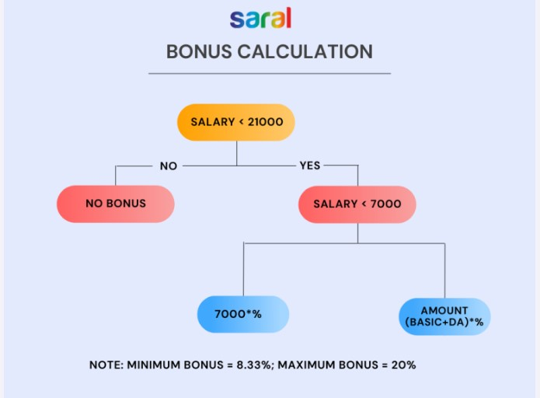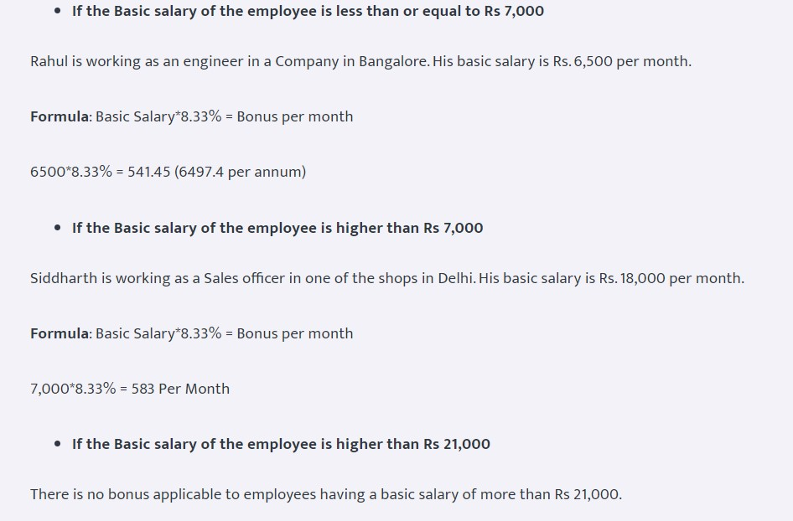

Statutory compliance:
Retention
Objective: The objective of this SOP is to establish guidelines and procedures to effectively identify, address, and manage factors contributing to employee turnover, with the goal of improving retention rates within the organization.
Scope: This SOP applies to HR personnel, managers, supervisors, and individuals responsible for identifying retention issues and implementing strategies to improve employee retention.
Responsibilities:
- HR Department/Retention Committee: Responsible for overseeing retention strategies, analyzing data, and implementing retention initiatives.
- Managers/Supervisors: Responsible for identifying retention risks within their teams, addressing concerns, and supporting retention efforts.
- Employees: Responsible for providing feedback and actively participating in programs designed to improve retention.
Procedure:
1. Retention Risk Identification:
a. Analyze data and metrics to identify trends and patterns related to employee turnover.
b. Conduct exit interviews and surveys to understand reasons for employee departures and gather feedback.
2. Identification of Retention Factors:
a. Identify factors contributing to employee turnover (e.g., lack of growth opportunities, work-life balance issues, compensation concerns).
b. Prioritize retention factors based on their impact and frequency.
3. Development of Retention Strategies:
a. Develop a range of retention strategies targeting identified factors, such as career development programs, flexible work arrangements, or enhanced benefits.
b. Customize strategies to address specific needs of different employee segments.
4. Implementation of Retention Initiatives:
a. Communicate and promote retention initiatives across the organization, emphasizing their importance and benefits.
b. Ensure proper training, resources, and support are provided for successful implementation.
5. Measurement and Evaluation:
a. Establish metrics and key performance indicators (KPIs) to measure the effectiveness of retention initiatives.
b. Regularly evaluate the success of retention strategies and make adjustments as needed.
6. Employee Engagement and Communication:
a. Foster open communication channels for employees to voice their concerns and provide feedback.
b. Encourage employee engagement through regular meetings, feedback sessions, and suggestion forums.
7. Leadership Support and Involvement:
a. Encourage leadership to support and actively participate in retention efforts.
b. Train managers on retention strategies and their role in fostering a positive work environment.
8. Talent Development and Career Growth:
a. Provide opportunities for skill development and career advancement to encourage employee growth and loyalty.
b. Offer mentorship programs, training sessions, and clear career paths.
9. Exit Interview Analysis and Action Plan:
a. Analyze exit interview data regularly to identify recurring issues and develop action plans to address them.
b. Implement changes based on the findings to prevent future attrition.
10. Revision and Approval of SOP:
a. Regularly review and update this SOP to align with changes in retention strategies, employee feedback, or industry best practices.
b. Obtain approval from relevant stakeholders for any revisions made to the SOP.

KPI governance process
Objective: The objective of this SOP is to establish guidelines and procedures to ensure effective governance practices are implemented and maintained across the organization, aligning with regulatory requirements and organizational goals.
Scope: This SOP applies to all employees, management, board members, and individuals responsible for overseeing and implementing governance processes within the organization.
Responsibilities:
- Board of Directors/Governance Committee: Responsible for setting governance policies, overseeing compliance, and strategic decision-making.
- Executive Leadership/Management: Responsible for implementing governance processes and ensuring compliance across departments.
- Employees: Responsible for adhering to governance policies and procedures relevant to their roles.
Procedure:
1. Governance Framework Establishment:
a. Establish a governance framework that defines the structure, roles, responsibilities, and decision-making processes within the organization.
b. Ensure alignment of the governance framework with legal and regulatory requirements, industry standards, and organizational objectives.
2. Policy Development and Documentation:
a. Develop and document governance policies covering areas such as ethics, compliance, risk management, data security, and financial reporting.
b. Clearly outline policy guidelines, procedures, and expectations for adherence.
3. Communication and Training:
a. Communicate governance policies, procedures, and updates to all employees, emphasizing their importance and implications.
b. Conduct regular training sessions to ensure employees understand and comply with governance requirements.
4. Compliance Monitoring and Oversight:
a. Establish mechanisms for monitoring and evaluating compliance with governance policies and procedures.
b. Conduct periodic audits and assessments to identify gaps and areas for improvement.
5. Risk Management and Mitigation:
a. Implement risk management practices to identify, assess, and mitigate risks associated with governance lapses.
b. Develop contingency plans and measures to address identified risks.
6. Reporting and Accountability:
a. Establish reporting mechanisms for tracking and reporting governance-related issues, incidents, and compliance status.
b. Hold accountable individuals or departments responsible for non-compliance or governance breaches.
7. Review and Update Processes:
a. Regularly review and update governance processes to adapt to changing regulatory requirements and industry best practices.
b. Incorporate feedback and lessons learned from incidents or audits into the governance framework.
8. Continuous Improvement:
a. Encourage a culture of continuous improvement by seeking feedback and suggestions for enhancing governance practices.
b. Benchmark against industry standards and best practices to enhance governance effectiveness.
9. Revision and Approval of SOP:
a. Regularly review and update this SOP to align with changes in governance practices, regulatory landscape, or organizational needs.
b. Obtain approval from relevant stakeholders for any revisions made to the SOP.

Program for process certification test
Objective: The objective of this SOP is to establish guidelines and procedures to conduct a standardized process certification test, ensuring the accuracy, consistency, and reliability of the assessment.
Scope: This SOP applies to individuals involved in designing, conducting, and evaluating process certification tests within the organization.
Responsibilities:
- Test Design Team: Responsible for designing the certification test, including defining criteria and assessment methods.
- Test Administrators/Evaluators: Responsible for administering the test, evaluating results, and providing feedback to candidates.
- Employees/Participants: Responsible for undergoing the certification test and complying with the test procedures.
Procedure:
1. Test Design and Preparation:
a. Define the objectives, scope, and criteria for the process certification test in line with organizational standards and requirements.
b. Develop a detailed test plan outlining the structure, format, and assessment methods to be used.
2. Candidate Eligibility and Registration:
a. Determine eligibility criteria for candidates to participate in the certification test.
b. Establish a registration process and communicate the requirements and deadlines to potential candidates.
3. Test Administration:
a. Arrange for a suitable test environment, including necessary tools, equipment, and resources.
b. Conduct the certification test according to the defined procedures and timeframes.
4. Evaluation and Assessment:
a. Use standardized assessment methods to evaluate candidates' performance based on predetermined criteria.
b. Ensure fairness and consistency in evaluating each candidate's test results.
5. Result Compilation and Feedback:
a. Compile test results accurately and maintain confidentiality of individual candidate scores.
b. Provide constructive feedback to candidates, highlighting strengths and areas for improvement.
6. Certification Decision:
a. Review the test results and determine whether candidates meet the established certification standards.
b. Grant certification to candidates who meet or exceed the required performance criteria.
7. Documentation and Records:
a. Maintain comprehensive records of the certification test process, including candidate details, test results, and evaluations.
b. Store documentation securely for future reference or audits.
8. Continuous Improvement:
a. Conduct regular reviews of the certification test process to identify areas for improvement.
b. Incorporate feedback from candidates and evaluators to enhance the test's effectiveness.
9. Revision and Approval of SOP:
a. Regularly review and update this SOP to align with changes in test methodologies, industry standards, or organizational needs.
b. Obtain approval from relevant stakeholders for any revisions made to the SOP.

KPI overtime management
Objective: The objective of this SOP is to establish guidelines and procedures to effectively manage, authorize, and compensate for overtime work while ensuring compliance with labor laws and organizational policies.
Scope: This SOP applies to all employees, supervisors, managers, HR personnel, and individuals responsible for overseeing and managing overtime within the organization.
Responsibilities:
- HR Department/HR Manager: Responsible for overseeing the implementation of overtime policies and ensuring compliance.
- Managers/Supervisors: Responsible for authorizing and managing overtime work within their respective teams.
- Employees: Responsible for adhering to the overtime policies and accurately recording their working hours.
Procedure:
1. Establish Overtime Policies:
a. Define the organization's policies and guidelines for overtime, including eligibility criteria, approval process, and compensation rates.
b. Ensure policies comply with labor laws, collective agreements, and industry standards.
2. Communication and Awareness:
a. Communicate overtime policies clearly to all employees, emphasizing the procedures for requesting, authorizing, and recording overtime hours.
b. Provide training or guidance on how to accurately report overtime worked.
3. Authorization of Overtime:
a. Require employees to obtain prior authorization from their supervisors or managers before working overtime hours.
b. Implement a clear process for obtaining authorization, including the circumstances under which overtime can be approved.
4. Recording and Documentation:
a. Instruct employees to accurately record their overtime hours using the organization's designated timekeeping system or method.
b. Maintain detailed records of authorized overtime, including dates, hours worked, reasons, and approvals.
5. Compensation and Benefits:
a. Ensure employees are compensated for overtime hours in accordance with the organization's policies and applicable laws.
b. Clearly outline the method of compensation (e.g., overtime pay, time off in lieu) and rates for overtime work.
6. Monitoring and Control:
a. Monitor overtime hours regularly to identify any trends or excessive overtime patterns.
b. Address any concerns or issues related to excessive or unauthorized overtime promptly.
7. Review and Approval of Overtime:
a. Review and approve submitted overtime hours by employees in accordance with the established procedures.
b. Verify the accuracy of reported hours before approving for compensation.
8. Compliance and Audit:
a. Conduct periodic audits to ensure compliance with overtime policies and regulations.
b. Address any non-compliance issues identified during audits promptly.
9. Continuous Improvement:
a. Gather feedback from employees and managers to improve the effectiveness of the overtime management process.
b. Update policies and procedures as necessary based on feedback and changing organizational needs.
10. Revision and Approval of SOP:
a. Regularly review and update this SOP to align with changes in labor laws, organizational policies, or industry best practices.
b. Obtain approval from relevant stakeholders for any revisions made to the SOP.
Labourers must be paid at the rate of Rs. 100/ hour basis
Staffs must be paid at the rate of Rs. /- hour basis

Technology management:
It management
Objective: The objective of this SOP is to establish guidelines and procedures to ensure the effective management, maintenance, and security of the organization's IT infrastructure and systems.
Scope: This SOP applies to the IT department, IT administrators, support staff, and all employees who use the organization's IT resources.
Responsibilities:
- IT Manager/IT Head: Responsible for overseeing IT operations, strategy, and implementation.
- IT Administrators/Support Staff: Responsible for maintaining, troubleshooting, and securing IT systems.
- Employees: Responsible for following IT policies and guidelines set by the IT department.
Procedure:
1. IT Infrastructure Maintenance:
a. Regularly monitor and maintain hardware, software, networks, and servers to ensure optimal performance.
b. Establish a schedule for system updates, patches, and backups to minimize downtime and data loss.
2. Help Desk and Support Services:
a. Set up a centralized help desk for addressing IT-related issues and requests from employees.
b. Develop procedures for logging, prioritizing, and resolving support tickets efficiently.
3. Security Measures and Protocols:
a. Implement robust cybersecurity measures, including firewalls, antivirus software, and regular security audits.
b. Educate employees on cybersecurity best practices and conduct periodic training sessions.
4. IT Asset Management:
a. Maintain an inventory of IT assets, including hardware, software licenses, and peripherals.
b. Implement procedures for tracking, updating, and retiring IT assets as per the organization's policies.
5. Disaster Recovery and Business Continuity:
a. Develop and maintain a comprehensive disaster recovery plan to mitigate IT-related disruptions.
b. Regularly test the disaster recovery plan and update it based on test results and changing needs.
6. Data Management and Compliance:
a. Establish protocols for data storage, access, and backup to ensure data integrity and security.
b. Ensure compliance with data protection laws, industry regulations, and organizational policies.
7. Change Management:
a. Implement a change management process to evaluate and approve IT changes and updates.
b. Document changes made to IT systems and conduct impact assessments before implementation.
8. IT Governance and Policies:
a. Develop and enforce IT policies covering areas such as acceptable use, access control, and data privacy.
b. Ensure policies are communicated effectively and regularly reviewed and updated.
9. Vendor Management:
a. Manage relationships with IT vendors and service providers to ensure quality service and support.
b. Evaluate vendor contracts and agreements regularly for compliance and cost-effectiveness.
10. Documentation and Reporting:
a. Maintain detailed documentation of IT procedures, configurations, and incidents.
b. Generate regular reports on IT performance, security status, and compliance.
11. Continuous Improvement:
a. Conduct regular assessments and gather feedback to identify areas for IT improvement.
b. Update procedures, systems, and policies based on assessments and emerging technologies.
12. Revision and Approval of SOP:
a. Regularly review and update this SOP to align with changes in technology, security threats, and organizational needs.
b. Obtain approval from relevant stakeholders for any revisions made to the SOP.

It asset procurement
Objective: The objective of this SOP is to establish guidelines and procedures to efficiently procure, deploy, and manage IT assets while ensuring compliance with organizational policies and budgetary constraints.
Scope: This SOP applies to the IT department, procurement team, finance department, and individuals involved in the procurement and management of IT assets.
Responsibilities:
- IT Department/IT Manager: Responsible for assessing IT needs, preparing requisitions, and overseeing asset deployment.
- Procurement Team: Responsible for sourcing, evaluating suppliers, negotiating contracts, and purchasing IT assets.
- Finance Department: Responsible for budget allocation, approval, and tracking of IT asset expenditures.
Procedure:
1. Assess IT Requirements:
a. Collaborate with various departments to determine IT asset needs and specifications.
b. Prepare a detailed list of required IT assets based on business requirements and technology trends.
2. Budget Planning and Approval:
a. Estimate the budget required for procuring the identified IT assets.
b. Obtain necessary approvals from the finance department or relevant stakeholders for budget allocation.
3. Vendor Selection and Evaluation:
a. Research and identify potential vendors or suppliers for the required IT assets.
b. Evaluate vendors based on criteria such as quality, pricing, warranty, support, and delivery timelines.
4. Request for Proposal (RFP) or Quotation:
a. Prepare an RFP or RFQ (Request for Proposal/Quotation) outlining the specifications and requirements.
b. Issue the RFP/RFQ to selected vendors and collect proposals or quotations.
5. Evaluation and Selection:
a. Evaluate vendor proposals based on predetermined criteria and select the most suitable vendor.
b. Consider factors such as pricing, quality, warranty, service level agreements (SLAs), and vendor reputation.
6. Negotiation and Contracting:
a. Initiate negotiations with the selected vendor to finalize pricing, terms, and conditions.
b. Draft and sign a procurement contract outlining agreed-upon terms and deliverables.
7. Purchase Order Issuance:
a. Create and issue a purchase order (PO) to the selected vendor based on the agreed contract.
b. Ensure accuracy and completeness of information in the PO, including quantities, specifications, delivery timelines, and payment terms.
8. Receipt and Deployment:
a. Receive and inspect delivered IT assets to verify conformity with specifications and quality standards.
b. Coordinate with the IT department for proper deployment, installation, and configuration of the assets.
9. Asset Tracking and Documentation:
a. Maintain a centralized inventory and asset management system to track and manage IT assets.
b. Document asset details, including serial numbers, warranties, maintenance schedules, and locations.
10. Payment and Invoice Processing:
a. Process vendor invoices promptly upon successful receipt and verification of IT assets.
b. Ensure accuracy of invoices and compliance with agreed-upon payment terms.
11. Disposal and End-of-Life Management:
a. Establish procedures for the disposal or retirement of obsolete or end-of-life IT assets.
b. Ensure proper data wiping, recycling, or disposal in compliance with environmental regulations.
12. Review and Continuous Improvement:
a. Conduct periodic reviews of procurement processes and vendor performance.
b. Implement improvements based on feedback, emerging technologies, and changing business needs.
13. Revision and Approval of SOP:
a. Regularly review and update this SOP to align with changes in procurement practices, technology advancements, or organizational policies.
b. Obtain approval from relevant stakeholders for any revisions made to the SOP.

It asset maintenance calendar
Objective: The objective of this SOP is to establish guidelines and procedures to schedule, conduct, and document maintenance activities for IT assets within the organization.
Scope: This SOP applies to the IT department, IT asset managers, support staff, and anyone responsible for overseeing the maintenance of IT assets.
Responsibilities:
- IT Asset Manager/Coordinator: Responsible for planning, scheduling, and overseeing asset maintenance activities.
- IT Support Staff/Technicians: Responsible for performing maintenance tasks and ensuring compliance with the maintenance calendar.
- Department Heads/Users: Responsible for reporting issues promptly and cooperating during asset maintenance schedules.
Procedure:
1. Asset Inventory and Categorization:
a. Create and maintain a comprehensive inventory of all IT assets within the organization.
b. Categorize assets based on type, criticality, and maintenance requirements.
2. Maintenance Schedule Creation:
a. Develop a maintenance schedule/calendar based on asset types, manufacturer recommendations, and historical maintenance data.
b. Schedule regular preventive maintenance tasks for each asset category.
3. Maintenance Task Identification:
a. Identify specific maintenance tasks required for each type of IT asset (e.g., updates, patches, cleaning, hardware checks).
b. Define the frequency and duration of each maintenance task.
4. Resource Allocation:
a. Allocate necessary resources, including personnel, tools, and downtime, for conducting maintenance activities.
b. Ensure availability of spare parts or replacement components, if needed.
5. Maintenance Execution:
a. Execute planned maintenance tasks according to the predetermined schedule.
b. Document maintenance activities performed, including details of tasks completed, dates, and personnel involved.
6. Asset Performance Assessment:
a. Monitor asset performance before and after maintenance tasks to assess improvements or issues.
b. Record any anomalies or recurring issues discovered during maintenance.
7. Adherence to Manufacturer Guidelines:
a. Ensure that maintenance tasks adhere to manufacturer recommendations and warranty conditions.
b. Avoid activities that may void warranties or support agreements.
8. Documentation and Records:
a. Maintain detailed records of maintenance activities for each IT asset.
b. Document maintenance schedules, checklists, reports, and any issues encountered.
9. Compliance and Review:
a. Regularly review and evaluate the effectiveness of the maintenance schedule and tasks.
b. Ensure compliance with established schedules and make adjustments as necessary.
10. Continuous Improvement:
a. Gather feedback from IT technicians and users to identify areas for improvement in the maintenance process.
b. Update maintenance schedules or procedures based on feedback and emerging technologies.
11. Revision and Approval of SOP:
a. Regularly review and update this SOP to align with changes in technology, asset types, or maintenance best practices.
b. Obtain approval from relevant stakeholders for any revisions made to the SOP.

IT asset maintenance
Objective: The objective of this SOP is to establish guidelines and procedures for the maintenance and upkeep of all IT assets within the organization to ensure their optimal performance and longevity.
Scope: This SOP applies to the IT department, IT asset managers, support staff, and anyone involved in maintaining IT assets.
Responsibilities:
- IT Asset Manager/Coordinator: Responsible for overseeing the maintenance schedule and ensuring its execution.
- IT Support Staff/Technicians: Responsible for conducting maintenance tasks as per the schedule and reporting any issues.
- Department Heads/Users: Responsible for reporting asset issues promptly and cooperating during maintenance schedules.
Procedure:
1. Asset Identification and Categorization:
a. Create and maintain an updated inventory of all IT assets within the organization.
b. Categorize assets based on type, criticality, and maintenance requirements.
2. Maintenance Schedule Creation:
a. Develop a maintenance schedule/calendar based on asset types, manufacturer recommendations, and historical maintenance data.
b. Schedule routine preventive maintenance tasks for each category of assets.
3. Maintenance Task Identification:
a. Identify specific maintenance tasks required for each type of IT asset (e.g., updates, patches, cleaning, hardware checks).
b. Define the frequency and duration of each maintenance task.
4. Resource Allocation:
a. Allocate necessary resources, including personnel, tools, and downtime, for conducting maintenance activities.
b. Ensure availability of spare parts or replacement components, if needed.
5. Maintenance Execution:
a. Execute planned maintenance tasks according to the predetermined schedule.
b. Document maintenance activities performed, including details of tasks completed, dates, and personnel involved.
6. Asset Performance Assessment:
a. Monitor asset performance before and after maintenance tasks to assess improvements or issues.
b. Record any anomalies or recurring issues discovered during maintenance.
7. Adherence to Manufacturer Guidelines:
a. Ensure that maintenance tasks adhere to manufacturer recommendations and warranty conditions.
b. Avoid activities that may void warranties or support agreements.
8. Documentation and Records:
a. Maintain detailed records of maintenance activities for each IT asset.
b. Document maintenance schedules, checklists, reports, and any issues encountered.
9. Compliance and Review:
a. Regularly review and evaluate the effectiveness of the maintenance schedule and tasks.
b. Ensure compliance with established schedules and make adjustments as necessary.
10. Continuous Improvement:
a. Gather feedback from IT technicians and users to identify areas for improvement in the maintenance process.
b. Update maintenance schedules or procedures based on feedback and emerging technologies.
11. Revision and Approval of SOP:
a. Regularly review and update this SOP to align with changes in technology, asset types, or maintenance best practices.
b. Obtain approval from relevant stakeholders for any revisions made to the SOP.

It network upgradation management
Objective: The objective of this SOP is to establish guidelines and procedures to effectively plan, implement, and document the upgrade of the organization's IT network infrastructure.
Scope: This SOP applies to the IT department, network administrators, support staff, and anyone involved in planning and executing network upgrades.
Responsibilities:
- IT Manager/Coordinator: Responsible for overseeing and coordinating the network upgrade process.
- Network Administrators/Technicians: Responsible for executing the upgrade tasks and ensuring smooth transition.
- Department Heads/Users: Responsible for cooperating during the upgrade process and reporting any issues.
Procedure:
1. Assessment and Planning:
a. Conduct a comprehensive assessment of the current network infrastructure, identifying areas that need upgrading.
b. Define the objectives, scope, and goals of the network upgrade.
2. Requirement Gathering:
a. Gather requirements for the upgraded network infrastructure, considering bandwidth, security, scalability, and technology advancements.
b. Consult with stakeholders to understand specific departmental needs and future growth projections.
3. Design and Solution Identification:
a. Develop a network upgrade plan that includes hardware, software, security measures, and data migration strategies.
b. Identify suitable network solutions or vendors based on requirements and budget constraints.
4. Testing and Prototyping:
a. Set up a testing environment to prototype the proposed network upgrades and configurations.
b. Conduct thorough testing to ensure compatibility, performance, and security of the new network setup.
5. Risk Assessment and Mitigation:
a. Identify potential risks and challenges associated with the network upgrade.
b. Develop contingency plans to mitigate risks and address potential disruptions during the upgrade.
6. Communication and User Notification:
a. Communicate the planned network upgrade to all stakeholders, including affected departments or users.
b. Provide clear instructions and timelines to minimize disruptions and ensure cooperation during the upgrade.
7. Implementation and Execution:
a. Schedule the upgrade during off-peak hours to minimize impact on operations.
b. Execute the upgrade process according to the planned schedule and procedures.
8. Monitoring and Testing:
a. Monitor the upgrade process in real-time to identify and resolve any issues or discrepancies.
b. Conduct post-upgrade testing and validation to ensure the network is functioning as intended.
9. Documentation and Reporting:
a. Document all steps taken during the upgrade, including configurations, changes made, and issues encountered.
b. Generate a comprehensive report detailing the upgrade process, outcomes, and any follow-up actions needed.
10. User Training and Support:
a. Provide training sessions to users on any new features or changes in the upgraded network.
b. Offer post-upgrade support to address any user concerns or issues.
11. Evaluation and Review:
a. Evaluate the success of the network upgrade based on predefined objectives and performance metrics.
b. Conduct a review meeting to gather feedback from stakeholders and identify areas for improvement.
12. Revision and Approval of SOP:
a. Regularly review and update this SOP to align with changes in technology, network requirements, or upgrade best practices.
b. Obtain approval from relevant stakeholders for any revisions made to the SOP.

It security
Objective: The objective of this SOP is to establish guidelines and procedures to maintain and enhance the security of the organization's IT infrastructure, data, and systems.
Scope: This SOP applies to the IT department, security team, employees, and anyone accessing or managing the organization's IT assets.
Responsibilities:
- Chief Information Security Officer (CISO)/IT Security Manager: Responsible for overseeing the implementation and enforcement of IT security measures.
- IT Security Team/Personnel: Responsible for monitoring, implementing security protocols, and responding to security incidents.
- Employees/Users: Responsible for complying with IT security policies and reporting any security concerns.
Procedure:
1. Risk Assessment:
a. Conduct regular risk assessments to identify potential vulnerabilities and threats to the IT infrastructure.
b. Evaluate the impact and likelihood of identified risks to prioritize mitigation efforts.
2. Security Policy Development:
a. Develop comprehensive security policies covering areas such as data protection, access control, password management, etc.
b. Communicate and enforce security policies across the organization.
3. Access Control:
a. Implement role-based access controls (RBAC) to limit system access to authorized personnel only.
b. Regularly review and update access privileges based on job roles and responsibilities.
4. Network Security:
a. Install and maintain firewalls, intrusion detection systems, and encryption protocols to protect the network.
b. Monitor network traffic for suspicious activities and potential security breaches.
5. Endpoint Security:
a. Deploy antivirus software, endpoint protection tools, and secure configurations on all devices within the network.
b. Conduct regular updates and patches to mitigate vulnerabilities.
6. Incident Response Plan:
a. Develop a detailed incident response plan outlining steps to be taken in the event of a security breach.
b. Assign roles and responsibilities for incident response team members.
7. Security Awareness Training:
a. Provide regular security awareness training to employees on identifying and responding to security threats.
b. Educate users on best practices for handling sensitive information and avoiding social engineering attacks.
8. Regular Audits and Compliance Checks:
a. Conduct periodic security audits to ensure compliance with security standards and regulations.
b. Address any non-compliance issues promptly and implement corrective measures.
9. Data Backup and Recovery:
a. Establish a robust data backup strategy to ensure data integrity and availability in the event of a breach or disaster.
b. Test data recovery procedures regularly to verify their effectiveness.
10. Security Incident Reporting:
a. Implement a system for reporting security incidents promptly and accurately.
b. Document and analyze security incidents to identify patterns and improve security measures.
11. Continuous Improvement:
a. Gather feedback from security incidents, audits, and user experiences to enhance security measures continually.
b. Update security protocols, policies, and procedures based on emerging threats and best practices.
12. Revision and Approval of SOP:
a. Regularly review and update this SOP to align with changes in technology, security threats, or regulatory requirements.
b. Obtain approval from relevant stakeholders for any revisions made to the SOP.

SAP backup
Objective: The objective of this SOP is to establish guidelines and procedures to regularly back up and safeguard critical data within the SAP system.
Scope: This SOP applies to SAP administrators, IT personnel responsible for data backup, and anyone involved in managing SAP data.
Responsibilities:
- SAP Administrator/IT Personnel: Responsible for planning, executing, and verifying SAP data backups.
- System Users: Responsible for compliance with data backup policies and reporting issues promptly.
Procedure:
1. Backup Strategy Development:
a. Define a comprehensive backup strategy considering the criticality of data, system performance, and recovery objectives.
b. Determine the frequency of backups, types of backups (full, incremental), and retention periods.
2. Backup Types and Methodology:
a. Implement a combination of full and incremental backups to optimize storage and recovery times.
b. Select appropriate backup methods (offline, online, database-specific tools) based on SAP system requirements.
3. Schedule and Frequency:
a. Establish a regular backup schedule that minimizes disruptions to system operations (e.g., during off-peak hours).
b. Define backup frequencies for different data types and modules within the SAP system.
4. Data Backup Execution:
a. Execute full backups as per the defined schedule to capture the entire SAP system.
b. Perform incremental backups to capture changes since the last full backup.
5. Storage and Retention:
a. Store backup data in secure and redundant storage systems to prevent data loss in case of hardware failure or disasters.
b. Define retention policies for backups considering compliance requirements and operational needs.
6. Testing and Verification:
a. Regularly test backup integrity and validity to ensure successful data recovery.
b. Verify the recoverability of data from backups through periodic restore tests.
7. Monitoring and Alerts:
a. Implement monitoring tools to track backup processes and identify any failures or anomalies.
b. Set up alerts for backup failures or incomplete backups to enable immediate action.
8. Documentation and Reporting:
a. Maintain detailed documentation of backup schedules, procedures, and logs of backup activities.
b. Generate regular reports summarizing backup status, success rates, and any issues encountered.
9. Backup Verification and Auditing:
a. Periodically review and audit backup procedures to ensure compliance with policies and standards.
b. Conduct internal or external audits to validate the effectiveness of backup measures.
10. Disaster Recovery Plan:
a. Integrate backup strategies into the overall disaster recovery plan for the SAP system.
b. Ensure alignment between backup processes and recovery objectives in case of system failures or disasters.
11. Continuous Improvement:
a. Evaluate backup strategies regularly based on technological advancements and changing business requirements.
b. Update backup procedures and technologies to enhance data protection and recovery capabilities.
12. Revision and Approval of SOP:
a. Regularly review and update this SOP to align with changes in SAP configurations, backup technologies, or best practices.
b. Obtain approval from relevant stakeholders for any revisions made to the SOP.

It backup
Objective: The objective of this SOP is to establish guidelines and procedures for systematically backing up critical data and ensuring its availability in the event of data loss or system failure.
Scope: This SOP applies to IT personnel, system administrators, and anyone involved in managing and executing data backups.
Responsibilities:
- IT Manager/Coordinator: Responsible for overseeing the backup process and ensuring compliance with backup policies.
- System Administrators/IT Personnel: Responsible for executing, monitoring, and verifying data backups.
- Department Heads/Users: Responsible for ensuring that critical data is identified and included in the backup process.
Procedure:
1. Data Identification and Prioritization:
a. Identify critical data, systems, databases, and applications that require regular backups.
b. Prioritize data based on importance, criticality, and business impact.
2. Backup Strategy Development:
a. Develop a comprehensive backup strategy outlining the frequency, types (full, incremental), and methods of backups.
b. Define backup retention periods and storage locations for different types of data.
3. Schedule and Frequency:
a. Establish a backup schedule that minimizes disruptions to daily operations (e.g., during off-peak hours).
b. Define backup frequencies based on data criticality and business requirements.
4. Backup Execution:
a. Execute regular full backups to capture entire systems or databases.
b. Perform incremental or differential backups to capture changes since the last full backup.
5. Storage and Retention:
a. Store backup data in secure and redundant storage systems to prevent data loss in case of failures.
b. Define retention policies ensuring compliance with legal/regulatory requirements and operational needs.
6. Testing and Verification:
a. Regularly test and verify the integrity and recoverability of backups.
b. Conduct periodic restore tests to ensure that data can be recovered effectively from backups.
7. Monitoring and Alerts:
a. Implement monitoring tools to track backup processes and identify any failures or deviations.
b. Set up alerts or notifications for backup failures or incomplete backups for immediate action.
8. Documentation and Reporting:
a. Maintain detailed documentation of backup schedules, procedures, logs, and reports of backup activities.
b. Generate regular reports summarizing backup status, success rates, and any issues encountered.
9. Auditing and Compliance:
a. Periodically audit backup procedures to ensure compliance with policies and standards.
b. Ensure that backups meet industry-specific regulations or compliance requirements.
10. Disaster Recovery Integration:
a. Integrate backup strategies into the overall disaster recovery plan of the organization.
b. Ensure alignment between backup processes and recovery objectives in case of system failures or disasters.
11. Continuous Improvement:
a. Review backup strategies regularly to incorporate technological advancements and evolving business needs.
b. Update backup procedures and technologies to enhance data protection and recovery capabilities.
12. Revision and Approval of SOP:
a. Regularly review and update this SOP to align with changes in technology, data types, or backup best practices.
b. Obtain approval from relevant stakeholders for any revisions made to the SOP.

Tally backup
Objective: The objective of this SOP is to establish guidelines and procedures to systematically back up and safeguard critical financial data managed within the Tally software.
Scope: This SOP applies to individuals responsible for financial data management, Tally administrators, and IT personnel involved in the backup process.
Responsibilities:
- Financial Data Manager/Tally Administrator: Responsible for overseeing Tally data backup and adherence to backup policies.
- System Administrators/IT Personnel: Responsible for executing, monitoring, and verifying Tally data backups.
- Department Heads/Users: Responsible for ensuring that critical financial data within Tally is identified and included in the backup process.
Procedure:
1. Data Identification and Prioritization:
a. Identify critical financial data managed within Tally, including ledgers, accounts, transactions, and reports.
b. Prioritize data based on importance, relevance, and regulatory requirements.
2. Backup Strategy Development:
a. Develop a backup strategy defining the frequency, types (full, incremental), and methods of Tally data backups.
b. Define backup retention periods and storage locations for different types of financial data.
3. Schedule and Frequency:
a. Establish a backup schedule that minimizes disruptions to financial operations (e.g., after business hours).
b. Define backup frequencies based on the criticality of financial data and business requirements.
4. Backup Execution:
a. Execute regular full backups of Tally data to ensure comprehensive data capture.
b. Perform incremental or differential backups as necessary to capture changes since the last full backup.
5. Storage and Retention:
a. Store Tally backup data in secure and redundant storage systems to prevent data loss in case of failures.
b. Define retention policies ensuring compliance with legal/regulatory requirements and operational needs.
6. Testing and Verification:
a. Regularly test and verify the integrity and recoverability of Tally backups.
b. Conduct periodic restore tests to ensure that financial data can be effectively recovered from backups.
7. Monitoring and Alerts:
a. Implement monitoring tools to track Tally backup processes and identify any failures or deviations.
b. Set up alerts or notifications for backup failures or incomplete backups for immediate action.
8. Documentation and Reporting:
a. Maintain detailed documentation of Tally backup schedules, procedures, logs, and reports of backup activities.
b. Generate regular reports summarizing backup status, success rates, and any issues encountered.
9. Auditing and Compliance:
a. Periodically audit backup procedures to ensure compliance with policies and standards.
b. Ensure that Tally backups meet industry-specific regulations or compliance requirements.
10. Disaster Recovery Integration:
a. Integrate Tally backup strategies into the overall disaster recovery plan of the organization.
b. Ensure alignment between backup processes and recovery objectives in case of financial data loss or system failures.
11. Continuous Improvement:
a. Review Tally backup strategies regularly to incorporate technological advancements and evolving financial needs.
b. Update backup procedures and technologies to enhance financial data protection and recovery capabilities.
12. Revision and Approval of SOP:
a. Regularly review and update this SOP to align with changes in technology, financial data requirements, or backup best practices.
b. Obtain approval from relevant stakeholders for any revisions made to the SOP.

Tally Backup should be taken on a daily basis at 6:00 pm

SAP management
Objective: The objective of this SOP is to establish guidelines and procedures for the effective management, maintenance, and optimization of SAP systems within the organization.
Scope: This SOP applies to SAP administrators, IT personnel responsible for SAP systems, and anyone involved in managing SAP environments.
Responsibilities:
- SAP Administrator/IT Manager: Responsible for overseeing SAP systems and ensuring compliance with SAP policies and procedures.
- System Administrators/IT Personnel: Responsible for executing, monitoring, and optimizing SAP systems.
- Department Heads/Users: Responsible for complying with SAP policies and reporting issues promptly.
Procedure:
1. SAP System Monitoring:
a. Implement tools and processes to continuously monitor SAP system performance, availability, and security.
b. Set up alerts and notifications for potential system issues or performance bottlenecks.
2. System Maintenance and Updates:
a. Develop a regular maintenance schedule for SAP systems to ensure optimal performance and security.
b. Plan and execute system updates, patches, and upgrades as recommended by SAP or based on organizational needs.
3. User Management:
a. Manage user access and permissions within the SAP system using role-based access controls (RBAC).
b. Ensure proper onboarding/offboarding procedures for user accounts and permissions.
4. Data Backup and Recovery:
a. Establish and maintain robust backup and recovery procedures for SAP databases and critical data.
b. Test data recovery procedures periodically to ensure their effectiveness.
5. Security and Compliance:
a. Implement security measures as per SAP best practices to protect against potential threats and vulnerabilities.
b. Ensure compliance with industry standards and regulations governing SAP systems.
6. Incident Response and Issue Resolution:
a. Develop an incident response plan for addressing SAP system failures, security breaches, or data loss.
b. Document and resolve issues promptly, following predefined protocols.
7. Performance Optimization:
a. Regularly analyze SAP system performance metrics and identify areas for improvement.
b. Optimize configurations, processes, and resources to enhance system performance.
8. Change Management:
a. Implement a structured change management process for implementing updates or making system changes.
b. Document all changes made to the SAP system for future reference.
9. Documentation and Reporting:
a. Maintain detailed documentation of SAP configurations, procedures, logs, and reports of system activities.
b. Generate regular reports summarizing system status, performance, and any issues encountered.
10. Disaster Recovery Planning:
a. Integrate SAP management strategies into the overall disaster recovery plan for the organization.
b. Ensure alignment between SAP system backups and recovery objectives in case of system failures or disasters.
11. Continuous Improvement:
a. Review SAP management strategies regularly to incorporate technological advancements and evolving business needs.
b. Update management procedures and technologies to enhance SAP system reliability and effectiveness.
12. Revision and Approval of SOP:
a. Regularly review and update this SOP to align with changes in SAP technology, organizational requirements, or best practices.
b. Obtain approval from relevant stakeholders for any revisions made to the SOP.

SAP document numbering - fiscal year
Objective: The objective of this SOP is to establish guidelines and procedures for managing document numbering within SAP modules in alignment with the fiscal year.
Scope: This SOP applies to SAP administrators, finance personnel, and anyone involved in managing document numbering within SAP modules.
Responsibilities:
- SAP Administrator/IT Manager: Responsible for overseeing SAP configurations and settings related to document numbering.
- Finance Personnel: Responsible for generating, managing, and verifying documents within SAP modules.
- Department Heads/Users: Responsible for complying with document numbering policies and procedures.
Procedure:
1. Understanding Fiscal Year Configuration:
a. Collaborate with finance and SAP teams to understand the organization's fiscal year settings and requirements.
b. Determine the start and end dates of the fiscal year within SAP modules.
2. Document Numbering Strategy:
a. Define a document numbering strategy that aligns with the fiscal year settings and organization's requirements.
b. Determine the format, structure, and prefixes/suffixes for document numbers related to fiscal periods.
3. SAP Customization for Fiscal Year Document Numbering:
a. Access SAP configuration settings relevant to document numbering (e.g., Finance, Materials Management modules).
b. Configure document number ranges and intervals specific to fiscal periods in alignment with the defined strategy.
4. Generation and Management of Fiscal Year Documents:
a. Create documents (e.g., invoices, purchase orders, financial reports) within SAP modules using the designated numbering scheme.
b. Ensure documents generated are correctly assigned sequential numbers as per the fiscal year settings.
5. Verification and Audit:
a. Regularly verify document numbering accuracy against the defined fiscal year settings.
b. Conduct periodic audits to ensure compliance with document numbering policies and alignment with fiscal periods.
6. Communication and Training:
a. Communicate the document numbering policy and procedures to relevant stakeholders.
b. Provide training sessions to users on generating and managing documents within SAP modules in accordance with fiscal year settings.
7. Error Handling and Corrections:
a. Establish protocols for handling document numbering errors or discrepancies.
b. Document and resolve numbering issues promptly following predefined protocols.
8. Continuous Improvement:
a. Collect feedback and insights from users to improve document numbering processes within SAP modules.
b. Periodically review and update document numbering strategies based on evolving needs or SAP updates.
9. Revision and Approval of SOP:
a. Regularly review and update this SOP to align with changes in fiscal year settings, SAP configurations, or best practices.
b. Obtain approval from relevant stakeholders for any revisions made to the SOP.

SAP document numbering - new location
Objective: The objective of this SOP is to establish guidelines and procedures for managing document numbering within SAP modules when adding a new business location or entity.
Scope: This SOP applies to SAP administrators, finance personnel, and anyone involved in managing document numbering within SAP modules for the new location.
Responsibilities:
- SAP Administrator/IT Manager: Responsible for overseeing SAP configurations and settings related to document numbering for new locations.
- Finance Personnel: Responsible for generating, managing, and verifying documents within SAP modules for the new location.
- Department Heads/Users: Responsible for complying with document numbering policies and procedures specific to the new location.
Procedure:
1. Assessment of Document Numbering Requirements:
a. Collaborate with stakeholders from the new location to understand specific document numbering requirements.
b. Determine document types, sequences, and any location-specific prefixes/suffixes for document numbers.
2. Configuration in SAP for New Location:
a. Access SAP configuration settings relevant to document numbering (e.g., Finance, Materials Management modules) for the new location.
b. Configure document number ranges and intervals specific to the new location based on the identified requirements.
3. Integration with Existing SAP System:
a. Ensure seamless integration of document numbering settings for the new location with the existing SAP system.
b. Verify that document numbering at the new location does not conflict with existing numbering structures.
4. Generation and Management of Location-Specific Documents:
a. Create documents (e.g., invoices, purchase orders, financial reports) within SAP modules using the designated numbering scheme for the new location.
b. Ensure documents generated at the new location are correctly assigned sequential numbers as per the established criteria.
5. Verification and Audit:
a. Regularly verify document numbering accuracy for the new location against the defined settings.
b. Conduct periodic audits to ensure compliance with document numbering policies specific to the new location.
6. Communication and Training:
a. Communicate the document numbering policy and procedures specific to the new location to relevant stakeholders.
b. Provide training sessions to users at the new location on generating and managing documents within SAP modules as per the established numbering scheme.
7. Error Handling and Corrections:
a. Establish protocols for handling document numbering errors or discrepancies at the new location.
b. Document and resolve numbering issues promptly following predefined protocols.
8. Continuous Improvement:
a. Collect feedback and insights from users at the new location to improve document numbering processes within SAP modules.
b. Periodically review and update document numbering strategies for the new location based on evolving needs or SAP updates.
9. Revision and Approval of SOP:
a. Regularly review and update this SOP for the new location to align with changes in requirements, SAP configurations, or best practices.
b. Obtain approval from relevant stakeholders for any revisions made to the SOP.

Business partner master management
Objective: The objective of this SOP is to establish guidelines and procedures for the creation, maintenance, and management of Business Partner Master data within SAP.
Scope: This SOP applies to SAP administrators, data management personnel, and anyone involved in handling Business Partner Master data.
Responsibilities:
- SAP Administrator/IT Manager: Responsible for overseeing SAP configurations related to Business Partner Master data.
- Data Management Personnel: Responsible for creating, updating, and maintaining Business Partner Master data within SAP.
- Department Heads/Users: Responsible for ensuring accurate and updated information for respective business partners.
Procedure:
1. Business Partner Data Creation:
a. Access SAP transaction codes (e.g., BP) to create new Business Partner Master records.
b. Gather accurate information, such as contact details, addresses, tax information, and relationship type (customer, vendor, etc.).
2. Data Validation and Entry:
a. Verify the accuracy and completeness of data before creating Business Partner Master records.
b. Enter data into the SAP system following standardized fields and formats.
3. Documenting Changes and Updates:
a. Maintain a log of changes made to Business Partner Master data, including creation, updates, or deletions.
b. Document reasons for changes and record the user responsible for making modifications.
4. Data Integrity and Consistency:
a. Ensure consistency in naming conventions, formats, and information representation across Business Partner records.
b. Implement data validation checks to maintain data integrity within SAP.
5. Authorization and Access Controls:
a. Establish role-based access controls to limit user access to Business Partner Master data.
b. Assign appropriate authorizations to users for creating, updating, or viewing Business Partner records.
6. Compliance and Data Security:
a. Ensure compliance with regulatory requirements and internal policies while handling Business Partner data.
b. Implement security measures to safeguard sensitive information stored in Business Partner records.
7. Regular Data Maintenance:
a. Periodically review and update Business Partner Master data to ensure accuracy and relevance.
b. Conduct data cleansing activities to remove duplicates, correct errors, and maintain data quality.
8. Documentation and Reporting:
a. Maintain comprehensive documentation of Business Partner Master data procedures and changes.
b. Generate reports on Business Partner data quality, updates, and any discrepancies identified.
9. Training and User Education:
a. Provide training sessions to users involved in managing Business Partner data within SAP.
b. Educate users on best practices, data entry standards, and adherence to data management protocols.
10. Review and Audit:
a. Periodically review Business Partner Master data management processes for optimization.
b. Conduct internal audits to ensure adherence to SOP and compliance with data management standards.
11. Revision and Approval of SOP:
a. Regularly review and update this SOP to align with changes in business requirements, SAP configurations, or data governance standards.
b. Obtain approval from relevant stakeholders for any revisions made to the SOP.

Item master management
Objective: The objective of this SOP is to establish guidelines and procedures for the creation, maintenance, and management of Item Master data within SAP.
Scope: This SOP applies to SAP administrators, inventory managers, data management personnel, and anyone involved in handling Item Master data.
Responsibilities:
- SAP Administrator/IT Manager: Responsible for overseeing SAP configurations related to Item Master data.
- Inventory Manager/Personnel: Responsible for creating, updating, and maintaining Item Master data within SAP.
- Department Heads/Users: Responsible for ensuring accurate and updated information for respective inventory items.
Procedure:
1. Item Master Data Creation:
a. Access SAP transaction codes (e.g., MM01) to create new Item Master records.
b. Gather accurate information, such as item descriptions, codes, categories, units of measure, pricing details, and any relevant specifications.
2. Data Validation and Entry:
a. Verify the accuracy and completeness of data before creating Item Master records.
b. Enter data into the SAP system following standardized fields and formats.
3. Documenting Changes and Updates:
a. Maintain a log of changes made to Item Master data, including creation, updates, or deletions.
b. Document reasons for changes and record the user responsible for making modifications.
4. Data Integrity and Consistency:
a. Ensure consistency in naming conventions, categorizations, and specifications across Item Master records.
b. Implement data validation checks to maintain data integrity within SAP.
5. Authorization and Access Controls:
a. Establish role-based access controls to limit user access to Item Master data.
b. Assign appropriate authorizations to users for creating, updating, or viewing Item Master records.
6. Compliance and Data Security:
a. Ensure compliance with regulatory requirements and internal policies while handling Item Master data.
b. Implement security measures to safeguard sensitive information stored in Item Master records.
7. Regular Data Maintenance:
a. Periodically review and update Item Master data to ensure accuracy, relevance, and consistency.
b. Conduct data cleansing activities to remove duplicates, correct errors, and maintain data quality.
8. Documentation and Reporting:
a. Maintain comprehensive documentation of Item Master data procedures and changes.
b. Generate reports on Item Master data quality, updates, and any discrepancies identified.
9. Training and User Education:
a. Provide training sessions to users involved in managing Item Master data within SAP.
b. Educate users on best practices, data entry standards, and adherence to data management protocols.
10. Review and Audit:
a. Periodically review Item Master data management processes for optimization.
b. Conduct internal audits to ensure adherence to SOP and compliance with data management standards.
11. Revision and Approval of SOP:
a. Regularly review and update this SOP to align with changes in business requirements, SAP configurations, or data governance standards.
b. Obtain approval from relevant stakeholders for any revisions made to the SOP.

User master management
Objective: The objective of this SOP is to establish guidelines and procedures for the creation, maintenance, and management of User Master data within SAP.
Scope: This SOP applies to SAP administrators, IT personnel, and anyone involved in managing User Master data and user access rights.
Responsibilities:
- SAP Administrator/IT Manager: Responsible for overseeing SAP configurations related to User Master data.
- IT Personnel/User Administrators: Responsible for creating, updating, and maintaining User Master data within SAP.
- Department Heads/Users: Responsible for ensuring appropriate access rights for their team members.
Procedure:
1. User Master Data Creation:
a. Access SAP transaction codes (e.g., SU01) to create new User Master records.
b. Gather accurate information, such as user IDs, names, roles, authorizations, and department affiliations.
2. Authorization and Access Rights:
a. Define access rights and permissions based on user roles and responsibilities within the organization.
b. Assign appropriate authorizations to users ensuring compliance with security and segregation of duties.
3. Documenting Changes and Updates:
a. Maintain a log of changes made to User Master data, including creation, updates, or deletions.
b. Document reasons for changes and record the user responsible for making modifications.
4. User Access Review:
a. Conduct periodic reviews of user access rights to ensure alignment with job roles and organizational changes.
b. Verify and update access permissions as necessary based on changing requirements.
5. Security Measures and Compliance:
a. Implement security measures to safeguard User Master data and prevent unauthorized access.
b. Ensure compliance with security protocols, data privacy regulations, and internal policies.
6. Regular Data Maintenance:
a. Periodically review and update User Master data to reflect changes in user roles or responsibilities.
b. Deactivate or remove user accounts promptly upon employee exits or role changes.
7. Documentation and Reporting:
a. Maintain comprehensive documentation of User Master data procedures and access rights.
b. Generate reports on user access, permissions, and any discrepancies identified during audits.
8. Training and User Education:
a. Provide training sessions to users on security protocols, access rights, and adherence to data management policies.
b. Educate users on best practices for secure login credentials and data access within SAP.
9. Review and Audit:
a. Periodically review User Master data management processes for optimization and compliance.
b. Conduct internal audits to ensure adherence to SOP and compliance with data security standards.
10. Revision and Approval of SOP:
a. Regularly review and update this SOP to align with changes in business requirements, SAP configurations, or data governance standards.
b. Obtain approval from relevant stakeholders for any revisions made to the SOP.

Software development
Objective: The objective of this SOP is to establish guidelines and procedures for efficient and quality-centric software development.
Scope: This SOP applies to software development teams, including developers, testers, project managers, and stakeholders involved in the software development lifecycle.
Responsibilities:
- Project Manager/Team Lead: Responsible for overseeing the software development process and ensuring adherence to SOP.
- Developers/Programmers: Responsible for coding and developing the software as per defined requirements and standards.
- Testers/QA Team: Responsible for testing the software to identify and report bugs or issues.
- Stakeholders: Responsible for providing requirements, feedback, and approvals at various stages of development.
Procedure:
1. Requirement Gathering and Analysis:
a. Collaborate with stakeholders to gather and document software requirements.
b. Analyze requirements to ensure clarity, feasibility, and alignment with business objectives.
2. Design and Planning:
a. Create a comprehensive software design document based on the gathered requirements.
b. Plan the development process, including timelines, milestones, and resource allocation.
3. Development Process:
a. Follow coding standards and best practices during software development.
b. Use version control systems for code management and collaboration (e.g., Git).
4. Code Review and Testing:
a. Conduct code reviews to ensure code quality, readability, and adherence to standards.
b. Perform unit testing to identify and rectify any issues at an early stage.
5. Integration and System Testing:
a. Integrate individual components/modules to form a complete system.
b. Perform system testing to verify functionality, performance, and compatibility.
6. Bug Fixing and Iterative Development:
a. Document and prioritize identified bugs and issues.
b. Address and fix reported issues through iterative development cycles.
7. Quality Assurance:
a. Conduct comprehensive quality assurance (QA) testing to validate software functionality and performance.
b. Document test cases, results, and any discovered defects.
8. User Acceptance Testing (UAT):
a. Collaborate with end-users to perform UAT.
b. Gather feedback and make necessary adjustments before finalizing the software.
9. Documentation and Deployment:
a. Prepare detailed documentation including user manuals, installation guides, and release notes.
b. Deploy the software following a controlled and documented process.
10. Maintenance and Support:
a. Establish protocols for software maintenance, updates, and support.
b. Provide ongoing support and address post-deployment issues promptly.
11. Review and Improvement:
a. Conduct post-project reviews to identify successes and areas for improvement.
b. Update the SOP based on lessons learned and evolving industry standards.
12. Revision and Approval of SOP:
a. Regularly review and update this SOP to align with changes in technology, best practices, or organizational needs.
b. Obtain approval from relevant stakeholders for any revisions made to the SOP.

Salesforce app
Objective: The objective of this SOP is to establish guidelines and procedures for the development, deployment, and maintenance of a Salesforce app.
Scope: This SOP applies to Salesforce administrators, developers, and stakeholders involved in the lifecycle management of the Salesforce app.
Responsibilities:
- Salesforce Administrator: Responsible for overseeing app configurations and permissions.
- Developers: Responsible for coding, testing, and deploying the Salesforce app.
- Project Manager/Stakeholders: Responsible for providing requirements, approvals, and feedback.
Procedure:
1. Requirement Gathering:
a. Collaborate with stakeholders to gather app requirements and document them thoroughly.
b. Analyze and refine requirements to ensure clarity and feasibility.
2. Design and Planning:
a. Create a design document outlining the app's structure, modules, and functionalities.
b. Plan the development process, including timelines, milestones, and resource allocation.
3. Development Process:
a. Develop the app following Salesforce best practices and coding standards.
b. Use Salesforce development tools (e.g., Salesforce DX, Apex, Lightning Web Components) for coding.
4. Testing:
a. Perform unit testing to validate individual app components.
b. Conduct integration testing to ensure seamless integration with existing Salesforce functionalities.
5. User Acceptance Testing (UAT):
a. Collaborate with end-users to conduct UAT and gather feedback.
b. Address reported issues and incorporate necessary changes.
6. Documentation:
a. Prepare comprehensive documentation including user guides, app functionalities, and support resources.
b. Create release notes documenting changes and updates made to the app.
7. Deployment:
a. Deploy the app following Salesforce best practices and guidelines.
b. Ensure proper version control and rollback strategies during deployment.
8. User Training:
a. Provide training sessions to users on how to use the new app effectively.
b. Offer ongoing support and resources for app-related queries.
9. Monitoring and Maintenance:
a. Monitor app performance and user feedback after deployment.
b. Schedule regular maintenance to address bugs, updates, and enhancements.
10. Security and Compliance:
a. Ensure the app complies with Salesforce security standards and data protection regulations.
b. Regularly review and update security configurations based on security best practices.
11. Review and Improvement:
a. Conduct post-deployment reviews to gather insights and identify areas for improvement.
b. Implement improvements and updates to enhance the app's functionality and user experience.
12. SOP Revision and Approval:
a. Periodically review and update this SOP to align with changes in Salesforce updates, industry standards, or organizational needs.
b. Obtain approval from relevant stakeholders for any revisions made to the SOP.

Location management
Objective: The objective of this SOP is to establish guidelines and procedures for the management and maintenance of physical or digital locations within an organization.
Scope: This SOP applies to facilities managers, administrators, and personnel responsible for overseeing locations within the organization.
Responsibilities:
- Facilities Manager/Location Administrators: Responsible for managing and maintaining locations.
- Support Staff/Personnel: Responsible for reporting issues and supporting location maintenance.
Procedure:
1. Location Setup:
a. Document details of each location, including address, facilities, infrastructure, and any specific requirements.
b. Assign a unique identifier or code to each location for easy reference and management.
2. Maintenance and Inspection:
a. Schedule regular inspections and maintenance for each location, considering safety, cleanliness, and functionality.
b. Document inspection reports and maintenance schedules for each location.
3. Reporting and Issue Resolution:
a. Establish a reporting mechanism for staff to report issues or concerns related to locations.
b. Create a protocol for addressing reported issues promptly and effectively.
4. Security and Access Control:
a. Implement access controls and security measures as per the location's requirements.
b. Regularly review access permissions and security protocols for each location.
5. Compliance and Regulations:
a. Ensure that each location complies with local regulations, safety standards, and accessibility requirements.
b. Maintain records of compliance checks and necessary certifications.
6. Emergency Response and Preparedness:
a. Develop and communicate emergency response plans specific to each location.
b. Conduct drills and training sessions to ensure staff readiness during emergencies.
7. Documentation and Records Management:
a. Maintain organized records for each location, including leases, contracts, maintenance logs, and inspection reports.
b. Document any changes or modifications made to the locations.
8. Communication and Coordination:
a. Facilitate communication channels between location managers and support staff.
b. Coordinate activities and updates among different departments related to location management.
9. Vendor and Supplier Management:
a. Manage relationships with vendors and suppliers providing services or goods to different locations.
b. Ensure timely payments and quality service delivery.
10. Review and Improvement:
a. Conduct periodic reviews of location management processes to identify improvements.
b. Implement necessary changes to enhance efficiency and effectiveness in managing locations.
11. SOP Revision and Approval:
a. Regularly review and update this SOP to align with changes in regulations, best practices, or organizational needs.
b. Obtain approval from relevant stakeholders for any revisions made to the SOP.

System enhancement
Objective: The objective of this SOP is to establish guidelines and procedures for planning, developing, and implementing enhancements to an existing system.
Scope: This SOP applies to system administrators, developers, project managers, and stakeholders involved in system enhancement processes.
Responsibilities:
- Project Manager/Team Lead: Responsible for overseeing the enhancement process and ensuring adherence to SOP.
- Developers/Programmers: Responsible for coding, testing, and implementing system enhancements.
- Stakeholders: Responsible for providing requirements, approvals, and feedback.
Procedure:
1. Requirement Gathering:
a. Collaborate with stakeholders to gather enhancement requirements and document them thoroughly.
b. Analyze and prioritize requirements based on business impact and feasibility.
2. Impact Analysis and Planning:
a. Conduct an impact analysis to assess the effects of proposed enhancements on the existing system.
b. Plan the enhancement process, including timelines, resources, and risk assessment.
3. Development Process:
a. Develop enhancements following coding standards, best practices, and system architecture guidelines.
b. Use version control systems to manage changes and collaboration among developers.
4. Testing:
a. Perform thorough testing of enhancements in a controlled environment.
b. Conduct various testing phases, including unit testing, integration testing, and user acceptance testing (UAT).
5. Review and Feedback:
a. Share the enhancements with stakeholders for review and feedback.
b. Incorporate feedback and make necessary adjustments based on received inputs.
6. Documentation:
a. Prepare comprehensive documentation outlining the new features, changes, and functionalities.
b. Create user guides or manuals for stakeholders and end-users to understand the enhancements.
7. Deployment:
a. Plan a deployment strategy considering potential system downtime and user impact.
b. Deploy enhancements following a controlled and documented process.
8. User Training and Support:
a. Provide training sessions to users on utilizing the new features effectively.
b. Offer ongoing support and resources for users to address queries or issues post-deployment.
9. Monitoring and Evaluation:
a. Monitor the performance and stability of the enhanced system after deployment.
b. Gather feedback and conduct post-implementation reviews to assess the success of the enhancements.
10. Maintenance and Updates:
a. Schedule regular maintenance to address any post-implementation issues or bugs.
b. Plan for future updates and iterations based on evolving requirements.
11. SOP Revision and Approval:
a. Periodically review and update this SOP to align with changes in technology, best practices, or organizational needs.
b. Obtain approval from relevant stakeholders for any revisions made to the SOP.

Server maintenance and checklist
Objective: The objective of this SOP is to establish guidelines and procedures for the regular maintenance and upkeep of servers within the organization.
Scope: This SOP applies to system administrators, IT personnel, and those responsible for managing and maintaining servers.
Responsibilities:
- System Administrators/IT Personnel: Responsible for server maintenance, updates, and security.
- Technical Support Team: Responsible for performing maintenance tasks following the SOP guidelines.
Procedure:
1. Scheduled Maintenance:
a. Establish a regular maintenance schedule for servers, considering system requirements and business needs.
b. Plan maintenance windows during off-peak hours to minimize user disruption.
2. Backup Procedures:
a. Perform regular backups of server data and configurations.
b. Verify the integrity of backups and store them securely in a designated location.
3. Software Updates and Patch Management:
a. Regularly check for available updates, patches, and security fixes for server operating systems and applications.
b. Schedule and implement updates following a change management process.
4. Hardware Inspections:
a. Conduct routine physical inspections of server hardware for signs of wear, damage, or potential failures.
b. Document hardware inventory and track any changes or replacements.
5. Performance Monitoring:
a. Use monitoring tools to track server performance, resource utilization, and potential bottlenecks.
b. Analyze performance metrics to identify areas needing optimization.
6. Security Measures:
a. Implement security measures, including firewalls, antivirus software, and intrusion detection systems.
b. Regularly review and update security configurations to address potential vulnerabilities.
7. Disaster Recovery Planning:
a. Develop and maintain a disaster recovery plan for servers to ensure data recovery in case of emergencies.
b. Test the recovery process periodically to validate its effectiveness.
8. Documentation and Reporting:
a. Maintain detailed documentation of maintenance activities, including dates, tasks performed, and outcomes.
b. Generate reports summarizing server health, performance, and maintenance history.
Server Maintenance Checklist:
Use this checklist as a reference during server maintenance tasks:
- Backup Procedures:
  - Backup server data and configurations.
  - Verify backup integrity and storage.
- Software Updates:
  - Check for available updates for OS and applications.
  - Schedule and implement updates.
- Hardware Inspections:
  - Conduct physical inspections of server hardware.
  - Document hardware inventory and changes.
- Performance Monitoring:
  - Monitor server performance and resource utilization.
  - Identify areas for optimization.
- Security Measures:
  - Review and update security configurations.
  - Run security scans and checks.
- Disaster Recovery Planning:
  - Maintain and test disaster recovery plans.
- Documentation and Reporting:
  - Maintain detailed records of maintenance activities.
  - Generate reports summarizing server health and maintenance history.

Accounts management:
Bank guarantee
Objective: The objective of this SOP is to establish guidelines and procedures for the issuance, management, and release of bank guarantees.
Scope: This SOP applies to finance departments, authorized personnel, and individuals responsible for managing bank guarantees within the organization.
Responsibilities:
- Finance Department: Responsible for overseeing bank guarantee procedures, documentation, and compliance.
- Authorized Personnel: Responsible for initiating, approving, and monitoring bank guarantee transactions.
Procedure:
1. Bank Guarantee Initiation:
a. Identify the need for a bank guarantee based on contractual obligations or business requirements.
b. Prepare a formal request outlining the details and purpose of the bank guarantee.
2. Selection of Bank and Type of Guarantee:
a. Evaluate and select a reputable bank based on their ability to issue the required guarantee.
b. Determine the appropriate type of guarantee (e.g., performance, payment, bid) as per the contractual terms.
3. Application and Documentation:
a. Complete the bank's application form for the desired guarantee.
b. Compile all necessary documentation required by the bank, including contract details, financial statements, and authorization letters.
4. Bank Approval and Issuance:
a. Submit the application and required documents to the bank for processing.
b. Await approval from the bank and issuance of the guarantee instrument.
5. Record Keeping and Tracking:
a. Maintain a comprehensive record of all bank guarantees issued, including details of the issuing bank, guarantee amount, validity, and purpose.
b. Create a tracking system to monitor the status, expiry, and renewal dates of guarantees.
6. Compliance and Renewals:
a. Ensure compliance with all terms and conditions stipulated in the guarantee.
b. Monitor expiration dates and initiate renewal procedures as necessary.
7. Release or Discharge of Guarantee:
a. Upon fulfilling contractual obligations, request the release or discharge of the bank guarantee from the issuing bank.
b. Ensure proper documentation and follow the bank's procedures for guarantee release.
8. Reporting and Auditing:
a. Generate periodic reports detailing the status and utilization of bank guarantees.
b. Facilitate auditing processes by maintaining accurate and up-to-date records.
9. SOP Revision and Approval:
a. Periodically review and update this SOP to align with changes in banking regulations or organizational needs.
b. Obtain approval from relevant stakeholders for any revisions made to the SOP.

Letter of credit
Objective: The objective of this SOP is to establish guidelines and procedures for the issuance, management, and utilization of letters of credit (LC).
Scope: This SOP applies to finance departments, authorized personnel, and individuals responsible for handling letters of credit within the organization.
Responsibilities:
- Finance Department: Responsible for overseeing LC procedures, documentation, and compliance.
- Authorized Personnel: Responsible for initiating, approving, and monitoring LC transactions.
Procedure:
1. LC Initiation:
a. Identify the need for an LC based on trade transactions or business requirements.
b. Prepare a formal request outlining the details, terms, and purpose of the LC.
2. Selection of Banks and Type of LC:
a. Evaluate and select a suitable bank based on their capabilities in handling LCs.
b. Determine the appropriate type of LC (e.g., sight, usance, revocable, irrevocable) based on the transaction requirements.
3. Application and Documentation:
a. Complete the bank's application form for the desired LC.
b. Compile all necessary documentation required by the bank, including contracts, invoices, shipping documents, and authorization letters.
4. Bank Approval and Issuance:
a. Submit the LC application and required documents to the bank for processing.
b. Await approval from the bank and issuance of the LC instrument.
5. Record Keeping and Tracking:
a. Maintain a comprehensive record of all LCs issued, including details of the issuing bank, LC value, validity, terms, and purpose.
b. Create a tracking system to monitor the status, expiry, and utilization of LCs.
6. Compliance and Amendments:
a. Ensure compliance with all terms and conditions stipulated in the LC.
b. Manage any amendments or modifications to the LC terms as required by the involved parties.
7. Utilization and Presentation:
a. Present the required documents and comply with LC terms to claim payment or fulfill obligations.
b. Ensure timely presentation of complying documents to the bank for LC utilization.
8. Reporting and Auditing:
a. Generate periodic reports detailing the status, utilization, and performance of LCs.
b. Facilitate auditing processes by maintaining accurate and up-to-date records.
9. Closure or Discharge of LC:
a. Upon completion of the transaction or fulfillment of obligations, request the closure or discharge of the LC from the issuing bank.
b. Ensure proper documentation and follow the bank's procedures for LC closure.
10. SOP Revision and Approval:
a. Periodically review and update this SOP to align with changes in trade regulations or organizational needs.
b. Obtain approval from relevant stakeholders for any revisions made to the SOP.

Incoming payment
Objective: The objective of this SOP is to establish guidelines and procedures for receiving, recording, and processing incoming payments from customers or clients.
Scope: This SOP applies to finance departments, accounts receivable teams, and personnel responsible for handling incoming payments.
Responsibilities:
- Finance Department: Responsible for overseeing incoming payment procedures, reconciliation, and compliance.
- Accounts Receivable Team: Responsible for receiving, recording, and reconciling incoming payments.
Procedure:
1. Receipt of Payments:
a. Receive payments through designated channels (e.g., bank transfers, checks, online payments).
b. Verify payment details against invoices or transaction records.
2. Recording and Documentation:
a. Record incoming payments accurately in the accounting system or payment tracking tool.
b. Create receipts or transaction records for each payment received.
3. Reconciliation and Allocation:
a. Match received payments with corresponding invoices or accounts receivable entries.
b. Allocate payments to the appropriate customer accounts or invoices.
4. Handling Different Payment Methods:
a. Follow specific procedures for different payment methods (e.g., bank transfers, credit card payments, checks).
b. Ensure compliance with internal controls and banking regulations for each payment type.
5. Unapplied or Unidentified Payments:
a. Investigate and resolve unapplied or unidentified payments promptly.
b. Contact customers for additional information if payment details are unclear.
6. Currency and Exchange Rate Handling:
a. Handle foreign currency payments and consider exchange rate fluctuations.
b. Record and reconcile payments in the appropriate currency.
7. Bank Reconciliation:
a. Reconcile incoming payments with bank statements regularly.
b. Investigate and resolve discrepancies between recorded payments and bank statements.
8. Reporting and Documentation:
a. Generate reports detailing incoming payments, outstanding receivables, and payment trends.
b. Maintain detailed records of all payment transactions and reconciliation activities.
9. Compliance and Auditing:
a. Ensure compliance with accounting standards, internal policies, and regulatory requirements.
b. Facilitate auditing processes by providing accurate and complete documentation.
10. SOP Revision and Approval:
a. Periodically review and update this SOP to align with changes in payment methods, regulations, or organizational needs.
b. Obtain approval from relevant stakeholders for any revisions made to the SOP.

Bank reconciliation
Objective: The objective of this SOP is to establish guidelines and procedures for reconciling company financial records with bank statements to ensure accuracy and completeness.
Scope: This SOP applies to finance departments, accounting teams, or personnel responsible for bank reconciliation activities within the organization.
Responsibilities:
- Accounting Department: Responsible for overseeing bank reconciliation procedures, documentation, and compliance.
- Accounts Reconciliation Team: Responsible for performing bank reconciliations and resolving discrepancies.
Procedure:
1. Receipt of Bank Statements:
a. Retrieve monthly bank statements for all company accounts from respective banks.
b. Ensure the confidentiality and safekeeping of bank statements.
2. Recording Transactions:
a. Record all financial transactions (deposits, withdrawals, checks issued or received) in the company's accounting system.
b. Verify that transactions are accurately and promptly recorded.
3. Bank Reconciliation Process:
a. Compare the transactions recorded in the company's books with those in the bank statement.
b. Identify and mark off transactions that match between the company's records and the bank statement.
4. Investigation of Differences:
a. Investigate any discrepancies between the company's records and the bank statement.
b. Verify outstanding checks, deposits in transit, bank fees, and other differences.
5. Adjustments and Corrections:
a. Make necessary adjustments in the accounting records for any identified discrepancies.
b. Rectify errors or omissions in recording transactions promptly.
6. Reconciliation Completion:
a. Ensure that all reconciling items are accounted for and resolved.
b. Prepare a bank reconciliation report summarizing the differences and their resolutions.
7. Review and Approval:
a. Review the bank reconciliation report for accuracy and completeness.
b. Obtain approval from authorized personnel or supervisors.
8. Documentation and Filing:
a. Maintain detailed records of bank reconciliation reports and supporting documents.
b. Store reconciled bank statements and related records securely for auditing purposes.
9. Reporting and Compliance:
a. Generate periodic reports on completed bank reconciliations.
b. Ensure compliance with accounting standards and internal controls.
10. SOP Revision and Approval:
a. Periodically review and update this SOP to align with changes in banking procedures, regulations, or organizational needs.
b. Obtain approval from relevant stakeholders for any revisions made to the SOP.

Vendor invoice booking
Objective: The objective of this SOP is to establish guidelines and procedures for the accurate and timely processing and recording of vendor invoices.
Scope: This SOP applies to accounts payable departments, finance teams, or personnel responsible for handling vendor invoices within the organization.
Responsibilities:
- Accounts Payable Department: Responsible for overseeing invoice booking procedures, documentation, and compliance.
- Accounts Payable Team: Responsible for receiving, processing, and recording vendor invoices.
Procedure:
1. Receipt of Vendor Invoices:
a. Receive vendor invoices through designated channels (e.g., email, mail, electronic submission).
b. Ensure all invoices are received with necessary supporting documentation (purchase orders, delivery receipts, etc.).
2. Review and Verification:
a. Verify the accuracy and completeness of each vendor invoice received.
b. Match invoices with corresponding purchase orders and receiving documents to ensure legitimacy.
3. Coding and Approval:
a. Assign appropriate account codes and cost centers to each invoice for proper accounting.
b. Obtain necessary approvals from authorized personnel or departments as per the organization's approval hierarchy.
4. Data Entry and Recording:
a. Enter invoice details accurately into the accounting system or financial software.
b. Record the invoice date, amount, payment terms, and any applicable discounts or taxes.
5. Duplicate and Error Checking:
a. Perform checks to avoid duplicate entries and ensure data accuracy.
b. Verify that the entered information matches the original invoice.
6. Reconciliation and Validation:
a. Reconcile the booked invoices with purchase orders, contracts, and receiving reports.
b. Validate that the booked amounts align with agreed-upon terms and pricing.
7. Approval and Sign-Off:
a. Obtain final approval or sign-off on the booked invoices as per the organization's approval process.
b. Ensure adherence to payment terms and due dates.
8. Documentation and Filing:
a. Maintain proper documentation of booked invoices, including supporting documents and approvals.
b. Store invoices and related records securely for auditing and reference purposes.
9. Reporting and Compliance:
a. Generate reports summarizing booked invoices, outstanding payables, and payment schedules.
b. Ensure compliance with accounting standards and internal controls.
10. SOP Revision and Approval:
a. Periodically review and update this SOP to align with changes in accounting practices, regulations, or organizational needs.
b. Obtain approval from relevant stakeholders for any revisions made to the SOP.

Bill to ship to AP booking
Objective: The objective of this SOP is to establish guidelines and procedures for accurately recording and processing invoices with "Bill to Ship to" arrangements in accounts payable.
Scope: This SOP applies to accounts payable departments, finance teams, or personnel responsible for handling "Bill to Ship to" invoices within the organization.
Responsibilities:
- Accounts Payable Department: Responsible for overseeing the "Bill to Ship to" AP booking procedures, documentation, and compliance.
- Accounts Payable Team: Responsible for receiving, processing, and accurately recording "Bill to Ship to" invoices.
Procedure:
1. Receipt of "Bill to Ship to" Invoices:
a. Receive invoices with "Bill to Ship to" arrangements through designated channels.
b. Ensure all invoices contain clear indications of the billing address and shipping address differences.
2. Verification of Details:
a. Verify the accuracy and completeness of each "Bill to Ship to" invoice received.
b. Confirm that the billing address and shipping address information align with the agreement or purchase order.
3. Cross-Referencing and Documentation:
a. Cross-reference the invoice details with purchase orders or agreements to validate the "Bill to Ship to" arrangement.
b. Document and record the relevant billing and shipping details accurately.
4. Coding and Account Allocation:
a. Assign appropriate account codes and allocate costs to the respective billing and shipping addresses.
b. Ensure proper accounting treatment for billing and shipping expenses.
5. Data Entry and Recording:
a. Enter the invoice details accurately into the accounting system or financial software.
b. Record the billing address, shipping address, amounts, payment terms, and any applicable taxes.
6. Duplicate and Error Checking:
a. Perform checks to prevent duplicate entries and verify data accuracy.
b. Validate that the entered information aligns with the original invoice and purchase order.
7. Approval Process:
a. Follow the organization's approval process for "Bill to Ship to" invoices.
b. Obtain necessary approvals from authorized personnel based on the invoice amount and payment terms.
8. Reconciliation and Validation:
a. Reconcile the booked "Bill to Ship to" invoices with supporting documentation and purchase order terms.
b. Validate that the booked amounts and addresses align with agreed-upon terms.
9. Documentation and Filing:
a. Maintain proper documentation of "Bill to Ship to" invoices, including supporting documents and approvals.
b. Securely store records for auditing and reference purposes.
10. SOP Revision and Approval:
a. Periodically review and update this SOP to align with changes in accounting practices, regulations, or organizational needs.
b. Obtain approval from relevant stakeholders for any revisions made to the SOP.

AP checking
Standard Operating Procedure (SOP) for Accounts Payable (AP) Checking
Objective: The objective of this SOP is to establish guidelines and procedures for accurately checking and verifying Accounts Payable transactions within the organization.
Scope: This SOP applies to the Accounts Payable department, finance teams, or personnel responsible for reviewing and verifying AP transactions.
Responsibilities:
- Accounts Payable Department: Responsible for overseeing the AP checking procedures, documentation, and compliance.
- Accounts Payable Team: Responsible for reviewing, verifying, and reconciling AP transactions.
Procedure:
1. Receipt of Invoices and Supporting Documents:
a. Receive invoices and supporting documents from vendors or suppliers.
b. Verify that all received documents are complete and accurate.
2. Review for Accuracy and Completeness:
a. Check invoices for accuracy in terms of amounts, quantities, descriptions, and billing details.
b. Verify that the invoices match the corresponding purchase orders and delivery receipts.
3. Coding and Account Allocation:
a. Assign appropriate account codes and allocate costs to each invoice for proper accounting.
b. Ensure consistency in coding and allocate expenses to the correct cost centers or departments.
4. Approval Process:
a. Follow the organization's approval process for AP transactions.
b. Obtain necessary approvals from authorized personnel based on invoice amounts and internal policies.
5. Data Entry and Recording:
a. Enter invoice details accurately into the accounting system or financial software.
b. Record invoice numbers, dates, vendor details, amounts, and payment terms.
6. Duplicate and Error Checking:
a. Perform checks to prevent duplicate entries and verify data accuracy.
b. Validate that the entered information aligns with the original invoices and supporting documents.
7. Reconciliation and Matching:
a. Reconcile AP transactions with purchase orders, contracts, and receiving reports.
b. Match vendor invoices with corresponding purchase orders and ensure consistency.
8. Compliance and Documentation:
a. Ensure compliance with accounting standards, internal controls, and company policies.
b. Maintain proper documentation of AP transactions, approvals, and supporting documents.
9. Reporting and Analysis:
a. Generate reports summarizing AP transactions, outstanding payables, and aging analysis.
b. Conduct periodic analysis to identify discrepancies or irregularities.
10. SOP Revision and Approval:
a. Periodically review and update this SOP to align with changes in accounting practices, regulations, or organizational needs.
b. Obtain approval from relevant stakeholders for any revisions made to the SOP.

Expense AP booking and checking
Objective: The objective of this SOP is to establish guidelines and procedures for accurately recording and verifying expenses in the Accounts Payable process.
Scope: This SOP applies to the Accounts Payable department, finance teams, or personnel responsible for managing and reviewing expense-related transactions.
Responsibilities:
- Accounts Payable Department: Responsible for overseeing the Expense AP booking and checking procedures, documentation, and compliance.
- Expense Reporting Team: Responsible for submitting expense reports and ensuring accuracy in expense documentation.
Procedure:
1. Receipt of Expense Reports:
a. Receive expense reports from employees through designated channels (e.g., expense management software, physical forms).
b. Ensure completeness and accuracy of expense report submissions.
2. Review for Compliance and Policy Adherence:
a. Verify that expense reports comply with company policies and guidelines.
b. Check for proper documentation, receipts, and adherence to expense approval processes.
3. Coding and Account Allocation:
a. Assign appropriate account codes and allocate expenses to relevant cost centers or accounts.
b. Ensure consistency in coding and allocation of expenses.
4. Data Entry and Recording:
a. Enter expense report details accurately into the accounting system or expense management software.
b. Record expense report numbers, dates, employee details, expense amounts, and supporting documentation.
5. Approval Process:
a. Follow the organization's expense approval process for employee-submitted expense reports.
b. Obtain necessary approvals from authorized personnel based on company policies and limits.
6. Duplicate and Error Checking:
a. Perform checks to avoid duplicate entries and verify data accuracy.
b. Validate that the entered information aligns with the original expense documentation.
7. Reconciliation and Verification:
a. Reconcile expense report details with supporting documents (receipts, invoices) submitted by employees.
b. Verify expenses against company policy and ensure they are in line with approved budgets.
8. Compliance and Documentation:
a. Ensure compliance with expense policies, internal controls, and regulatory requirements.
b. Maintain proper documentation of expense reports, approvals, and supporting documents.
9. Reporting and Analysis:
a. Generate reports summarizing expense transactions, reimbursements, and expense trends.
b. Conduct periodic analysis to identify discrepancies or areas for improvement.
10. SOP Revision and Approval:
a. Periodically review and update this SOP to align with changes in expense policies, regulations, or organizational needs.
b. Obtain approval from relevant stakeholders for any revisions made to the SOP.

Outgoing payment

Outgoing payment approval
Objective: The objective of this SOP is to establish guidelines and procedures for initiating, approving, and processing outgoing payments within the organization.
Scope: This SOP applies to the finance department, accounts payable team, or personnel responsible for managing outgoing payments.
Responsibilities:
- Finance Department: Responsible for overseeing outgoing payment procedures, documentation, and compliance.
- Accounts Payable Team: Responsible for initiating, recording, and processing outgoing payments.
Procedure:
1. Payment Request Initiation:
a. Receive payment requests through designated channels (e.g., invoices, expense reports).
b. Ensure all payment requests are supported by valid documentation and approvals.
2. Verification and Authorization:
a. Verify the accuracy and validity of the payment request details.
b. Obtain necessary approvals based on the organization's approval hierarchy.
3. Payment Method and Execution:
a. Select the appropriate payment method (e.g., checks, electronic transfers, wire transfers).
b. Execute the payment through the chosen method within the agreed-upon time frame.
4. Data Entry and Recording:
a. Enter payment details accurately into the accounting system or financial software.
b. Record payment reference numbers, dates, amounts, and vendor/supplier details.
5. Duplicate and Error Checking:
a. Perform checks to avoid duplicate payments and verify data accuracy.
b. Validate that the entered information aligns with the original payment request.
6. Approval Confirmation and Sign-Off:
a. Confirm successful payment processing and obtain confirmation/receipt of payment.
b. Obtain necessary sign-offs or acknowledgments to confirm payment completion.
7. Bank Reconciliation:
a. Reconcile outgoing payments with bank statements and financial records regularly.
b. Investigate and resolve any discrepancies between recorded payments and bank statements.
8. Documentation and Filing:
a. Maintain proper documentation of outgoing payments, including payment confirmations and approvals.
b. Store records securely for auditing and reference purposes.
9. Reporting and Compliance:
a. Generate reports summarizing outgoing payments, payment schedules, and trends.
b. Ensure compliance with accounting standards, internal controls, and payment policies.
10. SOP Revision and Approval:
a. Periodically review and update this SOP to align with changes in payment methods, regulations, or organizational needs.
b. Obtain approval from relevant stakeholders for any revisions made to the SOP.

Petty cash payment
Objective: The objective of this SOP is to establish guidelines and procedures for managing and controlling petty cash disbursements for small, routine expenses within the organization.
Scope: This SOP applies to personnel responsible for managing petty cash funds and processing petty cash payments.
Responsibilities:
- Petty Cash Custodian: Responsible for managing the petty cash fund, controlling disbursements, and maintaining proper records.
- Authorized Personnel: Responsible for requesting and receiving petty cash for approved expenses.
Procedure:
1. Establishment of Petty Cash Fund:
a. Determine the amount of the petty cash fund based on the organization's needs and budget.
b. Designate a petty cash custodian responsible for managing and controlling the fund.
2. Petty Cash Replenishment:
a. Establish a process for replenishing the petty cash fund when it runs low.
b. Document and record the replenishment of the fund, including the amount and purpose.
3. Petty Cash Disbursement Request:
a. Authorized personnel submit a petty cash disbursement request detailing the purpose, amount, and date.
b. Ensure that all disbursements align with the organization's policies and are for legitimate business expenses.
4. Approval and Authorization:
a. Review and approve the petty cash disbursement request based on the organization's approval structure.
b. Obtain necessary authorizations and signatures before processing the payment.
5. Cash Disbursement Process:
a. Withdraw the approved amount from the petty cash fund.
b. Issue cash to the authorized personnel based on the approved request.
6. Receipt and Documentation:
a. Collect receipts or supporting documents for each petty cash disbursement.
b. Ensure that the receipts detail the purpose, date, amount, and recipient.
7. Recording Transactions:
a. Record petty cash transactions accurately in the petty cash log or register.
b. Maintain a record of all disbursements, including date, purpose, amount, and recipient.
8. Reconciliation and Review:
a. Periodically reconcile the petty cash fund with the remaining cash and receipts.
b. Review petty cash transactions for accuracy and compliance with policies.
9. Fund Accountability and Security:
a. Ensure the safety and security of the petty cash fund at all times.
b. Maintain accountability for all petty cash transactions and funds.
10. SOP Revision and Approval:
a. Periodically review and update this SOP to align with changes in processes or organizational needs.
b. Obtain approval from relevant stakeholders for any revisions made to the SOP.

Vendor payment checklist
Objective: The objective of this SOP is to establish a checklist and procedures for verifying and processing vendor payments accurately and in compliance with the organization's policies.
Scope: This SOP applies to the finance department, accounts payable team, or personnel responsible for managing vendor payments.
Responsibilities:
- Accounts Payable Department: Responsible for overseeing vendor payment procedures, documentation, and compliance.
- Accounts Payable Team: Responsible for verifying, processing, and recording vendor payments.
Procedure:
1. Invoice Verification:
a. Check that the invoice is received from an authorized vendor and contains accurate details.
b. Verify that the invoice matches the agreed-upon goods or services received.
2. Purchase Order (PO) Matching:
a. Match the invoice with the corresponding purchase order and receipt of goods or services.
b. Ensure consistency between the PO, invoice, and goods receipt.
3. Approval and Authorization:
a. Obtain necessary approvals based on the organization's approval hierarchy.
b. Ensure that the payment approval is in line with company policies and authorization limits.
4. Invoice Coding and Accuracy:
a. Assign correct account codes and cost centers to the invoice for proper accounting.
b. Verify the accuracy of invoice details, including amounts, descriptions, and taxes.
5. Payment Terms and Due Dates:
a. Verify payment terms and due dates to ensure timely payments without penalties.
b. Schedule payments according to agreed-upon terms to avoid late fees.
6. Payment Method and Execution:
a. Select the appropriate payment method (e.g., electronic transfer, check).
b. Process payments through the chosen method within the stipulated time frame.
7. Duplicate and Error Checking:
a. Perform checks to prevent duplicate payments and verify data accuracy.
b. Ensure that payment details entered align with the original invoice and authorization.
8. Documentation and Filing:
a. Maintain proper documentation of vendor payments, including invoices, approvals, and payment confirmations.
b. Store records securely for auditing and reference purposes.
9. Bank Reconciliation:
a. Reconcile vendor payments with bank statements and financial records regularly.
b. Investigate and resolve any discrepancies between recorded payments and bank statements.
10. Reporting and Compliance:
a. Generate reports summarizing vendor payments, payment schedules, and aging analysis.
b. Ensure compliance with accounting standards, internal controls, and payment policies.
11. SOP Revision and Approval:
a. Periodically review and update this SOP to align with changes in payment methods, regulations, or organizational needs.
b. Obtain approval from relevant stakeholders for any revisions made to the SOP.

Book of accounts filing
Objective: The objective of this SOP is to establish guidelines and procedures for systematically organizing and maintaining the book of accounts and financial records.
Scope: This SOP applies to the finance department, accounting team, or personnel responsible for managing and organizing financial records.
Responsibilities:
- Finance Department/Accounting Team: Responsible for overseeing the filing procedures, documentation, and compliance.
- Designated Personnel: Responsible for maintaining and organizing the book of accounts and financial records.
Procedure:
1. Organizational Structure:
a. Designate a specific location or cabinet for storing physical financial documents.
b. Implement a digital filing system for electronic records, ensuring secure access and storage.
2. Chart of Accounts:
a. Establish a standardized chart of accounts for consistency in organizing financial data.
b. Ensure that each account has a designated folder or section for document storage.
3. Document Classification:
a. Categorize documents by type (e.g., receipts, invoices, bank statements) and chronological order.
b. Label folders or digital files with clear and descriptive names for easy identification.
4. Document Filing and Retrieval:
a. Physically file hard copies of documents in their respective folders or designated locations.
b. Save electronic copies of documents in appropriate folders or directories with descriptive file names.
5. Segregation and Security:
a. Segregate sensitive financial documents requiring restricted access.
b. Implement security measures to protect financial records from unauthorized access or loss.
6. Regular Maintenance:
a. Schedule regular reviews to ensure all documents are filed correctly and up-to-date.
b. Conduct periodic audits to verify the completeness and accuracy of the filed documents.
7. Document Retention and Disposal:
a. Follow document retention policies compliant with legal and regulatory requirements.
b. Dispose of outdated or irrelevant documents securely as per the retention policy.
8. Backup and Disaster Recovery:
a. Implement a backup system for electronic records to prevent data loss.
b. Have a disaster recovery plan in place to restore records in case of emergencies.
9. Training and Guidelines:
a. Provide training to personnel on filing procedures and document organization.
b. Maintain written guidelines or manuals for reference on filing practices.
10. SOP Revision and Approval:
a. Periodically review and update this SOP to align with changes in filing practices or organizational needs.
b. Obtain approval from relevant stakeholders for any revisions made to the SOP.

Ledger reconciliation (vendors)
Objective: The objective of this SOP is to outline the process for reconciling accounts payable ledger with vendor statements or invoices to ensure accuracy and resolve discrepancies.
Scope: This SOP applies to the accounts payable department or personnel responsible for reconciling vendor accounts.
Responsibilities:
- Accounts Payable Department: Responsible for overseeing the reconciliation process, documentation, and resolution of discrepancies.
- Designated Personnel: Responsible for reconciling vendor accounts and maintaining records.
Procedure:
1. Gathering Vendor Statements:
a. Collect vendor statements or invoices covering the reconciliation period.
b. Ensure that the statements encompass all transactions with the respective vendors.
2. Comparison of Invoices and Ledger:
a. Review vendor statements against the corresponding entries in the accounts payable ledger.
b. Match invoice details such as invoice number, date, amounts, and payment terms.
3. Identifying Discrepancies:
a. Identify any discrepancies between vendor statements and ledger entries.
b. Note differences in amounts, missing invoices, or mismatched payment dates.
4. Investigation of Discrepancies:
a. Investigate discrepancies by analyzing supporting documentation (invoices, purchase orders, receipts).
b. Communicate with the vendor to clarify discrepancies or obtain missing invoices.
5. Recording and Documenting Findings:
a. Document all identified discrepancies and the steps taken to investigate and resolve them.
b. Maintain a log or report detailing the reconciliation process for future reference.
6. Resolution of Discrepancies:
a. Rectify discrepancies by adjusting ledger entries or payments as per the verified information.
b. Obtain approvals for any adjustments made in accordance with company policies.
7. Reconciliation Verification:
a. Reconcile vendor accounts again after making adjustments to ensure accuracy.
b. Verify that the ledger now aligns with vendor statements without discrepancies.
8. Reporting and Analysis:
a. Generate reports summarizing the reconciliation process, identified discrepancies, and resolutions.
b. Analyze trends or recurring discrepancies for process improvement.
9. Documentation and Filing:
a. Maintain proper documentation of the reconciliation process, reports, and correspondence with vendors.
b. Store records securely for auditing and reference purposes.
10. SOP Revision and Approval:
a. Periodically review and update this SOP to align with changes in reconciliation practices or organizational needs.
b. Obtain approval from relevant stakeholders for any revisions made to the SOP.

GST payment process
Objective: The objective of this SOP is to establish guidelines and procedures for the accurate and timely processing of Goods and Services Tax (GST) payments.
Scope: This SOP applies to the finance department or personnel responsible for managing GST payments within the organization.
Responsibilities:
- Finance Department: Responsible for overseeing the GST payment process, documentation, and compliance.
- Accounts/Finance Team: Responsible for processing and recording GST payments.
Procedure:
1. GST Calculation:
a. Calculate GST liability accurately based on sales, purchases, and applicable rates.
b. Verify input tax credits (ITC) against eligible expenses.
2. Preparation of GST Challan/Form:
a. Generate the GST payment challan or form as per the calculated liability.
b. Enter accurate details such as GSTIN, taxpayer name, period, tax amount, and type of payment.
3. Verification and Review:
a. Verify the details entered in the GST challan for accuracy and correctness.
b. Review the calculations and confirm that they align with the tax liabilities.
4. Authorization and Approval:
a. Obtain necessary approvals for the GST payment process.
b. Ensure that the payment is within the authorized limits and complies with the company's policies.
5. Initiate Payment:
a. Initiate the payment through the designated payment mode (online banking, NEFT, RTGS, etc.).
b. Ensure timely initiation to meet GST payment deadlines.
6. Confirmation of Payment:
a. Obtain confirmation of successful GST payment from the banking channel.
b. Record the transaction reference number and payment confirmation details.
7. Reconciliation and Record Keeping:
a. Reconcile GST payments with the company's financial records.
b. Maintain proper documentation of GST payments, including challans, transaction IDs, and payment confirmations.
8. Filing of GST Returns:
a. File GST returns promptly after making the payment.
b. Ensure that the paid amount reflects in the GST return for the respective period.
9. Compliance and Reporting:
a. Ensure compliance with GST regulations and guidelines issued by the tax authorities.
b. Generate reports summarizing GST payments and maintain records for audits.
10. SOP Revision and Approval:
a. Periodically review and update this SOP to align with changes in GST laws or organizational needs.
b. Obtain approval from relevant stakeholders for any revisions made to the SOP.

Direct dispatch
Objective: The objective of this SOP is to establish guidelines and procedures for the direct dispatch of goods from the manufacturer or supplier to the customer.
Scope: This SOP applies to the logistics or operations department, personnel involved in managing direct dispatch processes, and relevant stakeholders.
Responsibilities:
- Logistics Department: Responsible for overseeing the direct dispatch process, documentation, and coordination.
- Suppliers/Manufacturers: Responsible for preparing and dispatching goods directly to the customer as per the purchase order.
Procedure:
1. Purchase Order Receipt:
a. Receive a purchase order specifying direct dispatch from the customer.
b. Verify the details, including product specifications, quantity, delivery address, and timeline.
2. Communication and Coordination:
a. Communicate the direct dispatch request to the supplier or manufacturer.
b. Coordinate with the supplier to ensure they understand the requirements and timelines.
3. Goods Preparation by Supplier/Manufacturer:
a. Prepare the goods according to the specifications mentioned in the purchase order.
b. Ensure proper packaging and labeling as required for direct dispatch.
4. Dispatch Authorization:
a. Obtain authorization from the logistics or operations manager to proceed with the direct dispatch.
b. Confirm that all necessary documentation and compliance checks are in place.
5. Shipment Details and Carrier Arrangement:
a. Arrange for the carrier or logistics partner responsible for transporting the goods to the customer.
b. Provide the carrier with shipment details, including delivery instructions and contact information.
6. Goods Dispatch:
a. Dispatch the goods from the supplier's or manufacturer's location directly to the customer's specified address.
b. Provide tracking information to monitor the shipment's progress if available.
7. Confirmation of Delivery:
a. Track the shipment and confirm its delivery to the customer.
b. Obtain proof of delivery, such as a signed delivery note or confirmation from the customer.
8. Documentation and Records:
a. Maintain records of the direct dispatch process, including purchase orders, dispatch authorizations, shipping documents, and delivery confirmations.
b. File and archive documents for future reference or audits.
9. Customer Feedback and Follow-Up:
a. Follow up with the customer to ensure satisfactory receipt of the goods.
b. Collect feedback regarding the direct dispatch process for process improvement.
10. SOP Revision and Approval:
a. Periodically review and update this SOP to align with changes in direct dispatch practices or organizational needs.
b. Obtain approval from relevant stakeholders for any revisions made to the SOP.

Statutory compliances:
Overview of compliance
Objective: The objective of this SOP is to provide an overview of compliance measures to ensure that the organization operates within legal boundaries, adheres to industry standards, and follows internal policies.
Scope: This SOP applies to all departments, employees, contractors, and stakeholders involved in the organization.
Responsibilities:
- Compliance Officer or Team: Responsible for overseeing, implementing, and updating compliance measures.
- Management and Employees: Responsible for understanding, complying with, and supporting the compliance efforts.
Procedure:
1. Introduction to Compliance:
a. Define compliance within the context of the organization.
b. Explain the importance of compliance in maintaining legal and ethical standards.
2. Legal Framework and Regulatory Standards:
a. Outline the legal regulations relevant to the organization's industry or sector.
b. Summarize key compliance areas, laws, and regulations to which the organization must adhere.
3. Internal Policies and Procedures:
a. Provide an overview of the organization's internal policies, code of conduct, and guidelines.
b. Explain how employees can access and understand internal policies.
4. Compliance Training and Awareness:
a. Detail the training programs or resources available to educate employees about compliance.
b. Highlight the importance of regular training sessions to keep employees updated.
5. Compliance Monitoring and Reporting:
a. Explain the methods and tools used for monitoring compliance activities.
b. Describe the reporting mechanisms for employees to raise compliance concerns or seek guidance.
6. Enforcement and Consequences:
a. Clarify the repercussions of non-compliance, including disciplinary actions or legal consequences.
b. Ensure transparency regarding the consequences of violating compliance standards.
7. Compliance Review and Updates:
a. Specify the frequency of compliance reviews and assessments within the organization.
b. Highlight the process for updating policies and procedures to align with changing regulations.
8. Resources and Support:
a. Provide information on available resources and support for employees seeking guidance on compliance matters.
b. Encourage a culture where employees feel comfortable seeking advice or reporting compliance issues.
9. Communication and Documentation:
a. Emphasize the importance of clear communication regarding compliance expectations.
b. Stress the need for proper documentation of compliance-related activities, including audits and assessments.
10. SOP Revision and Approval:
a. Regularly review and update this SOP to reflect changes in regulations or organizational needs.
b. Obtain approval from relevant stakeholders for any revisions made to the SOP.

Statutory calendar
Objective: The objective of this SOP is to establish guidelines and procedures for managing statutory compliance timelines and deadlines within the organization.
Scope: This SOP applies to the compliance department, HR department, finance department, and personnel responsible for ensuring statutory compliance.
Responsibilities:
- Compliance Officer/Team: Responsible for overseeing and managing statutory compliance timelines.
- Department Heads/Managers: Responsible for ensuring compliance within their respective departments.
Procedure:
1. Identification of Statutory Requirements:
a. Compile a comprehensive list of all applicable statutory requirements and deadlines relevant to the organization.
b. Categorize and prioritize these requirements based on their significance and timelines.
2. Statutory Calendar Creation:
a. Develop a statutory compliance calendar detailing all statutory requirements, deadlines, and submission dates.
b. Include details such as due dates for filings, submissions, taxes, audits, and regulatory reports.
3. Distribution and Communication:
a. Distribute the statutory calendar to relevant departments, managers, and stakeholders.
b. Ensure that all concerned individuals are aware of their responsibilities and timelines.
4. Compliance Tracking and Monitoring:
a. Establish a system to track and monitor compliance deadlines and progress.
b. Regularly update and review the statutory calendar for accuracy and changes in regulations.
5. Early Warning System:
a. Implement alerts or notifications in advance of upcoming deadlines to avoid last-minute rushes.
b. Ensure that responsible individuals receive timely reminders for pending compliance tasks.
6. Compliance Task Assignment:
a. Assign specific compliance tasks and responsibilities to designated individuals or departments.
b. Clarify roles and expectations to ensure smooth execution of compliance-related activities.
7. Documentation and Record Keeping:
a. Maintain accurate records of compliance activities, submissions, and filings.
b. Store documents securely for easy retrieval during audits or inspections.
8. Review and Audit Readiness:
a. Conduct periodic reviews of compliance efforts to ensure adherence to the statutory calendar.
b. Prepare the organization to be audit-ready by maintaining comprehensive records and documentation.
9. Non-Compliance Resolution:
a. Develop a process for addressing and resolving instances of non-compliance.
b. Take corrective actions promptly to mitigate risks associated with missed deadlines.
10. SOP Revision and Approval:
a. Periodically review and update this SOP to reflect changes in statutory requirements or organizational needs.
b. Obtain approval from relevant stakeholders for any revisions made to the SOP.

Preparation of financial statement
Objective: The objective of this SOP is to establish guidelines and procedures for the accurate and timely preparation of financial statements within the organization.
Scope: This SOP applies to the finance department, accounting team, or personnel responsible for preparing financial statements.
Responsibilities:
- Accounting Manager/Finance Department: Responsible for overseeing the preparation of financial statements.
- Accountants/Financial Analysts: Responsible for compiling, analyzing, and presenting financial data for the statements.
Procedure:
1. Data Collection:
a. Collect all relevant financial data including income, expenses, assets, liabilities, and equity.
b. Ensure accuracy and completeness of the data from various sources (e.g., ledgers, bank statements, invoices).
2. Adjustments and Reconciliations:
a. Review and make necessary adjustments for accruals, prepayments, depreciation, and any outstanding items.
b. Reconcile accounts to ensure consistency and accuracy in financial data.
3. Financial Statement Components:
a. Prepare the balance sheet, income statement, cash flow statement, and statement of retained earnings.
b. Arrange the information in a clear, standardized format for each financial statement.
4. Compliance and Accounting Standards:
a. Ensure compliance with applicable accounting standards (e.g., GAAP, IFRS).
b. Follow the organization's accounting policies and procedures.
5. Calculation and Analysis:
a. Calculate financial ratios, trends, and comparisons for analysis purposes.
b. Perform variance analysis to identify discrepancies or unusual trends.
6. Drafting and Review:
a. Draft the financial statements with appropriate headings, footnotes, and explanations.
b. Review the statements for accuracy, completeness, and adherence to reporting standards.
7. Management and Auditor Review:
a. Submit the draft financial statements for review by management or designated authorities.
b. Address any feedback or recommendations from the review process.
8. Finalization and Approval:
a. Incorporate necessary revisions based on feedback received during the review.
b. Obtain final approval from authorized personnel or management.
9. Distribution and Disclosure:
a. Distribute the finalized financial statements to stakeholders, investors, or regulatory bodies as required.
b. Ensure proper disclosure of information as per legal and regulatory requirements.
10. Documentation and Archiving:
a. Maintain records of the prepared financial statements and supporting documents.
b. Archive the documents securely for future reference or audits.
11. SOP Revision and Approval:
a. Periodically review and update this SOP to align with changes in accounting standards or organizational needs.
b. Obtain approval from relevant stakeholders for any revisions made to the SOP.

Invoice billing to merchant exporter
Objective: The objective of this SOP is to establish guidelines and procedures for generating and sending invoices to a merchant exporter for goods or services provided by the organization.
Scope: This SOP applies to the accounts receivable department, sales department, or personnel responsible for invoicing and billing procedures.
Responsibilities:
- Accounts Receivable Department: Responsible for generating and sending invoices to the merchant exporter.
- Sales Department/Personnel: Responsible for providing accurate information related to goods or services supplied.
Procedure:
1. Obtain Sales Details:
a. Gather accurate details of goods or services provided to the merchant exporter.
b. Verify the sales order or contract to ensure correctness in terms of quantity, pricing, and terms.
2. Invoice Generation:
a. Generate an invoice based on the agreed-upon terms and conditions with the merchant exporter.
b. Include essential details such as invoice number, date, billing address, description of goods/services, quantity, price, taxes, and total amount due.
3. Accuracy Check:
a. Review the invoice for accuracy, ensuring all details are correctly entered.
b. Cross-verify with supporting documents (sales orders, delivery receipts) to avoid discrepancies.
4. Invoice Approval:
a. Obtain necessary approvals as per the organization's approval hierarchy.
b. Ensure compliance with internal approval procedures before finalizing the invoice.
5. Sending the Invoice:
a. Send the invoice to the merchant exporter via the preferred mode of communication (email, postal mail, or electronic invoicing system).
b. Confirm receipt or delivery of the invoice and maintain communication records.
6. Follow-Up and Confirmation:
a. Follow up with the merchant exporter to confirm receipt of the invoice.
b. Address any queries or concerns raised by the exporter regarding the invoice.
7. Payment Tracking:
a. Monitor payment status to ensure timely receipt of payment from the merchant exporter.
b. Record payment details upon receipt.
8. Documentation and Record Keeping:
a. Maintain accurate records of invoices sent, communications, and payment receipts.
b. File and archive documents for future reference or audits.
9. Compliance and Reporting:
a. Ensure compliance with taxation and regulatory requirements related to invoicing.
b. Generate reports summarizing invoicing activities for internal record-keeping.
10. SOP Revision and Approval:
a. Periodically review and update this SOP to align with changes in invoicing practices or organizational needs.
b. Obtain approval from relevant stakeholders for any revisions made to the SOP.

Gstr 2a reconciliation
Objective: The objective of this SOP is to establish guidelines and procedures for reconciling GSTR-2A data with the organization's purchase records for accurate GST compliance.
Scope: This SOP applies to the finance or accounting department, tax or compliance team, or personnel responsible for GST reconciliation.
Responsibilities:
- Tax/Compliance Team: Responsible for overseeing the GSTR-2A reconciliation process.
- Accounting/Finance Team: Responsible for maintaining purchase records and reconciling with GSTR-2A.
Procedure:
1. Data Collection:
a. Collect GSTR-2A data from the GST portal for the respective tax periods.
b. Retrieve purchase records, including invoices and relevant supporting documents, from internal systems.
2. Match Records:
a. Compare the data auto-populated in GSTR-2A with the organization's purchase records.
b. Verify the details such as GSTIN, invoice number, invoice date, taxable value, and GST amount.
3. Identify Discrepancies:
a. Identify discrepancies or variances between the GSTR-2A data and internal purchase records.
b. Note missing invoices, mismatches in invoice details, or differences in values.
4. Reconciliation Process:
a. Contact suppliers for missing or mismatched invoices to reconcile the differences.
b. Cross-verify discrepancies by matching invoices and other supporting documents.
5. Adjustments and Corrections:
a. Make necessary adjustments in the organization's records based on the reconciled data.
b. Rectify discrepancies in the accounting or tax records to align with the corrected information.
6. Documentation and Record Keeping:
a. Maintain detailed records of the reconciliation process, including communications with suppliers.
b. Archive documents and reconciliation reports for future reference or audits.
7. Reconciliation Report:
a. Generate a reconciliation report detailing the discrepancies found and the actions taken.
b. Summarize the reconciled data and the adjusted figures for reporting purposes.
8. Compliance Review:
a. Review the reconciled data and adjustments made to ensure accuracy and compliance.
b. Seek approvals if significant changes impact financial or tax reporting.
9. Filing Corrected Returns:
a. File corrected returns or make necessary amendments in the subsequent GSTR filings, if required.
b. Ensure that revised figures align with the reconciled data.
10. SOP Revision and Approval:
a. Periodically review and update this SOP to align with changes in GST regulations or organizational needs.
b. Obtain approval from relevant stakeholders for any revisions made to the SOP.

Gstr 2a reconciliation in clear tax
Objective: The objective of this SOP is to establish guidelines and procedures for effectively reconciling GSTR-2A data within the ClearTax platform with an organization's purchase records.
Scope: This SOP applies to the finance or accounting department, tax or compliance team, or personnel responsible for GST reconciliation using ClearTax software.
Responsibilities:
- Tax/Compliance Team: Responsible for overseeing the GSTR-2A reconciliation process within ClearTax.
- Accounting/Finance Team: Responsible for maintaining purchase records and collaborating with the tax team for reconciliation.
Procedure:
1. Accessing ClearTax:
a. Log in to the ClearTax GST software using authorized credentials.
b. Navigate to the GSTR-2A reconciliation section within the platform.
2. Importing GSTR-2A Data:
a. Import GSTR-2A data from the GST portal using ClearTax's import functionality.
b. Verify the accuracy of imported data, ensuring it aligns with the relevant tax periods.
3. Uploading Purchase Records:
a. Upload the organization's purchase records or data files into ClearTax.
b. Ensure the format and structure of the uploaded data match the platform's requirements.
4. Data Comparison and Matching:
a. Utilize ClearTax tools to compare GSTR-2A data with the uploaded purchase records.
b. Match invoices based on GSTIN, invoice numbers, invoice dates, taxable values, and GST amounts.
5. Identifying Discrepancies:
a. Use ClearTax functionalities to identify discrepancies or variances between GSTR-2A data and uploaded purchase records.
b. Highlight missing invoices, mismatches, or differences in data.
6. Reconciliation Process:
a. Initiate the reconciliation process within ClearTax to resolve identified discrepancies.
b. Utilize ClearTax's reconciliation features to adjust or rectify discrepancies in the system.
7. Documenting Reconciliation Actions:
a. Document the reconciliation steps taken within ClearTax, including any adjustments or corrections made.
b. Maintain a record of communications or actions performed within the platform.
8. Reconciliation Report Generation:
a. Generate reconciliation reports or summaries within ClearTax showing the reconciled data and actions taken.
b. Review and verify the accuracy of the generated reports.
9. Compliance Review and Reporting:
a. Review the reconciled data and reports to ensure compliance and accuracy.
b. Use ClearTax's reporting functionalities to extract necessary reports for compliance or auditing purposes.
10. SOP Revision and Approval:
a. Periodically review and update this SOP to align with changes in GST regulations or ClearTax functionalities.
b. Obtain approval from relevant stakeholders for any revisions made to the SOP.

Gstr 2B reconciliation
Objective: The objective of this SOP is to establish guidelines and procedures for effectively reconciling GSTR-2B data with an organization's purchase records.
Scope: This SOP applies to the finance or accounting department, tax or compliance team, or personnel responsible for GST reconciliation.
Responsibilities:
- Tax/Compliance Team: Responsible for overseeing the GSTR-2B reconciliation process.
- Accounting/Finance Team: Responsible for maintaining purchase records and collaborating with the tax team for reconciliation.
Procedure:
1. Accessing GSTR-2B Data:
a. Access the GSTR-2B report from the GST portal for the respective tax periods.
b. Download the GSTR-2B report in the required format (Excel/CSV).
2. Obtain Purchase Records:
a. Gather the organization's purchase records, including invoices, bills, and relevant supporting documents.
b. Ensure completeness and accuracy of the purchase records.
3. Data Comparison and Matching:
a. Compare the details in the GSTR-2B report with the organization's purchase records.
b. Match invoices based on GSTIN, invoice numbers, invoice dates, taxable values, and GST amounts.
4. Identify Discrepancies:
a. Highlight discrepancies or variances between GSTR-2B data and the organization's purchase records.
b. Note any missing invoices, mismatches, or differences in data.
5. Reconciliation Process:
a. Initiate the reconciliation process to resolve identified discrepancies.
b. Communicate with suppliers for missing or mismatched invoices to reconcile the differences.
6. Adjustments and Corrections:
a. Make necessary adjustments in the organization's records based on the reconciled data.
b. Rectify discrepancies in the accounting or tax records to align with the corrected information.
7. Documentation and Record Keeping:
a. Maintain detailed records of the reconciliation process, including communications with suppliers.
b. Archive documents and reconciliation reports for future reference or audits.
8. Reconciliation Report Generation:
a. Generate a reconciliation report summarizing the discrepancies found and actions taken.
b. Include details of reconciled data and the adjusted figures for reporting purposes.
9. Compliance Review:
a. Review the reconciled data and adjustments made to ensure accuracy and compliance.
b. Seek approvals if significant changes impact financial or tax reporting.
10. SOP Revision and Approval:
a. Periodically review and update this SOP to align with changes in GST regulations or organizational needs.
b. Obtain approval from relevant stakeholders for any revisions made to the SOP.

GST 1 return filing and checking
Objective: The objective of this SOP is to establish guidelines and procedures for accurately filing and checking the GST-1 return form.
Scope: This SOP applies to the finance or accounting department, tax or compliance team, or personnel responsible for GST-1 return filing.
Responsibilities:
- Tax/Compliance Team: Responsible for overseeing the GST-1 return filing process.
- Accounting/Finance Team: Responsible for gathering and verifying transactional data for GST-1 filing.
Procedure:
1. Data Collection:
a. Collect transactional data for the respective tax period, including sales, output tax, and other relevant details.
b. Ensure the accuracy and completeness of data from internal accounting systems.
2. Preparation of GST-1 Return:
a. Use GST-compliant software or the GSTN portal to prepare the GST-1 return.
b. Enter sales details, outward supplies, and tax liabilities accurately in the specified format.
3. Verification of Data:
a. Verify the data entered in the GST-1 return form against the transactional records.
b. Cross-check sales invoices, output tax, and other relevant documents for accuracy.
4. Reconciliation and Review:
a. Reconcile the data to ensure that all transactions are correctly reflected in the GST-1 return.
b. Review the return thoroughly to identify any errors or discrepancies.
5. Approval and Filing:
a. Obtain necessary approvals as per the organization's approval hierarchy.
b. File the GST-1 return on the GSTN portal within the specified due date.
6. Acknowledgment and Reference Number:
a. Obtain the acknowledgment receipt and reference number for the filed return.
b. Confirm the successful filing and receipt of the acknowledgment.
7. Post-Filing Review:
a. Perform a post-filing review to ensure that the filed return aligns with the organization's records.
b. Rectify any errors or discrepancies identified after filing, if applicable.
8. Documentation and Record Keeping:
a. Maintain records of the filed GST-1 return, acknowledgment receipt, and related documents.
b. Archive documents securely for future reference or audits.
9. Compliance Review:
a. Review the filed return for compliance with GST laws and regulations.
b. Address any non-compliance issues and take corrective actions, if necessary.
10. SOP Revision and Approval:
a. Periodically review and update this SOP to align with changes in GST regulations or organizational needs.
b. Obtain approval from relevant stakeholders for any revisions made to the SOP.

Gstr1 return filing
Objective: The objective of this SOP is to establish guidelines and procedures for accurately preparing and filing the GSTR-1 return form.
Scope: This SOP applies to the finance or accounting department, tax or compliance team, or personnel responsible for GSTR-1 return filing.
Responsibilities:
- Tax/Compliance Team: Responsible for overseeing the GSTR-1 return filing process.
- Accounting/Finance Team: Responsible for gathering and verifying transactional data for GSTR-1 filing.
Procedure:
1. Data Collection:
a. Collect transactional data for the respective tax period, including sales, outward supplies, and other relevant details.
b. Ensure the accuracy and completeness of data from internal accounting systems.
2. Preparation of GSTR-1 Return:
a. Use GST-compliant software or the GSTN portal to prepare the GSTR-1 return.
b. Enter details of outward supplies, sales invoices, and relevant tax information accurately.
3. Verification of Data:
a. Verify the data entered in the GSTR-1 return form against the transactional records.
b. Cross-check sales invoices, HSN/SAC codes, and other relevant documents for accuracy.
4. Reconciliation and Review:
a. Reconcile the data to ensure that all outward supplies are correctly reflected in the GSTR-1 return.
b. Review the return thoroughly to identify any errors or discrepancies.
5. Approval and Filing:
a. Obtain necessary approvals as per the organization's approval hierarchy.
b. File the GSTR-1 return on the GSTN portal within the specified due date.
6. Acknowledgment and Reference Number:
a. Obtain the acknowledgment receipt and reference number for the filed return.
b. Confirm the successful filing and receipt of the acknowledgment.
7. Post-Filing Review:
a. Perform a post-filing review to ensure that the filed return aligns with the organization's records.
b. Rectify any errors or discrepancies identified after filing, if applicable.
8. Documentation and Record Keeping:
a. Maintain records of the filed GSTR-1 return, acknowledgment receipt, and related documents.
b. Archive documents securely for future reference or audits.
9. Compliance Review:
a. Review the filed return for compliance with GST laws and regulations.
b. Address any non-compliance issues and take corrective actions, if necessary.
10. SOP Revision and Approval:
a. Periodically review and update this SOP to align with changes in GST regulations or organizational needs.
b. Obtain approval from relevant stakeholders for any revisions made to the SOP.

Gstr 3b return filing and checking

Objective:
To outline the step-by-step process for filing and verifying GSTR-3B returns accurately and in compliance with GST regulations.

Scope:
This SOP covers the process from data collection to filing and verification of GSTR-3B returns for KPI.

Responsibilities:
- Taxation Team: Responsible for collecting and organizing relevant data for GSTR-3B filing.
- Accounting Team: Responsible for reconciling financial data and preparing GSTR-3B.
- Designated Filer: Responsible for the actual filing of GSTR-3B on the GSTN portal.
- Verification Team: Responsible for verifying the accuracy of GSTR-3B before final submission.

Procedure:
- Data Collection and Preparation:
  - Taxation team collects sales, purchase, and other relevant data for the tax period.
  - Verify the accuracy and completeness of input tax credit (ITC) data against supporting documents.
  - Ensure all necessary adjustments, if any, are made in compliance with GST rules.
- Reconciliation and Computation:
  - Accounting team reconciles the financial data with GST returns and books of accounts.
  - Calculate tax liabilities, ITC available, and any payable or refundable amounts for the tax period.
  - Verify the correctness of all calculations and entries made in GSTR-3B.
- GSTR-3B Preparation:
  - Using authorized accounting software or the GSTN portal, prepare the GSTR-3B return.
  - Enter the details accurately into the relevant sections (e.g., outward supplies, ITC, tax liability, etc.).
  - Cross-verify all data entries with supporting documents.
- Verification and Review:
  - The designated reviewer or team verifies the prepared GSTR-3B return.
  - Check for any discrepancies, errors, or omissions in the return.
  - Rectify errors and ensure compliance with GST laws and regulations.
- Filing GSTR-3B:
  - Log in to the GSTN portal using authorized credentials.
  - Upload the prepared GSTR-3B return to the portal.
  - Review the summary and details before proceeding with submission.
  - Submit the return and obtain the acknowledgment/reference number.
- Post-Filing Verification:
  - Save a copy of the filed return and acknowledgment/reference number for records.
  - Verify the filed return details against the prepared return to ensure consistency.
  - Address any issues or discrepancies identified post-filing.

Revision History:
Keep a log of revisions made to this SOP, including dates, changes, and responsible individuals.

Compliance and Training:
Regularly update team members involved in GSTR-3B filing with any changes in GST laws or procedures.

References:
Include relevant GST laws, circulars, notifications, and guidelines for easy reference.

Approval:
This SOP requires approval from the management before implementation.

Export and sez documents update in SAP

Objective:
To outline the step-by-step process for updating export and SEZ documents accurately in the SAP system.

Scope:
This SOP covers the procedure for updating export-related documents and SEZ details in SAP for KPI.

Responsibilities:
- Export Team: Responsible for preparing and validating export-related documents.
- SEZ Team: Responsible for SEZ-related documentation and compliance.
- SAP Administrator: Responsible for updating SAP with accurate export and SEZ information.

Procedure:
- Document Preparation:
  - The export team prepares all necessary export-related documents (invoices, shipping bills, etc.) complying with export regulations.
  - The SEZ team ensures SEZ-specific documents (Form A1, LUT/Bond, etc.) are accurately filled and verified.
- Data Verification:
  - Ensure all export and SEZ documents are validated against relevant regulations and internal policies.
  - Cross-verify document accuracy, including details such as invoice numbers, quantities, values, SEZ entitlements, etc.
- SAP Data Entry:
  - Log in to the SAP system with authorized credentials.
  - Navigate to the relevant modules for export and SEZ updates (e.g., MM, SD, etc.).
  - Enter/update export-related information:
    - Create or update sales orders, delivery documents, and invoices.
    - Update material master records with relevant export classifications, if applicable.
    - Input SEZ-specific data (LUT/Bond details, SEZ entitlements) in the system.
- Quality Check:
  - Perform a thorough quality check of all data entered into SAP.
  - Ensure accurate mapping of export documents to corresponding SAP transactions.
  - Verify SEZ-related entries for compliance with SEZ regulations.
- Approval and Submission:
  - Once data entry and verification are completed, submit the documents in SAP for approval as per internal workflows.
  - Obtain necessary approvals from designated authorities for export and SEZ-related entries.
- Post-Update Verification:
  - Review the updated information in SAP post-approval.
  - Cross-verify SAP entries with physical documents to ensure alignment and accuracy.
- Documentation and Record Keeping:
  - Maintain a record of all updated export and SEZ-related information in SAP.
  - Store physical copies of documents for audit and compliance purposes.

Compliance and Training:
- Regularly update teams involved in export and SEZ processes about any changes in regulations or SAP updates.
- Conduct training sessions to ensure proficiency in updating SAP with export and SEZ-related data.

References:
- Include relevant export and SEZ laws, guidelines, and SAP user manuals for easy reference.

Revision History:
Maintain a log of revisions made to this SOP, specifying dates, changes, and responsible individuals.

Approval:
This SOP requires approval from the management before implementation.

e-Invoicing

Objective:
To outline the step-by-step process for generating and processing e-Invoices in compliance with regulatory requirements.

Scope:
This SOP covers the procedure for creating, validating, and processing e-Invoices for KPI.

Responsibilities:
- Finance/Accounting Team: Responsible for generating and validating e-Invoices.
- IT Team: Responsible for ensuring the smooth functioning of the e-Invoicing system.
- Compliance Officer: Responsible for ensuring adherence to e-Invoicing regulations.

Procedure:
- Understanding e-Invoicing Requirements:
  - Stay updated with the latest e-Invoicing regulations and standards applicable in the respective jurisdiction.
- System Preparation:
  - Ensure the e-Invoicing module within the accounting software or a dedicated e-Invoicing system is configured and updated.
  - Conduct necessary testing to verify the system's compatibility and functionality.
- Invoice Generation:
  - Generate the invoice in the accounting software/system with all required details (invoice number, date, supplier details, recipient details, HSN codes, etc.).
  - Validate the accuracy and completeness of invoice information against regulatory standards.
- e-Invoice Registration:
  - Authenticate the invoice by generating a unique Invoice Reference Number (IRN) from the Invoice Registration Portal (IRP) specified by the regulatory authority.
  - Transmit the invoice data to the IRP via the defined standards (e.g., JSON, API integration).
- IRN Validation and Acknowledgment:
  - Retrieve the IRN and QR code from the IRP.
  - Validate the IRN and QR code against the original invoice data for accuracy.
  - Save the acknowledgment received from the IRP.
- Data Integration and Accounting:
  - Integrate the e-Invoice data into the accounting system.
  - Ensure reconciliation between e-Invoice data and accounting records.
- Storage and Retrieval:
  - Save the e-Invoice with the IRN and associated QR code in a secure and accessible repository.
  - Ensure compliance with data retention regulations.
- Regular Audits and Compliance Checks:
  - Conduct periodic audits to ensure compliance with e-Invoicing regulations.
  - Update the system or process based on any regulatory changes.

Compliance and Training:
- Regularly train the relevant teams on e-Invoicing procedures, compliance, and any updates in the regulations.
- Monitor compliance with e-Invoicing requirements and standards.

References:
- Include references to e-Invoicing guidelines, regulatory documents, and manuals for easy access and understanding.

Revision History:
Maintain a log of revisions made to this SOP, specifying dates, changes, and responsible individuals.

Approval:
This SOP requires approval from the management before implementation.

Blocking of generation of e-way Bill

Objective:
To outline the procedure for blocking the generation of e-way bills in cases where necessary, to ensure compliance and prevent unauthorized movement of goods.

Scope:
This SOP covers the process of blocking e-way bill generation for KPI in compliance with relevant regulations.

Responsibilities:
- Compliance Team: Responsible for monitoring and implementing e-way bill blocking as per regulatory guidelines.
- Authorized Personnel: Responsible for initiating and overseeing the blocking process.

Procedure:
- Identification of Reasons for Blocking:
  - Identify the specific reasons necessitating the blocking of e-way bill generation (e.g., non-compliance, discrepancies in documentation, etc.).
  - Ensure adherence to legal provisions before initiating the blocking process.
- Verification and Confirmation:
  - Validate the reasons for blocking against supporting documentation and relevant records.
  - Ensure that blocking is necessary and justified in accordance with applicable regulations.
- Initiation of Blocking Process:
  - Log in to the designated portal or system authorized for e-way bill generation.
  - Access the specific section or functionality designated for blocking e-way bill generation.
- Data Entry and Reason Specification:
  - Enter the necessary details of the concerned consignment or GSTIN for which e-way bill generation needs to be blocked.
  - Specify the reason(s) for blocking with clear and concise descriptions.
- Documentation and Authorization:
  - Document the blocking request, including details of the consignment, reason(s) for blocking, and any supporting documentation.
  - Obtain necessary authorization from the designated authority or supervisor before proceeding further.
- Blocking Confirmation and Communication:
  - Confirm the successful blocking of e-way bill generation for the specified consignment or GSTIN.
  - Notify relevant stakeholders internally about the blocking to prevent any attempt to generate e-way bills for the identified consignment.
- Regular Monitoring and Follow-Up:
  - Periodically review the status of blocked e-way bill generation to ensure compliance.
  - Follow up on unblocking once the reasons for blocking are resolved or rectified.
- Documentation and Record Keeping:
  - Maintain a comprehensive record of all blocking actions taken, including reasons and resolutions.
  - Securely store supporting documents and correspondence related to the blocking process.

Compliance and Training:
- Regularly update the concerned teams regarding e-way bill blocking procedures and any changes in regulations.
- Conduct training sessions to ensure awareness of the protocols and their proper implementation.

References:
- Include references to the relevant laws, regulations, and guidelines pertaining to e-way bill blocking.

Revision History:
Maintain a log of revisions made to this SOP, specifying dates, changes, and responsible individuals.

Approval:
This SOP requires approval from the management before implementation.

TCS and TDS provision on sales and collection

Objective:
To outline the systematic procedure for complying with TCS and TDS provisions on sales and collections at KPI.

Scope:
This SOP covers the process for implementing TCS and TDS provisions on sales and collections as per applicable tax laws.

Responsibilities:
- Finance/Accounts Team: Responsible for calculating, deducting, and remitting TCS/TDS as required.
- Sales Team: Responsible for ensuring proper documentation and compliance with TCS provisions during sales transactions.
- Compliance Officer: Responsible for overseeing adherence to TCS and TDS regulations.

Procedure:
- Understanding TCS and TDS Regulations:
  - Stay updated with the latest TCS and TDS provisions applicable in the respective jurisdiction.
- Identification of Applicable Transactions:
  - Identify transactions subject to TCS and TDS, considering thresholds, types of transactions, and applicable rates.
- Sales and Collection Process:
  - Sales team to ensure proper invoicing and documentation, including mentioning TCS where applicable as per tax regulations.
  - Accounts team to record sales and collection data accurately in the system for TCS/TDS computation.
- TCS Calculation and Deduction:
  - Calculate TCS on relevant transactions as per prescribed rates and thresholds.
  - Deduct TCS from the amount payable by the buyer and remit it to the government within the specified timelines.
- TDS Calculation and Deduction (if applicable):
  - Identify transactions subject to TDS based on thresholds and categories.
  - Deduct TDS at the prescribed rates from payments made to vendors or parties as required.
- Documentation and Compliance:
  - Maintain proper documentation of TCS/TDS deductions, including invoices, challans, and certificates.
  - Ensure compliance with filing TCS/TDS returns and issuing necessary certificates within specified deadlines.
- Reconciliation and Reporting:
  - Reconcile TCS/TDS data with accounting records regularly.
  - Generate reports detailing TCS/TDS deductions and payments for internal review and compliance checks.
- Monitoring and Compliance Review:
  - Conduct periodic internal audits to ensure compliance with TCS/TDS provisions.
  - Rectify any discrepancies or errors found during audits promptly.

Compliance and Training:
- Conduct regular training sessions for the finance and sales teams on TCS/TDS provisions and compliance requirements.
- Monitor regulatory updates and communicate changes in TCS/TDS provisions to relevant stakeholders.

References:
- Include references to relevant tax laws, circulars, notifications, and guidelines for TCS and TDS provisions.

Revision History:
Maintain a log of revisions made to this SOP, specifying dates, changes, and responsible individuals.

Approval:
This SOP requires approval from the management before implementation.

Reconciliation of gstr1 with E way bill

Objective:
To outline the systematic process for reconciling data between GSTR-1 filings and e-way bills to ensure accuracy and compliance.

Scope:
This SOP covers the reconciliation process between GSTR-1 and e-way bills for KPI.

Responsibilities:
- Finance/Accounts Team: Responsible for reconciling GSTR-1 data with e-way bills.
- Taxation Team: Responsible for ensuring compliance with tax regulations and accurate filings.
- IT/Systems Team: Responsible for providing necessary data from the systems for reconciliation.

Procedure:
- Data Collection and Compilation:
  - Obtain GSTR-1 data for the relevant tax periods from the GST portal or accounting system.
  - Collect e-way bill data from the e-way bill portal or internal records for the same period.
- Data Validation and Preparation:
  - Review and validate GSTR-1 data for accuracy and completeness, ensuring it matches the sales and invoice details.
  - Validate e-way bill data, cross-verifying with the invoices and transportation details.
- Data Reconciliation:
  - Compare GSTR-1 data (invoices, values, HSN codes) with the corresponding e-way bill data for consistency.
  - Match e-way bill details like e-way bill numbers, vehicle numbers, dates, and invoice numbers with GSTR-1 data.
- Identification of Discrepancies:
  - Identify any discrepancies or mismatches between GSTR-1 and e-way bill data.
  - Analyze the reasons for discrepancies, such as missing e-way bills, invoice mismatches, or data entry errors.
- Resolution of Discrepancies:
  - Rectify discrepancies by cross-verifying with internal records, contacting suppliers/buyers for missing information, or correcting data entry errors.
- Reconciliation Report Generation:
  - Prepare a reconciliation report detailing the findings, discrepancies, and resolutions.
  - Include a summary highlighting reconciled and unreconciled transactions.
- Documentation and Record Keeping:
  - Maintain records of reconciled data, documentation supporting the reconciliation process, and resolution of discrepancies.
- Review and Approval:
  - Review the reconciliation report internally to ensure accuracy and completeness.
  - Obtain necessary approvals before finalizing the reconciliation process.
- Follow-Up and Compliance:
  - Implement corrective measures to prevent future discrepancies.
  - Ensure compliance by updating GSTR-1 filings based on the reconciled data.

Compliance and Training:
- Conduct training sessions for the finance and accounts team on the reconciliation process and its importance for compliance.
- Regularly update teams on any changes in reconciliation procedures or tax regulations.

References:
- Include references to relevant GST laws, guidelines, and circulars related to GSTR-1 and e-way bill reconciliation.

Revision History:
Maintain a log of revisions made to this SOP, specifying dates, changes, and responsible individuals.

Approval:
This SOP requires approval from the management before implementation.

Understanding of eway bill

Objective:
To outline the process for understanding, generating, and managing e-way bills in compliance with relevant regulations.

Scope:
This SOP covers the procedures for comprehending and implementing e-way bill requirements for KPI.

Responsibilities:
- Finance/Accounts Team: Responsible for generating, managing, and validating e-way bills.
- Logistics/Operations Team: Responsible for ensuring the necessary documentation during the transportation of goods.
- Compliance Officer: Responsible for ensuring adherence to e-way bill regulations.

Procedure:
- Understanding E-Way Bill Regulations:
  - Study and comprehend the e-way bill regulations and guidelines applicable in the respective jurisdiction.
- Identifying E-Way Bill Requirements:
  - Determine the transactions mandating e-way bills based on value thresholds, types of goods, and inter-state movement.
- E-Way Bill Generation Process:
  - Log in to the designated portal authorized for e-way bill generation.
  - Enter necessary details such as invoice number, date, goods description, transporter details, etc., for e-way bill generation.
- Validation and Compliance Checks:
  - Validate the accuracy and completeness of data entered for e-way bill generation.
  - Ensure compliance with e-way bill rules, including HSN codes, transporter details, vehicle numbers, and distance.
- E-Way Bill Generation Confirmation:
  - Confirm the successful generation of the e-way bill and obtain the unique e-way bill number (EBN).
- Document Management:
  - Attach the e-way bill document to the goods being transported as mandated by regulations.
  - Maintain records of e-way bills electronically for easy retrieval and compliance checks.
- E-Way Bill Updating and Cancellation:
  - Update or cancel e-way bills if there are any changes or cancellations in the consignment details or transportation.
- Periodic Review and Reconciliation:
  - Regularly review and reconcile e-way bills with the corresponding invoices and transportation details.
  - Rectify any discrepancies found during reconciliation promptly.

Compliance and Training:
- Conduct training sessions for the concerned teams regarding e-way bill regulations, processes, and compliance requirements.
- Regularly update the teams on any amendments or changes in e-way bill rules and procedures.

References:
- Include references to relevant laws, circulars, notifications, and guidelines concerning e-way bills for easy access and understanding.

Revision History:
Maintain a log of revisions made to this SOP, specifying dates, changes, and responsible individuals.

Approval:
This SOP requires approval from the management before implementation.

System and Audit process:
Daily audit checklist

Objective:
To facilitate a structured daily audit process ensuring adherence to operational standards and compliance requirements.

Scope:
This checklist covers key areas requiring daily audit verification to maintain operational efficiency and compliance.

Responsibilities:
- Audit Team/Designated Personnel: Responsible for conducting daily audits.
- Department Heads/Supervisors: Responsible for ensuring corrective actions based on audit findings.

Daily Audit Checklist:
- Financial Transactions:
  - Verify cash transactions and reconcile with cash register and accounting records.
  - Check credit/debit card transactions against receipts and bank statements.
- Inventory Management:
  - Conduct physical inventory checks against records in designated areas.
  - Check expiry dates, stock levels, and condition of inventory items.
- Operational Procedures:
  - Review adherence to standard operating procedures (SOPs) in various departments.
  - Ensure compliance with safety protocols and equipment maintenance.
- Customer Service and Satisfaction:
  - Assess customer service quality by interacting with customers or reviewing feedback.
  - Check resolution of customer queries or issues from the previous day.
- Compliance Checks:
  - Verify compliance with regulatory requirements and industry standards.
  - Review documentation for compliance with legal and internal standards.
- Data Integrity and System Checks:
  - Verify data entry accuracy and completeness in relevant systems.
  - Perform system checks to ensure proper functioning of critical systems.
- Hygiene and Cleanliness:
  - Inspect cleanliness and hygiene standards in different areas (workstations, restrooms, common areas).
  - Ensure adherence to sanitation protocols.
- Security Measures:
  - Check security protocols such as surveillance cameras, access controls, and alarms.
  - Review any incidents or irregularities reported from the previous day.
- Environmental and Sustainability Measures:
  - Monitor adherence to environmental policies (waste disposal, energy conservation, etc.).
  - Review compliance with sustainability initiatives or practices.
- Communication and Reporting:
  - Communicate audit findings to relevant departments or responsible individuals.
  - Document and maintain records of daily audit findings and actions taken.

Follow-Up Actions:
- Immediate Action:
  - Address critical issues identified during the audit immediately.
- Corrective Action:
  - Assign responsibilities for rectifying non-compliance or discrepancies.
  - Set deadlines for corrective measures and monitor their implementation.
- Reporting:
  - Prepare a summary report detailing audit findings and actions taken.
  - Submit the report to relevant stakeholders or management.

Compliance and Training:
- Conduct regular training sessions for staff involved in audit processes.
- Ensure compliance with audit protocols and provide necessary support for adherence.

Revision History:
Maintain a log of revisions made to the checklist, specifying dates, changes, and responsible individuals.

Approval:
This checklist requires approval from the management before implementation.

Audit procedure step by step

Objective:
To outline the step-by-step process for conducting audits in accordance with established standards and compliance requirements.

Scope:
This SOP covers the comprehensive audit procedures for KPI across various departments and functions.

Responsibilities:
- Audit Team/Designated Auditor: Responsible for conducting audits.
- Department Heads/Managers: Responsible for providing necessary information and implementing audit recommendations.

Procedure:
- Pre-Audit Preparation:
  - Define the audit scope, objectives, and criteria based on regulatory requirements and organizational needs.
  - Schedule the audit, notifying relevant departments and personnel about the impending audit.
- Gathering Audit Documentation:
  - Collect previous audit reports, relevant policies, procedures, and documentation for review.
  - Prepare an audit checklist based on audit objectives and areas to be covered.
- Entrance Meeting:
  - Conduct an entrance meeting with department heads or personnel to explain the audit purpose, scope, and procedures.
  - Clarify roles, responsibilities, and expectations during the audit process.
- Risk Assessment and Planning:
  - Perform a risk assessment to identify areas with potential risks or non-compliance.
  - Develop an audit plan outlining audit procedures, sampling techniques, and timelines.
- Audit Fieldwork:
  - Conduct detailed examination and testing of processes, transactions, and controls based on the audit plan.
  - Use sampling methodologies to ensure representative data examination.
- Document Review and Analysis:
  - Review documentation, records, financial statements, and supporting evidence for accuracy and compliance.
  - Analyze findings against established criteria and benchmarks.
- Interviews and Inquiry:
  - Interview key personnel to gather information, validate processes, and clarify any discrepancies identified during the audit.
- Data Analysis and Testing:
  - Analyze data obtained during the audit for anomalies, trends, or irregularities.
  - Perform substantive tests to verify the accuracy and reliability of financial information.
- Identifying and Documenting Findings:
  - Document audit findings, including observations, deviations, non-compliance, or areas for improvement.
  - Categorize findings based on severity and potential impact on operations or compliance.
- Exit Meeting and Reporting:
  - Conduct an exit meeting to communicate audit findings, observations, and recommendations to relevant stakeholders.
  - Prepare an audit report detailing findings, conclusions, recommendations, and action plans.
- Follow-Up and Resolution:
  - Monitor implementation of corrective actions based on audit recommendations.
  - Follow up to ensure identified issues have been adequately addressed and resolved.

Compliance and Training:
- Conduct regular training sessions for audit team members on audit methodologies, standards, and regulatory compliance.
- Ensure compliance with audit protocols and provide necessary support for adherence.

References:
- Include references to relevant audit standards, regulations, guidelines, and industry best practices for audits.

Revision History:
Maintain a log of revisions made to this SOP, specifying dates, changes, and responsible individuals.

Approval:
This SOP requires approval from the management before implementation.

Audit compliance

Objective:
To outline the procedures and guidelines for ensuring audit compliance in accordance with regulatory requirements and organizational standards.

Scope:
This SOP covers the processes for maintaining audit compliance across all audit activities within KPI.

Responsibilities:
- Audit Team/Designated Auditor: Responsible for conducting audits in compliance with established standards.
- Compliance Officer: Responsible for overseeing and ensuring adherence to audit compliance guidelines.
- Department Heads/Managers: Responsible for implementing recommendations to address audit findings.

Procedure:
- Understanding Regulatory Requirements:
  - Stay updated with relevant laws, regulations, accounting standards, and industry-specific guidelines applicable to audits.
- Establishing Audit Framework:
  - Define an audit framework that aligns with regulatory requirements and industry best practices.
  - Develop audit policies, procedures, and checklists based on established standards.
- Assigning Qualified Auditors:
  - Ensure that auditors possess the necessary qualifications, expertise, and training to conduct audits effectively.
  - Provide ongoing training to auditors on changes in regulations and audit methodologies.
- Audit Planning and Risk Assessment:
  - Plan audits based on risk assessments, considering areas of high risk or non-compliance.
  - Develop a risk-based audit plan focusing on critical areas and processes.
- Compliance with Audit Procedures:
  - Follow standardized audit procedures, methodologies, and checklists during audit fieldwork.
  - Ensure adherence to the defined audit scope, objectives, and timelines.
- Documentation and Evidence Gathering:
  - Document audit procedures, observations, findings, and evidence obtained during the audit.
  - Maintain organized and comprehensive audit files with supporting documentation.
- Review and Validation of Audit Findings:
  - Review audit findings against established criteria, regulations, and organizational policies.
  - Validate findings for accuracy, reliability, and compliance relevance.
- Reporting and Communication:
  - Prepare accurate and comprehensive audit reports detailing findings, conclusions, and recommendations.
  - Communicate audit results to relevant stakeholders, including management and department heads.
- Corrective Action and Follow-Up:
  - Collaborate with department heads to implement corrective actions based on audit recommendations.
  - Follow up to ensure timely and effective resolution of identified audit issues.
- Audit Quality Assurance:
  - Conduct internal reviews and quality assurance checks on audit processes and reports.
  - Incorporate feedback to continuously improve audit compliance practices.

Compliance and Training:
- Conduct regular training sessions for audit team members on audit compliance standards, regulations, and industry best practices.
- Implement and monitor compliance with audit protocols and guidelines.

References:
- Include references to relevant audit standards, laws, regulations, and industry-specific guidelines for audits.

Revision History:
Maintain a log of revisions made to this SOP, specifying dates, changes, and responsible individuals.

Approval:
This SOP requires approval from the management before implementation.

Balance score card

Objective:
To outline the procedures for developing, implementing, and managing a Balanced Scorecard framework to align organizational goals and measure performance effectively.

Scope:
This SOP covers the processes involved in establishing and using a Balanced Scorecard system within KPI.

Responsibilities:
- Management Team: Responsible for overseeing the development and implementation of the Balanced Scorecard.
- Department Heads/Managers: Responsible for cascading objectives and aligning departmental goals with the Balanced Scorecard framework.

Procedure:
- Planning and Objective Setting:
  - Define the organizational vision, mission, and strategic objectives.
  - Identify key performance areas (financial, customer, internal processes, learning and growth) aligned with the strategic objectives.
- Scorecard Development:
  - Develop a Balanced Scorecard framework with key performance indicators (KPIs) for each perspective.
  - Define measurable targets and initiatives linked to each KPI.
- Selection of Metrics and KPIs:
  - Select relevant metrics and KPIs that align with strategic objectives and contribute to each perspective of the Balanced Scorecard.
  - Ensure KPIs are specific, measurable, achievable, relevant, and time-bound (SMART).
- Data Collection and Reporting:
  - Establish mechanisms for data collection and measurement against defined KPIs.
  - Implement systems to capture and analyze performance data regularly.
- Communication and Cascading Objectives:
  - Communicate the Balanced Scorecard framework and objectives to all employees.
  - Cascade objectives to individual departments and teams, aligning their goals with the overall strategic objectives.
- Performance Review Meetings:
  - Conduct periodic performance review meetings to assess progress against the Balanced Scorecard KPIs.
  - Analyze performance data and discuss areas needing improvement or adjustments.
- Initiatives and Action Plans:
  - Develop action plans and initiatives to address areas of underperformance or to capitalize on strengths identified through the Scorecard.
  - Allocate resources and responsibilities for implementing these initiatives.
- Monitoring and Adjustment:
  - Monitor performance against the Balanced Scorecard on an ongoing basis.
  - Evaluate the effectiveness of initiatives and KPIs and make adjustments as necessary.
- Reporting and Documentation:
  - Prepare regular reports summarizing performance against KPIs for management review.
  - Document decisions made, actions taken, and outcomes achieved from Scorecard initiatives.

Training and Alignment:
- Conduct training sessions for employees to understand the Balanced Scorecard framework and their roles in achieving objectives.
- Ensure continuous alignment of individual and departmental goals with the Balanced Scorecard.

References:
- Include references to Balanced Scorecard methodology, best practices, and case studies for further understanding and reference.

Revision History:
Maintain a log of revisions made to this SOP, specifying dates, changes, and responsible individuals.

Approval:
This SOP requires approval from the management before implementation.

Marketing management:
Marketing calendar

Objective:
To outline the procedures for developing, implementing, and managing a comprehensive marketing calendar to plan and coordinate marketing activities effectively.

Scope:
This SOP covers the processes involved in creating, maintaining, and utilizing a marketing calendar within KPI.

Responsibilities:
- Marketing Team: Responsible for creating, managing, and executing marketing activities aligned with the calendar.
- Department Heads/Managers: Collaborate with the marketing team to align departmental initiatives with the marketing calendar.

Procedure:
- Identifying Key Dates and Events:
  - Gather information on important dates, events, holidays, and industry-specific milestones relevant to the company.
- Defining Marketing Objectives:
  - Align marketing goals and objectives with the company's overall strategic plan.
  - Determine specific marketing objectives to achieve during the calendar period.
- Developing the Marketing Calendar:
  - Create a centralized marketing calendar tool (digital or physical) detailing months, weeks, and days.
  - Assign specific dates for campaigns, product launches, promotions, content publishing, and other marketing activities.
- Aligning Campaigns with Seasons/Themes:
  - Plan marketing campaigns to coincide with relevant seasons, holidays, or thematic events.
  - Ensure campaigns align with the preferences and behaviors of the target audience during specific periods.
- Coordinating with Cross-Functional Teams:
  - Collaborate with sales, product development, and other relevant departments to align their activities with the marketing calendar.
  - Communicate marketing plans and campaign schedules to ensure synchronization.
- Resource Allocation and Budgeting:
  - Allocate resources (financial, human, and technological) to support planned marketing activities.
  - Develop and allocate budgets for each marketing initiative based on the calendar.
- Execution and Monitoring:
  - Initiate marketing activities according to the calendar schedule.
  - Monitor the progress of campaigns and initiatives, ensuring they align with predefined timelines.
- Performance Evaluation and Analysis:
  - Evaluate the effectiveness of marketing activities against predefined KPIs.
  - Analyze campaign performance, ROI, and audience engagement to identify successes and areas for improvement.
- Adjustments and Optimization:
  - Make necessary adjustments to ongoing campaigns based on real-time data and feedback.
  - Optimize future marketing strategies based on insights gained from performance analysis.

Training and Alignment:
- Conduct training sessions for the marketing team on calendar management, campaign planning, and execution.
- Ensure continuous alignment of marketing strategies with changing market trends and company objectives.

References:
- Include references to industry best practices, marketing strategy guides, and successful case studies for further insights and reference.

Revision History:
Maintain a log of revisions made to this SOP, specifying dates, changes, and responsible individuals.

Approval:
This SOP requires approval from the management before implementation.

Print media

Objective:
To outline the procedures and guidelines for creating, managing, and publishing content in print media for KPI.

Scope:
This SOP covers the processes involved in producing and publishing content for print media, including newspapers, magazines, brochures, etc.

Responsibilities:
- Editorial Team: Responsible for content creation, editing, and quality control.
- Design and Layout Team: Responsible for designing and formatting content for print.
- Publication Management Team: Responsible for coordination, scheduling, and distribution.

Procedure:
- Content Planning and Ideation:
  - Define content objectives and themes aligned with the publication's goals and target audience.
  - Brainstorm ideas, topics, and story angles for articles, features, or advertisements.
- Content Creation and Editing:
  - Assign tasks to writers or contributors based on the planned content calendar.
  - Create engaging and accurate content adhering to journalistic or editorial standards.
  - Review and edit content for accuracy, clarity, grammar, and style.
- Design and Layout Preparation:
  - Coordinate with the design team to create layouts that complement the content.
  - Format and design content elements, considering typography, images, and illustrations.
- Review and Approval Process:
  - Conduct internal reviews to ensure content and design alignment with brand guidelines.
  - Obtain necessary approvals from editorial and management teams before finalizing content.
- Printing and Production:
  - Collaborate with printing vendors to ensure quality printing and timely delivery.
  - Review printing proofs for accuracy and adherence to design and content specifications.
- Publication and Distribution:
  - Coordinate distribution logistics, including quantity, locations, and delivery timelines.
  - Monitor distribution channels to ensure timely and widespread availability.
- Content Archiving and Documentation:
  - Maintain an organized archive of published print materials for future reference.
  - Document production schedules, costs, distribution data, and any issues encountered.

Compliance and Quality Assurance:
- Ensure compliance with legal and ethical guidelines in content creation and publication.
- Implement quality assurance checks at each stage of production to maintain standards.

Training and Guidelines:
- Provide training sessions for content creators, editors, and designers on SOP adherence and best practices.
- Create a comprehensive guidebook detailing style guidelines, brand standards, and publishing processes.

Revision History:
Maintain a log of revisions made to this SOP, specifying dates, changes, and responsible individuals.

Approval:
This SOP requires approval from the editorial management before implementation.

Design development and branding

Objective:
To outline the procedures and guidelines for creating, developing, and maintaining design elements and branding consistency for KPI.

Scope:
This SOP covers the processes involved in designing and branding for various materials, ensuring consistency and adherence to brand guidelines.

Responsibilities:
- Design Team: Responsible for creating and developing design elements.
- Marketing/Brand Management Team: Responsible for ensuring brand consistency and adherence to guidelines.
- Department Heads: Responsible for approving design assets in line with company branding.

Procedure:
- Understanding Brand Guidelines:
  - Familiarize all design team members with the company's brand guidelines, including logo usage, colors, typography, and style guides.
- Design Request and Briefing:
  - Receive design requests through a designated channel or system, accompanied by a detailed brief outlining requirements and objectives.
  - Clarify any ambiguities or seek additional information if needed before starting the design process.
- Research and Concept Development:
  - Conduct research into the project’s context, target audience, and industry benchmarks.
  - Develop initial design concepts aligned with the project brief and brand guidelines.
- Design Creation and Presentation:
  - Create design drafts or prototypes based on approved concepts.
  - Prepare presentations or mock-ups to showcase design options, ensuring they align with the brand's visual identity.
- Review and Feedback:
  - Present designs to relevant stakeholders for review and feedback.
  - Collect feedback and make necessary revisions, ensuring they align with the brand guidelines and project objectives.
- Approval Process:
  - Obtain approvals from designated authorities or department heads for the finalized designs.
  - Ensure all approved designs meet quality standards and align with brand consistency.
- File Management and Documentation:
  - Maintain an organized file management system for storing design assets, including versions and source files.
  - Document design approvals, feedback, and any revisions made during the process.
- Implementation and Rollout:
  - Implement approved designs across relevant channels, materials, or campaigns.
  - Ensure proper communication and dissemination of the finalized designs to relevant teams or stakeholders.

Compliance and Quality Assurance:
- Regularly conduct audits to ensure designs adhere to brand guidelines and quality standards.
- Review designs against established benchmarks and industry best practices.

Training and Guidelines:
- Provide training sessions to the design team on brand guidelines and design principles.
- Create a comprehensive guidebook or manual outlining design standards and best practices.

Revision History:
Maintain a log of revisions made to this SOP, specifying dates, changes, and responsible individuals.

Approval:
This SOP requires approval from the designated authorities before implementation or revision.

Digital advertising

Objective:
To outline the procedures and guidelines for planning, executing, and optimizing digital advertising campaigns effectively for KPI.

Scope:
This SOP covers the processes involved in creating, managing, and optimizing digital advertising campaigns across various platforms.

Responsibilities:
- Digital Marketing Team: Responsible for planning, executing, and monitoring digital advertising campaigns.
- Creative Team: Responsible for creating visual assets and ad content.
- Analytics Team: Responsible for tracking and analyzing campaign performance.

Procedure:
- Campaign Planning and Objective Setting:
  - Define campaign objectives, target audience, budget, and key performance indicators (KPIs).
  - Determine the platforms (e.g., Google Ads, Facebook Ads, LinkedIn Ads) based on the campaign goals and audience.
- Creative Asset Creation:
  - Collaborate with the creative team to develop ad creatives, ensuring they align with the campaign goals and platform specifications.
  - Ensure the ad creatives comply with brand guidelines and are optimized for various devices.
- Campaign Setup and Launch:
  - Set up advertising campaigns on selected platforms, configuring targeting options, budget, ad placements, and scheduling.
  - Review campaign settings to ensure accuracy and alignment with the campaign strategy before launching.
- Monitoring and Optimization:
  - Monitor campaign performance regularly, analyzing metrics such as impressions, clicks, conversions, and ROI.
  - Optimize campaigns by adjusting targeting, ad content, bidding strategies, and budgets based on performance insights.
- A/B Testing and Experimentation:
  - Conduct A/B tests for different ad variations to identify high-performing elements.
  - Experiment with different audience segments, ad formats, or messaging to optimize campaign performance.
- Budget Management and Reporting:
  - Track advertising spend against allocated budgets and adjust allocations based on performance.
  - Generate regular reports outlining campaign performance, highlighting key metrics and insights.
- Compliance and Adherence to Policies:
  - Ensure compliance with advertising platform policies, regulations (e.g., GDPR), and industry best practices.
  - Review and update ad content regularly to comply with changing policies or guidelines.
- Post-Campaign Analysis and Documentation:
  - Analyze the overall campaign performance against predefined KPIs.
  - Document insights, learnings, and best practices to apply to future campaigns.

Compliance and Quality Assurance:
- Conduct periodic reviews to ensure campaigns comply with legal and ethical standards.
- Implement quality checks to maintain ad content relevance and alignment with brand values.

Training and Guidelines:
- Provide training sessions to the marketing team on platform-specific ad creation, campaign optimization, and analytics tools.
- Create a comprehensive guidebook outlining best practices and compliance guidelines for digital advertising.

Revision History:
Maintain a log of revisions made to this SOP, specifying dates, changes, and responsible individuals.

Approval:
This SOP requires approval from the digital marketing manager or relevant authority before implementation.

Website maintenance

Objective:
To outline the procedures and guidelines for maintaining and updating the company website for KPI to ensure its functionality, security, and optimal performance.

Scope:
This SOP covers the processes involved in regularly maintaining, updating, and monitoring the company website to ensure it meets quality standards and remains secure.

Responsibilities:
- Website Management Team: Responsible for overseeing website maintenance tasks.
- IT/Development Team: Responsible for technical updates and troubleshooting.
- Content Creators/Managers: Responsible for updating and managing website content.

Procedure:
- Regular Content Review and Update:
  - Review website content regularly for accuracy, relevance, and freshness.
  - Update outdated information, including product details, contact information, and blog posts as necessary.
- Functionality and Performance Checks:
  - Conduct regular checks for website functionality, including links, forms, and navigation.
  - Monitor website loading speed and performance to identify and address any slowdowns or issues.
- Security Updates and Maintenance:
  - Regularly update website software, plugins, and security patches to protect against vulnerabilities.
  - Perform routine security scans and backups to safeguard against potential threats or data loss.
- SEO and Optimization:
  - Review and optimize website content for search engine visibility and user experience.
  - Ensure metadata, headings, images, and URLs are optimized for SEO best practices.
- User Feedback and Bug Reporting:
  - Monitor user feedback, comments, and reported issues related to the website.
  - Document reported bugs or issues and prioritize them for resolution.
- Content Management and Publishing:
  - Coordinate with content creators/managers to schedule and publish new content, updates, or announcements.
  - Ensure proper formatting, proofreading, and adherence to brand guidelines for new content.
- Quality Assurance and Testing:
  - Perform regular checks across various browsers, devices, and screen sizes to ensure website compatibility and responsiveness.
  - Conduct usability testing to identify any user experience issues and make necessary improvements.
- Documentation and Reporting:
  - Maintain records of website maintenance activities, updates, and issues addressed.
  - Generate periodic reports detailing website performance, maintenance tasks completed, and ongoing challenges.

Compliance and Security Measures:
- Adhere to data protection regulations and ensure website compliance with privacy laws.
- Conduct security audits and implement measures to prevent cyber threats or breaches.

Training and Guidelines:
- Provide training sessions to website managers and content creators on content updates, SEO best practices, and security measures.
- Create a comprehensive guidebook outlining website maintenance procedures, standards, and protocols.

Revision History:
Maintain a log of revisions made to this SOP, specifying dates, changes, and responsible individuals.

Approval:
This SOP requires approval from the website management team or relevant authority before implementation.

Social media

Objective:
To outline the procedures and guidelines for planning, executing, and optimizing social media activities for KPI to enhance brand presence and engagement.

Scope:
This SOP covers the processes involved in creating, managing, and optimizing social media content and campaigns across various platforms.

Responsibilities:
- Social Media Team: Responsible for social media strategy, content creation, and community engagement.
- Marketing Team: Collaborates on overall marketing strategy alignment with social media efforts.
- Customer Support Team: Assists in handling customer queries and feedback received via social channels.

Procedure:
- Strategy Development:
  - Define social media objectives aligned with overall marketing and business goals.
  - Identify target audience demographics, content themes, and key messaging.
- Platform Selection and Setup:
  - Select social media platforms based on target audience preferences and business objectives.
  - Set up and optimize social media profiles with accurate information and branding elements.
- Content Calendar Creation:
  - Develop a content calendar outlining planned posts, campaigns, and engagement activities.
  - Align content types (text, images, videos) with platform best practices and audience preferences.
- Content Creation and Approval:
  - Create engaging and relevant content in line with the content calendar and brand voice.
  - Obtain necessary approvals for content from relevant stakeholders before publishing.
- Posting and Engagement:
  - Schedule posts at optimal times for maximum audience reach and engagement.
  - Monitor comments, messages, and mentions, responding promptly and engaging with the audience.
- Monitoring and Analytics:
  - Regularly monitor social media metrics (engagement, reach, conversions) using analytics tools.
  - Analyze performance data to identify trends, successes, and areas for improvement.
- Community Management:
  - Foster a positive community by addressing customer inquiries, concerns, and feedback.
  - Manage social media crises or negative feedback with a proactive and empathetic approach.
- Paid Advertising and Boosting:
  - Develop and execute paid advertising campaigns on social media platforms.
  - Boost high-performing organic posts to reach a wider audience.
- Reporting and Insights:
  - Generate regular reports summarizing social media performance against predefined KPIs.
  - Document insights and key learnings from analytics to optimize future strategies.

Compliance and Guidelines:
- Ensure compliance with platform policies, data protection regulations, and copyright laws.
- Adhere to brand guidelines, maintaining consistency in tone, imagery, and messaging.

Training and Guidelines:
- Conduct training sessions for the social media team on platform-specific best practices and tools.
- Create a social media playbook detailing posting guidelines, crisis management protocols, and brand voice.

Revision History:
Maintain a log of revisions made to this SOP, specifying dates, changes, and responsible individuals.

Approval:
This SOP requires approval from the social media management team or relevant authority before implementation.

Exhibitions, customer meet and seminars

Objective:
To outline the procedures and guidelines for planning, organizing, and executing exhibitions, customer meetings, and seminars for KPI.

Scope:
This SOP covers the processes involved in managing events such as exhibitions, customer meetups, and seminars aimed at engaging clients, prospects, and industry stakeholders.

Responsibilities:
- Event Management Team: Responsible for planning, organizing, and executing the events.
- Sales/Marketing Team: Collaborates on event strategies and client engagement.
- Logistics and Operations Team: Supports with venue arrangements and event logistics.

Procedure:
- Event Planning and Objectives:
  - Define clear objectives for each event type (exhibition, customer meeting, seminar) aligned with business goals.
  - Determine target audience, themes, and key messages for the event.
- Venue Selection and Booking:
  - Research and select appropriate venues considering capacity, accessibility, and facilities required for the event type.
  - Negotiate contracts and secure bookings with selected venues.
- Budgeting and Resource Allocation:
  - Prepare a detailed budget covering expenses for venue, marketing, staffing, and materials.
  - Allocate resources and responsibilities to team members involved in organizing the event.
- Invitations and Marketing:
  - Develop a comprehensive marketing plan to promote the event through various channels.
  - Send invitations, create event pages, and use social media platforms to generate interest and registrations.
- Logistics and Setup:
  - Coordinate logistics including setup, booth designs (for exhibitions), audiovisuals, signage, and seating arrangements.
  - Ensure all necessary equipment and materials are available and in working condition.
- Event Execution:
  - Ensure all staff members are briefed and prepared to manage different aspects of the event.
  - Oversee smooth execution, managing registrations, guiding attendees, and addressing any on-site issues.
- Customer Engagement and Networking:
  - Encourage team members to engage attendees actively, answering queries, and fostering relationships.
  - Facilitate networking opportunities among attendees and industry peers.
- Post-Event Follow-Up:
  - Gather feedback from attendees through surveys or post-event communication to evaluate event success.
  - Thank attendees and follow up with leads or potential clients within a reasonable time frame.

Compliance and Safety Measures:
- Ensure compliance with local regulations, safety standards, and venue requirements for each event type.
- Implement necessary safety measures and emergency protocols for the events.

Training and Guidelines:
- Conduct training sessions for event staff on event protocols, customer interaction, and emergency procedures.
- Develop an event playbook detailing event procedures, roles, and responsibilities.

Revision History:
Maintain a log of revisions made to this SOP, specifying dates, changes, and responsible individuals.

Approval:
This SOP requires approval from the event management team or relevant authority before implementation.

Database generation file

Objective:
To outline the procedures for systematically generating and organizing a database file for KPI to efficiently store and manage data.

Scope:
This SOP covers the processes involved in creating, organizing, and managing a database file containing essential information for the company.

Responsibilities:
- Database Administrator/Team: Responsible for creating, updating, and maintaining the database file.
- Data Entry Staff: Responsible for inputting accurate and relevant information into the database file.

Procedure:
- Database Requirements Identification:
  - Define the purpose and scope of the database file, identifying the types of information to be stored.
  - Determine the format and structure of the database (e.g., spreadsheets, relational database).
- Data Collection and Compilation:
  - Collect relevant data from various sources such as internal records, forms, surveys, or external databases.
  - Ensure accuracy, consistency, and relevance of collected data.
- Data Organization and Classification:
  - Develop a data classification system to categorize information into appropriate fields or tables.
  - Assign unique identifiers or keys to facilitate data retrieval and organization.
- Database Structure Design:
  - Determine the database structure, including tables, columns, and relationships between different data elements.
  - Create a blueprint or schema outlining the database structure for reference.
- Data Entry and Input:
  - Enter collected data into the database file using standardized formats and guidelines.
  - Validate and cross-check entered data to ensure accuracy and completeness.
- Quality Assurance and Validation:
  - Perform data quality checks and validation processes to identify and rectify any errors or inconsistencies.
  - Ensure data integrity and adherence to predefined standards.
- Backup and Security Measures:
  - Implement regular backup protocols to prevent data loss or corruption.
  - Establish security measures, including access controls and encryption, to safeguard sensitive information.
- Documentation and Metadata Creation:
  - Document the database creation process, including descriptions of data fields and definitions.
  - Create metadata or data dictionary to explain the meaning and usage of each data element.
- Testing and User Training:
  - Conduct testing to ensure the database functions correctly, retrieving and displaying data accurately.
  - Provide training to users on accessing, querying, and updating the database effectively.

Compliance and Data Protection:
- Ensure compliance with data protection laws and company policies regarding data storage and handling.
- Encrypt sensitive information and establish access controls to maintain data confidentiality.

Revision History:
Maintain a log of revisions made to this SOP, specifying dates, changes, and responsible individuals.

Approval:
This SOP requires approval from the database management team or relevant authority before implementation.

Admission management:
Canteen management

Objective:
To outline the procedures and guidelines for efficiently managing the canteen facilities and services for KPI to provide quality meals and ensure a pleasant dining experience for employees.

Scope:
This SOP covers the processes involved in managing food services, hygiene standards, staffing, and administration within the company canteen.

Responsibilities:
- Canteen Manager/Supervisor: Responsible for overall management and supervision of canteen operations.
- Catering Staff: Responsible for food preparation, serving, and maintaining hygiene standards.
- Administrative Personnel: Responsible for logistical and administrative support.

Procedure:
- Menu Planning and Procurement:
  - Plan a diverse and balanced menu offering nutritious and appealing meals.
  - Source quality ingredients from reliable suppliers ensuring freshness and adherence to health standards.
- Food Preparation and Hygiene:
  - Ensure food handlers maintain high hygiene standards and follow food safety protocols.
  - Implement cleaning schedules, proper storage, and handling of perishable items.
- Canteen Facilities Maintenance:
  - Regularly inspect and maintain canteen facilities, including seating, kitchen equipment, and utilities.
  - Conduct routine checks for equipment functionality and arrange timely repairs or replacements as needed.
- Staffing and Training:
  - Recruit and train canteen staff on food handling, hygiene, customer service, and safety protocols.
  - Maintain a roster for efficient staffing during peak hours and special events.
- Inventory Management and Stock Control:
  - Monitor inventory levels regularly to avoid shortages or wastage.
  - Implement an inventory management system for tracking stock and ordering supplies efficiently.
- Customer Service and Satisfaction:
  - Maintain a customer-centric approach, ensuring a pleasant dining experience for employees.
  - Encourage feedback and address concerns promptly to enhance service quality.
- Health and Safety Compliance:
  - Comply with health and safety regulations, including food hygiene standards and fire safety protocols.
  - Conduct regular health inspections and ensure compliance with local health authorities.
- Financial Management and Reporting:
  - Maintain accurate financial records of expenses, revenues, and transactions related to the canteen.
  - Prepare regular reports on financial performance and budget utilization.
- Communication and Promotion:
  - Communicate canteen schedules, menus, and special offers to employees through appropriate channels.
  - Promote healthy eating habits and wellness initiatives through the canteen.

Compliance and Quality Assurance:
- Regularly conduct audits to ensure compliance with food safety regulations and quality standards.
- Implement quality control measures to maintain high-quality food and service.

Revision History:
Maintain a log of revisions made to this SOP, specifying dates, changes, and responsible individuals.

Approval:
This SOP requires approval from the canteen management or relevant authority before implementation.

Housekeeping management

Objective:
To outline the procedures and guidelines for maintaining cleanliness, orderliness, and hygiene standards within KPI premises to ensure a safe and comfortable working environment for employees and visitors.

Scope:
This SOP covers the processes involved in managing housekeeping services, cleaning protocols, and maintenance tasks within the company premises.

Responsibilities:
- Housekeeping Supervisor/Manager: Responsible for overseeing and managing housekeeping operations.
- Housekeeping Staff: Responsible for executing cleaning tasks as per the defined procedures.
- Facilities Management Team: Collaborates on maintenance and repair tasks related to housekeeping.

Procedure:
- Facility Inspection and Planning:
  - Conduct regular inspections to assess cleanliness standards and identify areas needing attention.
  - Plan cleaning schedules, considering high-traffic areas and specific cleaning requirements.
- Cleaning Protocols and Procedures:
  - Develop detailed cleaning protocols for different areas, including offices, restrooms, common areas, and specialized zones.
  - Define cleaning methods, tools, and products required for each area based on specific needs.
- Waste Management and Disposal:
  - Establish waste disposal guidelines and schedules for collecting and disposing of different types of waste.
  - Ensure compliance with recycling and waste management regulations.
- Surface and Equipment Maintenance:
  - Schedule routine cleaning and maintenance of surfaces, furniture, fixtures, and equipment.
  - Arrange for periodic deep cleaning of carpets, curtains, and upholstery.
- Hygiene and Sanitization:
  - Implement sanitization protocols, especially during illness outbreaks or health emergencies.
  - Provide adequate supplies of hand sanitizers, soap, and hygiene products in accessible locations.
- Inventory Management and Stock Control:
  - Maintain an inventory of cleaning supplies and equipment, ensuring adequate stock levels.
  - Implement an inventory management system to track usage and reorder supplies as needed.
- Safety and Compliance Measures:
  - Ensure housekeeping staff are trained on safety protocols and proper use of cleaning chemicals and equipment.
  - Comply with safety regulations and protocols to prevent accidents and hazards.
- Communication and Reporting:
  - Establish communication channels for reporting maintenance issues or additional cleaning requirements.
  - Prepare regular reports on housekeeping activities, including tasks completed and any issues encountered.

Compliance and Quality Assurance:
- Conduct regular audits to ensure compliance with cleanliness standards and health regulations.
- Implement quality control measures to maintain consistent cleaning standards.

Revision History:
Maintain a log of revisions made to this SOP, specifying dates, changes, and responsible individuals.

Approval:
This SOP requires approval from the housekeeping management or relevant authority before implementation.

Fixed asset non IT

Objective:
To outline the procedures and guidelines for managing non-IT fixed assets effectively to ensure accurate tracking, maintenance, and utilization for KPI.

Scope:
This SOP covers the processes involved in the acquisition, recording, maintenance, disposal, and tracking of non-IT fixed assets within the company.

Responsibilities:
- Asset Manager/Custodian: Responsible for overseeing the management of non-IT fixed assets.
- Procurement Team: Collaborates on acquisition and initial recording of assets.
- Maintenance Staff: Responsible for upkeep and periodic maintenance of fixed assets.

Procedure:
- Asset Acquisition and Recording:
  - Define and document asset acquisition policies, including approval processes and budget allocation.
  - Record all non-IT fixed assets upon acquisition, capturing essential details (e.g., description, serial number, acquisition date, cost) in the asset register or database.
- Asset Identification and Labeling:
  - Assign unique asset identification numbers or codes to each non-IT fixed asset for easy tracking.
  - Label assets with identification tags or labels displaying asset information.
- Maintenance and Upkeep:
  - Schedule regular maintenance checks and upkeep for non-IT assets to ensure their optimal functionality.
  - Establish a maintenance calendar for each asset type, detailing required inspections or servicing.
- Asset Movement and Disposal:
  - Document and authorize any movements or transfers of non-IT assets within or outside the company.
  - Establish guidelines for disposing of obsolete or non-functioning assets, following company policies and legal regulations.
- Physical Verification and Audits:
  - Conduct periodic physical verifications of non-IT fixed assets to reconcile records with physical existence.
  - Perform asset audits to ensure accurate record-keeping and identify discrepancies, if any.
- Depreciation Calculation and Reporting:
  - Calculate depreciation for non-IT fixed assets according to the applicable depreciation method (e.g., straight-line, reducing balance).
  - Generate depreciation reports periodically for financial reporting purposes.
- Documentation and Record-Keeping:
  - Maintain comprehensive records for each non-IT fixed asset, including purchase invoices, maintenance logs, disposal documents, and depreciation schedules.
  - Store documentation in a secure and organized manner for easy accessibility.

Compliance and Quality Assurance:
- Ensure compliance with accounting standards, legal regulations, and company policies regarding fixed asset management.
- Implement internal controls to prevent asset misuse, misplacement, or unauthorized disposal.

Revision History:
Maintain a log of revisions made to this SOP, specifying dates, changes, and responsible individuals.

Approval:
This SOP requires approval from the asset management or relevant authority before implementation.

Outstation travel management(with accommodation)

Objective:
To outline the procedures and guidelines for planning, organizing, and managing employee outstation travel, including accommodation arrangements, to ensure a safe and comfortable travel experience for KPI employees.

Scope:
This SOP covers the processes involved in planning, booking, and coordinating outstation travel, including accommodation, for employees on company-related trips.

Responsibilities:
- Travel Coordinator/Manager: Responsible for overseeing and managing travel arrangements.
- Travelers: Responsible for providing necessary trip details and adhering to company travel policies.
- Administrative Personnel: Collaborates on logistical and administrative support.

Procedure:
- Travel Request and Approval:
  - Employees initiate travel requests, providing trip details such as destination, duration, purpose, and estimated expenses.
  - Travel requests are submitted for approval, following the company's travel policy and approval hierarchy.
- Travel Planning and Coordination:
  - Designate a travel coordinator to plan and coordinate travel logistics, including transportation and accommodation.
  - Select suitable travel dates and modes of transportation based on trip requirements.
- Accommodation Booking:
  - Research and select accommodation options based on employee preferences, company policies, and budget constraints.
  - Book accommodations considering proximity to the travel destination, amenities, safety, and company travel policies.
- Travel Itinerary and Documentation:
  - Create a detailed travel itinerary outlining departure and arrival times, accommodation details, transportation modes, and contact information.
  - Provide travelers with necessary travel documents, including itinerary, booking confirmations, and emergency contacts.
- Expense Reimbursement and Budgeting:
  - Set clear guidelines for expense reimbursement, ensuring adherence to company policies and allowable expenses.
  - Maintain accurate records of expenses incurred for travel and accommodation.
- Traveler Safety and Assistance:
  - Communicate safety protocols, emergency procedures, and local guidelines to travelers before departure.
  - Provide 24/7 assistance and support for travelers during their trip, including emergency contacts and resources.
- Post-Trip Reporting and Feedback:
  - Require travelers to submit post-trip reports outlining their experiences, including feedback on accommodation, transportation, and overall trip satisfaction.
  - Use feedback to improve future travel planning and accommodations.

Compliance and Quality Assurance:
- Ensure compliance with company travel policies, budget constraints, and safety regulations during travel and accommodation arrangements.
- Periodically review and update travel policies to align with changing requirements and best practices.

Revision History:
Maintain a log of revisions made to this SOP, specifying dates, changes, and responsible individuals.

Approval:
This SOP requires approval from the travel management or relevant authority before implementation.

Consumables management

Objective:
To outline the procedures and guidelines for the efficient procurement, utilization, and monitoring of consumable supplies for KPI to maintain adequate stock levels while controlling costs.

Scope:
This SOP covers the processes involved in the procurement, storage, distribution, and monitoring of consumable supplies used within the company.

Responsibilities:
- Procurement Officer/Team: Responsible for sourcing and purchasing consumable supplies.
- Storekeepers/Inventory Managers: Responsible for storage, distribution, and inventory management of consumables.
- Department Heads/Managers: Responsible for monitoring usage and requisitioning supplies for their respective departments.

Procedure:
- Demand Assessment and Planning:
  - Collaborate with department heads to assess and forecast consumable needs based on usage patterns and operational requirements.
  - Establish minimum stock levels and reorder points for each consumable item.
- Supplier Identification and Procurement:
  - Identify reliable suppliers for consumable items based on quality, cost, and delivery timelines.
  - Initiate the procurement process through purchase orders or requisitions, adhering to company procurement policies.
- Receipt and Quality Check:
  - Receive incoming consumable supplies and conduct quality checks to ensure they meet specified standards.
  - Verify quantities received against purchase orders and document any discrepancies.
- Storage and Inventory Management:
  - Store consumable supplies in designated areas, ensuring proper labeling, organization, and stock rotation (FIFO - First In, First Out).
  - Implement an inventory management system to track stock levels, movements, and expiration dates (if applicable).
- Distribution and Usage Monitoring:
  - Maintain a system for requisitioning consumables, ensuring proper authorization and documentation for each request.
  - Monitor consumable usage regularly and reconcile usage with inventory records to identify discrepancies or unusual consumption patterns.
- Waste Reduction and Cost Control:
  - Implement measures to minimize wastage and optimize consumable usage across departments.
  - Review consumption trends and identify opportunities for cost savings or alternative supplies.
- Replenishment and Reordering:
  - Replenish consumable supplies in a timely manner, following predetermined reorder points and procurement procedures.
  - Initiate purchase requisitions based on actual usage and anticipated needs.
- Periodic Audits and Reporting:
  - Conduct periodic audits of consumable inventory to ensure accuracy and compliance with established procedures.
  - Generate reports detailing consumption patterns, inventory levels, and cost analysis for management review.

Compliance and Quality Assurance:
- Ensure compliance with procurement policies, quality standards, and regulatory requirements for the procurement and use of consumables.
- Implement quality control measures to maintain the quality and integrity of consumable supplies.

Revision History:
Maintain a log of revisions made to this SOP, specifying dates, changes, and responsible individuals.

Approval:
This SOP requires approval from the management or relevant authority before implementation.

Safety and security

Objective:
To outline the procedures and guidelines for ensuring a safe and secure environment for employees, visitors, and assets within KPI.

Scope:
This SOP covers the processes involved in establishing safety protocols, emergency procedures, and security measures within the company premises.

Responsibilities:
- Safety and Security Officer/Team: Responsible for overseeing safety and security measures.
- Facilities Management: Collaborates on infrastructure and safety equipment maintenance.
- All Employees: Responsible for adhering to safety guidelines and reporting security concerns.

Procedure:
- Risk Assessment and Mitigation:
  - Conduct regular risk assessments to identify potential hazards, both physical and environmental.
  - Develop mitigation strategies and corrective measures to address identified risks.
- Safety Protocols and Guidelines:
  - Establish comprehensive safety protocols and guidelines for various scenarios, including emergencies and everyday operations.
  - Communicate and train employees on safety procedures, including evacuation plans, first aid, and handling hazardous materials.
- Security Measures and Access Control:
  - Implement access control measures for entry and exit points, including visitor management protocols.
  - Maintain surveillance systems, security personnel, and alarm systems for monitoring and preventing unauthorized access.
- Emergency Preparedness and Response:
  - Develop emergency response plans for various scenarios (fire, medical emergencies, natural disasters) with clearly defined roles and responsibilities.
  - Conduct regular drills and simulations to ensure employees are familiar with emergency procedures.
- Safety Equipment and Maintenance:
  - Install and maintain safety equipment such as fire extinguishers, smoke detectors, emergency lights, and first aid kits.
  - Schedule regular maintenance and inspections of safety equipment to ensure functionality.
- Incident Reporting and Investigation:
  - Establish a protocol for reporting safety incidents, accidents, or security breaches.
  - Conduct thorough investigations of incidents, document findings, and implement corrective actions to prevent recurrence.
- Compliance and Regulatory Adherence:
  - Ensure compliance with local safety regulations, building codes, and industry standards.
  - Conduct periodic reviews to update safety protocols in accordance with evolving regulations.
- Employee Awareness and Training:
  - Provide regular safety and security awareness programs and training sessions for employees at all levels.
  - Encourage reporting of safety concerns and provide channels for anonymous reporting if needed.

Compliance and Quality Assurance:
- Regularly audit safety and security measures to ensure compliance and effectiveness.
- Implement continuous improvement strategies to enhance safety protocols based on audit findings.

Revision History:
Maintain a log of revisions made to this SOP, specifying dates, changes, and responsible individuals.

Approval:
This SOP requires approval from the safety and security management or relevant authority before implementation.

Guest relation management

Objective:
To outline the procedures and guidelines for providing exceptional service and fostering positive relationships with guests or clients visiting KPI.

Scope:
This SOP covers the processes involved in managing interactions, accommodations, and services provided to guests or clients during their visit to the company premises.

Responsibilities:
- Guest Relations Officer/Team: Responsible for overseeing guest interactions and ensuring a pleasant experience.
- Receptionists/Staff: Collaborates on facilitating guest check-ins, inquiries, and services.
- Department Representatives: Assist in coordinating specialized services or meetings for guests.

Procedure:
- Pre-Arrival Preparations:
  - Collect necessary information about the guest's visit, including purpose, preferences, and any special requirements.
  - Prepare welcome materials, visitor passes, and accommodations (if applicable) in advance.
- Welcoming Guests:
  - Greet guests warmly upon arrival and guide them through the check-in process or reception area.
  - Provide necessary information about facilities, amenities, and services available during their visit.
- Accommodating Guest Needs:
  - Address any specific requests or accommodations promptly and efficiently.
  - Coordinate with relevant departments (e.g., facilities, catering) to fulfill guest requirements.
- Information and Assistance:
  - Offer information and assistance regarding directions, local amenities, or any other inquiries.
  - Ensure clear and concise communication, and offer assistance proactively.
- Facilitating Meetings or Engagements:
  - Coordinate meeting spaces, schedule appointments, or facilitate interactions with company representatives as required.
  - Ensure that all arrangements for meetings or events run smoothly.
- Follow-Up and Feedback:
  - Follow up with guests post-visit to gather feedback and ensure their satisfaction with the experience.
  - Use feedback to improve guest services and address any areas for enhancement.
- Documentation and Records:
  - Maintain records of guest interactions, preferences, and special requests for future reference.
  - Store guest information securely and ensure compliance with data protection regulations.

Compliance and Quality Assurance:
- Ensure compliance with privacy policies and confidentiality agreements when handling guest information.
- Regularly evaluate guest satisfaction and review procedures to enhance guest experience.

Revision History:
Maintain a log of revisions made to this SOP, specifying dates, changes, and responsible individuals.

Approval:
This SOP requires approval from the guest relations management or relevant authority before implementation.

Insurance

Objective:
To outline the procedures and guidelines for managing insurance policies, claims, and coverage to protect KPI against risks and ensure compliance with insurance-related requirements.

Scope:
This SOP covers the processes involved in insurance policy procurement, documentation, claims handling, and compliance within the company.

Responsibilities:
- Insurance Manager/Officer: Responsible for overseeing insurance-related matters and compliance.
- Department Heads/Managers: Collaborate on identifying department-specific insurance needs and requirements.
- Finance Department: Assists in budgeting, payments, and reconciliations related to insurance.

Procedure:
- Assessment of Insurance Needs:
  - Conduct a thorough assessment of the company's insurance requirements considering various risks and liabilities.
  - Collaborate with department heads to identify specific insurance needs for different departments or operations.
- Insurance Policy Procurement:
  - Research and identify reputable insurance providers or brokers based on the company's insurance needs.
  - Obtain quotes, negotiate terms, and select appropriate insurance policies aligned with company requirements.
- Documentation and Record-Keeping:
  - Maintain comprehensive records of insurance policies, including policy documents, coverage details, and renewal dates.
  - Store insurance documents securely and ensure accessibility to authorized personnel.
- Policy Review and Renewal:
  - Conduct periodic reviews of insurance policies to ensure they align with the company's evolving needs and industry standards.
  - Initiate policy renewals well in advance to prevent coverage gaps.
- Claims Management:
  - Establish clear protocols for filing insurance claims, including documentation requirements and reporting procedures.
  - Coordinate with insurance providers to process and follow up on claims efficiently.
- Risk Management and Compliance:
  - Implement risk management strategies to minimize potential losses and ensure compliance with insurance policy requirements.
  - Regularly review policies to ensure compliance with legal and regulatory standards.
- Premium Payments and Budgeting:
  - Set up a budget allocation for insurance premiums and ensure timely payments to maintain coverage.
  - Monitor insurance-related expenses and reconcile payments with budgetary allocations.
- Employee Education and Communication:
  - Conduct training sessions or provide materials to employees on understanding insurance coverage and claims procedures.
  - Maintain open communication channels to address employee queries or concerns regarding insurance matters.

Compliance and Quality Assurance:
- Ensure compliance with insurance policy requirements, regulatory standards, and legal obligations.
- Conduct periodic audits to verify policy adherence and identify areas for improvement.

Revision History:
Maintain a log of revisions made to this SOP, specifying dates, changes, and responsible individuals.

Approval:
This SOP requires approval from the insurance management or relevant authority before implementation.

Meeting protocol

Objective:
To outline the procedures and guidelines for conducting efficient and productive meetings at KPI.

Scope:
This SOP covers the processes involved in planning, conducting, and following up on meetings to ensure clarity, participation, and actionable outcomes.

Responsibilities:
- Meeting Organizer/Facilitator: Responsible for coordinating and leading the meeting.
- Attendees/Participants: Responsible for active participation and contribution during the meeting.
- Administrative Support: Assists in logistical arrangements and documentation.

Procedure:
- Meeting Planning and Scheduling:
  - Identify the purpose, objectives, and agenda items for the meeting.
  - Schedule the meeting, ensuring it aligns with the availability of key participants.
- Agenda Creation and Distribution:
  - Develop a detailed agenda outlining topics, time allocations, and responsible presenters or discussion leaders.
  - Distribute the agenda to attendees in advance to allow for preparation.
- Logistical Arrangements:
  - Arrange meeting room or virtual conference space with necessary equipment and amenities.
  - Confirm technical requirements (if virtual) and ensure a conducive environment for discussion.
- Meeting Conduct:
  - Start the meeting on time and welcome participants, establishing meeting ground rules or guidelines.
  - Follow the agenda, encourage active participation, and manage time effectively for each agenda item.
- Recording and Documentation:
  - Assign a note-taker or use recording tools to document key discussion points, decisions, and action items.
  - Capture responsibilities and deadlines for action items identified during the meeting.
- Decision-making and Consensus:
  - Facilitate discussions to achieve consensus on critical issues or decisions.
  - Document decisions made, ensuring clarity on next steps and responsibilities.
- Follow-Up and Action Items:
  - Circulate meeting minutes promptly after the meeting, summarizing key points and action items.
  - Assign responsibility for action items and follow up on progress during subsequent meetings or as required.
- Evaluation and Feedback:
  - Gather feedback from participants on the meeting's effectiveness, structure, and outcomes.
  - Use feedback to improve future meetings and protocols.

Compliance and Quality Assurance:
- Ensure compliance with established meeting protocols and adherence to timeframes outlined in the agenda.
- Conduct periodic reviews to refine meeting protocols based on feedback and changing needs.

Revision History:
Maintain a log of revisions made to this SOP, specifying dates, changes, and responsible individuals.

Approval:
This SOP requires approval from the management or relevant authority before implementation.

Warehouse management :
Good inwards management

Objective:
To outline the procedures and guidelines for receiving, inspecting, documenting, and storing incoming goods at KPI.

Scope:
This SOP covers the processes involved in receiving, inspecting, recording, and storing incoming goods within the warehouse or receiving area.

Responsibilities:
- Receiving Clerk/Team: Responsible for receiving and inspecting incoming goods.
- Warehouse Personnel: Assist in proper storage and inventory updating.
- Quality Control: Collaborates on inspecting goods for quality and compliance.

Procedure:
- Pre-Arrival Preparation:
  - Prepare receiving areas with necessary equipment, tools, and personnel for incoming deliveries.
  - Ensure availability of documentation, such as purchase orders, packing lists, and receiving logs.
- Receiving and Inspection:
  - Receive goods following the established protocols outlined in the purchase orders or delivery notes.
  - Conduct visual inspections and checks for damages, quantity discrepancies, and compliance with specifications.
- Documentation and Record-Keeping:
  - Document received goods by matching them with corresponding purchase orders and packing lists.
  - Record details of received goods in the inventory management system or receiving log.
- Quality Assurance Check:
  - Perform quality checks on received goods based on predetermined quality standards and inspection criteria.
  - Quarantine or flag goods that do not meet quality requirements for further assessment.
- Storage and Handling:
  - Properly label and categorize received goods for easy identification and retrieval.
  - Store goods in designated storage areas following FIFO (First In, First Out) or other inventory management principles.
- Reporting and Communication:
  - Communicate any discrepancies, damages, or quality issues found during inspection to relevant departments.
  - Generate receiving reports and share them with relevant stakeholders for transparency.
- Inventory Updating:
  - Update inventory records in the system promptly to reflect the receipt of new goods.
  - Ensure accurate stock levels are maintained and discrepancies are investigated and resolved.
- Disposal or Return of Unacceptable Goods:
  - Initiate the process for disposing of damaged or unsuitable goods following company policies.
  - Arrange returns or replacements for incorrect or unacceptable items as per supplier agreements.

Compliance and Quality Assurance:
- Ensure compliance with receiving protocols, quality standards, and safety regulations.
- Implement regular audits to maintain accuracy and integrity in goods inward processes.

Revision History:
Maintain a log of revisions made to this SOP, specifying dates, changes, and responsible individuals.

Approval:
This SOP requires approval from the warehouse management or relevant authority before implementation.

Material inward process

Objective:
To outline the procedures and guidelines for receiving, inspecting, and processing materials upon their arrival at KPI.

Scope:
This SOP covers the processes involved in receiving, verifying, documenting, and storing incoming materials in the warehouse or designated storage areas.

Responsibilities:
- Receiving Clerk/Team: Responsible for receiving, inspecting, and processing incoming materials.
- Warehouse Personnel: Assists in handling, storage, and inventory updates.
- Quality Control: Collaborates on material inspection for quality and compliance.

Procedure:
- Pre-Arrival Preparation:
  - Prepare receiving areas and designate space for incoming materials.
  - Ensure availability of necessary tools, equipment, and documentation (e.g., purchase orders, packing lists).
- Material Receipt and Verification:
  - Receive materials as per the specified delivery schedule or supplier instructions.
  - Match delivered materials with corresponding purchase orders and packing lists.
- Inspection and Quality Checks:
  - Conduct visual inspection and quality checks on received materials for damages, quantity accuracy, and compliance with specifications.
  - Record any discrepancies or damages observed during inspection.
- Documentation and Record-Keeping:
  - Document received materials accurately in the inventory management system or receiving log.
  - Update inventory records with details including quantities, specifications, and any noted discrepancies.
- Quality Assurance and Compliance Check:
  - Perform quality checks based on predetermined quality standards and specifications.
  - Flag or quarantine materials that do not meet quality requirements for further assessment or rejection.
- Storage and Handling:
  - Label, categorize, and properly store materials in designated areas following appropriate storage guidelines and inventory management principles.
  - Ensure proper handling to avoid damage or deterioration of materials.
- Communication and Reporting:
  - Communicate any discrepancies, damages, or quality issues found during inspection to relevant departments or stakeholders.
  - Generate material inward reports and share them with concerned departments for visibility and resolution.
- Disposition of Unacceptable Materials:
  - Initiate procedures for disposal or return of damaged, incorrect, or unsuitable materials following company policies and supplier agreements.
  - Arrange for replacements or refunds as required.

Compliance and Quality Assurance:
- Ensure adherence to receiving protocols, quality standards, and safety regulations.
- Conduct regular audits to maintain accuracy and integrity in material inward processes.

Revision History:
Maintain a log of revisions made to this SOP, specifying dates, changes, and responsible individuals.

Approval:
This SOP requires approval from the warehouse management or relevant authority before implementation.

Delivery challan process

Objective:
To outline the procedures and guidelines for the issuance, handling, and record-keeping of delivery challans at KPI.

Scope:
This SOP covers the processes involved in generating, verifying, issuing, and managing delivery challans for goods or services delivered by the company.

Responsibilities:
- Logistics Coordinator/Team: Responsible for overseeing and managing the delivery challan process.
- Warehouse/Dispatch Personnel: Assists in verifying and preparing goods for delivery.
- Accounts/Documentation Department: Collaborates on maintaining records and documentation.

Procedure:
- Challan Generation:
  - Generate a delivery challan upon the preparation of goods or services for delivery.
  - Include details such as delivery date, consignee details, item description, quantities, and any special instructions.
- Verification and Validation:
  - Verify the accuracy of goods or services against the delivery challan before dispatch.
  - Ensure all items listed match the actual items being sent and are in suitable condition for delivery.
- Challan Issuance:
  - Issue the delivery challan along with the goods or services to the transporter or delivery personnel.
  - Provide necessary instructions and documentation required for delivery.
- Acknowledgment and Signature:
  - Obtain acknowledgment on the delivery challan from the recipient or transporter upon goods or services receipt.
  - Ensure the recipient or transporter signs and stamps the challan as confirmation.
- Record-Keeping and Documentation:
  - Maintain copies of issued delivery challans for record-keeping and documentation purposes.
  - Store copies systematically and securely for easy retrieval and reference.
- Challan Reconciliation:
  - Reconcile issued delivery challans with the sales or dispatch records periodically.
  - Investigate and resolve any discrepancies found during reconciliation.
- Archiving and Filing:
  - Archive delivery challans as per the company's retention policy.
  - File challans systematically for future reference and audit purposes.

Compliance and Quality Assurance:
- Ensure compliance with company policies, legal requirements, and industry standards for delivery challan issuance and management.
- Conduct periodic audits to ensure accuracy and adherence to SOP.

Revision History:
Maintain a log of revisions made to this SOP, specifying dates, changes, and responsible individuals.

Approval:
This SOP requires approval from the logistics or operations management before implementation.

Good storage management

Objective:
To outline the procedures and guidelines for the efficient storage, handling, and organization of goods at KPI.

Scope:
This SOP covers the processes involved in receiving, storing, organizing, and maintaining inventory within the warehouse or designated storage areas.

Responsibilities:
- Warehouse Manager/Supervisor: Responsible for overseeing goods storage and inventory management.
- Warehouse Personnel: Assists in handling, storing, and organizing goods.
- Quality Control: Collaborates on storage conditions and inventory accuracy.

Procedure:
- Receiving and Inspection:
  - Receive goods following the Material Inward Process SOP guidelines.
  - Inspect incoming goods for damages, quality, and compliance with specifications.
- Categorization and Labeling:
  - Categorize goods based on type, size, nature, or other relevant criteria.
  - Label each item or pallet clearly with identification details (e.g., SKU, description, batch number).
- Storage Area Designation:
  - Designate specific areas within the warehouse for different categories or types of goods.
  - Allocate space based on storage requirements (e.g., temperature-sensitive, hazardous, fragile).
- Storage Organization:
  - Implement an efficient storage system (e.g., bin locations, racks, shelving) based on the frequency of retrieval and nature of goods.
  - Follow principles such as FIFO (First In, First Out) or FEFO (First Expired, First Out) for perishable items.
- Optimization of Space:
  - Utilize available storage space efficiently without overcrowding or impeding accessibility.
  - Regularly assess space utilization and make adjustments as needed.
- Safety and Security Measures:
  - Ensure compliance with safety standards and protocols for storing hazardous or flammable goods.
  - Implement security measures to prevent theft, damage, or unauthorized access to stored goods.
- Inventory Maintenance:
  - Maintain accurate inventory records using an inventory management system or manual logs.
  - Conduct periodic stock counts or cycle counts to verify physical inventory against recorded quantities.
- Handling and Movement Protocols:
  - Establish guidelines for handling and moving goods within the warehouse to prevent damage or accidents.
  - Train personnel on proper handling techniques and equipment usage.

Compliance and Quality Assurance:
- Ensure compliance with storage regulations, safety standards, and company policies.
- Conduct regular audits to maintain accuracy and integrity in goods storage processes.

Revision History:
Maintain a log of revisions made to this SOP, specifying dates, changes, and responsible individuals.

Approval:
This SOP requires approval from the warehouse management or relevant authority before implementation.

Goods outward management

Objective:
To outline the procedures and guidelines for the accurate and efficient handling of outgoing goods at KPI.

Scope:
This SOP covers the processes involved in preparing, verifying, documenting, and dispatching goods from the warehouse or storage areas.

Responsibilities:
- Dispatch Coordinator/Team: Responsible for overseeing goods outward processes.
- Warehouse Personnel: Assists in picking, packing, and preparing goods for dispatch.
- Logistics/Transportation Department: Collaborates on transportation and delivery arrangements.

Procedure:
- Order Verification:
  - Verify outgoing orders against customer or internal requests to ensure accuracy.
  - Cross-check items and quantities to be dispatched with the order details.
- Picking and Packing:
  - Retrieve items from the designated storage areas following pick-lists or order requirements.
  - Pack goods securely using appropriate packaging materials to prevent damage during transit.
- Verification and Quality Check:
  - Perform a final quality check on packed goods to ensure they meet quality standards.
  - Verify accuracy in terms of items, quantities, and specifications.
- Documentation and Labeling:
  - Prepare necessary shipping documentation, including invoices, packing slips, and shipping labels.
  - Label packages clearly with destination details, shipping addresses, and handling instructions.
- Loading and Dispatch:
  - Arrange goods in the loading area according to the shipping schedule or transportation mode.
  - Coordinate with logistics or transportation teams for timely pickup or delivery schedules.
- Delivery Confirmation and Records:
  - Obtain delivery confirmation or acknowledgment from the transporter or recipient upon goods dispatch.
  - Maintain records of dispatched items, delivery receipts, and transportation details.
- Inventory Update and Reconciliation:
  - Update inventory records promptly to reflect the outgoing items and quantities dispatched.
  - Reconcile dispatched items with the sales or dispatch records for accuracy.

Compliance and Quality Assurance:
- Ensure compliance with dispatch protocols, shipping regulations, and quality standards.
- Conduct periodic audits to maintain accuracy and efficiency in goods outward processes.

Revision History:
Maintain a log of revisions made to this SOP, specifying dates, changes, and responsible individuals.

Approval:
This SOP requires approval from the warehouse or logistics management before implementation.

Perpetual inventory counting process
Objective: The objective of this SOP is to establish guidelines and procedures to ensure the effective management, maintenance, and security of the organization's IT infrastructure and systems.
Scope: This SOP applies to the IT department, IT administrators, support staff, and all employees who use the organization's IT resources.
Responsibilities:
- IT Manager/IT Head: Responsible for overseeing IT operations, strategy, and implementation.
- IT Administrators/Support Staff: Responsible for maintaining, troubleshooting, and securing IT systems.
- Employees: Responsible for following IT policies and guidelines set by the IT department.
Procedure:
1. IT Infrastructure Maintenance:
a. Regularly monitor and maintain hardware, software, networks, and servers to ensure optimal performance.
b. Establish a schedule for system updates, patches, and backups to minimize downtime and data loss.
2. Help Desk and Support Services:
a. Set up a centralized help desk for addressing IT-related issues and requests from employees.
b. Develop procedures for logging, prioritizing, and resolving support tickets efficiently.
3. Security Measures and Protocols:
a. Implement robust cybersecurity measures, including firewalls, antivirus software, and regular security audits.
b. Educate employees on cybersecurity best practices and conduct periodic training sessions.
4. IT Asset Management:
a. Maintain an inventory of IT assets, including hardware, software licenses, and peripherals.
b. Implement procedures for tracking, updating, and retiring IT assets as per the organization's policies.
5. Disaster Recovery and Business Continuity:
a. Develop and maintain a comprehensive disaster recovery plan to mitigate IT-related disruptions.
b. Regularly test the disaster recovery plan and update it based on test results and changing needs.
6. Data Management and Compliance:
a. Establish protocols for data storage, access, and backup to ensure data integrity and security.
b. Ensure compliance with data protection laws, industry regulations, and organizational policies.
7. Change Management:
a. Implement a change management process to evaluate and approve IT changes and updates.
b. Document changes made to IT systems and conduct impact assessments before implementation.
8. IT Governance and Policies:
a. Develop and enforce IT policies covering areas such as acceptable use, access control, and data privacy.
b. Ensure policies are communicated effectively and regularly reviewed and updated.
9. Vendor Management:
a. Manage relationships with IT vendors and service providers to ensure quality service and support.
b. Evaluate vendor contracts and agreements regularly for compliance and cost-effectiveness.
10. Documentation and Reporting:
a. Maintain detailed documentation of IT procedures, configurations, and incidents.
b. Generate regular reports on IT performance, security status, and compliance.
11. Continuous Improvement:
a. Conduct regular assessments and gather feedback to identify areas for IT improvement.
b. Update procedures, systems, and policies based on assessments and emerging technologies.
12. Revision and Approval of SOP:
a. Regularly review and update this SOP to align with changes in technology, security threats, and organizational needs.
b. Obtain approval from relevant stakeholders for any revisions made to the SOP.

Goods transport management

Objective:
To outline the procedures and guidelines for the safe and efficient transportation of goods from KPI to designated destinations.

Scope:
This SOP covers the processes involved in planning, coordinating, and executing the transportation of goods to ensure timely and secure delivery.

Responsibilities:
- Logistics Manager/Coordinator: Responsible for overseeing goods transportation processes.
- Transportation Team: Responsible for arranging and coordinating the transportation of goods.
- Warehouse Personnel: Collaborates on loading and preparing goods for transport.

Procedure:
- Transport Planning and Scheduling:
  - Determine transportation requirements based on delivery schedules, order volumes, and destination details.
  - Plan transportation routes considering factors such as distance, mode of transport, and delivery timelines.
- Carrier Selection and Contracting:
  - Identify and select reliable carriers or transport providers based on reliability, cost, and service quality.
  - Negotiate contracts or agreements with carriers ensuring adherence to delivery standards.
- Loading and Preparation:
  - Prepare goods for transportation, ensuring proper packaging and labeling for safe handling.
  - Coordinate with the warehouse team to load goods onto transport vehicles securely.
- Documentation and Compliance:
  - Prepare shipping documentation including bills of lading, manifests, and any required permits or customs documentation.
  - Ensure compliance with transportation regulations and standards for different modes of transport.
- Vehicle Inspection and Maintenance:
  - Conduct pre-transportation inspections of vehicles to ensure they meet safety and operational standards.
  - Schedule regular maintenance checks and servicing of transport vehicles to prevent breakdowns during transit.
- Tracking and Monitoring:
  - Implement a system to track and monitor the movement of goods during transportation.
  - Maintain communication channels with drivers or carriers to track progress and address any issues in transit.
- Delivery Confirmation and Record-Keeping:
  - Obtain delivery confirmation upon goods arrival at the destination.
  - Maintain records of delivery receipts, proof of delivery, and any relevant documentation.
- Exception Handling and Customer Service:
  - Address any transportation delays, damages, or discrepancies promptly.
  - Provide excellent customer service by addressing inquiries or concerns related to transportation.

Compliance and Quality Assurance:
- Ensure compliance with transportation regulations, safety standards, and contractual agreements.
- Conduct periodic audits to evaluate carrier performance and adherence to SOP.

Revision History:
Maintain a log of revisions made to this SOP, specifying dates, changes, and responsible individuals.

Approval:
This SOP requires approval from the logistics or transportation management before implementation.

Inward management

Objective:
To outline the procedures and guidelines for the efficient handling, inspection, and documentation of incoming materials at KPI.

Scope:
This SOP covers the processes involved in receiving, inspecting, documenting, and storing incoming materials in the warehouse or designated storage areas.

Responsibilities:
- Receiving Clerk/Team: Responsible for receiving, inspecting, and processing incoming materials.
- Warehouse Personnel: Assists in handling, storage, and organization of received materials.
- Quality Control: Collaborates on material inspection for quality and compliance.

Procedure:
- Pre-Arrival Preparation:
  - Prepare receiving areas with necessary tools, equipment, and documentation.
  - Ensure availability of receiving logs, inspection checklists, and relevant forms.
- Receiving and Unloading:
  - Receive materials following the guidelines outlined in the Purchase Order or Delivery Note.
  - Unload materials safely and efficiently, verifying quantities against packing lists.
- Inspection and Quality Check:
  - Inspect incoming materials for damages, discrepancies, or quality issues.
  - Perform quality checks based on predetermined criteria and industry standards.
- Documentation and Recording:
  - Document received materials by accurately recording details in the inventory management system.
  - Update receiving logs with specifics such as quantities, descriptions, and inspection outcomes.
- Storage and Handling:
  - Label, categorize, and store materials in designated areas based on storage requirements.
  - Handle materials carefully to prevent damage or deterioration.
- Quality Assurance Confirmation:
  - Obtain quality assurance confirmation or certification for materials meeting the required standards.
  - Flag or quarantine materials that do not meet quality requirements for further assessment.
- Notification and Communication:
  - Communicate any discrepancies, damages, or quality issues found during inspection to relevant departments or suppliers.
  - Generate inward receipt notifications and share them with concerned departments for transparency.
- Inventory Update and Reconciliation:
  - Update inventory records promptly to reflect the received items and quantities.
  - Reconcile received items with purchase orders or supplier invoices for accuracy.

Compliance and Quality Assurance:
- Ensure compliance with receiving protocols, quality standards, and safety regulations.
- Conduct regular audits to maintain accuracy and integrity in the inward material processes.

Revision History:
Maintain a log of revisions made to this SOP, specifying dates, changes, and responsible individuals.

Approval:
This SOP requires approval from the warehouse management or relevant authority before implementation.

Outward management

Objective:
To outline the procedures and guidelines for the efficient handling, preparation, and documentation of outgoing materials at KPI.

Scope:
This SOP covers the processes involved in preparing, verifying, documenting, and dispatching outgoing materials from the warehouse or designated storage areas.

Responsibilities:
- Dispatch Coordinator/Team: Responsible for overseeing and managing the outward material processes.
- Warehouse Personnel: Assists in picking, packing, and preparing materials for dispatch.
- Logistics/Transportation Department: Collaborates on transportation and delivery arrangements.

Procedure:
- Order Verification:
  - Verify outgoing orders against customer requests or internal requirements to ensure accuracy.
  - Cross-check items and quantities to be dispatched with the order details.
- Picking and Packing:
  - Pick materials from designated storage areas following pick-lists or order requirements.
  - Pack materials securely using appropriate packaging materials to prevent damage during transit.
- Verification and Quality Check:
  - Conduct a final quality check on packed materials to ensure they meet quality standards.
  - Verify accuracy in terms of items, quantities, and specifications.
- Documentation and Labeling:
  - Prepare necessary shipping documentation, including invoices, packing slips, and shipping labels.
  - Label packages clearly with destination details, shipping addresses, and handling instructions.
- Loading and Dispatch:
  - Arrange materials in the loading area according to the shipping schedule or transportation mode.
  - Coordinate with logistics or transportation teams for timely pickup or delivery schedules.
- Delivery Confirmation and Records:
  - Obtain delivery confirmation upon materials reaching the destination.
  - Maintain records of dispatched materials, delivery receipts, and any relevant documentation.
- Inventory Update and Reconciliation:
  - Update inventory records promptly to reflect the outgoing items and quantities dispatched.
  - Reconcile dispatched items with the sales or dispatch records for accuracy.

Compliance and Quality Assurance:
- Ensure compliance with dispatch protocols, shipping regulations, and quality standards.
- Conduct periodic audits to maintain accuracy and efficiency in outward material processes.

Revision History:
Maintain a log of revisions made to this SOP, specifying dates, changes, and responsible individuals.

Approval:
This SOP requires approval from the warehouse or logistics management before implementation.

Test certificate from SAP

Objective:
To outline the procedures and guidelines for generating, verifying, and documenting test certificates using SAP at KPI.

Scope:
This SOP covers the processes involved in creating, validating, and maintaining test certificates through the SAP system.

Responsibilities:
- Quality Assurance Team: Responsible for generating and validating test certificates.
- SAP Administrators/Users: Assist in SAP-related processes for certificate generation.

Procedure:
- Preparation:
  - Access the SAP system with appropriate user credentials and permissions.
- Accessing Test Certificate Functionality:
  - Navigate to the SAP module or transaction used for test certificate generation.
- Inputting Test Parameters:
  - Input relevant parameters such as material details, test specifications, and testing dates.
  - Verify the accuracy and completeness of the input data.
- Certificate Generation:
  - Initiate the process to generate the test certificate within SAP.
  - Review the generated certificate for correctness and completeness.
- Quality Check and Approval:
  - Perform a quality check on the test certificate to ensure it meets predefined standards.
  - Obtain necessary approvals from designated personnel for validation.
- Recording and Documentation:
  - Record details of the generated test certificate in the SAP system.
  - Store a copy of the test certificate in a secure and accessible location for future reference.
- Communication and Distribution:
  - Communicate the availability of the test certificate to concerned stakeholders.
  - Distribute copies of the validated test certificate to relevant departments or individuals.
- Archiving and Record-Keeping:
  - Archive the test certificate according to company policies or regulatory requirements.
  - Maintain records of generated test certificates for auditing and reference purposes.

Compliance and Quality Assurance:
- Ensure compliance with standard procedures, regulations, and quality standards during the entire process.
- Conduct periodic audits to verify adherence to SOP and regulatory requirements.

Revision History:
Maintain a log of revisions made to this SOP, specifying dates, changes, and responsible individuals.

Approval:
This SOP requires approval from the Quality Assurance department or relevant authority before implementation.

Bulk green copy/ LR upload in invoice

Objective:
To outline the procedures and guidelines for bulk uploading of consignment notes or green copies into the invoicing system at KPI.

Scope:
This SOP covers the processes involved in efficiently uploading multiple consignment notes or LR copies into the invoicing system for billing purposes.

Responsibilities:
- Accounts/Finance Team: Responsible for invoice generation and uploading consignment notes.
- Logistics Team: Provides consignment notes or LR copies for uploading.

Procedure:
- Collection of Consignment Notes:
  - Collect consignment notes or LR copies from the logistics team in a batch format.
- Preparation of Files:
  - Organize and rename consignment note files in a standardized format for easy identification and upload.
- Accessing the Invoicing System:
  - Log in to the company's invoicing software/system with authorized credentials.
- Navigating to Bulk Upload Section:
  - Locate the section or tool within the invoicing system designated for bulk document uploads.
- File Selection and Upload:
  - Select the batch of consignment note files prepared for uploading.
  - Upload the selected files into the invoicing system.
- Verification and Confirmation:
  - Verify the successful upload of consignment notes in the system.
  - Confirm the correctness and completeness of the uploaded files.
- Linking Consignment Notes to Invoices:
  - Link or associate the uploaded consignment notes with respective invoices or billing records in the system.
- Communication and Documentation:
  - Notify relevant departments or stakeholders about the successful bulk upload of consignment notes.
  - Document details of uploaded consignment notes for future reference or auditing purposes.

Compliance and Quality Assurance:
- Ensure compliance with internal policies, data security measures, and regulatory requirements during the uploading process.
- Conduct periodic checks to ensure accuracy and completeness of uploaded consignment notes.

Revision History:
Maintain a log of revisions made to this SOP, specifying dates, changes, and responsible individuals.

Approval:
This SOP requires approval from the Accounts/Finance Department or relevant authority before implementation.

Single click invoicing of multi dNS

Objective:
To outline the procedures and guidelines for efficiently creating invoices from multiple Delivery Note entries with a single click at KPI.

Scope:
This SOP covers the processes involved in generating invoices by consolidating multiple Delivery Note entries through a simplified single-click process.

Responsibilities:
- Accounts/Finance Team: Responsible for invoice generation and consolidation of Delivery Notes.
- ERP/SAP Users/Administrators: Assist in using the system for the single-click invoicing process.

Procedure:
- Collection of Delivery Notes:
  - Collect all relevant Delivery Note entries or references intended for consolidation into a single invoice.
- Accessing the Invoicing System:
  - Log in to the company's ERP or invoicing software/system with authorized credentials.
- Navigating to Single-Click Invoicing Section:
  - Locate the section or tool within the invoicing system designed for bulk or single-click invoicing.
- Selecting Multiple DN Entries:
  - Choose or select the multiple Delivery Note entries intended for invoicing in a single batch.
- Initiating Single-Click Invoicing:
  - Initiate the single-click invoicing process within the system, triggering the consolidation of selected DN entries.
- Verification and Review:
  - Verify the system-generated invoice details, ensuring accuracy in terms of items, quantities, and prices.
- Approval and Finalization:
  - Review the consolidated invoice for any discrepancies or errors.
  - Approve and finalize the invoice generation process.
- Communication and Distribution:
  - Notify relevant departments or stakeholders about the successful creation of the consolidated invoice.
  - Distribute the generated invoice to concerned parties or departments for further processing or documentation.

Compliance and Quality Assurance:
- Ensure compliance with internal policies, data security measures, and regulatory requirements during the single-click invoicing process.
- Conduct periodic checks to verify accuracy and completeness of the generated invoices.

Revision History:
Maintain a log of revisions made to this SOP, specifying dates, changes, and responsible individuals.

Approval:
This SOP requires approval from the Accounts/Finance Department or relevant authority before implementation.

Auto AP of St and batch creation process

Objective:
To outline the procedures and guidelines for automating Accounts Payable processes for Sales Tax payments and batch creation at KPI.

Scope:
This SOP covers the processes involved in automating AP for ST payments and batch creation to streamline accounting procedures.

Responsibilities:
- Accounts Payable Team: Responsible for initiating and overseeing automated AP processes.
- Finance/Accounting Department: Collaborates on reconciliations and approvals.

Procedure:
- Data Collection and Verification:
  - Collect relevant Sales Tax payment data, including invoices, tax calculations, and vendor details.
- Accessing the Accounts Payable System:
  - Log in to the company's Accounts Payable system or ERP software with authorized credentials.
- Configuring Automated AP for ST Payments:
  - Access the AP module and configure automation settings for Sales Tax payments.
  - Set up predefined rules and parameters for automated payment processing.
- Initiating Automated AP Process:
  - Trigger the automated AP process for Sales Tax payments based on configured rules.
  - Ensure system-generated payments comply with tax regulations and vendor agreements.
- Review and Verification:
  - Review the generated payments for accuracy, including tax amounts and vendor details.
  - Verify that the automated process aligns with company policies and legal requirements.
- Batch Creation for Accounting Records:
  - Create batches or groups within the accounting system to track automated AP transactions.
  - Organize transactions based on predefined criteria for better accounting management.
- Approval and Reconciliation:
  - Obtain necessary approvals for processed ST payments as per internal approval workflows.
  - Reconcile automated AP transactions with financial records to ensure accuracy.
- Documentation and Reporting:
  - Maintain records of automated AP processes, including payment details and batch information.
  - Generate reports summarizing automated AP activities for auditing and reporting purposes.

Compliance and Quality Assurance:
- Ensure compliance with tax regulations, vendor agreements, and internal control standards during automated AP processes.
- Conduct periodic audits to verify the accuracy and compliance of automated AP transactions.

Revision History:
Maintain a log of revisions made to this SOP, specifying dates, changes, and responsible individuals.

Approval:
This SOP requires approval from the Accounts Payable Manager or relevant authority before implementation.

Invoice transport details update

Objective:
To outline the procedures and guidelines for updating and maintaining transport-related details on invoices at KPI.

Scope:
This SOP covers the processes involved in accurately updating transportation information on invoices before sending them to customers.

Responsibilities:
- Billing/Invoicing Department: Responsible for updating and verifying transport details on invoices.
- Sales/Logistics Department: Provides accurate transport information for invoicing.

Procedure:
- Receipt of Transport Information:
  - Receive accurate transport details from the Sales or Logistics Department to be included in invoices.
- Accessing the Invoicing System:
  - Log in to the billing or invoicing system using authorized credentials.
- Invoice Identification:
  - Identify the invoice(s) that require updates or inclusion of transport-related information.
- Updating Transport Details:
  - Access the specific fields or sections within the invoicing system designated for transport details.
  - Input accurate transportation information including:
    - Carrier name, mode of transport, transport ID/number, dispatch date, expected delivery date, etc.
- Verification and Accuracy Check:
  - Review the entered transport details for accuracy, ensuring they align with provided information.
- Incorporating Changes:
  - Make necessary modifications or additions to the invoice's transport details based on the verified information.
- Documenting Changes:
  - Maintain records or logs within the invoicing system to track updates made to transport details.
  - Include notes or comments indicating the updated transport information for reference.
- Final Review and Approval:
  - Conduct a final review of the modified transport details on the invoice.
  - Obtain necessary approvals, if required, before finalizing the invoice.
- Communication and Dispatch:
  - Communicate any changes made to the transport details to relevant departments or stakeholders.
  - Dispatch the updated invoices with accurate transport information to customers.

Compliance and Quality Assurance:
- Ensure compliance with company standards and guidelines for updating transport details on invoices.
- Conduct periodic checks to verify the accuracy and consistency of transport information across invoices.

Revision History:
Maintain a log of revisions made to this SOP, specifying dates, changes, and responsible individuals.

Approval:
This SOP requires approval from the Billing/Invoicing Manager or relevant authority before implementation.

E invoicing

Objective:
To outline the procedures and guidelines for generating, validating, and submitting electronic invoices at KPI following e-invoicing standards.

Scope:
This SOP covers the processes involved in creating, verifying, and transmitting electronic invoices compliant with e-invoicing regulations.

Responsibilities:
- Invoicing Department: Responsible for generating and validating e-invoices.
- IT/Technical Support: Assists in system configuration and troubleshooting for e-invoicing.

Procedure:
- Preparation and Data Collection:
  - Collect invoice details including customer information, billing amounts, invoice date, and other relevant data.
- Accessing E-Invoicing System:
  - Log in to the company's e-invoicing platform or system with authorized credentials.
- Creating E-Invoice:
  - Navigate to the section for creating new invoices within the e-invoicing system.
  - Enter the collected invoice data accurately into the system fields.
- Verification and Validation:
  - Verify the entered data for accuracy and completeness against the original documentation.
  - Validate the e-invoice format and details to ensure compliance with e-invoicing standards.
- Attachment and Supporting Documents:
  - Attach any necessary supporting documents or files to the e-invoice as per requirements.
  - Ensure all relevant documentation is appropriately linked and accessible.
- Review and Approval:
  - Review the e-invoice for any discrepancies or errors.
  - Obtain necessary approvals as per internal approval workflows or designated authority.
- Submission and Transmission:
  - Submit the finalized e-invoice through the designated channels or e-invoicing platform.
  - Ensure transmission to the correct recipient(s) with proper routing and delivery confirmation.
- Documentation and Archiving:
  - Maintain records of the generated e-invoices in a secure database or repository.
  - Archive e-invoices according to regulatory and company retention policies.

Compliance and Quality Assurance:
- Ensure compliance with e-invoicing regulations, standards, and company policies.
- Conduct periodic audits to ensure accuracy, security, and adherence to SOP.

Revision History:
Maintain a log of revisions made to this SOP, specifying dates, changes, and responsible individuals.

Approval:
This SOP requires approval from the Invoicing Manager or relevant authority before implementation.

Bulk invoice printing process

Objective:
To outline the procedures and guidelines for efficiently printing a large batch of invoices at KPI.

Scope:
This SOP covers the processes involved in printing a bulk quantity of invoices using the designated printing systems or tools.

Responsibilities:
- Printing Team/Department: Responsible for managing and executing the bulk invoice printing process.
- IT Support: Provides assistance with printer configuration and troubleshooting, if needed.

Procedure:
- Invoice Selection and Segregation:
  - Segregate the invoices based on criteria such as batch number, customer, or billing period.
- Accessing Printing Systems:
  - Log in to the designated invoicing system or software with authorized credentials.
- Selection of Invoices for Printing:
  - Navigate to the section within the invoicing system for bulk printing or invoice selection.
- Configuring Print Settings:
  - Set printing parameters including paper size, layout, and any specific requirements for the invoices.
- Bulk Printing Execution:
  - Initiate the bulk printing process for the selected invoices through the printing interface.
  - Monitor the printing progress to ensure the smooth execution of the printing job.
- Quality Check and Verification:
  - Conduct a visual check of the printed invoices for quality, accuracy, and completeness.
  - Verify that all pages are printed correctly and legibly.
- Batch Sorting and Organization:
  - Sort the printed invoices into batches based on predetermined criteria (e.g., customer, invoice number).
  - Organize the batches for ease of distribution or further processing.
- Documentation and Record-Keeping:
  - Maintain records of the printed invoices, including batch numbers, quantities, and any identified issues.
- Distribution or Dispatch:
  - Distribute or dispatch the printed invoices to the relevant departments or customers as per the company's distribution protocol.

Compliance and Quality Assurance:
- Ensure compliance with printing standards, accuracy in printouts, and adherence to company protocols.
- Conduct periodic checks to verify the accuracy and legibility of printed invoices.

Revision History:
Maintain a log of revisions made to this SOP, specifying dates, changes, and responsible individuals.

Approval:
This SOP requires approval from the Printing Manager or relevant authority before implementation.

E way bill

Objective:
To outline the procedures and guidelines for the generation, validation, and management of e-way bills at KPI in compliance with regulatory requirements.

Scope:
This SOP covers the processes involved in creating, verifying, and managing e-way bills for the transportation of goods.

Responsibilities:
- Logistics/Dispatch Team: Responsible for generating and managing e-way bills.
- Finance/Accounts Department: Collaborates on e-way bill compliance and documentation.

Procedure:
- Requirement Assessment:
  - Determine the need for an e-way bill based on the consignment value, distance, and applicable regulations.
- Accessing E-Way Bill Portal:
  - Log in to the designated e-way bill portal or government platform using authorized credentials.
- Entering Shipment Details:
  - Fill in the required fields with accurate shipment details: supplier, recipient, goods description, value, and transportation details.
- Validation and Verification:
  - Validate the entered data for accuracy and completeness in compliance with e-way bill rules.
  - Verify the correctness of HSN codes, tax rates, and transportation vehicle details.
- Generation and Retrieval:
  - Generate the e-way bill after ensuring the accuracy of the entered information.
  - Retrieve the e-way bill in a printable format or electronically for further use.
- Documentation and Compliance:
  - Store a copy of the generated e-way bill securely as per regulatory requirements.
  - Ensure the e-way bill accompanies the transportation of goods as mandated by regulations.
- Periodic Review and Renewal:
  - Periodically review the validity period of e-way bills and renew them when necessary.
  - Ensure timely renewal or extension of e-way bills to avoid non-compliance issues.
- Record-Keeping and Reporting:
  - Maintain comprehensive records of generated e-way bills for auditing and reporting purposes.
  - Archive e-way bills according to regulatory retention guidelines.

Compliance and Quality Assurance:
- Ensure strict adherence to e-way bill regulations and accuracy in e-way bill generation.
- Conduct periodic audits to verify the accuracy and completeness of e-way bill records.

Revision History:
Maintain a log of revisions made to this SOP, specifying dates, changes, and responsible individuals.

Approval:
This SOP requires approval from the Logistics/Dispatch Manager or relevant authority before implementation.

DN return

Objective:
To outline the procedures and guidelines for managing the return of goods initiated through a Delivery Note at KPI.

Scope:
This SOP covers the processes involved in handling the return of goods for which a Delivery Note was originally generated.

Responsibilities:
- Sales/Customer Service Team: Responsible for managing and processing DN returns.
- Warehouse/Logistics Team: Coordinates returns and inspects received goods.

Procedure:
- Return Request Initiation:
  - Customer initiates the return request citing reasons for returning the goods delivered via DN.
- Verification of Return Eligibility:
  - Check if the returned goods meet the company's return policy and if they were originally delivered via DN.
- Creation of Return Request:
  - Document the return request in the system, referencing the original DN and reasons for return.
- Return Authorization:
  - Authorized personnel review the return request for approval based on company policies.
- Communication with Customer:
  - Notify the customer regarding the return approval or any additional steps required.
- Return Packaging and Labeling:
  - Provide return shipping instructions to the customer if applicable.
  - Ensure goods are securely packaged and labeled for return transit.
- Receipt and Inspection of Returned Goods:
  - Receive the returned goods in the warehouse or designated return area.
  - Inspect returned items for damages, completeness, and alignment with return request details.
- Return Validation and Update:
  - Validate the returned goods against the original DN and return request details.
  - Update the system with return status, documenting any discrepancies or damages found.
- Refund or Replacement Processing:
  - Initiate refund processing or arrange replacements based on company policy.
  - Communicate refund/replacement details to the customer.
- Documentation and Records:
  - Maintain detailed records of the return process including reasons, inspection outcomes, refunds, or replacements issued.

Compliance and Quality Assurance:
- Ensure compliance with company return policies and regulations during the return process.
- Conduct periodic audits to verify adherence to the SOP and improve return handling efficiency.

Revision History:
Maintain a log of revisions made to this SOP, specifying dates, changes, and responsible individuals.

Approval:
This SOP requires approval from the Sales/Customer Service Manager or relevant authority before implementation.

Repair warehouse inventory

Objective:
To outline the procedures and guidelines for managing inventory in the repair warehouse at KPI to ensure efficient handling and tracking of items under repair.

Scope:
This SOP covers the processes involved in receiving, storing, tracking, and managing inventory designated for repair in the warehouse.

Responsibilities:
- Warehouse Manager/Supervisor: Oversees and manages inventory in the repair warehouse.
- Repair Technicians/Team: Performs repairs on items and manages their status updates.

Procedure:
- Receipt of Items for Repair:
  - Receive items designated for repair along with associated documentation or repair requests.
- Inspection and Documentation:
  - Inspect incoming items for damages and document their condition upon arrival.
  - Create a unique identification code or tag for each item entering repair inventory.
- System Entry and Tracking:
  - Enter item details into the inventory management system, including item code, description, condition, and repair request details.
  - Assign a unique tracking number or barcode for easy identification and tracking.
- Segregation and Storage:
  - Segregate items based on repair type or priority for efficient handling.
  - Store items in designated repair inventory areas with proper labeling for easy retrieval.
- Repair Allocation and Initiation:
  - Allocate items to repair technicians or teams based on their expertise or workload capacity.
  - Initiate the repair process with documented repair procedures and timelines.
- Regular Progress Updates:
  - Maintain regular communication channels for technicians to update repair progress in the system.
  - Ensure timely updates on repair statuses such as 'in progress,' 'on hold,' or 'completed.'
- Quality Checks and Testing:
  - Perform quality checks or tests post-repair to ensure items meet quality standards before dispatch.
  - Document any additional work or adjustments made during the repair process.
- Completion and Dispatch:
  - Update the system with repair completion details, including any replaced parts or additional notes.
  - Prepare items for dispatch or return to the inventory based on the completed repair status.
- Documentation and Record-Keeping:
  - Maintain comprehensive records of repair history, including repair dates, technician details, and repair outcomes.

Compliance and Quality Assurance:
- Ensure compliance with repair procedures, quality standards, and safety regulations.
- Conduct periodic audits to verify accuracy in inventory tracking and repair progress.

Revision History:
Maintain a log of revisions made to this SOP, specifying dates, changes, and responsible individuals.

Approval:
This SOP requires approval from the Warehouse Manager or relevant authority before implementation.

Interview Questions:

Objective:
To outline the procedures and guidelines for preparing, asking, and evaluating interview questions at KPI.

Scope:
This SOP covers the processes involved in formulating, asking, and assessing interview questions during candidate evaluations.

Responsibilities:
- Human Resources/Recruitment Team: Responsible for conducting interviews and evaluating candidates.
- Hiring Managers/Panel: Collaborate in formulating interview questions relevant to job roles.

Procedure:
- Job Analysis and Question Preparation:
  - Conduct a job analysis to understand role requirements and competencies.
  - Prepare interview questions aligned with job-specific skills, experience, and behavioral traits.
- Question Type and Structure:
  - Craft a mix of behavioral, situational, and technical questions based on the role.
  - Structure questions to elicit specific examples, problem-solving approaches, and job-related scenarios.
- Compliance and Fairness:
  - Ensure interview questions comply with company policies, legal standards, and diversity guidelines.
  - Avoid discriminatory or biased questions; focus on job-related criteria.
- Interview Questionnaire Creation:
  - Compile the set of questions into an interview questionnaire for consistency.
  - Include probing follow-up questions to delve deeper into candidate responses.
- Interviewer Training:
  - Train interviewers on asking questions professionally and objectively.
  - Provide guidance on active listening and note-taking during interviews.
- Interview Execution:
  - Follow the interview questionnaire but remain flexible for natural conversation.
  - Pose questions clearly and allow candidates sufficient time to respond.
- Note-taking and Evaluation:
  - Take detailed notes during the interview, capturing key responses and observations.
  - Evaluate candidate responses against pre-defined criteria for assessment.
- Feedback Consolidation:
  - Share interview feedback and assessment with the hiring team or stakeholders.
  - Discuss candidate strengths, areas for development, and overall fit for the role.

Compliance and Quality Assurance:
- Ensure interview questions comply with legal and ethical standards.
- Monitor interview consistency and fairness across all candidates.

Revision History:
Maintain a log of revisions made to this SOP, specifying dates, changes, and responsible individuals.

Approval:
This SOP requires approval from the HR Manager or relevant authority before implementation.

What is the colour of the wall behind you?
- Observational Questions:
  - "What's the view like from your window right now?"
  - "Is that a piece of artwork behind you? What does it depict?"
- Casual Environment Questions:
  - "Are you a coffee or tea person? What's your go-to beverage?"
  - "What's your favorite thing to do to unwind after a busy day?"
- Interest-Based Questions:
  - "Have you read any good books or watched any interesting movies lately?"
  - "Do you have a favorite hobby or passion you enjoy outside of work?"
- Current Situation Questions:
  - "How has your day been so far?"
  - "Any exciting plans for the upcoming weekend?"
- Observation about the Surroundings:
  - "I notice a plant in the background. Are you a plant enthusiast?"
  - "I see a bookshelf. What's the last book you read or plan to read?"
- Complimentary Questions:
  - "That's a lovely [item visible in the background]. Is there a story behind it?"
  - "You seem to have a great setup there. How have you adapted to working remotely?"

Cylinder Entry:
Challan Book Entry:
- Vehicle comes in (Electric Rickshaw, Thela, Di Pickup or Truck)
- KPI Personnel would ask the following questions:
- For whose company it is?
- Will take full Oxygen or Empty Oxygen.
- If Yes, then how many will it take or empty in the lot?
- If the vehicle has come to drop empty ones, then the cylinders are parked on the left side of the road.
- If the vehicle has come to pick up full ones, then the cylinders are picked from the right side of the road. (The ones that have come first are picked up first)
- On reaching the location, the KPI Employee had to immediately pick up the Oxygen Cylinder Challan Book from the office and report at the cylinder location to note the details.
- If emptied cylinders are being parked, then number of empty cylinders being parked has to be recorded along with party name, date and vehicle number and type.
- If full cylinders are being picked up, then name of party, vehicle number or type should be entered, along with date, and each cylinder number.
- After entering the details, the KPI employee has to sign in the challan and similarly take a signature of the driver of the vehicle or any other person responsible at that moment along with their respective phone numbers.
- The Carbon copy of the challan is given to the driver or person responsible and the original challan is brought back in the office attached to the challan book.
- The KPI Employee should confirm with the office members that is the party a cash one or credit one.
- If the party is of cash / credit nature, then vehicle should not be allowed to leave the premises without office’s approval.
- The entry of the cylinder challan book takes place in KPI Cylinder Excel by a office person responsible.
- The total number of emptied cylinders parked and number of full oxygen cylinders taken should be entered in Google Sheets for faster reference.
- In case of non-availability of cylinders or because of any other reason we are not able to supply the cylinders, then it should be informed in the office at the earliest.

Laptop Entry:

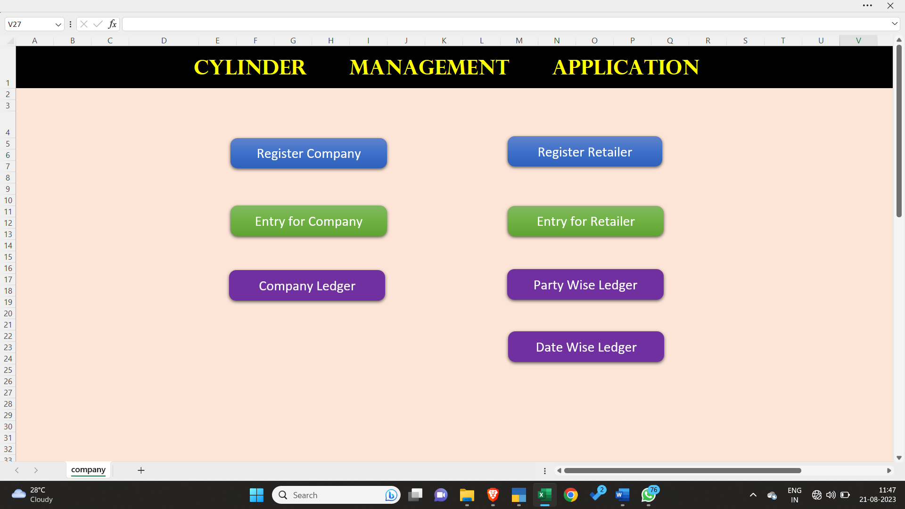
- The Left hand side panel represents the purchase panel for the oxygen cylinders.
- The first option is register company, where we can enter a new company for the purchase of oxygen cylinder.
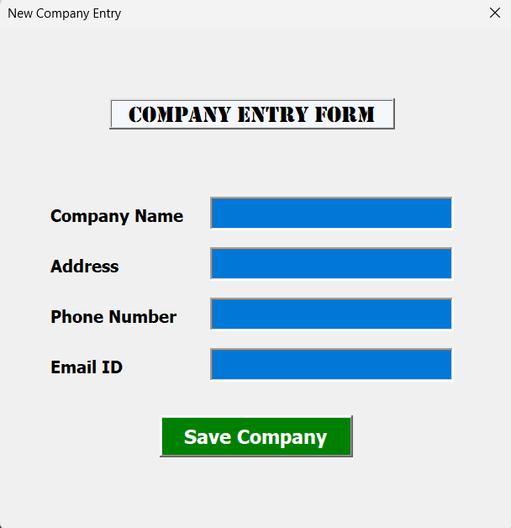
- The next option is entry for company, here when the cylinders are received from the company all the details of the cylinder along with the vehicle details are to be filled up.

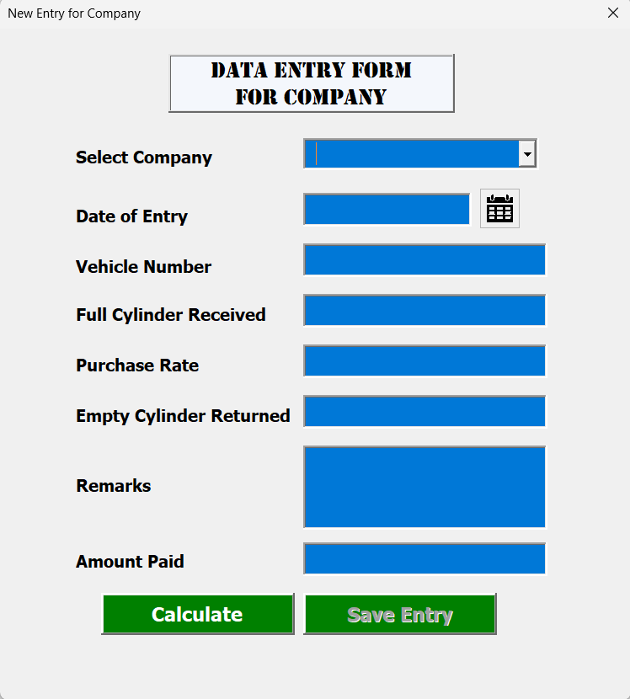
- The next option is of company ledger, this option shows us the quantity of oxygen cylinder purchased from the manufacturing company. It also shows the amount paid to the company and the amount that is due.
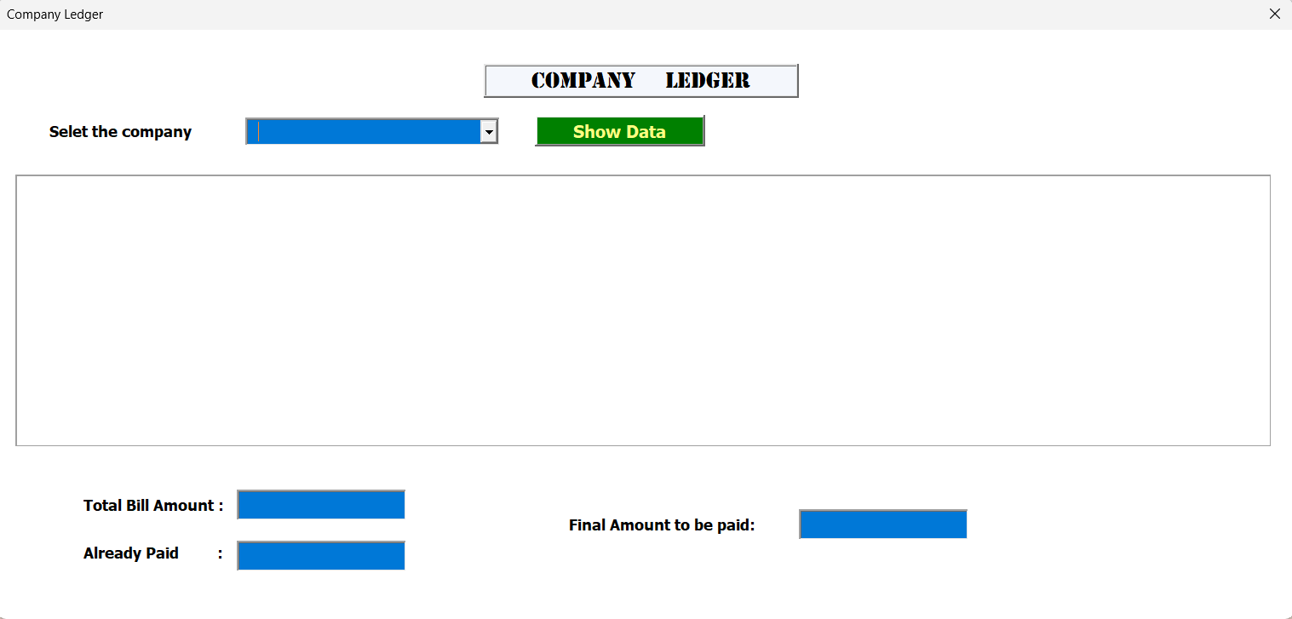
- Now coming onto the right hand side of the app.
- The first option is of registered retailer, here any new party to whom oxygen cylinder has been sold or will be sold must be registered in this tab.
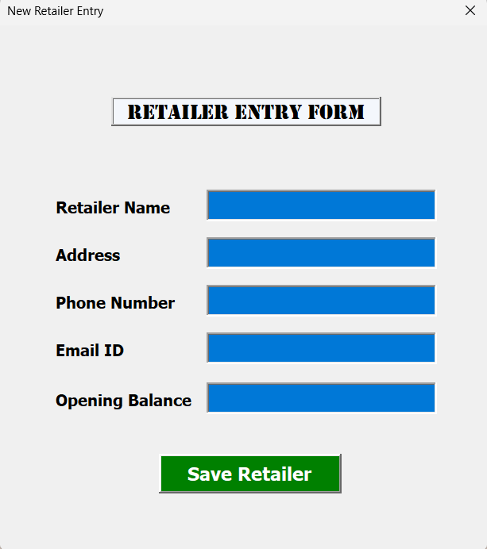
- The next option comes of entry for retailer, here all the details related to the cylinder that has been issued to the concerned party must be entered along with the vehicle details in which it was taken or brought.
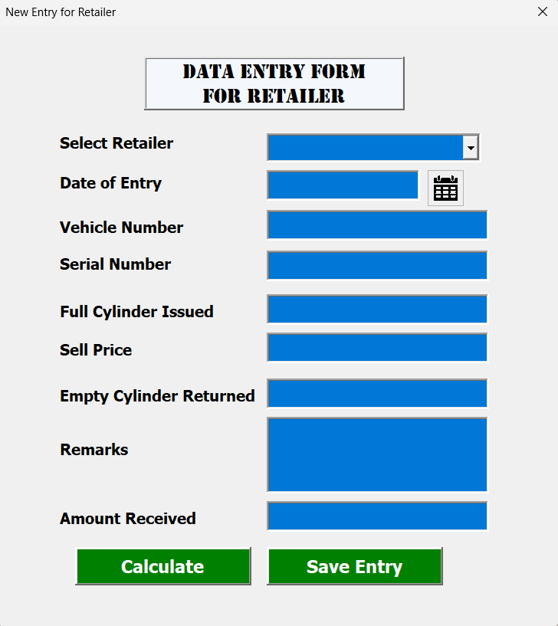

- The next option comes for party wise ledger, where the balance of the number of cylinder and payment with each party can be found.
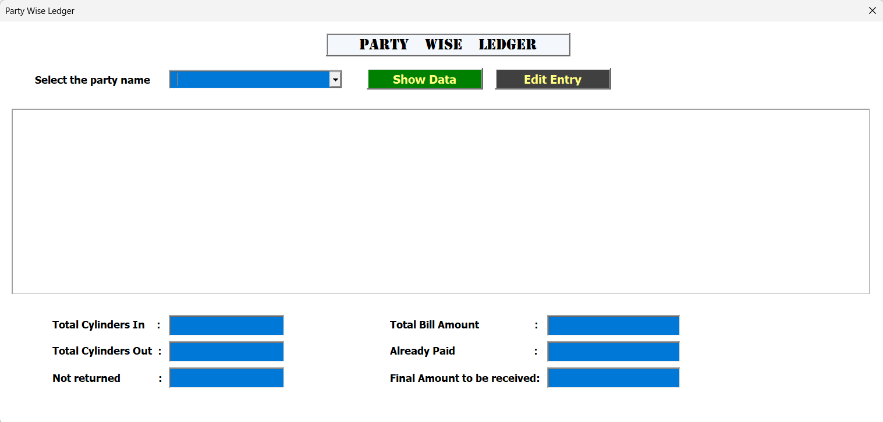
- The next option comes of date wise ledger, here we can find the number of cylinders that has been rented or returned during a fixed period of time.
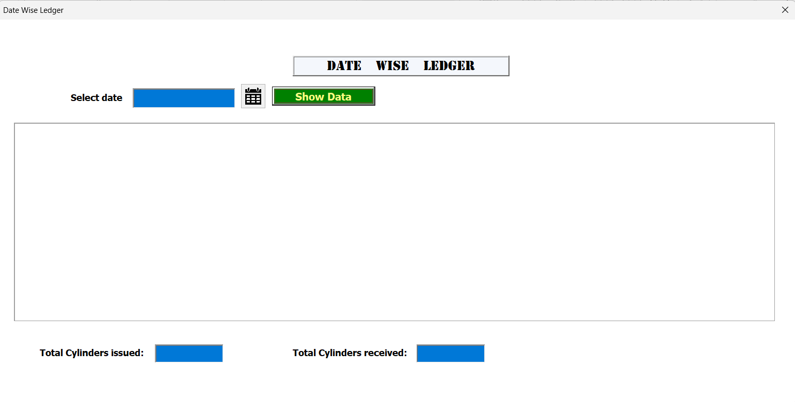

Clappia Entry:
Things to record in Clappia app:
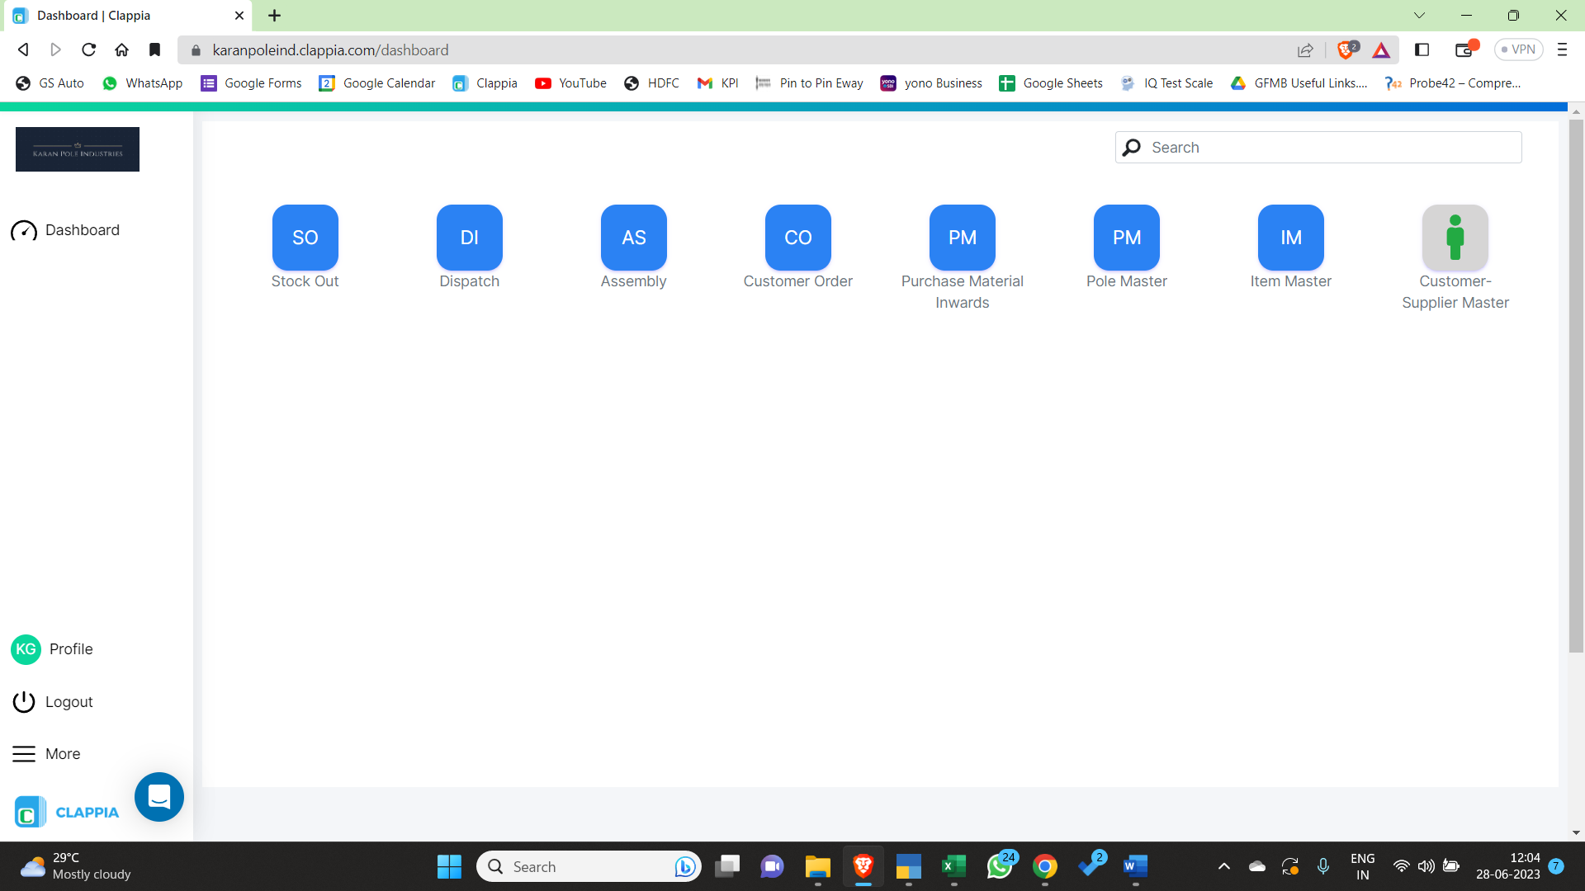
1. The use of any stock such as Red oxide paint, Black paint, Welding electrodes, Thinner, Nut/bolts which was present in Karan pole industries and is used for manufacturing of items, should be recorded in stock out app under Clappia.
2. Any manufactured item or accessory which is dispatched to the party should be recorded in the dispatch app under Clappia.
3. Assembly app is still under construction.
4. Any final customer order has to be recorded in the customer order app under Clappia.
5. Purchase of raw materials is recorded in Purchase Material Inward App under Clappia.
6. Purchase of supporting items such as Red oxide paint, Black paint, Welding electrodes, Thinner, Nut/bolts or any other related item should be recorded in Purchase Material Inward App under Clappia.
7. Pole master app is under construction.
8. Item master records all the products or accessory that we sell.
9. Customer supplier master records all the customers and suppliers details of Karan Pole industries.

Tally Purchase Entry:
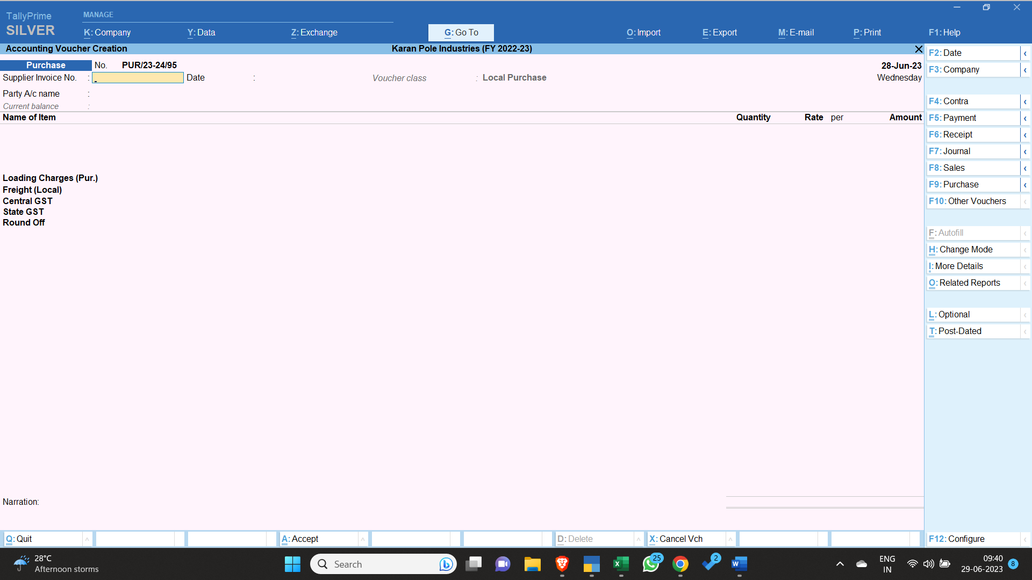

-1. The vehicle enters the factory and a weight slip is generated.
2. The products in the vehicle are unloaded.
3. The vehicle goes to the weigh bridge again to calculate net weight of product arrived.
4. The tax invoice is collected from the driver of the vehicle.
5. Both the weight written in the tax invoice and weight slip is compared.
6. A difference of 50 Kilos (+, -) plus minus is accepted in weight received.
7. If the purchase is IGST then the above date (the date mentioned in the top right corner of the above photo displayed) or the date of entering the bill is the arriving date of the products.
8. The invoice date is the date of the bill generated by the seller for us.
9. The same format should be followed while entering the bill as it was received.
10. The total invoice amount should tally up with the bill irrespective of the price and the quantity received.
11. The e-way bill number should be accurately entered in the bill.
12. Any discrepancy in this regard should be immediately informed to the office.
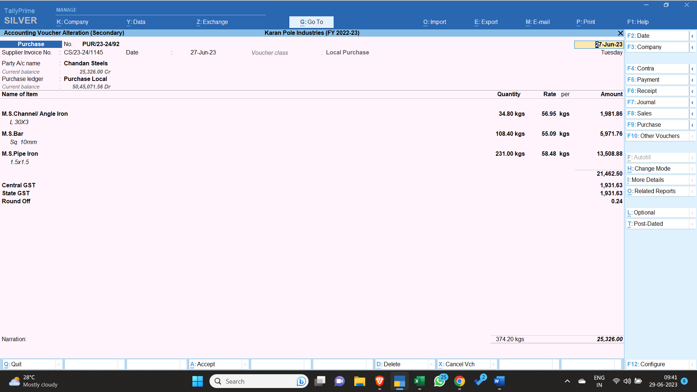

Tally Sales Entry:
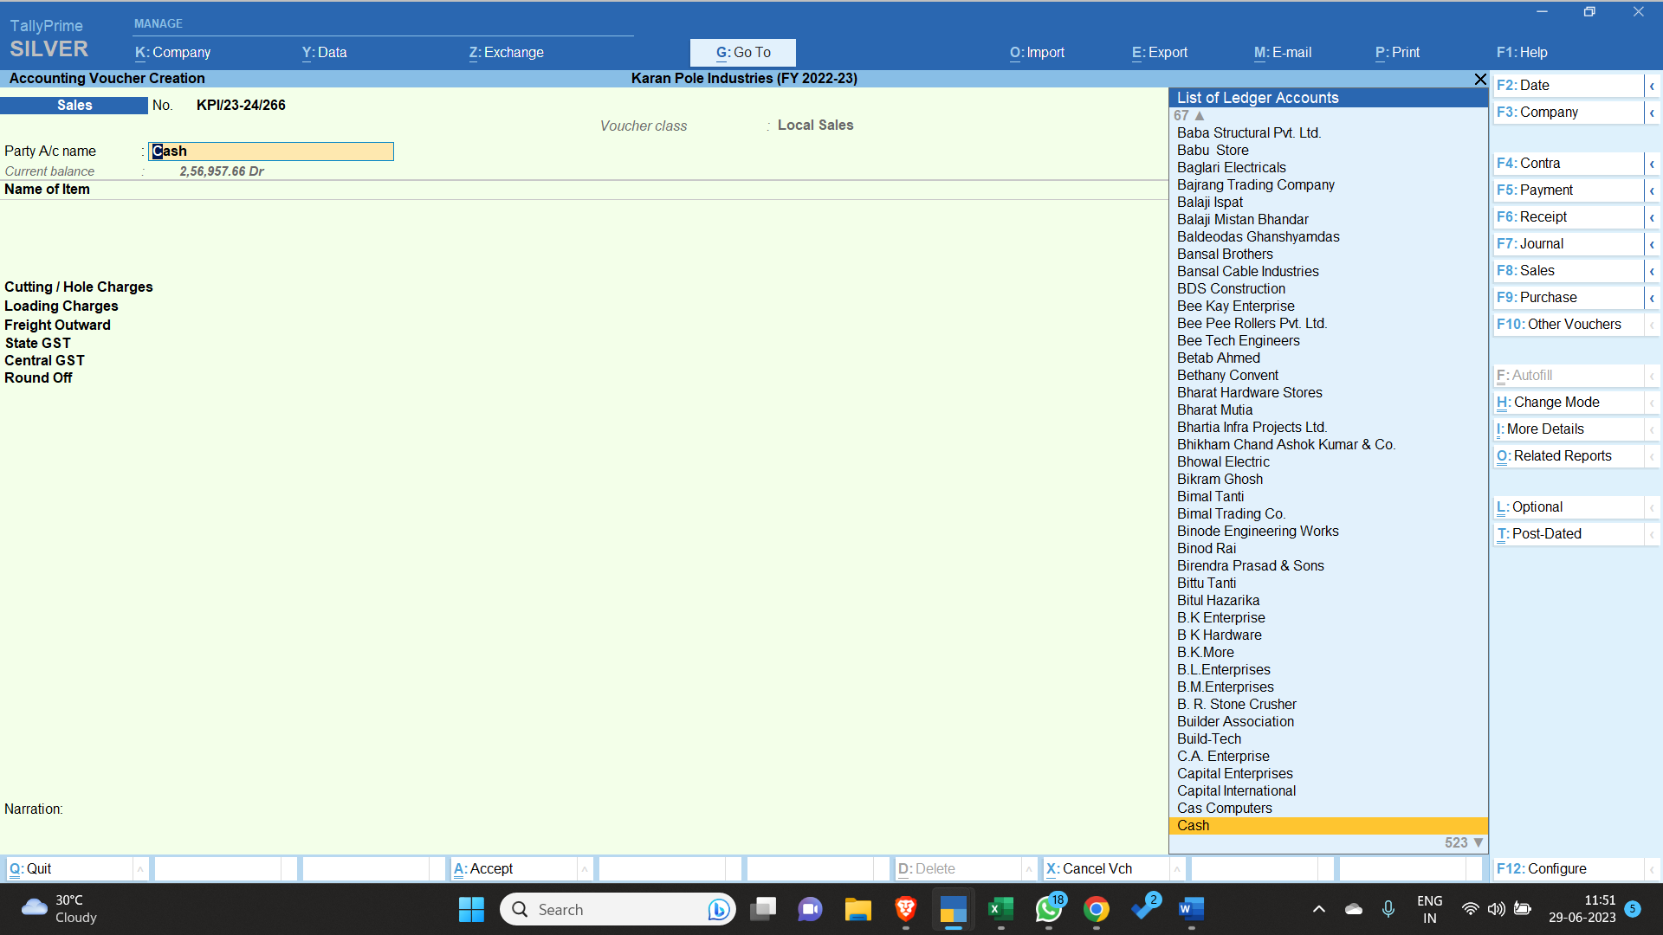
- The sales voucher can be accessed under the voucher section and then by pressing F8 or by a click on the right-hand side panel.
- If the party has previously transacted with us then its name should be selected or if the client is new and has a GST number, then it should be registered under the create ledger section or if the client just wants the bill and is unregistered then a bill under the name of cash can be generated.
- All the details below should be filled to the best of knowledge of the person entering the details:
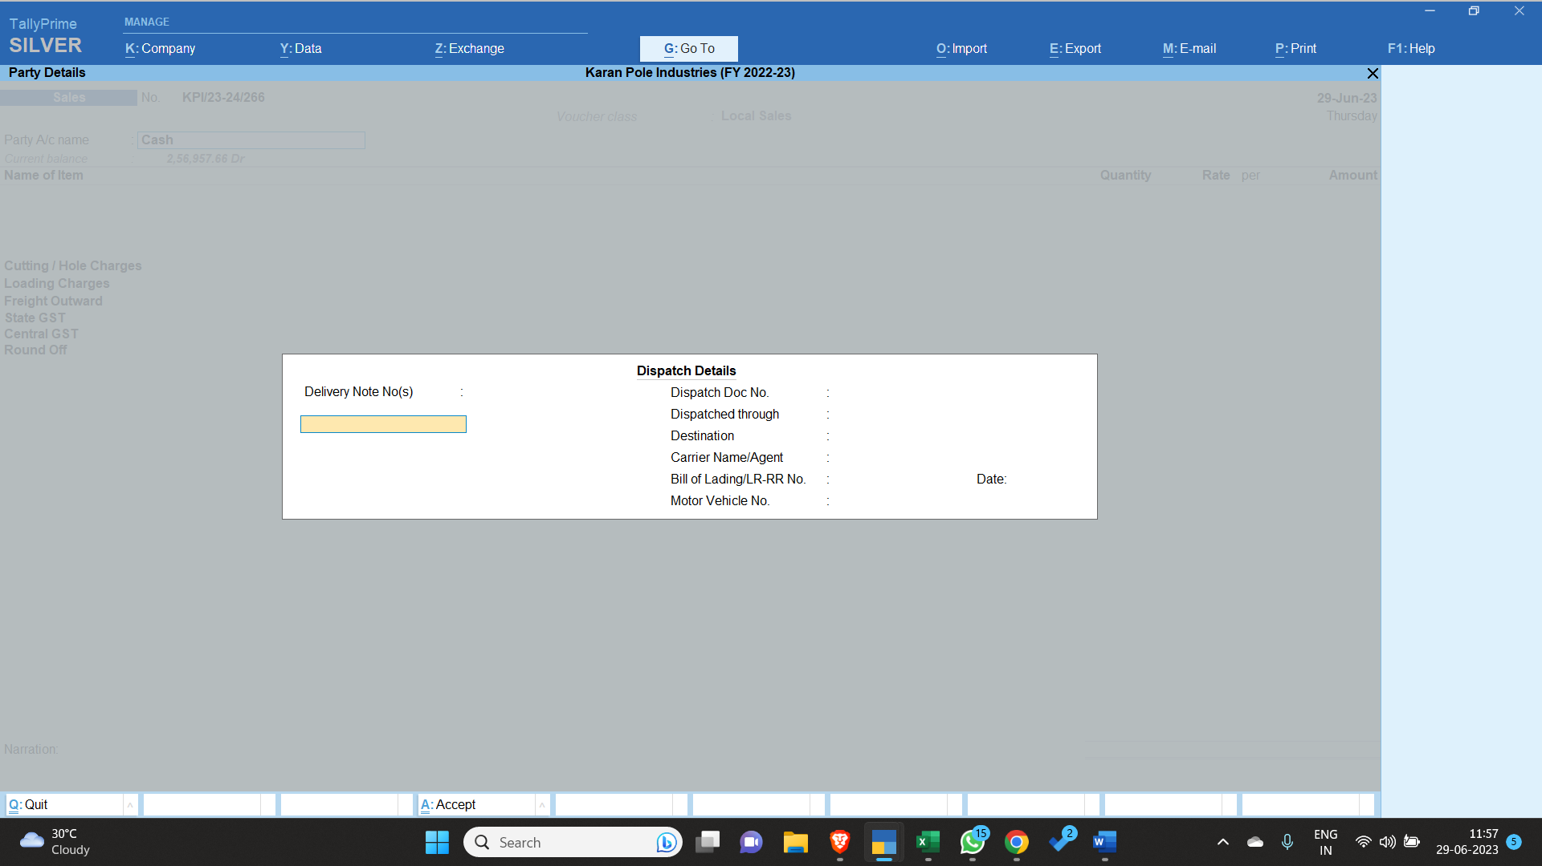
- The vehicle number should not have any spaces in between them, as e-way bill will not be generated otherwise.

- For going to the next screen CTRL + A should be applied to save time.

- If the client’s address and the delivery address are different then these spaces should be filled separately. The left side of the ‘party details’ indicates the buyer details and the right side indicates the consignee details. The buyer of the product must be registered in the consignee's state with a valid GST number to claim input on tax paid. If not done so then the GST input cannot be claimed.
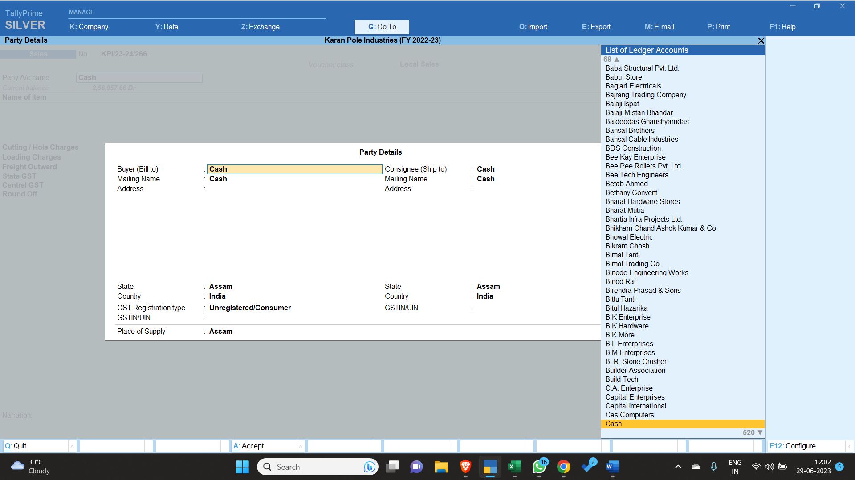
- All the manufactured products or the retail products that we sell are mentioned in the list, if any new product is being sold then in the first place it's ledger must be created in the create section with proper details and HSN code.
- If a specific product is not available in the list and only the product type is available then a narration (description of the product like sizes) should be entered below the product type as to know what is the product so there is no confusion in the future.
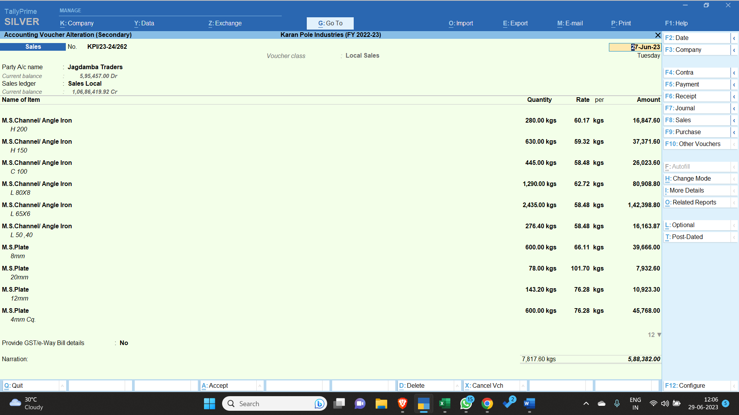
- If the bill amount crosses a value of Rs. 50,000 then E-way bill needs to be generated for the same.
- If the e-way bill is generated, then all the products listed in the bill must have a clear and a proper HSN code of at least 4-digit.
- The buyers GST number with proper address must be present to generate e way bill.
- The distance between the pin codes can be calculated by clicking on the right-hand side panel (Calculate distance on portal). 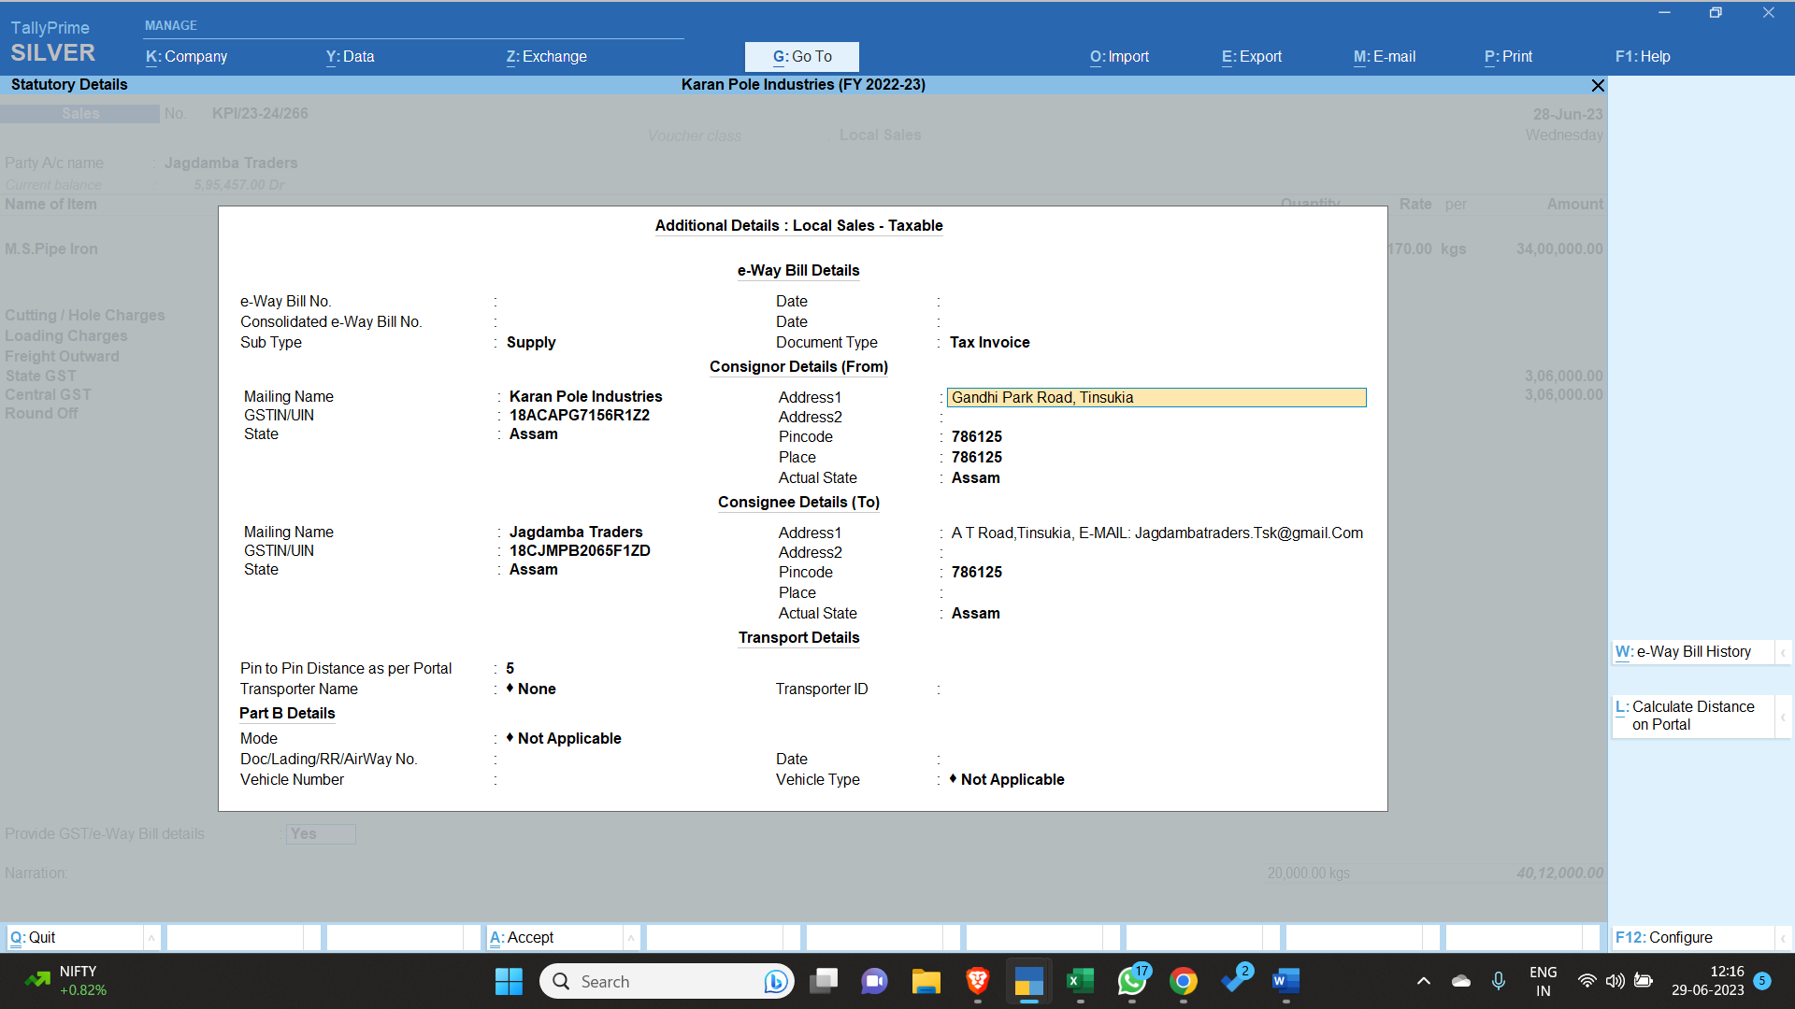

- Without entering the distance between the locations, e-way will not be generated.
- After entering the mandatory details, the next dialogue box appears.
- Here the username and password of the company must be entered to clear the final stage of e-way Bill preparation.
- If all the data that has been entered is correct, then eway will be generated automatically whereas if the data is incorrect e way bill be rejected.
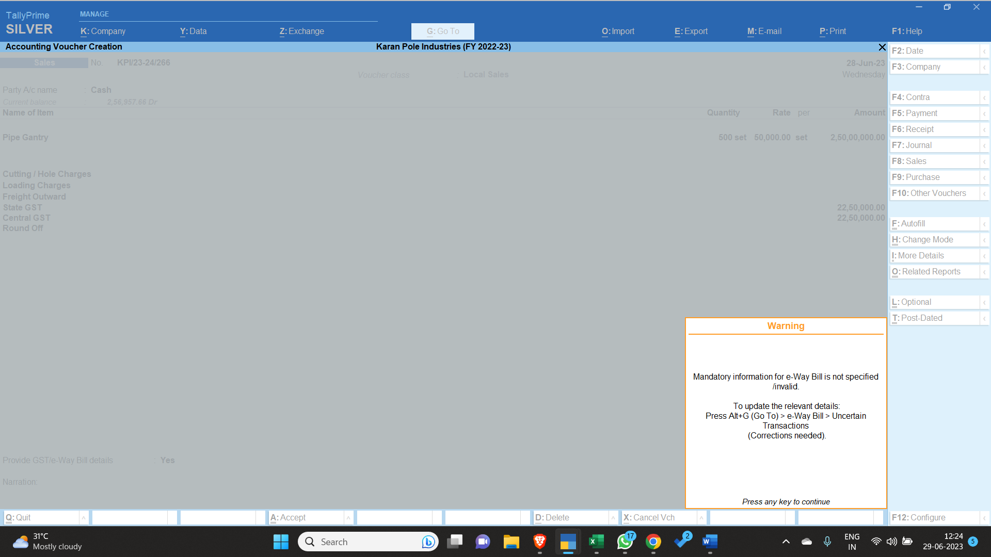
- If the e-way bill is rejected, then the user should go to display option under that accounts option and under that sales register, after that the user has to open the bill that has been rejected by the way bill system, after opening the bill the user has to go to the provide eway bill details section, and select yes. After selecting yes, a new dialogue box will appear which will show us the reason why the way bill was rejected.
- The rejection reason should be noted and informed in the office at the earliest.
- Any sales voucher should not be deleted as it will disturb all the future voucher numbers.
- If a wrong sales will has been generated then without deleting it, it should be informed to the office at the earliest.

Tally Ledger Creation Entry:
1.
Tally Ledger Alter Entry:

1.

Google Sheets Entry:

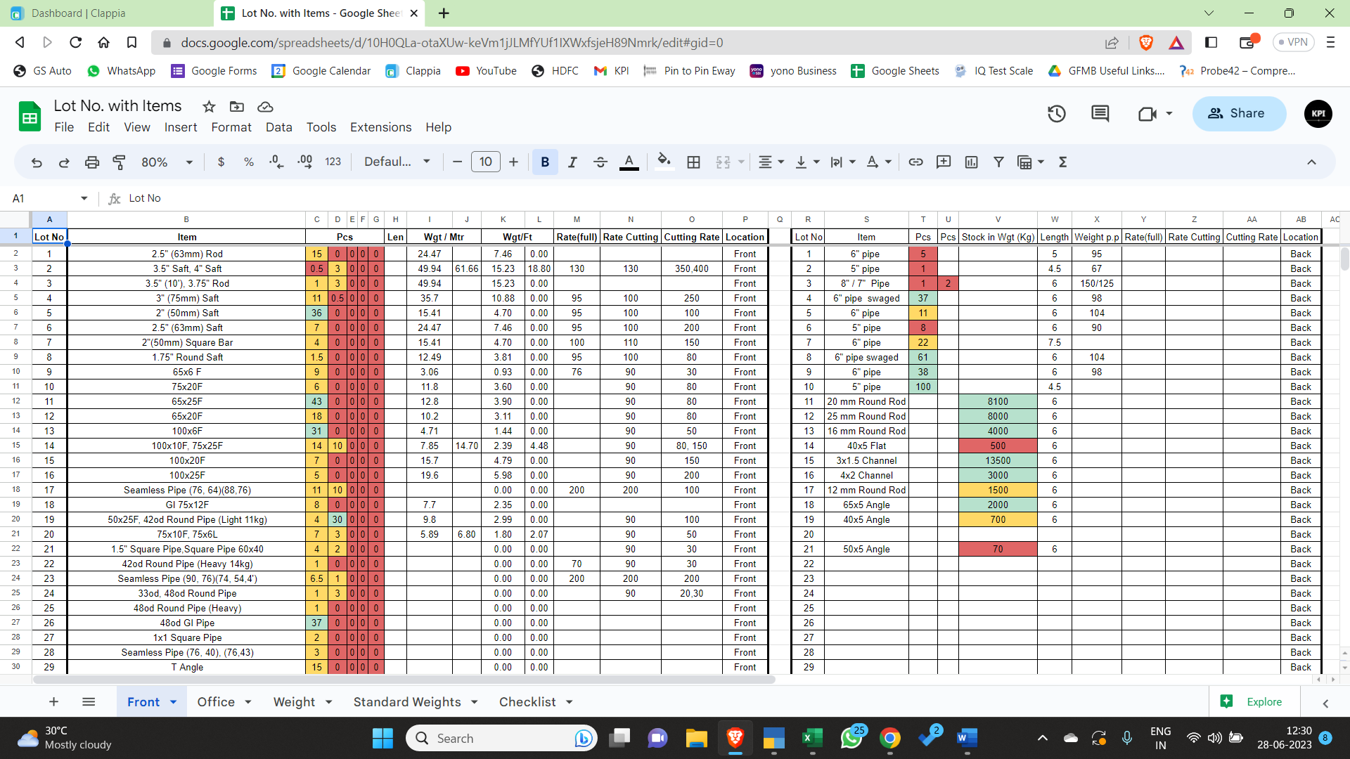
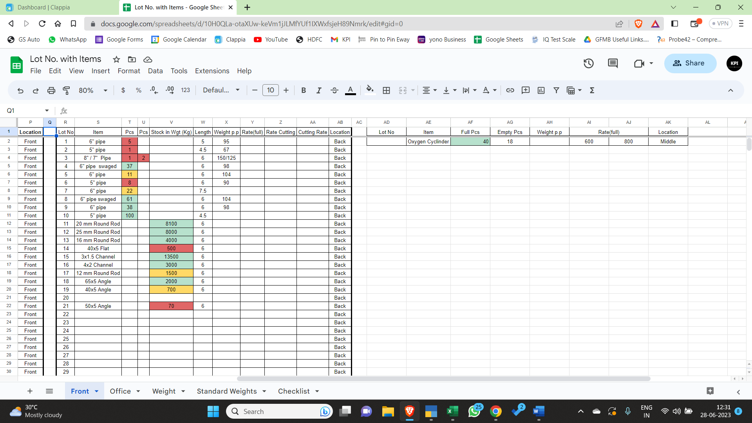

Kata Entry:
- Every vehicle that contains purchase materials either from local or outside Assam must be weighed in the Goyal Udyog weight bridge to cross check from the tax invoice.
- If the vehicle has multiple materials that has to be unloaded, then the vehicle should be weighed multiple times as per the situation, and the weight should be noted in the same kata slip.
- Generally multiple data slips are not required but if the situation demands it can be printed.
- After successfully unloading the vehicle, the vehicle should again weigh itself in the bridge.
- If a customer purchases the product from us then the kata charges are to be paid by the customer.
- But if the material is to be unloaded at our godown or we are just checking the weight for a own purpose and a slip has been generated for the same, then the expense would be written in the office column of the entry sheet available in the kata.
- The serial number of the vehicle is generated automatically.
- First the vehicle number has to be entered, for example AS23CC 3457, the last four digits and the previous information has a space between them.
- Secondly the vehicle code number has to be entered by seeing the number of wheels in the vehicle. For example vehicle code number 1 is for 6 wheeler. For all different vehicles different codes has been allotted which has been put up in the kata.
- The gross weight of the vehicle is the total weight of the vehicle with the goods / products in it.
- The tare weight of the vehicle is just the total weight of the vehicle without the goods / products in it.
- The net weight is the difference between the gross weight and the tare weight, which gives the net product / goods weight that has been received or is being sent.
- Different number of vehicle tyres have different charges, the rate of which has been provided in the sheet in the Kata.
- While entering the Kata data, one should press enter slowly and check the weight that has been displayed in the display box with the weight that has been displayed in the monitor of the Kata, to prevent any mishappening.
- If the data in the display box and the computer screen do not match then the employee has to immediately cancel the slip by pressing the escape (Esc) button on the top left side of the keyboard.
- If wrong weight gets printed in the slip then the employee has to immediately inform the office management to rectify the error.
- There is no credit system for people who come in the Kata. Its a full cash to cash business.
- If the payment is being made online then it has to be confirmed with the office management that whether the payment has been received or not.
- No manipulation of weights is possible or going to happen in anyway by any member of the organization.
- If any malpractices is found then legal actions against the concerned person will be taken.
- After the cash transaction has happened, the employee has to put the last two digits of the serial number in the sheet provided followed by a " - " and the amount collected. For example: 56 – 100. (This indicates that on 56 number slip, an amount of Rs. 100 has been collected)
- If the material has been purchased by Karan Pole industries, then the employees has to enter manually in the weight slip what all items are present in the vehicle along with the company name. Along with that the employee also has to write the word " (Office) " in the data sheet after the amount so that during calculation no discrepancy should arise. For example: 56 – 100 (Office).
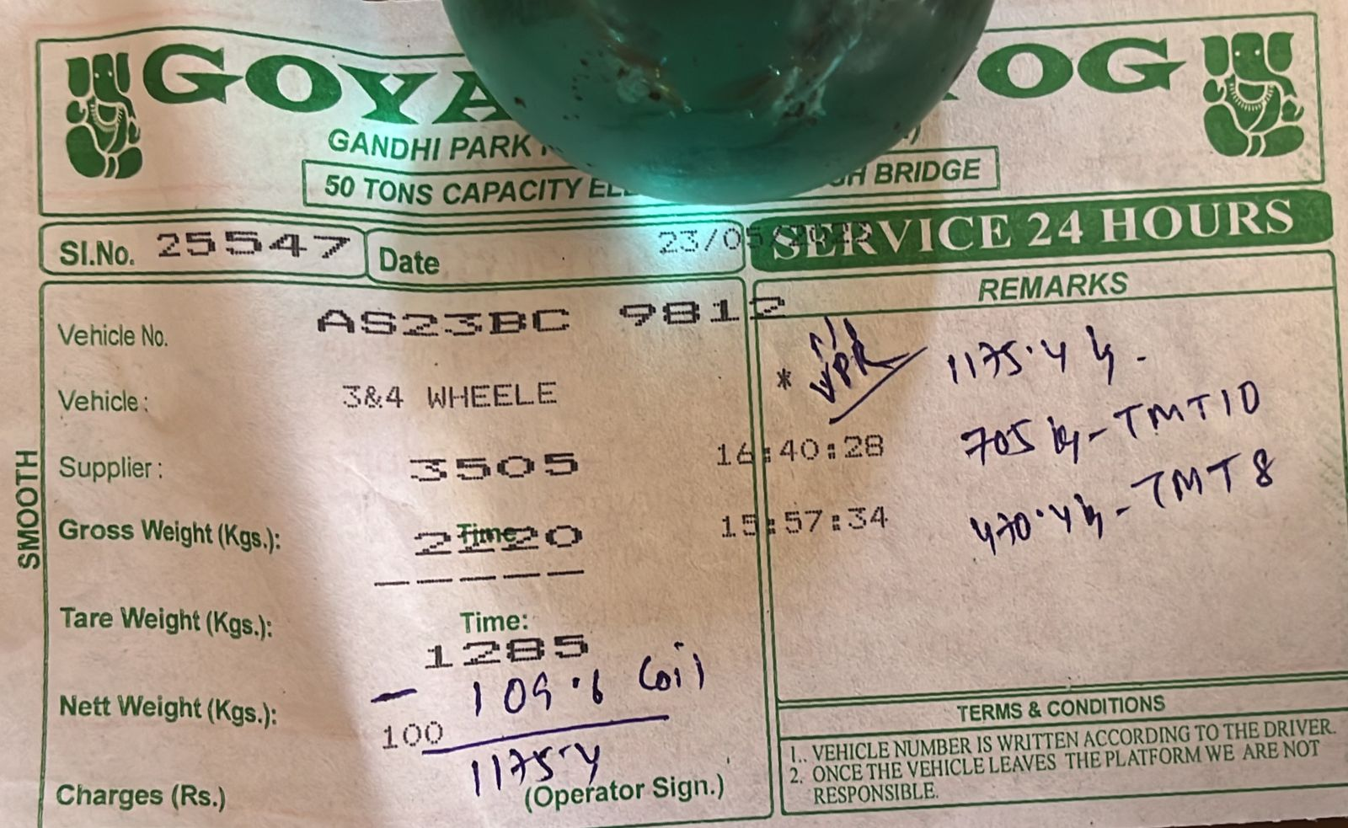

Send Ledger to Parties:
- As soon as bill is made, a bill copy along with the ledger of the party is sent in their WhatsApp number, from the office WhatsApp number.
- The file which contains the Ledger for XYZ Co. having a balance of Rs. 59987 is named as XYZ 55987, to bring clarity in terms of balance payment.
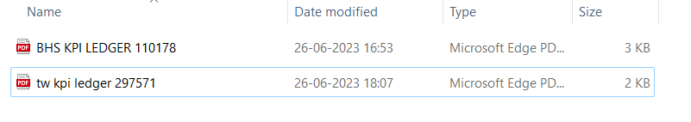
- Every week on Friday, the ledger account in the above-mentioned format is sent to the parties with a message to keep the cheque ready of the amount or if the party is outside Tinsukia, NEFT / RTGS is requested for the same.
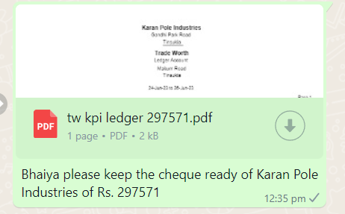
- On Saturday, the party is again reminded to clear the balance payment. This is a recurring process.
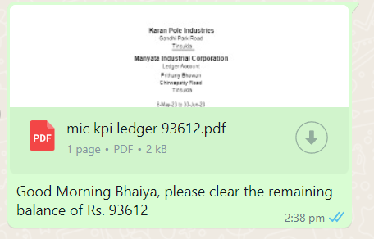
- If the party proposes a future date, then the date should be noted in the Tasks App of Microsoft to remind us on that particular date to collect payment from the part, no negligence is tolerated in this part.


Calling Debtors:
- Every week on Friday, the ledger account in the above-mentioned format is sent to the parties with a message to keep the cheque ready of the amount or if the party is outside Tinsukia, NEFT / RTGS is requested for the same. If the party is not clearing the payment after one reminder then the party has to be called every Friday along with sending of ledgers on WhatsApp.

- On Saturday, the party is again reminded to clear the balance payment. This is a recurring process.
- If the party proposes a future date, then the date should be noted in the Tasks App of Microsoft to remind us on that particular date to collect payment from the part, no negligence is tolerated in this part.

- If the party keeps on giving excuses then the company is flagged and future transactions with the company are only done based on Instant Payment or Post Dated Cheque. No credit facility is entertained for late payment parties.

Enquire Rates from Godown:
1. If an item is not available with us, then we have to enquire it from either of the parties: Anil brothers or Chandan Steel.
While enquiring we have to keep in mind that we are also have to ask the rate as well as the weight of the product per piece.
If the rate of Chandan steel is higher than Anil brothers then we can tell Chandan Steel to reduce the rate, and he would do that.
Chandan steel is preferred over Anil brothers as they provide bill invoice right hand in hand.
2. If the item is required for manufacturing pole and no godown has it then we will enquire from Paban Steel (Tinsukia) or Purbanchal Udyog (Dibrugarh) or Bharat Ispat (Dibrugarh), since they keep odd item stock.

Indiamart Entry:
1.
IndiaMART should be opened on a daily basis to find out the buyleads.
IndiaMART needs to be logged in using the number 9957834347.
The OTP will be received in Karan Goyal's mobile number.
Buyleads from all over the India are acceptable.
The contact number of different suppliers from different cities are as follows:
Guwahati:
Name | Phone Number | Items | Shop Name
Anirudh Hansaria | 81338-58923 |  | Jaya Trade and Agencies
Gaurav Murarka | 99992-74801 |  | BK Associates
Gaurav Murarka | 60268-50082 |  | BK Associates
 | 99545-25162 |  | Kamrup Steel
Pratik Modi | 70021-05324 |  | Paban Steel Ghy
Kolkata:
Name | Phone Number | Items | Shop Name
 | 98300-30848 |  | Ankit Steels
Arpit Agarwal | 62910-09638 |  | Dhruv Enterprise
Bharat Gupta | 98310-76767
Kunal Jalan | 98368-11184 |  | Shree Bishandas Iron Works
Anuj Sharda | 70444-49919 |  | Satsai Infrarelty Pvt Ltd
Shubham Bansal | 93301-44426 |  | MLU Metaliks Pvt Ltd.

Delhi:
Name | Phone Number | Place | Items | Shop Name
Sameer Mehta | 98992-66222 |  |  | Jain Steel Corporation
Akshay Bansal | 96504-91701 | Ghaziabad |  | SM Trading Corp

Dehradun:
Name | Phone Number | Items | Shop Name
Sajal Tayal | 73512-96850 | Only Apollo Brand Iron | Shri Durga Metalx

Telangana:
Name | Phone Number | Items | Shop Name
Shiven Gaggar | 90000-02281 | Iron Trading and Job Work | HST Steel Pvt. Ltd

Chennai:
Name | Phone Number | Items | Shop Name

Ludhiana:
Name | Phone Number | Address | Shop Name

Stock Entry:

Cash Management:
1.
Handling Customers:
1.

Handling Machines:
- No Machine should ever be left unattended.
- Cleaning of machines is important after every successful operation.
- Any product should not be left near the machine, thereby blocking the way, it should be placed back in the Lot from where it originated.
Loading / Unloading:
- Loading will be done through EOT Crane or Labourers or Labours plus Staff.
- Loading Charges are applicable on the bill @ Rs. 500 / tonne. (For Example: 1850kg of material sold will attract a loading charge of Rs. (1850 x 0.5) =Rs. 925)
- If Loading is done beyond working hours, i.e., 5:00 p.m., labourers are paid @ Rs. 70/hour and staffs are paid @ Rs. 100 /hour.
- If the Loading goes beyond 7:00 p.m., then Tea and Samosa shall be brought in for the loaders of our company.
- Unloading will be firstly tried with EOT Crane.
- If Work is less then our own labourers can start to unload the truck, if not then labourer contractor is called.
- During Unloading, Labour Contractors are called to put the product from the truck into the lots. They charge around @ Rs. 100+ / Tonne. Labour Contractors numbers are available in the office.
- The rate of outside laborers should be cleared out before starting of the task.
- A Surplus amount of Rs. 200 maximum can be given to the labour head to keep good relations with him.
- The driver of the truck has to give a Dala fees to the labourers since they unloaded his truck.

New Material Entry:
1.
Sale Entry:
1.
Problem Solving Process:
- If a staff comes with a problem in the office then he should also the come up with the probable solution to the same.
Hiring:
1.
Credit Calculation:
1.
Bank Entry:
1.
Tally Stock Entry:
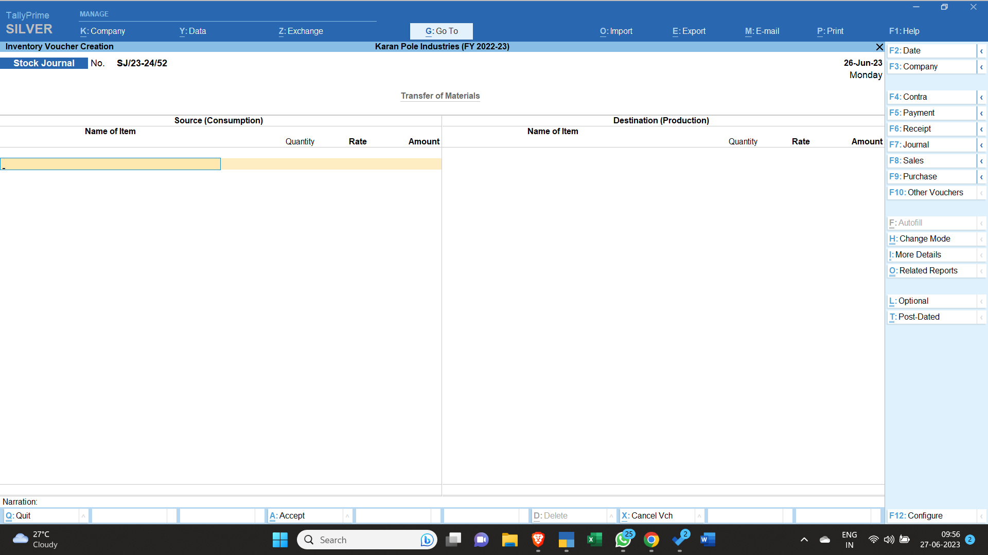
- Firstly we have to open Stock Journal, which is available in the “other voucher” section on the right hand side.
- The same screen as above appears.
- Now we open one more tally app from the taskbar (Right click on Tally App from Taskbar and select the app), so that one tally app we can enter stock data and on the other we can see our negative stock inventory.
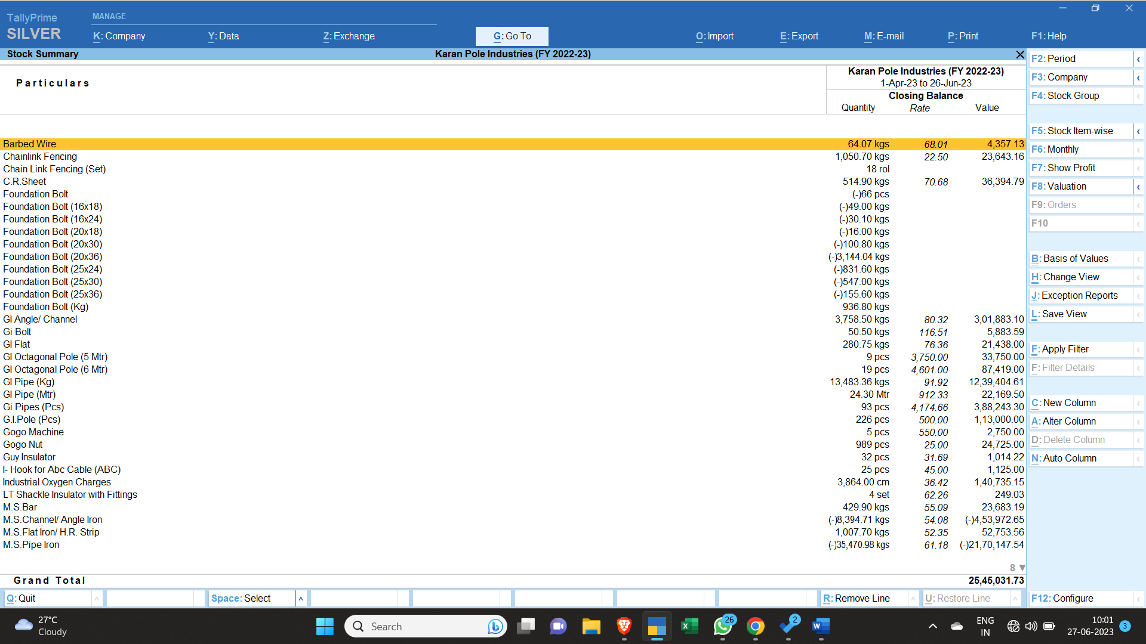
- We would press ALT + Tab to change between the screens to do our work faster.
- Now we would see what all products are showing a negative balance and along with it we would also have to see if the raw materials required to make it has what balance figure in our stock summary.
- Now we would bring all manufactured products that are manufactured using the same raw materials within a gap of 1/2 weeks and try to create its stock first.
- (2 wire Cross Arm, 4 Wire Cross Arm, Channel for GOAB, Channel Set for S/s, Cross Bracing, DP Cross Arm, SP Cross Arm, SP Top Arm, Fencing Post, Gate, Stay Set and V Cross Arm are manufactured using the stock of Channel / Angle / Joist Iron)
- (Foundation Bolts are manufactured using the stock of MS Round / Bright Bar / TMT Bars along with Nut Bolt / Waser Stock)
- (Ht Half Round Clamps, Ht Stay Clamps, Lt Half Round Clamps, Lt Stay Clamps are manufactured using the stock of MS Flat Iron / H.R. Strip)
- (MS Base Plate is manufactured using the stock of HR Sheet / CR Coil / CR Sheet / Plate Iron / Flat Iron)
- (Poles of all sizes are manufactured using the stock of MS Pipe Iron along with HR sheet / CR Coil / CR Sheet / Flat Iron Stock, additionally welding electrodes or cutting wheels can be used to clear up their little stock if any)
- (Pole Arm, Street Light Arm, Street Light Cap is manufactured using the stock of Pipe Iron)
- Now Doing Stock Entries of Different Items:
- Foundation Bolts:
- To make Foundation Bolts, firstly we have to use Nut bolt / Waser Stock, steps to calculate the quantity of nut to be used:
Nut Size | Nut Weight per piece
- 16mm | - 0.040 gram
- 20mm | - 0.055 gram
- 25mm | - 0.140 gram
- 32mm | - 0.410 gram
Foundation Bolt Size | Foundation Bolt Per Piece
25x36 | 4
25x30 | 3.3
25x24 | 3
25x18 | 2.2
20x36 | 2.5
20x30 | 2.3
20x24 | 2
20x18 | 1.5
16x36 | 1.6
16x30 | 1.4
16x24 | 1.1
16x18 | 0.9
Nut Size per Foundation Bolt | Percentage
16mm Nut , 16x36 F/Bolt | =40/1600 =0.025
16mm Nut , 16x30 F/Bolt | 0.028
16mm Nut , 16x24 F/Bolt | 0.036
16mm Nut , 16x18 F/Bolt | 0.044
20mm Nut , 20x36 F/Bolt | 0.022
20mm Nut , 20x30 F/Bolt | 0.023
20mm Nut , 20x24 F/Bolt | 0.027
20mm Nut , 20x18 F/Bolt | 0.036
25mm Nut , 25x36 F/Bolt | 0.035
25mm Nut , 25x30 F/Bolt | 0.042
25mm Nut , 25x24 F/Bolt | 0.046
25mm Nut , 25x18 F/Bolt | 0.063
- Any other foundation size which is uncommon, their nut weight is taken in average percentage of 0.035 and the bolt weight is taken in average of 2.15 kgs.

- Now for example, we would open the stock of 20x36 Foundation Bolt, and see from which month is our stock negative. In this case it is June. We would enter June Data then.
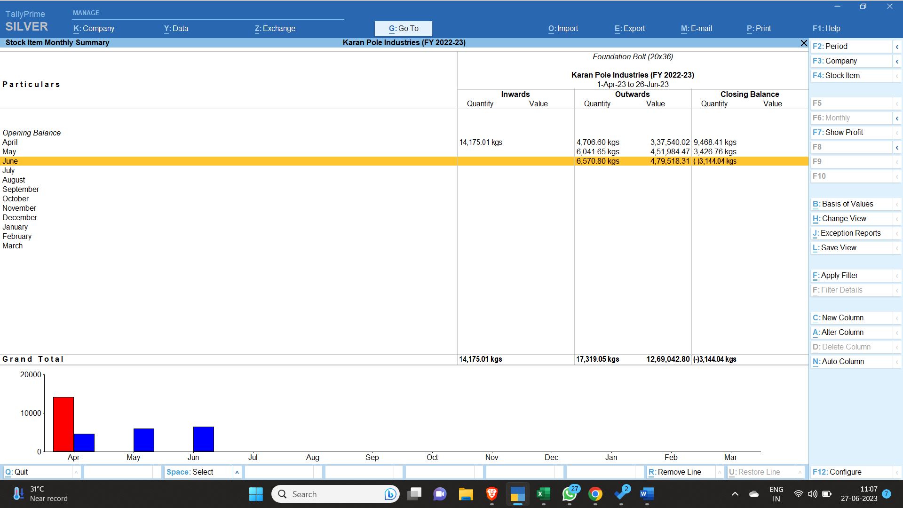

- On Opening June, we see the following Data:
- We see from 17th June,2023 we have a negative stock.
- Total negative stock of 20x36 Foundation bolt is 3144.04 kgs
- So Foundation bolt of 20x36 needs to be manufactured on a day that is before 17th June,2023 and also not a Sunday.
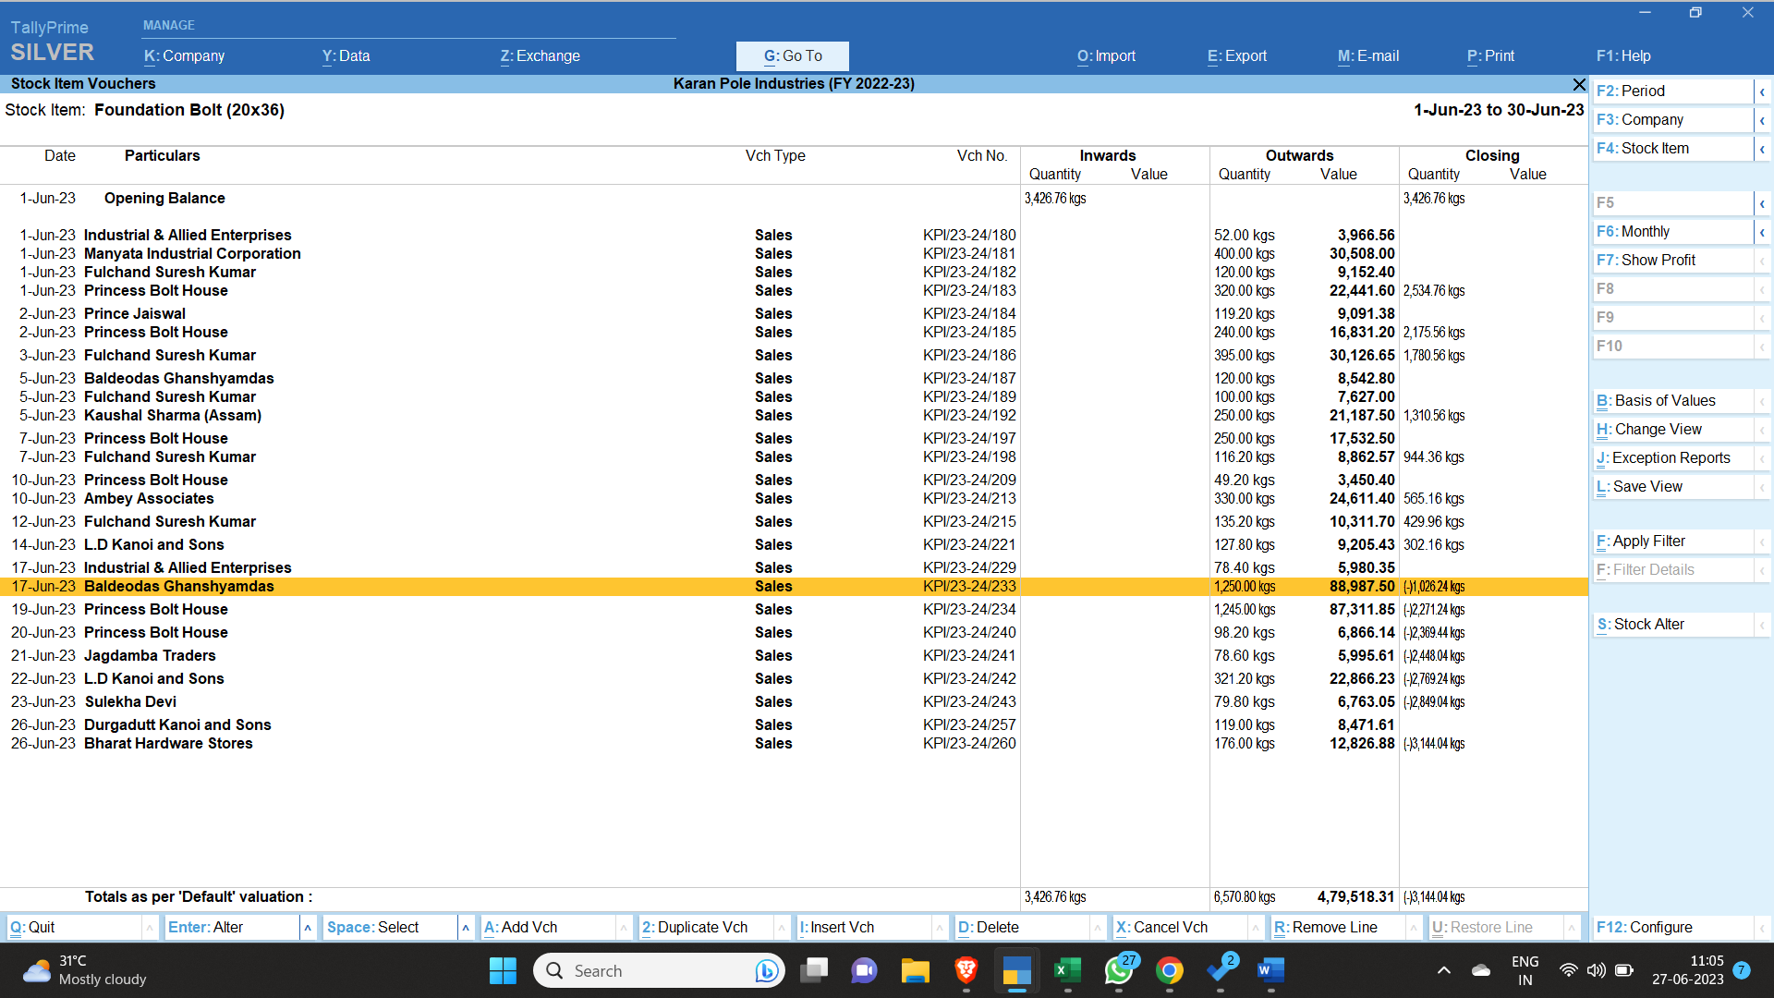
- We would first fill up the right hand side data (Destination (Production)) side so that no items are missed out while making stock.
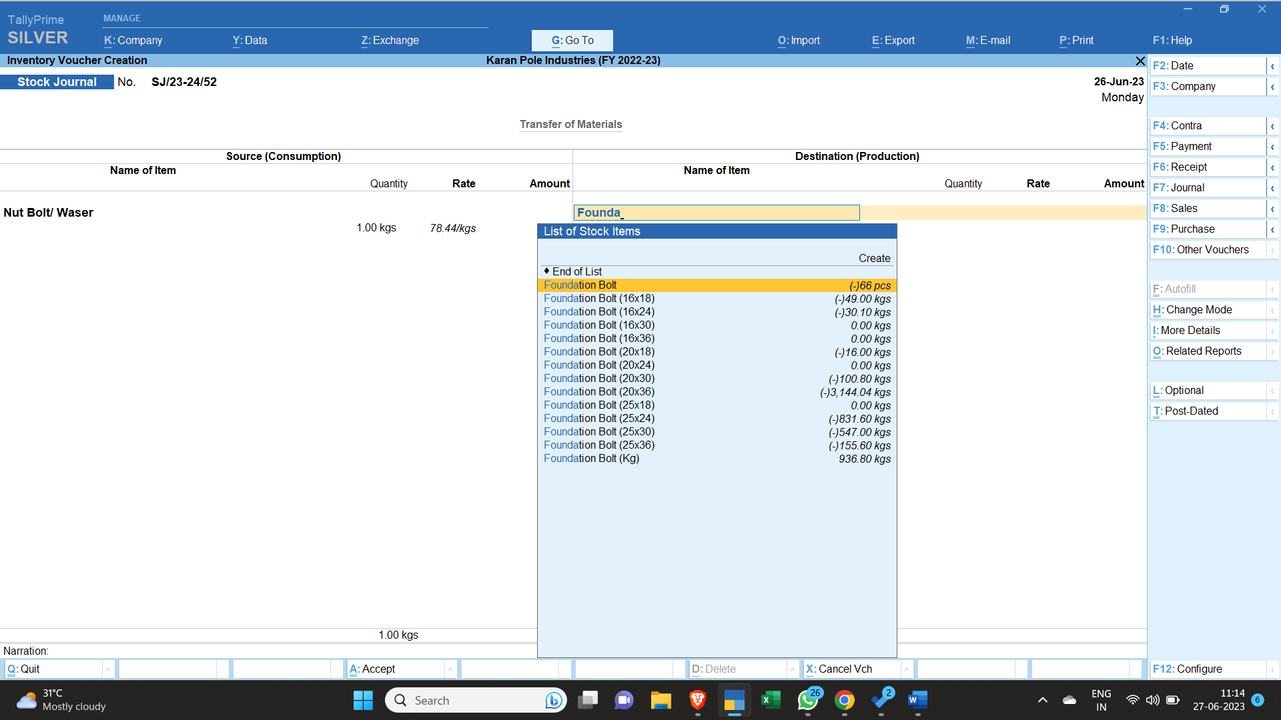

- All Items on the right hand side are listed in the following way (Note: Foundation Bolt of 20x36 is being manufactured extra as it is a top running product)
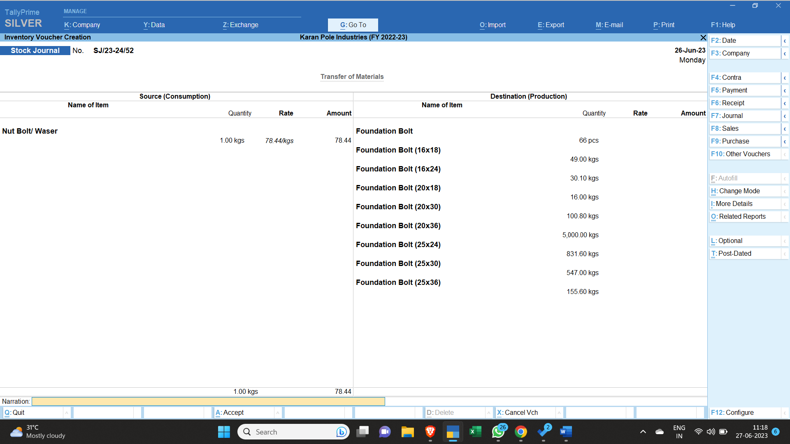
- Now 66 pieces is multiplied with 2.15 kgs to calculate average weight of stock sold, i.e. 142 kgs.
- So Nut Stock to be taken for Foundation bolt in pieces would be 4.97 kg (i.e. 5 kgs)
- For 16x18 Foundation bolt, nut quantity would be 49 kgs x 0.044 (I.e. 2.16 kgs)
- Similarly we do it for other items even.
- After calculation of nut weights for all items, it comes around 188 kgs.
- Before Entering the Nut weights we have to check the date. We have to put that date before the stock goes into negative. In our case we would take it as 5th June,2023 (Monday).
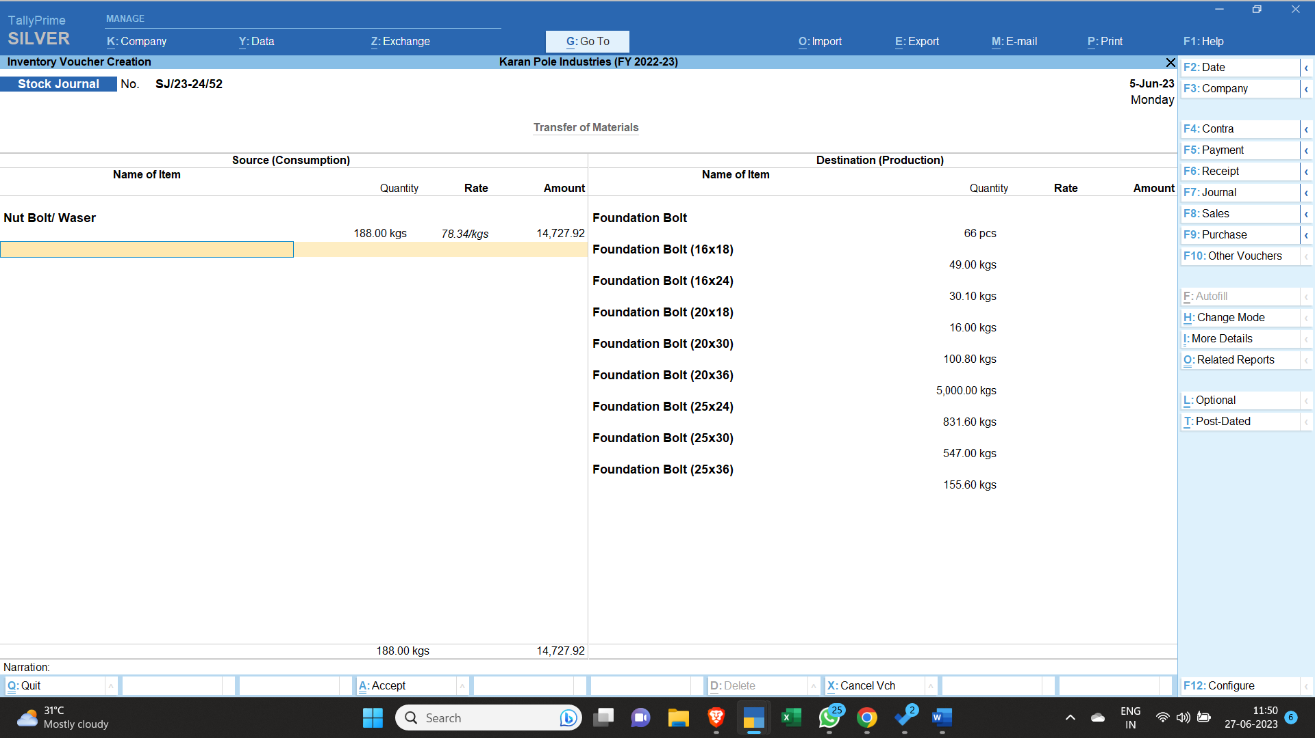
- Now we would have to add the total negative balances of all the foundation bolts.

- The following negative balance exists of all negative foundation bolts:
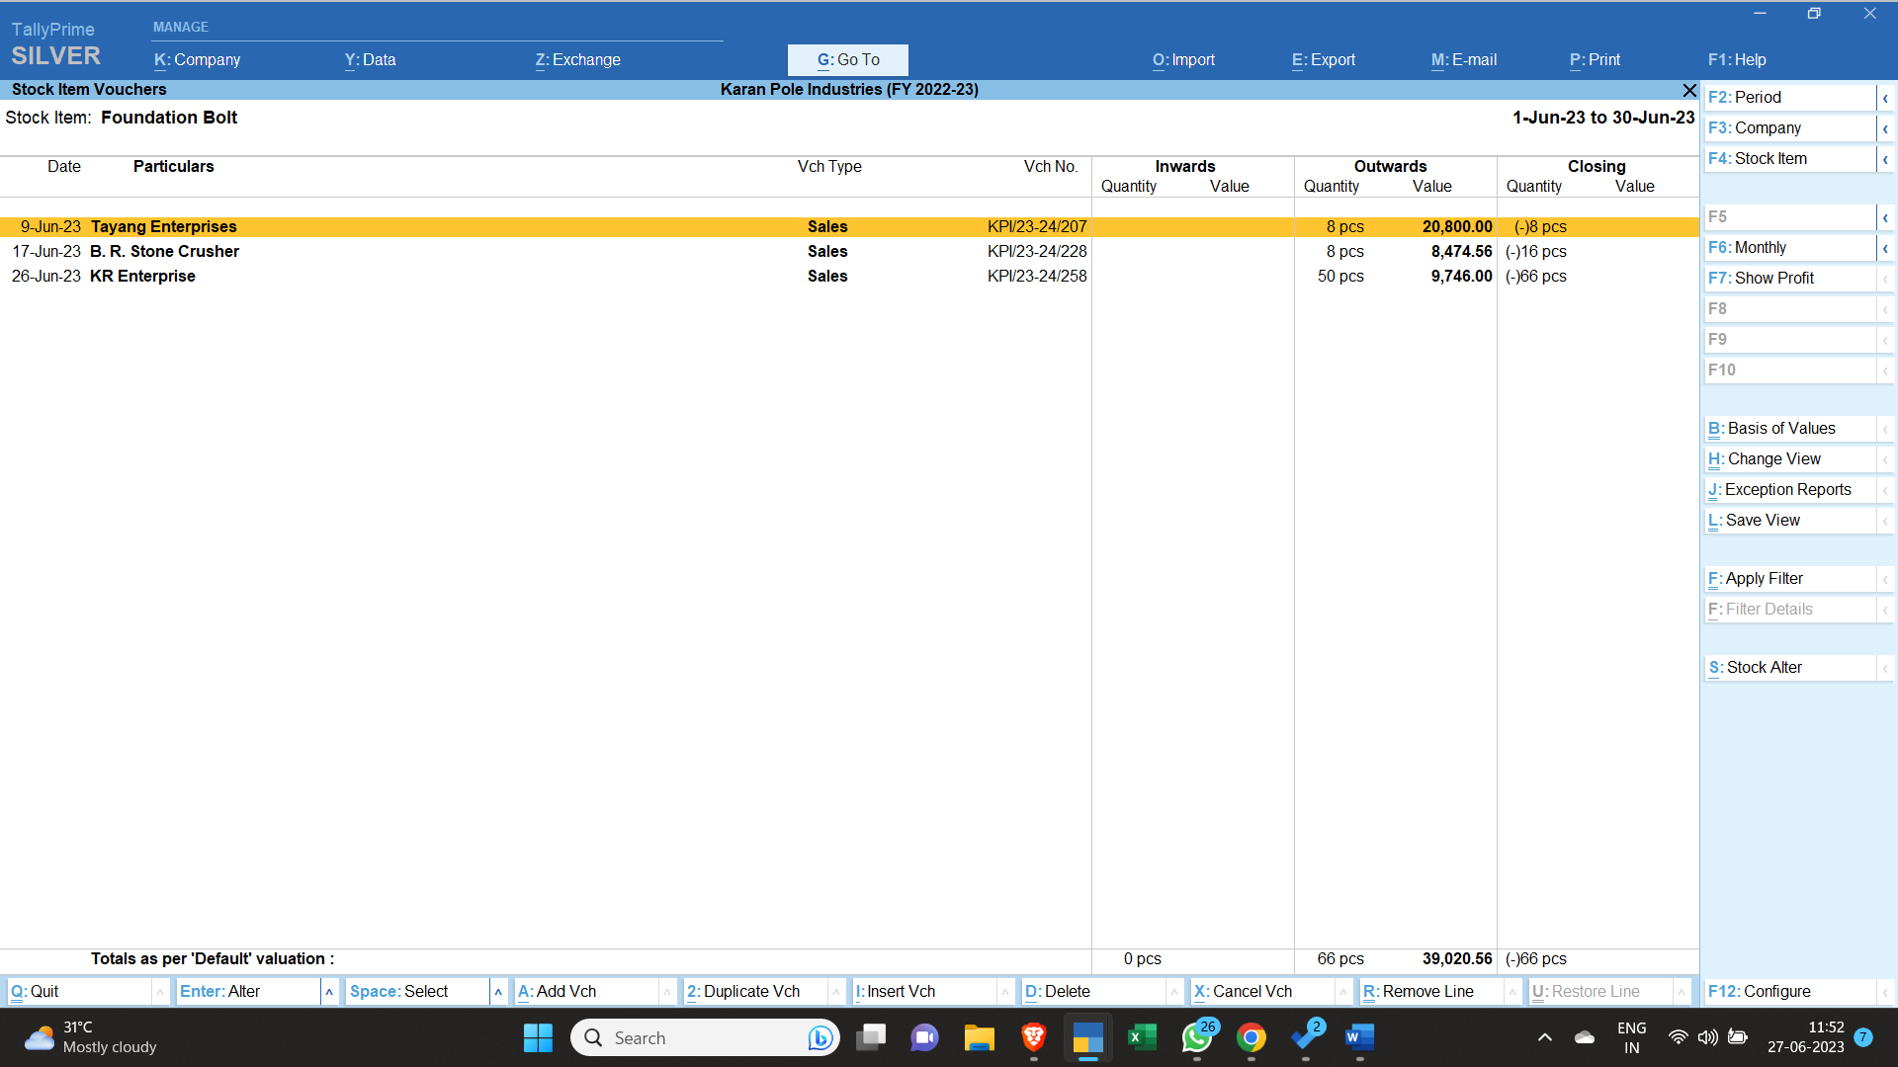
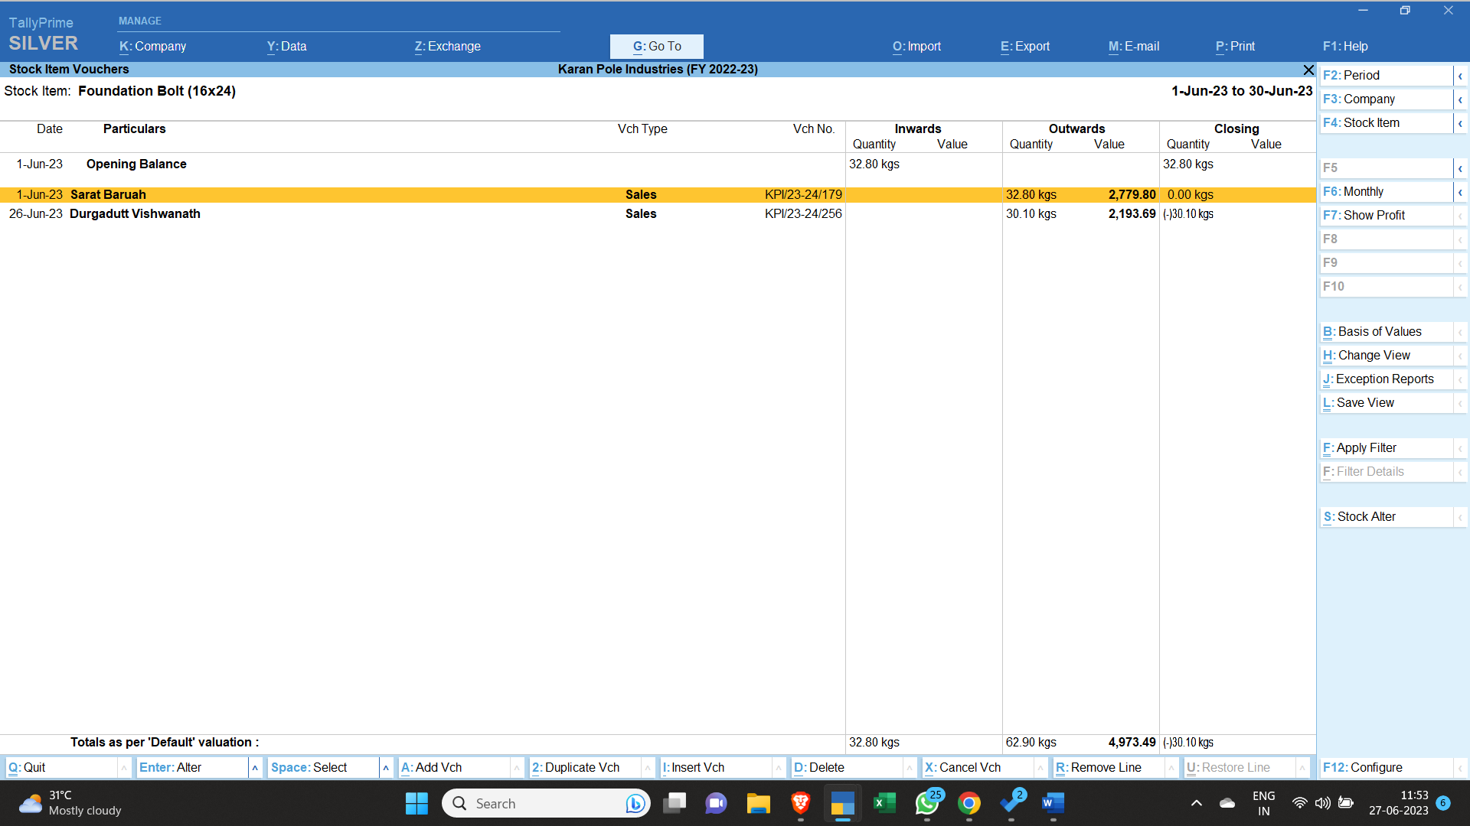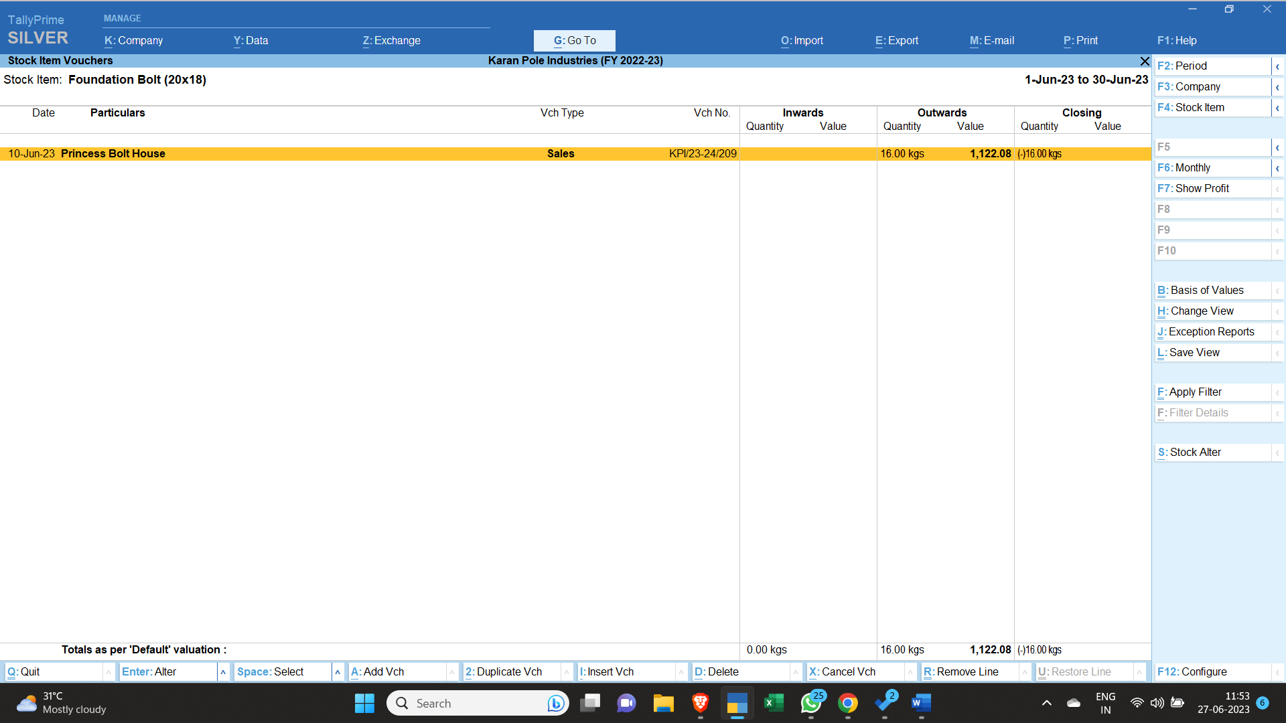
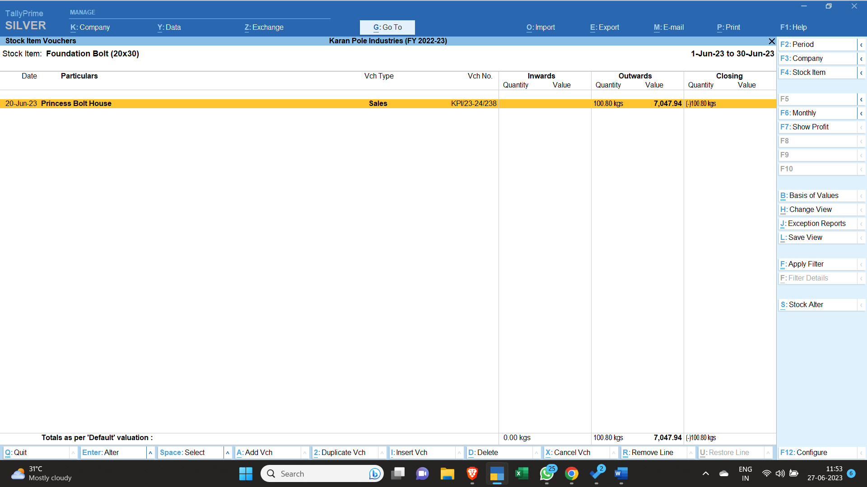
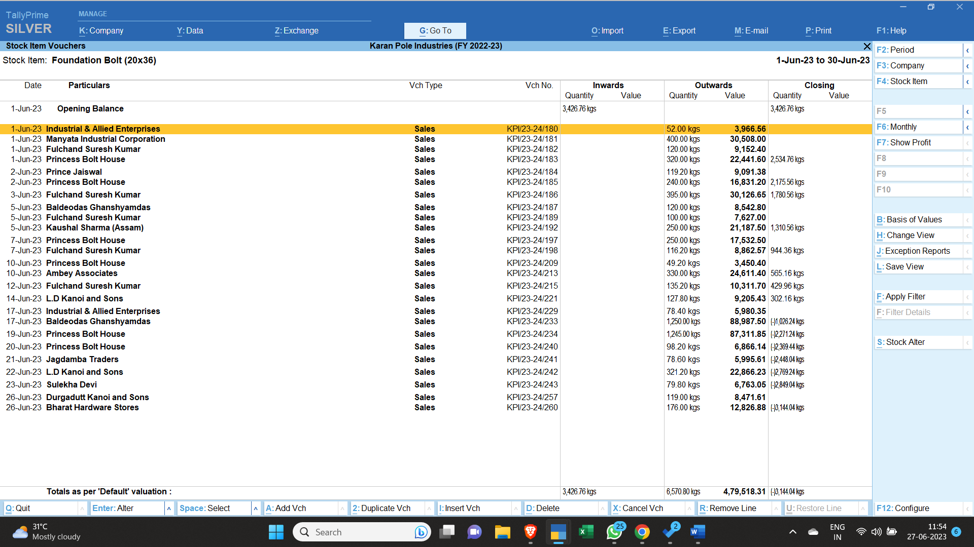
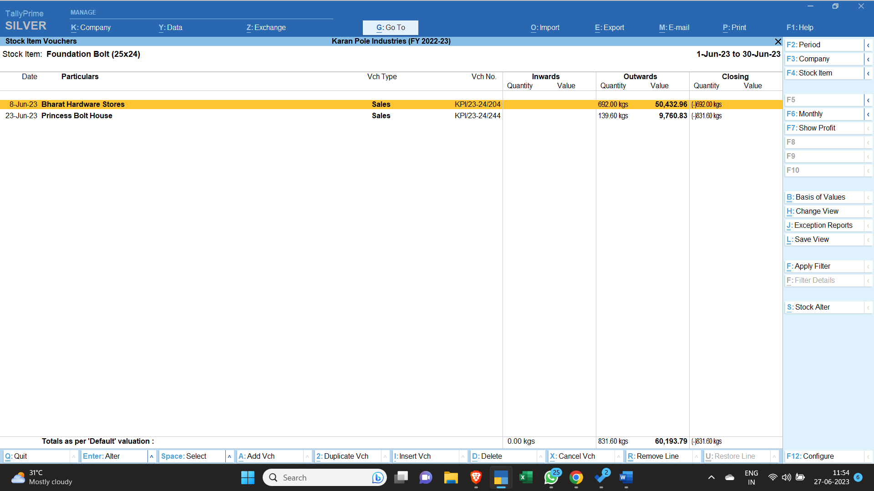
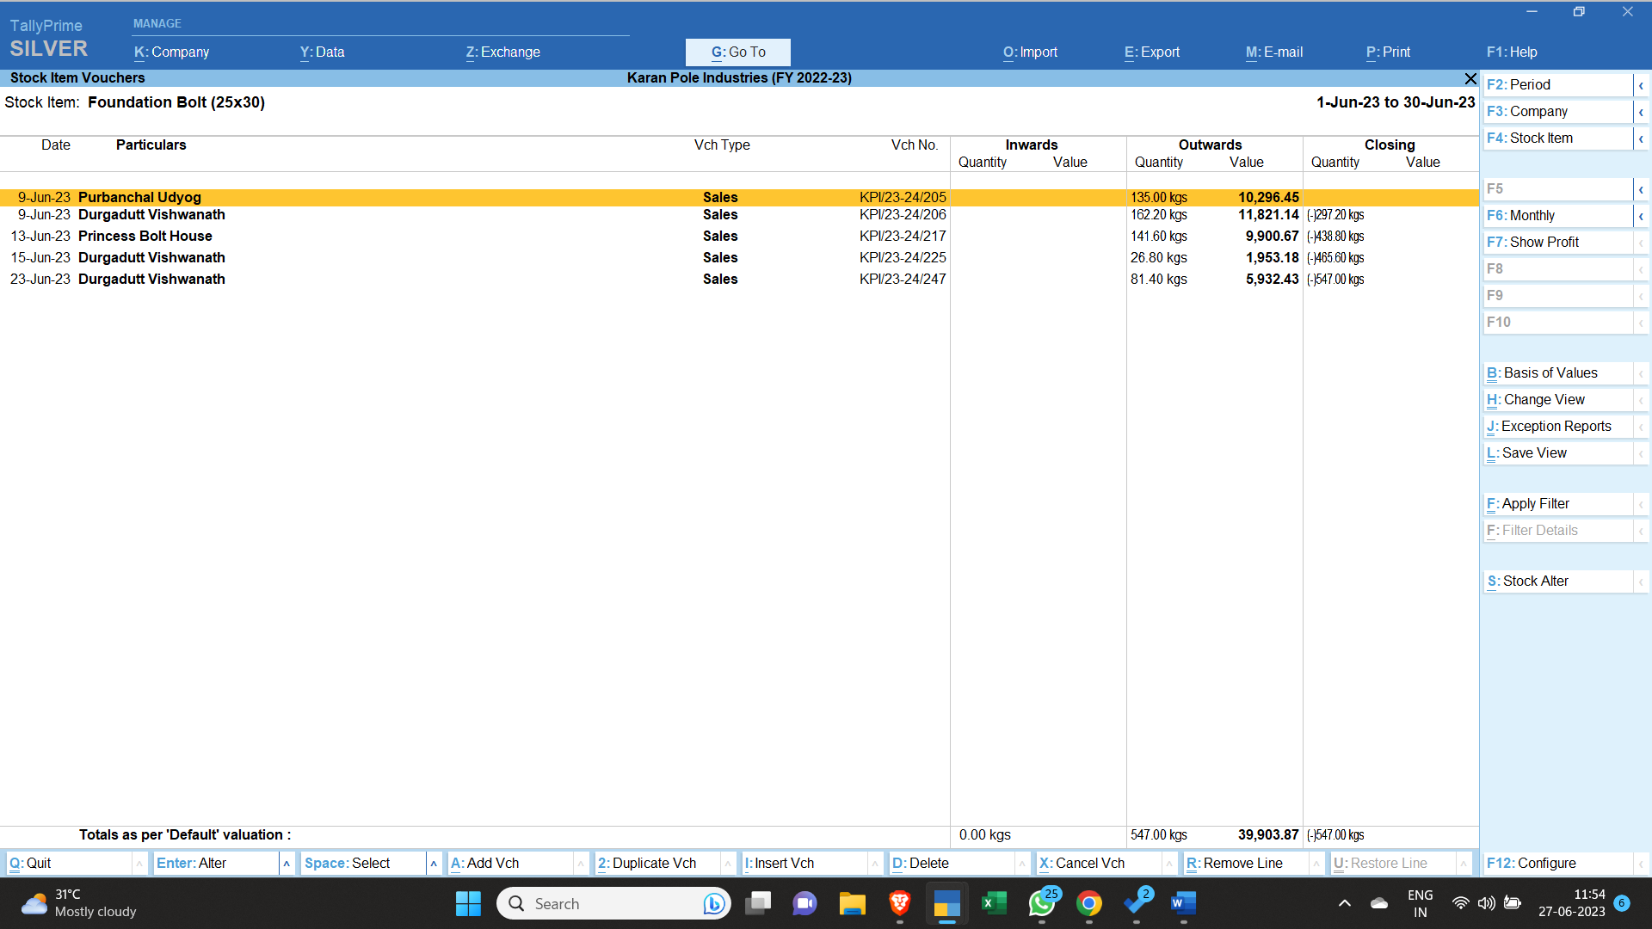
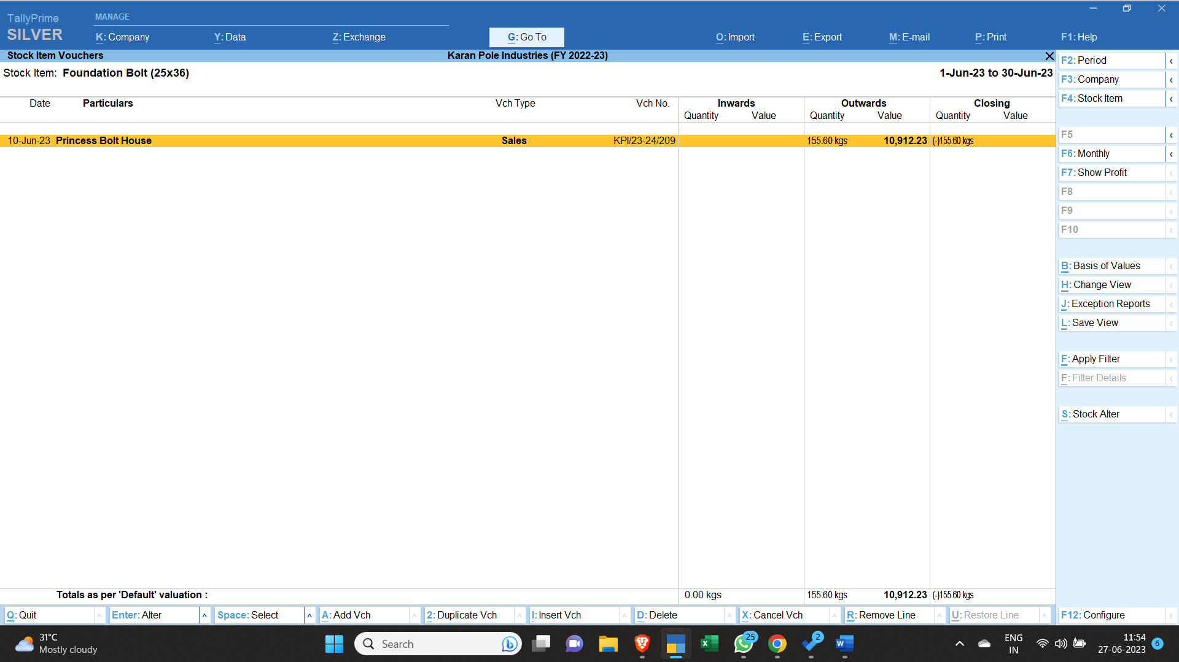

- Now we would add the amount of all the negative stock, it is coming around Rs. 393716/- (Ignoring the decimals)
- Now we would subtract our profit percentage from it (i.e. around 13%). Type in calculator as 393716 * (13%, - , =)
- The value comes as Rs. 342532.92
- Now we would subtract the nut amount from this to calculate required round weight.
- Now to subtract, (342533 – 14728) = Rs.327805
- Now to divide 327805 by the rate of item appearing in Tally (In this case it is Rs. 51.43)
- So the quantity comes as 6373.81 kgs.
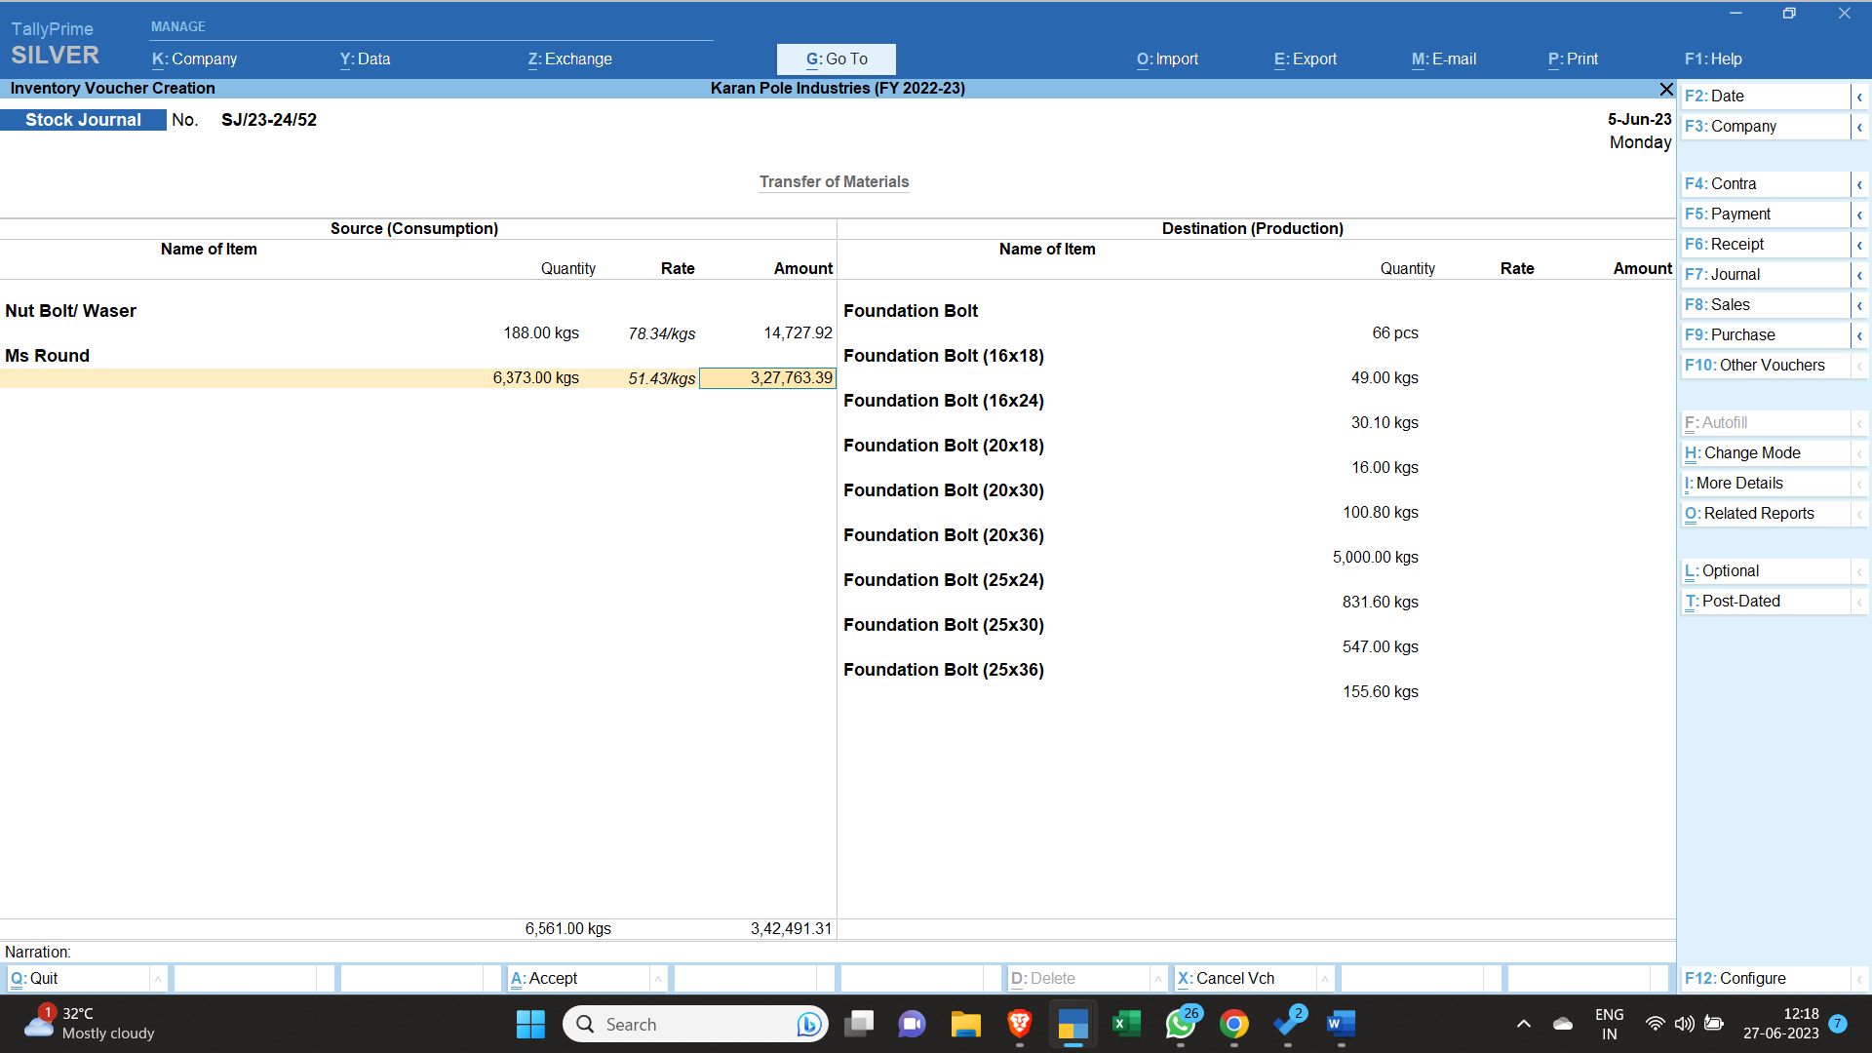
- Now we go on pressing enter and accept the entry. The Stock Entry of Foundation Bolts is complete.
Entry:

